|  | **MINISTRY OF EDUCATION AND TRAINING** |
| --- | --- |

| **FPT UNIVERSITY** |
| --- |
| Capstone Project Document |
| AI-Enhanced Pickleball Learning and Coaching Connection Platform |

| **GFA25SE123** | |
| --- | --- |
| **Group Members** | Lâm Tiên Hưng - SE170176  Nguyễn Anh Tuấn - SE170164  Nguyễn Thị Thu Hoài - SE170202  Đỗ Minh Quang - SE170316 |
| **Supervisor** | Lại Đức Hùng |
| **Capstone Project code** | FA25SE069 |

- TPHCM, December 2025 -

**Table of Contents**

Acknowledgement 4

Definition and Acronyms 4

I. Project Introduction 5

1. Overview 5

2. Product Background 5

3. Existing Systems 5

4. Business Opportunity 5

5. Software Product Vision 5

6. Project Scope & Limitations 5

II. Project Management Plan 6

1. Overview 6

2. Management Approach 6

3. Master Schedule 6

4. Project Organization 6

5. Project Communication 6

6. Configuration Management 6

III. Software Requirement Specification 7

1. Overall Description 7

2. User Requirements 7

3. Functional Requirements 7

4. Non-Functional Requirements 7

5. Other Requirements 7

IV. Software Design Description 8

1. Overall Description 8

2. System Architecture Design 8

3. System Detailed Design 8

4. Class Specification 8

5. Data & Database Design 8

V. Software Testing Documentation 9

1. Overall Description 9

2. Test Plan 9

3. Test Cases 9

4. Test Reports 9

VI. Release Package & User Guides 10

1. Deliverable Package 10

2. Installation Guides 10

3. User Manual 10

VII. Appendix 10

1. Glossary [Optional] 10

2. References [Optional] 10

3. Others [Optional] 10

# Acknowledgement

We would like to express our sincere gratitude to all those who supported us throughout the process of completing this project.

First and foremost, we would like to extend our deepest appreciation to our instructor, Lai Duc Hung, for the valuable guidance, feedback, and encouragement provided during the development of this project. Your expertise and dedication greatly contributed to our understanding and successful completion of the work.

We would also like to thank our university, FPT , and the Faculty of international technology , for creating a supportive learning environment and providing the necessary resources for us to carry out this project.

Our heartfelt thanks go to all team members for their collaboration, commitment, and continuous effort. Each member has contributed significantly to the project’s progress and success. The teamwork experience has helped us grow not only in technical skills but also in problem-solving, communication, and project management.

Finally, we would like to express our gratitude to our families and friends for their support, motivation, and understanding throughout this period.

This project would not have been possible without the collective support of everyone involved. Thank you very much.

# 

# Definition and Acronyms

| **Acronym** | **Definition** |
| --- | --- |
| PWM | Psychology website |
| AWS | Amazon Web Services |
| BA | Business Analysis |
| BR | Business Rule |
| ERD | Entity Relationship Diagram |
| GUI | Graphical User Interface |
| PM | Project Manager |
| SDD | Software Design Description |
| SPMP | Software Project Management Plan |
| SRS | Software Requirement Specification |
| UAT | User Acceptance Test |
| UC | Use Case |
| API | Application Program Interface |

# I. Project Introduction

## 1. Overview

### 1.1 Project Information

* Project name: AI-Enhanced Pickleball Learning and Coaching Connection Platform
* Project code: FA25SE069
* Group name: GFA25SE123
* Software type: Web, Mobile App

### 1.2 Project Team

| **Full Name** | **Role** | **Email** | **Mobile** |
| --- | --- | --- | --- |
| Lại Đức Hùng | Lecturer | hungld5@fe.edu.vn | 0976710580 |
| Lâm Tiên Hưng | Leader | hungltse170176@fpt.edu.vn | 0832824279 |
| Nguyễn Anh Tuấn | Member | tuannase170164@fpt.edu.vn | 0905038319 |
| Nguyễn Thị Thu Hoài | Member | hoainttse170202@fpt.edu.vn | 0839671415 |
| Đỗ Minh Quang | Member | quangdmse170316@fpt.edu.vn | 0394232378 |

## 2. Product Background

Pickleball has rapidly grown in popularity worldwide, attracting players of all ages. However, learners, especially beginners and intermediates, face challenges including limited access to qualified coaches, inconsistent instructional resources, high costs of traditional training, and difficulty in tracking skill development. Coaches, on the other hand, lack a centralized platform to showcase their profiles, manage schedules, and connect with students efficiently. Additionally, learners often struggle to find high quality courses, resulting in reduced motivation and engagement.

In response to these challenges, the proposed project **PICKLE-LEARN** aims to develop an AI-enhanced platform that provides structured learning materials, AI-assisted technique analysis. The project idea arises from the increasing demand for accessible, efficient, and connected pickleball education, as identified through feedback from learners and coaches. The platform is designed to improve learning outcomes, streamline coaching processes, and foster a more active and supportive pickleball community.

## 3. Existing Systems

Here are the names of the systems we reference:

* Learning Management System (LMS)
* Coursera
* My DUPR Coach
* CoachNow

### 3.1 Learning Management System (LMS)

* Description: LMS is software for administration, documentation, tracking, reporting, automation, and delivery of educational courses or training programs.
* Features: Course creation and management, learner progress tracking, assessment tools, content hosting, certification issuing, communication tools (forums, messaging), and reporting.
* Pros: Centralized learning management, scalable, reduces training costs, improves accessibility and engagement.
* Cons: Can be complex to set up and customize, may require technical skills for administration.
* Actor: Student, Admin, instructors
* Link: <https://lms-hcm.fpt.edu.vn/login/index.php>

### 3.2 Coursera

* Description: Coursera is a leading online learning platform offering a wide range of courses across diverse fields. It aims to enhance learner employability with job-relevant skills through flexible, accessible digital learning.
* Features:
* Wide range of free and paid courses with accredited certificates and digital badges.
* Interactive learning including quizzes, assignments, peer grading, and discussion forums.
* Personalized learning paths, skill assessment, comprehension checks, and skill gap analysis.
* Integration with other learning management systems (LMS) and corporate training tools.
* Offline access, mobile app support, and multi-language interface.
* Career services and university partnerships to support job-ready skills development.
* Pros: Extensive course variety, credible certification, flexibility in learning format, strong integration capabilities, community engagement through peer discussions.
* Cons: Some courses require payment for certification, variable interaction quality in peer forums, and require internet access for most features.
* Actor: Learners (students, professionals), instructors, corporate trainers, administrators.
* Link: [Coursera](https://www.coursera.org/)

### 3.3 My DUPR Coach

* Description: A sports coaching app focusing on pickleball, providing personalized skill ratings and coach matching.
* Features: Certified coach assessments, video upload for rating, flexible rating options, accessible for beginners and advanced players.
* Pros: Personalized coaching, easy access to certified coaches, flexible rating methods.
* Cons: Focused on pickleball only, limited sport scope.
* Actor: Players, coaches.
* Link: [My DUPR Coach](https://www.dupr.com/my-dupr-coach)

### 3.4 CoachNow

* Description: Coaching platform enhancing collaboration, performance tracking, and administration for coaches and athletes across sports.
* Features: Video analysis, messaging, file sharing, progress tracking, team collaboration, customizable templates, calendar integration, wearable integration
* Pros: Multi-sport support, comprehensive communication tools, offline access, mobile app.
* Cons: May require subscription cost, complexity for new users.
* Actor: Coaches, athletes, administrators.
* Link: [CoachNow](https://www.softwaresuggest.com/coachnow)

## 4. Business Opportunity

The rapid growth of pickleball has created a strong demand for accessible training, qualified coaching, and structured learning tools. However, existing solutions are fragmented: lack of structured learning materials, coaching platforms do not provide technique analysis. As a result, learners struggle to improve effectively, while coaches lack a centralized system to manage profiles, sessions, and student progress.

PICKLE-learn addresses these gaps by integrating AI-assisted technique analysis, verified coach-learner connection, AI-assisted structured learning modules creation, and personalized learning progress with AI engagement. The product aligns with current trends in AI-driven sports training and remote coaching. Without such a system, key needs—such as personalized feedback, efficient coaching management cannot be met. This makes PICKLE-learn an attractive and timely solution for the emerging pickleball market.

## 5. Software Product Vision

For pickleball learners seeking accessible, high-quality training and for coaches looking to connect with students more effectively, PICKLE-learn is an AI-enhanced, multi-platform application that provides structured learning paths, personalized technique analysis, and a verified coach–learner connection system. The platform supports both online and offline coaching. Online coaching is exclusively available to learners who are unable to attend offline sessions, progress tracking, . Unlike scattered video tutorials, manual scheduling, and unstructured self-training methods, PICKLE-LEARN offers an integrated and intelligent environment where players can learn more efficiently, coaches can manage their services more effectively.

## 6. Project Scope & Limitations

### 6.1 Major Features

**FE-01:** Admin verifies coach’s profile, monitors new courses and learning materials.

**FE-02:** Learner submits his/her technique video for analysis by the AI ​​system; coach views the analysis results, adds comments, and sends detailed feedback.

**FE-03:** Learner practices exercises, accesses instructional videos, takes quizzes, views comprehensive AI analysis course learning progress

**FE-04:** Coach summarizes and analyzes learner's practice progress, sends personalized reports

**FE-05:** Learner receives new badge/achievement certificate after completing course skill milestones

**FE-06:** Coach manages courses, AI-assisted create learning materials, schedules, pricing options, and session structures.

**FE-07:** Secure payment and standardized pricing for training sessions and courses.

### 6.2 Limitations & Exclusions

**LI-01:** The system does not offer advanced AI motion analysis (e.g., real-time biomechanics, intricate posture correction); only basic pose recognition and simple movement categorization are available**.**

**LI-02:** The initial version is developed exclusively for mobile devices; web or desktop versions are not supported**.**

**LI-03:** There is no automated partner/player matching using real-time location; users can only search for general courses or training sessions.

**LI-04:** Financial functions like refunds, installment plans, or integrations with external marketplaces/equipment shops are excluded.

**LI-05:** Downloading videos or accessing training materials for offline use is not supported in this version.

**LI-06:** The system does not manage large-scale community activities such as organizing tournaments, managing events, or booking courts.  
**LI-07:** AI feature depends heavily on Gemini

# II. Project Management Plan

## 1. Overview

### 1.1 Scope & Estimation

| **#** | **WBS Item** | **Complexity** | **Est. Effort**  **(man-days)** |
| --- | --- | --- | --- |
| ***1*** | ***Feature 1: Instructional Content & Learning Materials*** |  | ***20*** |
| 1.1 | Video handling for instructional lessons | Medium | 6 |
| 1.2 | Drill & exercise display module | Simple | 4 |
| 1.3 | Quiz module for knowledge checks | Simple | 4 |
| 1.4 | AI-assisted learning materials creation | Medium | 6 |
| ***2*** | ***Feature 2: AI Video Analysis & Coach Feedback*** |  | ***30*** |
| 2.1 | Learner video upload | Simple | 3 |
| 2.1 | AI technique analysis processing | Complex | 12 |
| 2.3 | Coach review + comment + feedback module | Complex | 15 |
| ***3*** | ***Feature 3: Course Management (Coach)*** |  | ***16*** |
| 3.1 | Coach creates & updates course content | Medium | 4 |
| 3.2 | Subject & pricing structure setup | Medium | 6 |
| 3.3 | Progress tracking management | Medium | 6 |
| ***4*** | ***Feature 4: Learner Progress Dashboard*** |  | ***15*** |
| 4.1 | Progress visualization graphs | Medium | 5 |
| 4.2 | Performance summary reports | Medium | 5 |
| 4.3 | AI-assisted learning progresses improvement | Medium | 5 |
| ***5*** | ***Feature 5: Badges & Achievement Certification*** |  | ***10*** |
| 5.1 | Badge awarding logic | Simple | 4 |
| 5.2 | Certificate generation | Medium | 6 |
| ***6*** | ***Feature 6: Coach–Learner Interaction*** |  | ***8*** |
| 6.1 | Learner views coach profile includes rating and feedbacks | Simple | 4 |
| 6.2 | Learner takes feedback after completes a course | Simple | 4 |
| ***7*** | ***Feature 7: Configuration Management*** |  | ***4*** |
| 7.1 | Admin views and updates configuration | Simple | 4 |
| ***8*** | ***Feature 8: Base Credential Management*** |  | ***4*** |
| 8.1 | Admin CRUD base credentials | Simple | 4 |
| ***9*** | ***Feature 9: Admin - Coach Interaction*** |  | ***10*** |
| 9.1 | Admin monitors and verifies coach profile | Medium | 6 |
| 9.2 | Admin approves new course creation | Simple | 4 |
| ***Total Estimated Effort (man-days)*** | | | ***117*** |

### 

### 1.2 Project Objectives

Quality:

| **#** | **Testing Stage** | **Test Coverage** | **No. of Defects** | **% of Defect** | **Notes** |
| --- | --- | --- | --- | --- | --- |
| 1 | Reviewing | ≥ 95% requirements reviewed | ≤ 3 major | ≤ 5% | Review SRS, design, UI flow |
| 2 | Unit Test | ≥ 80% code coverage | ≤ 10 minor | ≤ 10% | FE + BE automated unit tests |
| 3 | Integration Test | All modules integrated | ≤ 8 medium | ≤ 8% | AI analysis ↔ Feedback ↔ Course modules |
| 4 | System Test | 100% major functions tested | ≤ 5 major | ≤ 5% | End-to-end: Upload video → AI analysis → Coach feedback → Progress tracking |
| 5 | Acceptance Test | ≥ 95% test cases passed | 0 blocking defects | 0% | UAT (User Acceptance Testing) with representative learners and coaches |

Milestone Timeliness (%):

* **Target Timeliness:** **≥ 90%** milestones delivered on planned schedule
* **Maximum allowable deviation**: **10%**

Allocated Effort (man-days):

| **Activity** | **Allocated %** | **Estimated Man-days** |
| --- | --- | --- |
| Requirements Analysis | 12% | 14.04 |
| System & UI/UX Design | 15% | 17.55 |
| Frontend Development | 30% | 35.1 |
| Backend Development | 28% | 32.76 |
| Testing (Unit + Integration + System + UAT) | 12% | 14.04 |
| Project Management | 3% | 3.51 |
| **Total** | **100%** | **117** |

### 1.3 Project Risks

| **#** | **Risk Description** | **Impact** | **Possibility** | **Response Plans** |
| --- | --- | --- | --- | --- |
| 1 | AI video analysis may produce inaccurate or incomplete technique detection | High | Medium | Improve the model, expand the training dataset, allow coaches to manually adjust analysis results |
| 2 | AI backend workload may overload when many learners submit videos simultaneously | High | Medium | Optimize queue processing, enable autoscaling, and use dedicated worker servers |
| 3 | Compatibility issues on older mobile devices or different browsers | Medium | Medium | Perform cross-browser and device testing, optimize responsiveness, add fallback UI |
| 4 | Coaches or learners may abandon courses midway, lowering training effectiveness | Low | Medium | Use gamification (badges/certificates), progress reminders, and motivational notifications |

## 2. Management Approach

* An agile management approach for your project means organizing work in short, iterative cycles, focusing on small, valuable increments, and adapting the plan based on feedback rather than following a fixed, upfront schedule.

### 2.1 Project Process

Sprints 1–2: Foundation and Core Model (Weeks 1–4)

* Define domain model: Subject, Course, Lesson, Quiz, User, Role, Enrollment, Payment, Video.
* Build basic auth, AuthGuard, and simple course/lesson browsing (no payment yet).
* Decide payment provider (PayOS) and AI approach (video comparison, subject generation, learner progress improvement).

Sprints 3–4: Course, Lesson, Video Features (Weeks 5–8)

* Implement subject and course management (create, enrollments and payment).
* Add lesson and video features: upload/attach video to lesson, streaming player, basic progress tracking.
* Refine UX for course → section/subject → lesson navigation; update class/sequence diagrams.

Sprints 5–6: Payments and AI Features (Weeks 9–12)

* Implement course/lesson payment: checkout flow, orders, transactions, receipts, and access control (only paid users can view paid courses/lessons).
* Add AI features: e.g., AI subject generation from coach prompts, AI recommendations for improvement for next lesson/course and video comparison.
* Handle edge cases: failed payments, refunds, invoice history; monitor AI usage, rate‑limits, and safety.

Sprint 7: Stabilization and Documentation (Weeks 13–14)

* End‑to‑end testing of flows: registration → purchase course → watch videos → do quizzes → AI assistance.
* Optimize performance for video streaming and payment callbacks; fix bugs.
* Finalize documentation: class specs (including shared classes like AuthGuard, PaymentService, AIService), sequence diagrams for payment and AI flows, user guide, and deployment guide.

### 2.2 Quality Management

* Defect Prevention
* Apply coding standards and best practices.
* Use linters and static code analysis to detect errors early.
* Provide team training to improve skills.
* Reviewing
* Every feature/bug fix must go through **peer review** on GitHub.
* Focus on logic, readability, security, and performance.
* Unit Testing
* Write **unit tests** for all core modules.
* Use Jest or equivalent testing tools.
* Target coverage: ≥80%.
* Integration Testing
* Test interactions between modules: Front-end ↔ Back-end ↔ Database.
* Use Postman or supertest for API testing.
* System Testing
* Conduct full system testing before release.
* Include functional, performance, security testing, and User Acceptance Testing (UAT).
* Continuous Improvement
* Track and analyze issues/bugs on GitHub.
* Hold retrospectives to learn from mistakes and improve processes.

### 2.3 Training Plan

| **Training Area** | **Participants** | **When, Duration** | **Waiver Criteria** |
| --- | --- | --- | --- |
| Next.js (React + SSR/SSG) | Front-end developers who lack Next.js experience | Week 1–2, 3 sessions × 2 hours each | Able to create pages, use API routes, and fetch data using SSR/SSG independently |
| NestJS (Back-end API framework) | Back-end developers | Week 1–2, 3 sessions × 2 hours each | Able to create modules, controllers, services, and RESTful APIs independently |
| Expo + React Native | Mobile developers or front-end developers moving to mobile | Week 2–3, 4 sessions × 2 hours each | Able to create functional components, use navigation, handle state, and fetch API data independently |
| Git, Github | All team members | Week 1, 2 sessions × 1.5 hours each | Able to commit, push, pull, create branches, merge, and resolve conflicts independently |
| PostgreSQL Database | Back-end developers | Week 2–3, 3 sessions × 2 hours each | Able to design schema, write queries, and integrate with NestJS API routes |
| Testing (Unit & Integration Testing) | All developers | Week 3–4, 2 sessions × 2 hours each | Able to write and run unit and integration tests using Jest or equivalent tools |

## 3. Project Deliverables

| **#** | **Deliverable** | **Due Date** | **Notes** |
| --- | --- | --- | --- |
| 1 | Project Introduction Document | 10/12/2025 | Overview, objectives, scope, and team roles |
| 2 | Software Requirements Specification (SRS) – Overview | 10/12/2025 | Includes high-level system requirements |
| 3 | SRS – User Requirements | 10/12/2025 | Detailed functional and non-functional requirements |
| 4 | Major Features & Functional Requirements List | 10/12/2025 | Key features and highlight features |
| 5 | Limitations & Exclusions | 10/12/2025 | Define what is out of scope |
| 6 | Software Product Vision | 10/12/2025 | Concise statement of project purpose and intent |
| 7 | Configuration Management Plan | 10/12/2025 | Document & source code versioning plan |
| 8 | Learner Mobile Application (Frontend) | 15/12/2025 | Developed app for learners with video library and AI analysis |
| 9 | Coach Mobile Application (Frontend) | 15/12/2025 | Developed app for coach functionalities |
| 10 | Backend & API Services | 15/12/2025 | NextJS backend, database(Postgresql), AI integration (google AI studio) |
| 11 | Testing Documents & Test Cases | 15/12/2025 | Unit tests, integration tests, UAT plans |
| 12 | Final Report & Documentation Package | 14/12/2025 | Complete SRS, design docs, source code, installation guide |

## 4. Responsibility Assignments

| **Responsibility** | **HungLTSE170176** | **TuanNASE170164** | **HoaiNTTSE170202** | **QuangDMSE170316** |
| --- | --- | --- | --- | --- |
| Project Planning & Tracking | S | R | D | R |
| Prepare Project Introduction Document | R | S | D | R |
| Prepare SRS Document (Overview Part) | R |  | D | S |
| Prepare SRS Document (User Requirements) | R | R | D | S |
| Prepare Function Requirement | D | D | S | S |
| Prepare Non-Functional Requirements | R |  | D |  |
| Prepare Major Features List | R | D | S | S |
| Prepare Limitations & Exclusions |  | R | S | D |
| Prepare Software Product Vision | R | D | R | S |
| Prepare Configuration Management Plan | S | D |  | R |
| Develop Learner App Frontend | S | S | D | R |
| Develop Backend & API | D | S |  | S |
| Implement AI Video Analysis Module | D | S |  |  |
| Testing & QA | S | S | D | S |
| Deployment & Release | D | S | S | S |
| Documentation Review & Finalization | R | R | D | R |

## 5. Project Communications

| **Communication Item** | **Who/ Target** | **Purpose** | **When, Frequency** | **Type, Tool, Method(s)** |
| --- | --- | --- | --- | --- |
| Project Kickoff Meeting | Project Team, Supervisor | Align goals, roles, scope, schedule | Once, at project start | Meet offline |
| Weekly Progress Report | Project Team, Supervisor | Update on tasks completed, blockers, next steps | Weekly | Meet offline |
| Sprint Review / Demo | Project Team, Supervisor | Demonstrate completed features, gather feedback | Weekly | Meet offline |
| Code review | Leader, Member | Ensure code quality, progress | As needed per commit | Git pull requests / GitHub |
| Documentation Updates | Project Team | Keep SRS, design docs, test plans up-to-date | Ongoing | Google Drive |
| Issue Tracking & Bug Reporting | Project Team, Supervisor | Report, assign, and track bugs or issues | As issues arise | Github |

## 6. Configuration Management

### 6.1 Document Management

All project documents (SRS, design, test cases, user manuals, reports) will be managed using **version-controlled document storage**.

* Each document will have a **unique version number** and **date of modification**.
* Changes will be tracked with a **changelog** specifying the author, modification date, and description of the changes.
* Documents will be stored on a **shared cloud repository** (e.g., Google Drive, OneDrive, or SharePoint) accessible to all team members.
* Periodic **reviews and approvals** will be conducted to ensure documents remain accurate and up-to-date.

### 6.2 Source Code Management

All source code will be managed using **Git** and hosted on a **Git repository** (e.g., GitHub, GitLab).

* Each feature, bug fix, or update will be implemented on a **separate branch** and merged to the main branch only after **peer review and testing**.
* Commit messages will follow a **consistent format** describing changes clearly.
* Version tags will be created for **major releases or milestones**.
* Continuous integration (CI) tools can be optionally used to ensure builds are **automated and stable**.
* Regular **backups** will be maintained to prevent data loss.

### 6.3 Tools & Infrastructures

| **Category** | **Tools / Infrastructure** |
| --- | --- |
| **Technology** | NextJS (FrontEnd), React Native + Expo (Mobile App), NestJS (BackEnd) |
| **Database** | PostgreSQL |
| **IDEs/Editors** | Visual Studio Code, Cursor, Anti Gravity, Notepad++ |
| **Diagramming** | PlantUML, DrawIO |
| **Documentation** | Microsoft Office, Google Docs/Sheets/Slides |
| **Version Control** | GitHub (Source Codes), Google Drive (Documents) |
| **Deployment server** | Vercel, Railway |
| **Project management** | Notion |

# III. Software Requirement Specification

## 1. Product Overview

The **AI-Enhanced Pickleball Learning and Coaching Connection Platform (PICKLE-LEARN)** is a unified digital system designed to improve how learners study pickleball and how coaches deliver training. The platform solves key challenges such as limited access to qualified instructors, inconsistent learning resources, and difficulties in skill tracking by integrating AI-assisted technique analysis, structured coaching tools, and a centralized booking system.

PICKLE-learn provides mobile and web applications for learners and coaches, supported by an admin web portal and an AI analysis backend. Learners can upload videos for AI-based technique evaluation, book online/offline courses, join live coaching sessions, and track their progress. Coaches can manage profiles, availability, training content, student progress, and receive payments. The system also ensures secure transactions, scalable cloud infrastructure, and multi-platform accessibility.

Overall, the platform offers a modern, intelligent, and connected ecosystem for pickleball training—enhancing learning efficiency, coaching quality, and user experience.

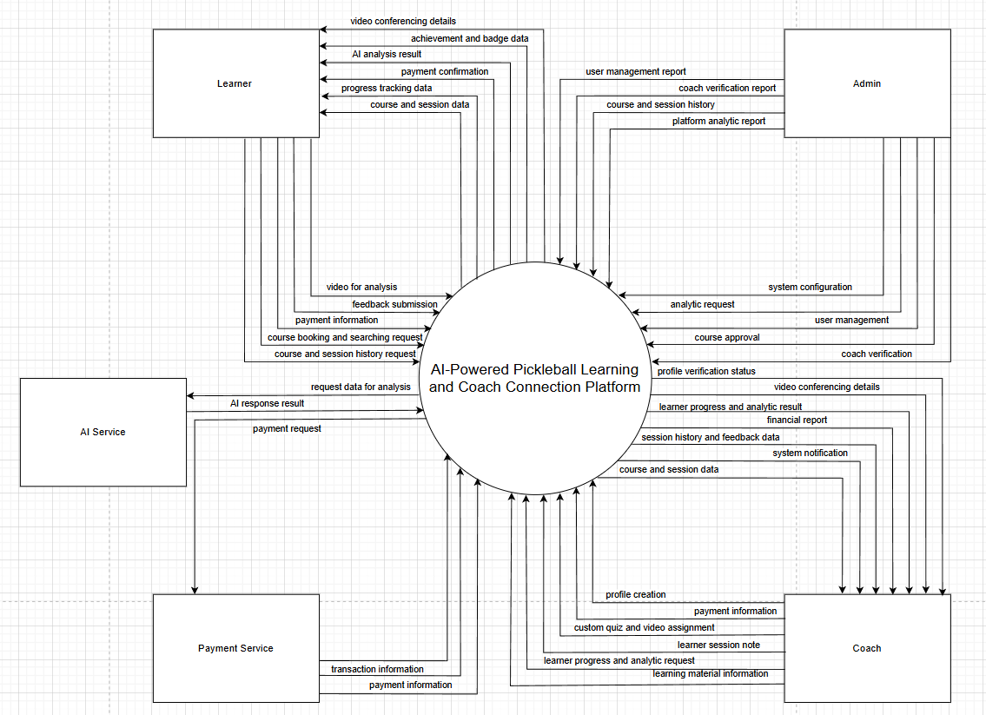

## 2. User Requirements

### 2.1 Actors

| **#** | **Actor** | **Description** |
| --- | --- | --- |
| 1 | Administrator | Manages the overall platform, including user verification, coach approval, course oversight, system configuration, and monitoring platform analytics. |
| 2 | Learner | Uses the mobile app to register, assess skill level, upload videos for AI analysis, book courses, track progress, and provide feedback. |
| 3 | Coach | Creates a professional profile, manages availability, builds training content, conducts online sessions, reviews learner progress, and handles financial transactions. |
| 4 | Payment Service | External payment service for secure transactions, creating fast and secure payment links. |
| 5 | AI Service | Handle requests from the system, in charge of responding to the data for AI video comparison, AI-assisted learning materials creation and learning progress improvements. |

### 2.2 Use Cases

#### 2.2.1 Diagram(s)

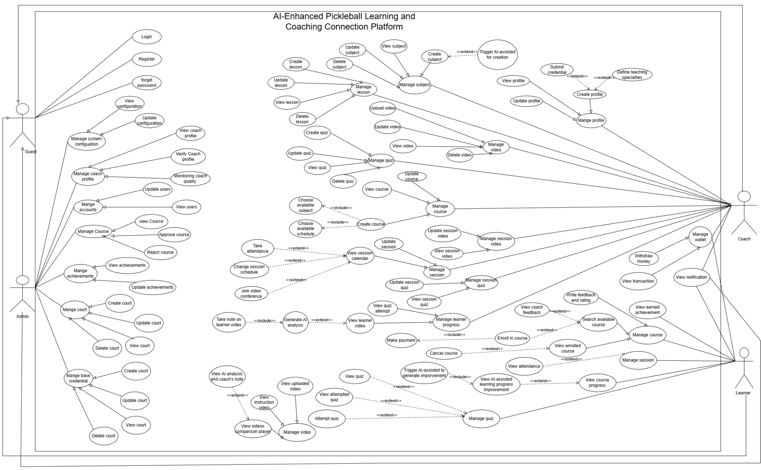

#### 2.2.2 Description

| **ID** | **Use Case** | **Actors** | **Use Case Description** |
| --- | --- | --- | --- |
| 01 | Login | Guest | Users (Admin, Coach, Learner) enter their credentials to access the system. |
| 02 | Register | Guest | New users create an account by providing required information and selecting their role. |
| 03 | Forget password | Guest | User requests password reset; system sends mail or OTP to verify and allow creating a new password. |
| 04 | View configuration | Admin | Admin views current system configuration settings |
| 05 | Update configuration | Admin | Admin updates and saves system configuration settings. |
| 06 | View coach profile | Admin | Admin views detailed information of a coach’s profile |
| 07 | Verify coach profile | Admin | Admin reviews and approves or rejects a coach’s submitted credentials. |
| 08 | Monitoring coach quality | Admin | Admin tracks coach performance through learner ratings, feedback, and activity. |
| 09 | View users | Admin | Admin views the list of all system users. |
| 10 | Update user | Admin | Admin edits account details or status of a selected user. |
| 12 | View course | Admin | Admin views course details, structure, and status. |
| 13 | Approve course | Admin | Admin reviews and approves a newly created course. |
| 14 | Reject course | Admin | Admin reviews and rejects a course with a required rejection reason. |
| 15 | View achievement | Admin | Admin views the list of system achievements and their criteria. |
| 16 | Update achievement | Admin | Admin edits achievement details, criteria, or reward information. |
| 17 | View court | Admin | Admin views court details, province, district and location related details |
| 18 | Update court | Admin | Admin update court details, province, district, latitude and longitude information |
| 19 | Create court | Admin | Admin create new court with location related details |
| 20 | Delete court | Admin | Admin delete existing court |
| 21 | View base credential | Admin | Admin view base credential details such as name, image |
| 22 | Create base credential | Admin | Admin create new base credential with details |
| 23 | Update base credential | Admin | Admin update base credential with new information |
| 24 | Delete base credential | Admin | Admin delete base credential |
| 25 | Update profile | Coach | The coach updates personal information, bio, credentials, or teaching details. |
| 26 | View profile | Coach | Coach views his/her profile information and credential status. |
| 27 | Create profile | Coach | Coach sets up a new profile by providing required personal and professional details. |
| 28 | Define teaching specialties | Coach | The coach defines specific skill areas or topics they specialize in teaching. |
| 2129 | Submit credential | Coach | Coach uploads certifications or documents for admin verification. |
| 30 | View subject | Coach | The coach views the list of subjects they created or have access to. |
| 31 | Create subject | Coach | The coach creates a new subject with name, description,.. |
| 32 | Trigger AI-assisted for subject creation | Coach | The coach can trigger the AI-assisted for comprehensive subject creation |
| 33 | Update subject | Coach | Coach edits an existing subject’s information or content. |
| 34 | Delete subject | Coach | Coach removes an existing subject from the system. |
| 35 | AI create lesson | Coach | AI suggests creating lessons. |
| 36 | Create lesson | Coach | The coach creates a new lesson with content, video, and instructions. |
| 37 | Update lesson | Coach | The coach edits lesson details, materials, or structure. |
| 38 | View lesson | Coach | Coach views lesson content and related resources. |
| 39 | Delete lesson | Coach | The coach deletes a selected lesson from their subject or course. |
| 40 | Create quiz | Coach | The coach creates a new quiz with questions and answer options. |
| 41 | Update quiz | Coach | Coach edits quiz questions, answers |
| 42 | View quiz | Coach | Coach views quiz details and question list. |
| 43 | Delete quiz | Coach | The coach deletes a selected quiz from their course or lesson. |
| 44 | Upload video | Coach | Coach uploads instructional or practice videos to the system. |
| 45 | Update video | Coach | Coach updates video details such as title, description, or tags. |
| 46 | View video | Coach | Coach views uploaded instructional or practice videos. |
| 47 | Delete video | Coach | Coach removes a selected video from the system. |
| 48 | View course | Coach | The coach views details of courses they created, including structure and status. |
| 49 | Update course | Coach | The coach updates course information such as name, description, location. |
| 50 | Create course | Coach | The coach creates a new course with basic information, selecting subject and schedule. |
| 51 | Choose available subject | Coach | The coach selects an available subject to add to the course. |
| 52 | Choose available schedule | Coach | The coach selects a suitable time schedule for the course. |
| 53 | Update session video | Coach | The coach updates the video for a specific session in the course. |
| 54 | View session video | Coach | The coach views the video of a specific session in the course. |
| 55 | Update session | Coach | Coach updates details of a session, such as title, description |
| 56 | Update session quiz | Coach | The coach edits or updates the quiz associated with a session. |
| 57 | View session quiz | Coach | The coach views the quiz for a specific session, including questions and answers. |
| 58 | View session calendar | Coach | The coach views the schedule/calendar of all sessions in a course. |
| 59 | Take attendance | Coach | Allows the coach to mark learners’ attendance for a session and update attendance status. |
| 60 | Update session schedule | Coach | Enables the coach to modify the date, time, or duration of an existing learning session. |
| 61 | Join video conference | Coach | Allows the coach to enter the live video meeting room to conduct an online training session. |
| 62 | View quiz attempt | Coach | Coach can view learners’ submitted quiz attempts, including scores and question-by-question responses |
| 63 | View learner video | Coach | Coaches can access and watch videos uploaded by learners for review or analysis. |
| 64 | Generate AI analysis | Coach | Allows the coach to trigger AI processing to analyze a learner’s uploaded video and receive technique insights. |
| 65 | Take note on learner video | Coach | Enables the coach to add comments, notes, or time-based annotations directly on the learner’s video. |
| 66 | View transaction | Coach | Coaches can access the transaction history related to course payments, withdrawals, or earnings. |
| 67 | Withdraw money | Coach | Allows the coach to request a withdrawal of available balance from their earnings. |
| 68 | View notification | Admin,  Coach, Learner | Allows users to view system notifications, including updates, reminders, and activity alerts. |
| 69 | View earned achievement | Learner | Allows the learner to view badges, achievements, and certificates they have earned during their learning progress. |
| 70 | Search available course | Learner | Enables the learner to search for courses based on keywords, location |
| 71 | View coach feedback | Learner | Learner can view feedback, comments, and AI-assisted notes provided by the coach for their uploaded videos or activities. |
| 72 | Enroll in course | Learner | Allows the learner to register for a selected course and gain access to its lessons and materials. |
| 73 | Make payment | Learner | Enables the learner to complete payment for a course using available payment methods. |
| 74 | View enrolled course | Learner | Allows the learner to see a list of courses they have enrolled in along with course details and progress. |
| 75 | Cancel course | Learner | Enables the learner to cancel or withdraw from a course they previously enrolled in. |
| 76 | View attendance | Learner | Learners can view their attendance records for sessions within the course. |
| 77 | View quiz | Learner | Allows the learner to access the list of quizzes available in the course. |
| 78 | View attempted quiz | Learner | Enables the learner to see their previous quiz attempts, including scores and answers. |
| 79 | Attempt quiz | Learner | Allows the learner to take a quiz by answering all required questions within the allowed time. |
| 80 | View course progress | Learner | Learners can track their progress in the course, including completed lessons, quizzes, and achievements. |
| 81 | View AI-assisted learning progress improvement | Learner | Learners can view AI-assisted learning progress improvement details based on submitted videos and quizzes |
| 82 | Trigger AI to generate learning progress improvement | Learner | After each completed session, learner can trigger AI to generate learning progress improvement |
| 83 | View instruction | Learner | Enables the learner to read lesson instructions, session guidelines, or course requirements provided by the coach. |
| 84 | View uploaded video | Learner | Allows the learner to view the videos they previously uploaded for AI analysis or coach review |
| 85 | View videos comparison player | Learner | Learners can compare their uploaded video side-by-side with the coach’s sample or reference video. |
| 86 | View AI analysis and coach’s note | Learner | Allows the learner to review AI-generated analysis and the coach’s comments or annotations on their video. |
| 87 | Write feedback and rating | Learner | Enables the learner to submit feedback and a rating for the course or coach after completing sessions. |

## 3. Functional Requirements

### 3.1 System Functional Overview

#### 3.1.1 Screens Flow

**Admin**

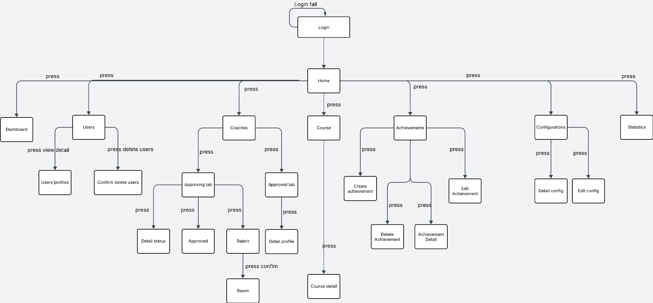

**Learner**

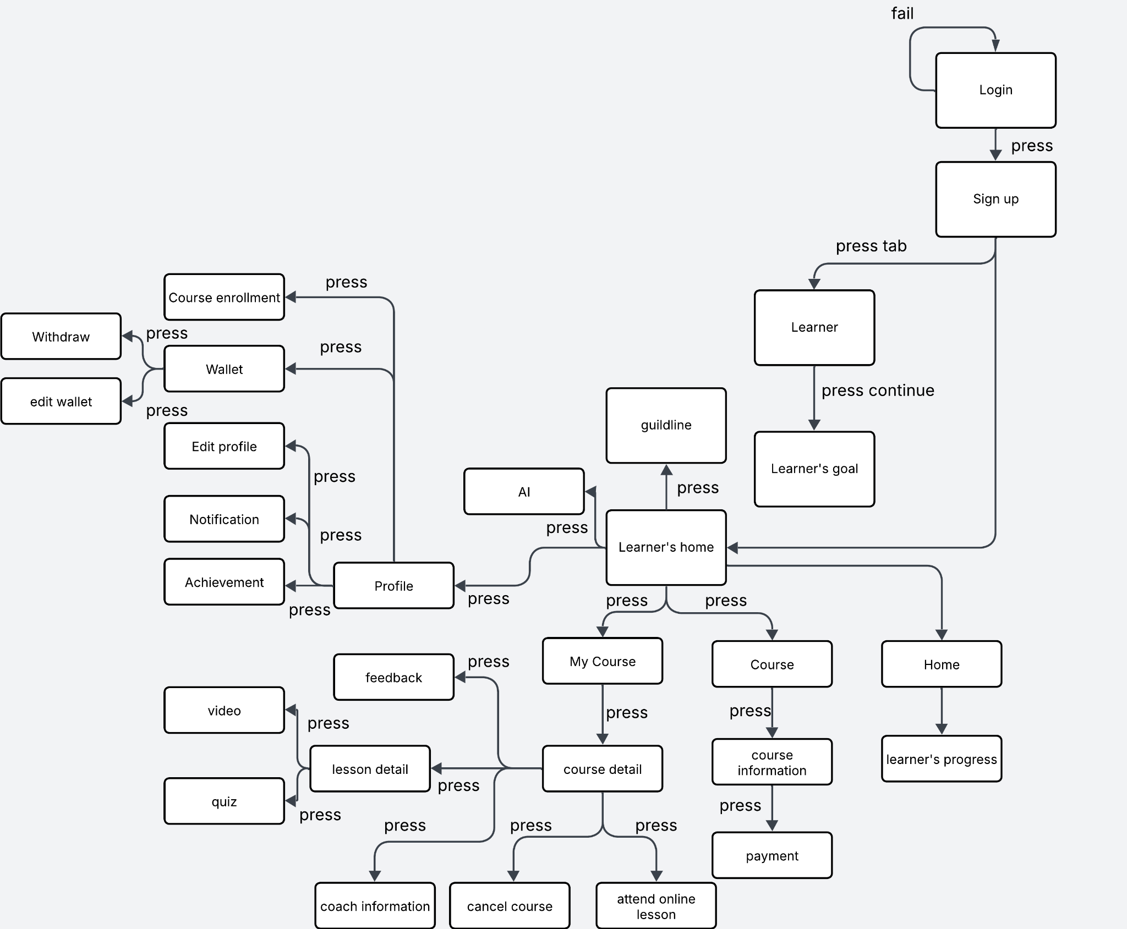

**Coach**

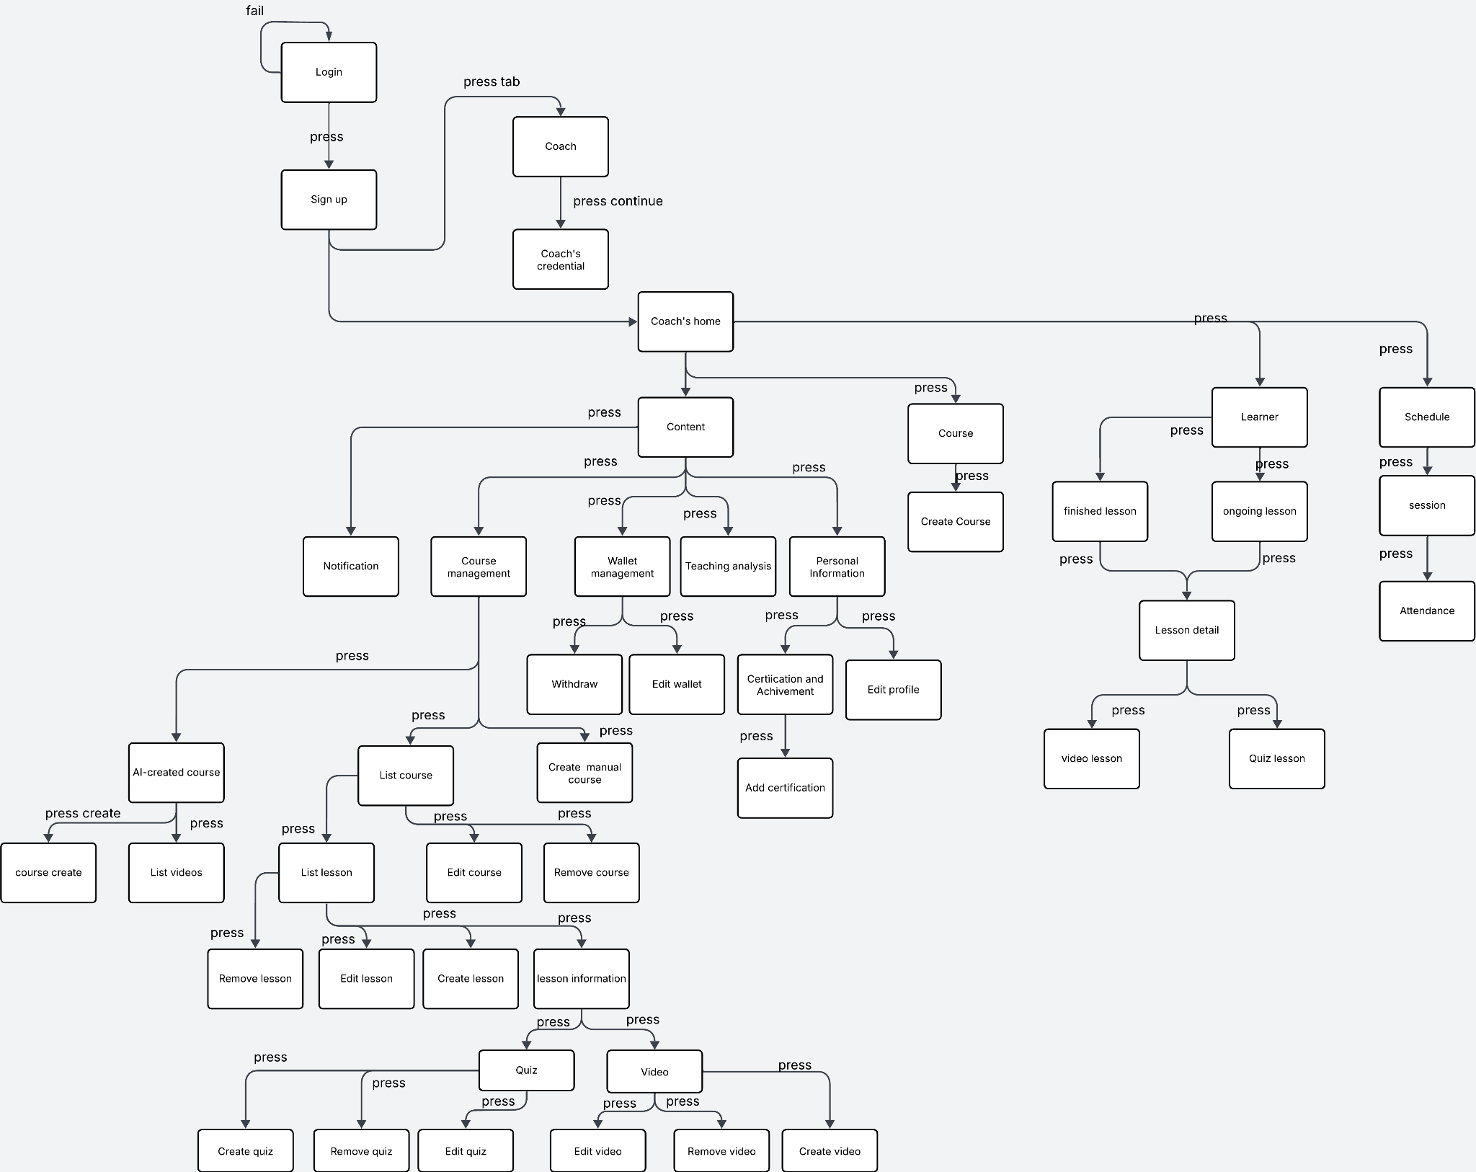

#### 3.1.2 Screen Descriptions

**Admin Screen Descriptions**

| **#** | **Feature** | **Screen** | **Description** |
| --- | --- | --- | --- |
| 1 | Authentication | Login | Screen where the admin enters email and password to access the system; displays an error when login fails. |
| 2 | Home Navigation | Home | Main dashboard screen displaying management modules: Dashboard, Users, Coaches, Courses, Achievements, Configurations, and Statistics. |
| 3 | Dashboard | Dashboard | Shows system overview metrics including number of users, coaches, courses, and key statistics. |
| 4 | User Management | Users | Displays the list of all users with actions to view details or delete a user. |
| 5 | User Management | Users' Profiles | Shows detailed information of a selected user |
| 6 | User Management | Confirm Delete Users | Confirmation popup shown before deleting a user. |
| 7 | Coach Management | Coaches | Displays all coaches separated into two tabs: Approving and Approved. |
| 8 | Coach Management | Approving Tab | Shows coaches whose profiles are pending approval. |
| 9 | Coach Management | Approved Tab | Shows coaches whose profiles have already been approved |
| 10 | Coach Management | Detail Status | Shows detailed status of a coach who is pending approval. |
| 11 | Coach Management | Approve | Screen to confirm the approval of a coach’s profile. |
| 12 | Coach Management | Reject | Screen to reject a coach’s profile and provide a reason. |
| 13 | Coach Management | Reason | Displays the rejection reason for a coach’s profile |
| 14 | Coach Management | Detail Profile | Shows the full profile details of an approved coach |
| 15 | Coach Management | Course | Displays the list of available courses in the system. |
| 16 | Coach Management | Course Detail | Shows detailed information about a selected course, including content, assigned coach, level, and lessons. |
| 17 | Achievement Management | Achievements | Displays the list of achievements in the system. |
| 18 | Achievement Management | Create Achievement | Screen to create a new achievement with fields for title, description, and criteria. |
| 19 | Achievement Management | Edit Achievement | Screen to modify an existing achievement’s information. |
| 20 | Achievement Management | Delete Achievement | Confirmation popup shown before deleting an achievement |
| 21 | Achievement Management | Achievement Detail | Shows full details of a selected achievement. |
| 22 | Configuration | Configurations | Displays the list of system configuration items. |
| 23 | Configuration | Detail Config | Shows detailed information of a selected configuration item. |
| 24 | Configuration | Edit Config | Screen to edit system configuration values. |
| 25 | Statistics | Statistics | Screen showing aggregated statistical data across the system |

**Learner and Coach Screen Descriptions**

| **#** | **Feature** | **Screen** | **Description** |
| --- | --- | --- | --- |
| 1 | Authentication | Login | User enters phone number/password to access the system; shows error on invalid login. |
| 2 | Authentication | Sign Up | New user register and select role (Learner/Coach). |
| 3 | Learner Onboarding | Learner Tab | Learner selects the “Learner” role during registration. |
| 4 | Learner Onboarding | Learner’s Goal | The learner selects goals to customize learning experience. |
| 5 | Learner | Learner’s Home | Learner dashboard: courses, profile, AI, notifications. |
| 6 | Learner Profile | Profile | Shows the learner's personal information. |
| 7 | Learner Profile | Edit Profile | Learner updates personal details. |
| 8 | Learner Wallet | Wallet | Shows the learner's balance and transactions. |
| 9 | Learner Wallet | Edit Wallet | Add or withdraw money from your wallet. |
| 10 | Learner Achievement | Achievement | Displays achievements the learner has earned. |
| 11 | Notification | Notification | Shows all system notifications |
| 12 | AI Assistance | AI | Personalized guidance based on goals and course activity. |
| 13 | Course Enrollment | Course Enrollment | Shows available courses for learners to enroll. |
| 14 | Course Enrollment | Course | Course overview including lessons and coach. |
| 15 | Course Enrollment | Course Information | Course full description and learning path. |
| 16 | Payment | Payment | Learner pays for a course |
| 17 | My Course | My Course | Learner sees all enrolled courses. |
| 18 | My Course | Course Detail | Detailed view of lesson progress and coach info. |
| 19 | Lesson | Lesson Detail | Shows lesson contents (video/quiz/info). |
| 20 | Lesson | Video Lesson | Displays lesson video. |
| 21 | Lesson | Quiz Lesson | Takes lesson quiz |
| 22 | Coach Information | Coach Information | Shows coach profile for a course. |
| 23 | Online Lesson | Attend Online Lesson | Learner joins an online session. |
| 24 | Course Management (Learner) | Cancel Course | Learner cancels enrolled course. |
| 25 | Feedback | Feedback | Learner gives rating & feedback. |
| 26 | Schedule | Finished Lesson | Shows completed lessons. |
| 27 | Schedule | Ongoing Lesson | Shows lessons in progress. |
| 28 | Schedule | Schedule | Lesson & course schedule overview. |
| 29 | Schedule | Session | Shows session details. |
| 30 | Attendance | Attendance | Tracks learner attendance. |
| 31 | Coach Onboarding | Coach Tab | Coach selects the “Coach” role during registration |
| 32 | Coach Onboarding | Coach’s Credentials | Upload qualifications for approval. |
| 33 | Coach | Coach’s Home | Coach dashboard: courses, wallet, analytics. |
| 34 | Content Management | Content | Main area for managing lessons, quizzes, videos. |
| 35 | Course Management | Course Management | List of all courses created by the coach. |
| 36 | Course Management | Create Course | The coach creates a new course. |
| 37 | Course Management | List Course | Displays all created courses. |
| 38 | Course Management | Edit Course | Edit course details. |
| 39 | Course Management | Remove Course | Delete a course with confirmation. |
| 40 | Course Management | Course Information | Full information of a coach-created course. |
| 41 | Lesson Management | List Lesson | Shows lessons under a course. |
| 42 | Lesson Management | Create Lesson | Create a new lesson. |
| 43 | Lesson Management | Edit Lesson | Edit lesson details |
| 44 | Lesson Management | Remove Lesson | Delete a lesson with confirmation. |
| 45 | Lesson Management | Lesson Information | Lesson content and related materials. |
| 46 | Quiz Management | Create Quiz | Create quiz for a lesson. |
| 47 | Quiz Management | Edit Quiz | Edit existing quiz. |
| 48 | Quiz Management | Remove Quiz | Delete quiz with confirmation. |
| 49 | Video Management | Upload Video | Upload lesson video. |
| 50 | Video Management | Edit Video | Edit or replace video. |
| 51 | Video Management | Remove Video | Delete video with confirmation. |
| 52 | Coach Wallet | Wallet Management | Shows earnings and transaction list. |
| 53 | Coach Wallet | Withdraw | Coach withdraws earnings. |
| 54 | Coach Wallet | Edit Wallet | Edit wallet/bank account details. |
| 55 | Teaching Analytics | Teaching Analysis | Shows learner engagement and performance stats. |
| 56 | Certification | Certification & Achievement | Shows coach’s certificates. |
| 57 | Certification | Add Certification | Coach uploads certificate for verification. |
| 58 | Coach Profile | Personal Information | Shows coach profile. |
| 59 | Coach Profile | Edit Profile | Coach updates personal details |

#### 3.1.3 Screen Authorization

* Only Admin can login and view web admin: view statistics, config system, coach verification, course verification, users management,court management, achievement management, overview. Admin cannot log in to Mobile App. Screen Authorization below show list Mobile Screen List

#### 

| **#** | **Screen** | **Learner** | **Coach** |
| --- | --- | --- | --- |
| 1 | Login | x | x |
| 2 | Sign up | x | x |
| 3 | Choose mode | x | x |
| 4 | Goal | x |  |
| 5 | Credential |  | x |
| 6 | Learner’s home | x |  |
| 7 | Guildline | x |  |
| 8 | AI | x |  |
| 9 | Profile | x | x |
| 10 | Course enrollment | x |  |
| 11 | Wallet | x | x |
| 12 | Withdraw | x | x |
| 13 | Edit wallet | x | x |
| 14 | Edit profile | x | x |
| 15 | Notification | x | x |
| 16 | achievement | x | x |
| 17 | My course | x |  |
| 18 | Course detail | x | x |
| 19 | Lesson detail | x | x |
| 20 | Feedback | x |  |
| 21 | Coach information | x |  |
| 22 | Attend online lesson | x |  |
| 23 | Course | x | x |
| 24 | Payment | x |  |
| 25 | Coach’s home |  | x |
| 26 | Content |  | x |
| 27 | Course management |  | x |
| 28 | Teaching analysis |  | x |
| 29 | Certification and achievement |  | x |
| 30 | Lesson management |  | x |
| 31 | Quiz management |  | x |
| 32 | Video management |  | x |
| 33 | Finished lesson | x | x |
| 34 | Ongoing lesson | x | x |
| 35 | Schedule | x | x |
| 36 | Attendance |  | x |
| 37 | Edit wallet | x | x |
| 38 | AI feedback |  | x |

#### 

#### 3.1.4 Non-Screen Functions

| **#** | **Feature** | **System Function** | **Description** |
| --- | --- | --- | --- |
| 1 | User Authentication | Token Refresh Service | Automatically refreshes access tokens at scheduled intervals to maintain secure user sessions. |
| 2 | User Authentication | Password Hashing Service | Encrypts user passwords during registration or password change before saving them to the database |
| 3 | Lesson Module | Lesson Completion Tracker | Tracks learner progress and updates lesson completion status based on user activities. |
| 4 | Practice Upload | Video Processing Service | Handles uploaded practice videos: compression, transcoding, thumbnail generation, and cloud storage upload. |
| 5 | AI feedback | AI Analysis API | Sends learner practice videos to the AI engine for evaluation and receives automated feedback results. |
| 6 | Notification | Email Service | Sends account confirmation, password reset, and lesson completion emails. |

#### 3.1.5 Entity Relationship Diagram

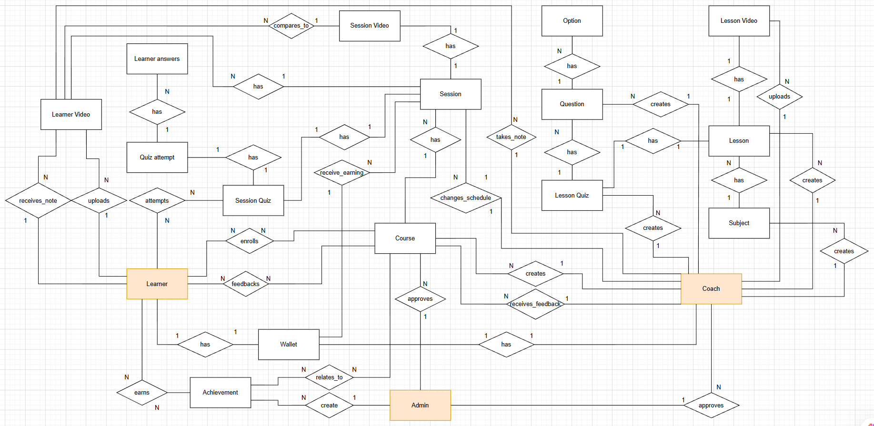

### 3.2 User Management & Authentication

#### 3.2.1 Login

**Function Trigger**

* ***Landing Page → Login***
* *Automatically redirected to the Login screen when a user attempts to access a protected feature without authentication*

**Function Description**

* ***Actors/Roles:*** *Learner, Coach, Admin*
* ***Purpose:****Authenticate users and grant system access based on their assigned roles.*
* ***Interface:*** *Login screen.*
* ***Data Processing:***
  + *Receive email/phoneNumber and password*
  + *Validate credentials against the system database*
  + *Generate an authentication session/token*
  + *Redirect the user to the role-based dashboard*

**Screen Layout**

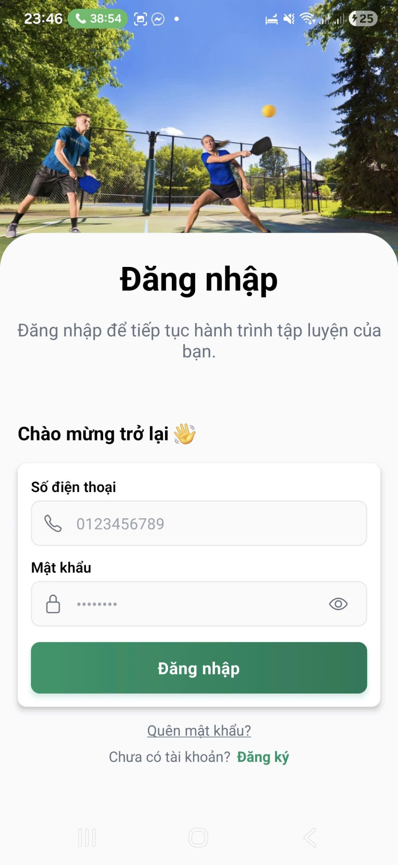

**Function Details**

* ***Validation:***
  + *All required fields must be complete*
* ***Business Rules:***
  + *Passwords must be securely encrypted/hashed*
  + *Only active user accounts are allowed to log in*
* ***Normal Case:***
  + *User enters valid credentials → login is successful → system redirects the user to the appropriate home*
* ***Abnormal Case:***
  + *Invalid credentials → error message is displayed*

#### 3.2.2 Logout

**Function Trigger**

* ***Profile Menu → Logout***
* *Automatically triggered when the authentication session/token expires*

**Function Description**

* ***Actors/Roles:*** *Learner, Coach, Admin*
* ***Purpose:*** *Securely terminate the user’s authenticated session.*
* ***Interface:*** *Logout action.*
* ***Data Processing:***
  + *Invalidate the active session or authentication token*
  + *Clear locally stored authentication data*
  + *Redirect the user to the Login screen*

**Screen Layout**

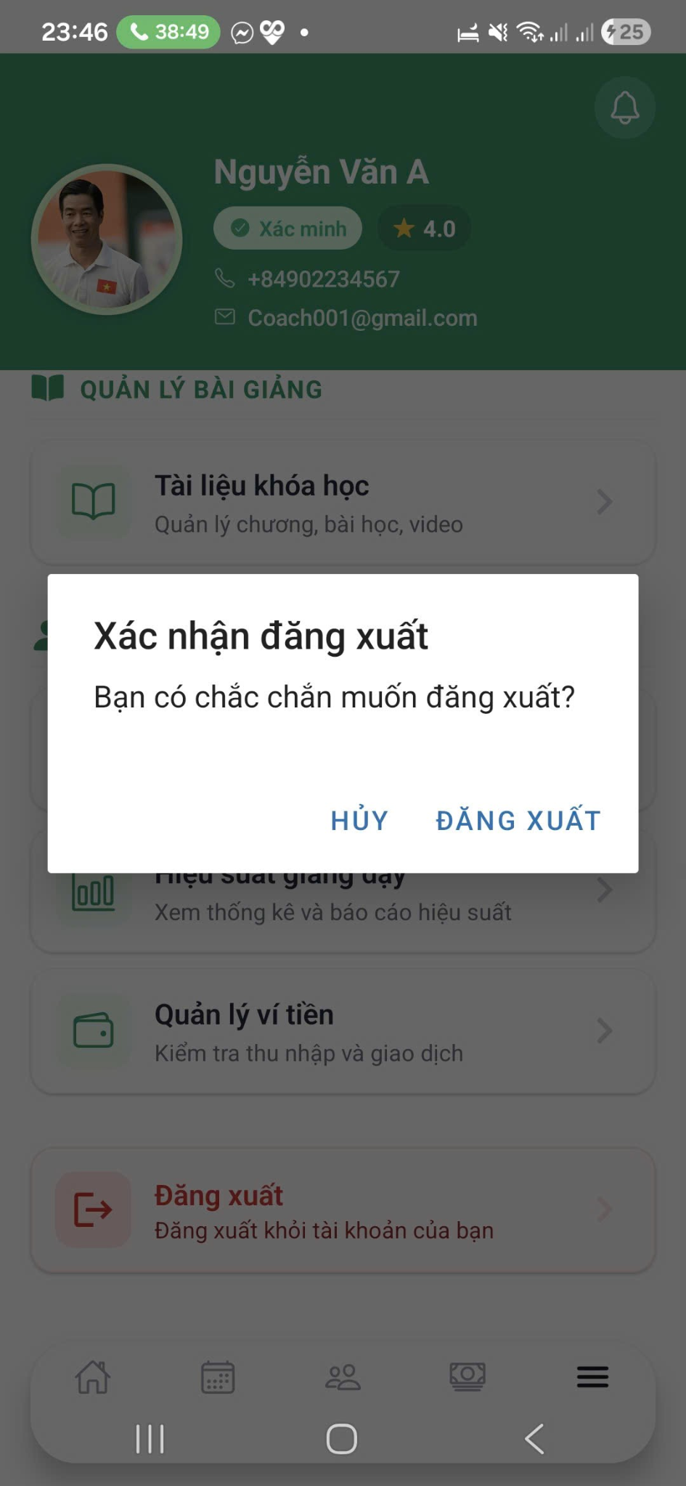

**Function Details**

* ***Business Rules:***
  + *Users must re-authenticate to access protected system features after logout*
  + *Expired or invalid tokens trigger automatic logout*
* ***Normal Case:***
  + *User initiates logout → session is terminated successfully → user is redirected to the Login screen*
* ***Abnormal Case:***
  + *Network or server error during logout → system clears local session data and logs the user out safely*

#### 3.2.3 Register coach

Function Trigger

* **Navigation Path**:
  + Login page → "Đăng ký" (Register) button → Select "Huấn luyện viên" (Coach) role
* **Actor**: Guest User (not logged in)
* **Frequency**: On-demand, when new coaches want to join the platform

Function Description

* **Actors/Roles**: Guest User (prospective coach)
* **Purpose**: Enable qualified pickleball instructors to create accounts and professional profiles on the platform. The registration process collects essential information for coach verification, profile creation, and credential validation before admin approval.
* **Interface**: Multi-step registration form with progressive disclosure pattern:

1. Account Creation (Email/Password)
2. Personal Information
3. Professional Profile
4. Credentials & Certifications (optional)
5. Bank Account Setup
6. Review & Submit

* **Data Processing**:

1. Client-side validation for immediate feedback
2. Email verification via token link
3. Password encryption using bcrypt
4. Image upload to bunny CDN for credentials
5. Profile data stored in Postgreql
6. Verification status tracking in PostgreSQL

**Screen layout**

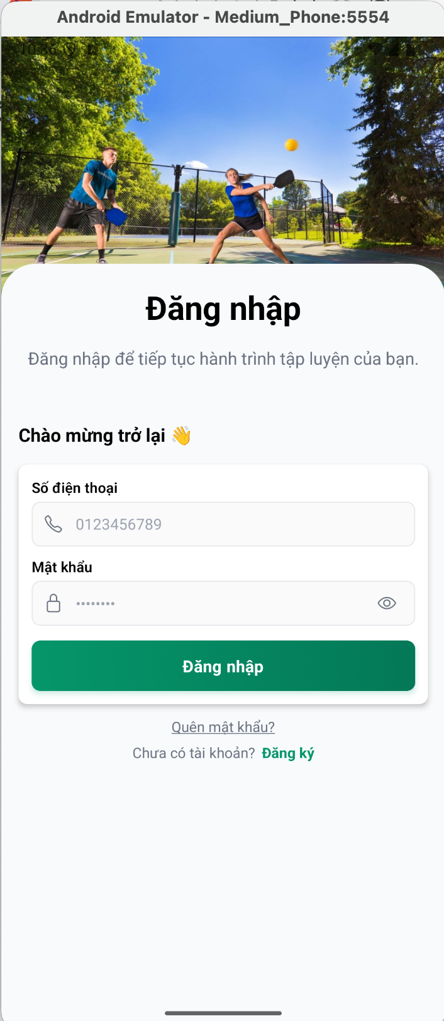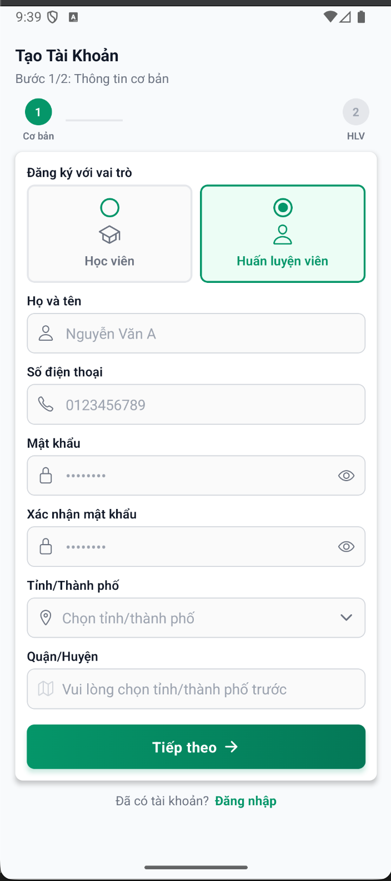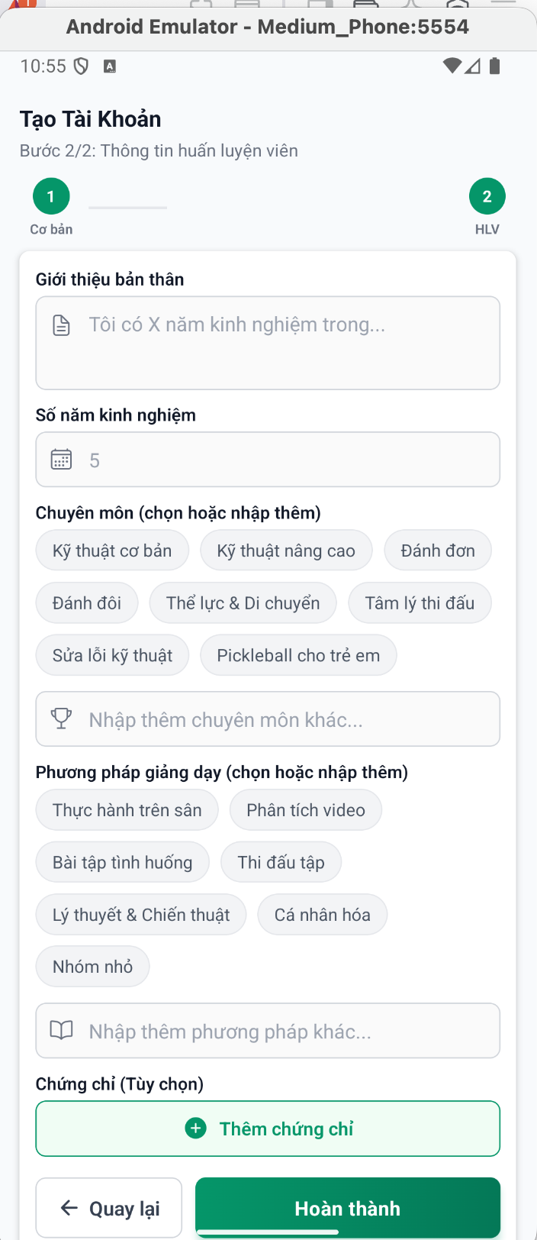

**Function Details**

**1. Input Data & Validation**

|  | Format | Validation rules | Error Messages |
| --- | --- | --- | --- |
| 1 Email (required) | Valid email format (user@domain.com) | Must contain @ symbol  Valid domain extension  No special characters except @ . _ -  Maximum 255 characters  Must be unique in system | "Email không hợp lệ"  "Email đã được sử dụng"  "Vui lòng nhập email" |
| Password (required) |  | Minimum 8 characters  At least 1 uppercase letter  At least 1 lowercase letter  At least 1 number  At least 1 special character (!@#$%^&*)  Cannot contain email username | "Mật khẩu phải có ít nhất 8 ký tự"  "Mật khẩu phải chứa chữ hoa, chữ thường và số"  "Mật khẩu không đủ mạnh" |
| Confirm password |  | Must match password field | Error: "Mật khẩu xác nhận không khớp" |
| Full name (required) |  | Minimum 2 characters  Maximum 100 characters  Only letters and spaces  No numbers or special characters  Must match bank account name later | "Tên không hợp lệ"  "Vui lòng nhập họ và tên đầy đủ" |
| Phone Number (Required) | Vietnamese phone format | Start with +84 or 0  9-10 digits after country code  Valid Vietnamese mobile prefixes (09, 08, 07, 05, 03)  Must be unique in system | "Số điện thoại không hợp lệ"  "Số điện thoại đã được sử dụng" |
| Select city (required) |  | Choose a city in a select option |  |
| Select district (required) |  | Choose a district in a select option |  |
| Specialties (required) | Space-separated string | Minimum 1 specialty  Maximum 10 specialties  Each specialty 2-50 characters | Vui lòng chọn ít nhất 1 chuyên môn" |
| Teaching Methods (Required) | Space-separated string | Minimum 1 method  Maximum 10 methods | "Vui lòng chọn phương pháp dạy" |
| Years of Experience (required) |  | Minimum: 0  Maximum: 50  Integer only | “Vui nhập số năm kinh nghiệm” |
| Introduction (required) |  | Minimum: 0  Maximum: 500 | “Vui lòng nhập giới thiệu bản thân”  “Giới hạn kí tự là 500” |
| Certificate |  | Upload certificate  Fill in dates | “Vui lòng nhập bằng cấp” |

Business Rules

1. **Registration:**
   * Email & phone must be unique across all users
   * Must verify email within 24 hours
   * Password must match
   * Must select city and district
   * Must fill in these fields: teaching methods, introduction, year of experience, certificates, specialties
2. **Submission:**
   * All required fields completed
   * Terms accepted
   * Email verified
   * Creates profile with status "Pending"
3. **Admin Review:**
   * Approved → Account activated
   * Rejected → Reason provided, can reapply

**Normal Flow**

* Learner select "Đăng ký"
* Enter email/password → Validate
* Enter personal info
* Enter professional profile
* (Optional) Upload credentials
* Review all info
* System creates profile (status: Pending)
* Send verification otp
* Show success message
* Notify admin

**Abnormal Cases**

1. **Email Exists**:

* Enter existing email → Error: "Email đã tồn tại"

1. **Weak Password:**

* Enter "123456" → Strength indicator: Red → Error: "Mật khẩu không đủ mạnh"

1. **Network Error**:

* Click submit → Network fails → Error: "Kết nối thất bại"

**Function Trigger**

* **Navigation**: Admin Dashboard → "huấn luyện viên" → "Chờ phê duyệt" tab
* **Notification**: Email/push when new coach registration submitted
* **Actor**: Admin
* **Frequency**: Daily

**Function Description**

**Purpose:** Enable admins to review and verify coach registration profiles, ensuring quality and authenticity before granting platform access**.**

**Interface:**

1. Coach profile review page with all submitted information
2. Action buttons: Approve, Reject
3. Feedback form for revisions/rejections

**Data Processing**:

1. Load pending coach profile from DB
2. Display credentials from bunny cdn (optional)
3. Update verification status in PostgreSQL
4. Log review actions

**Screen Layout**

1. Pending Coaches List

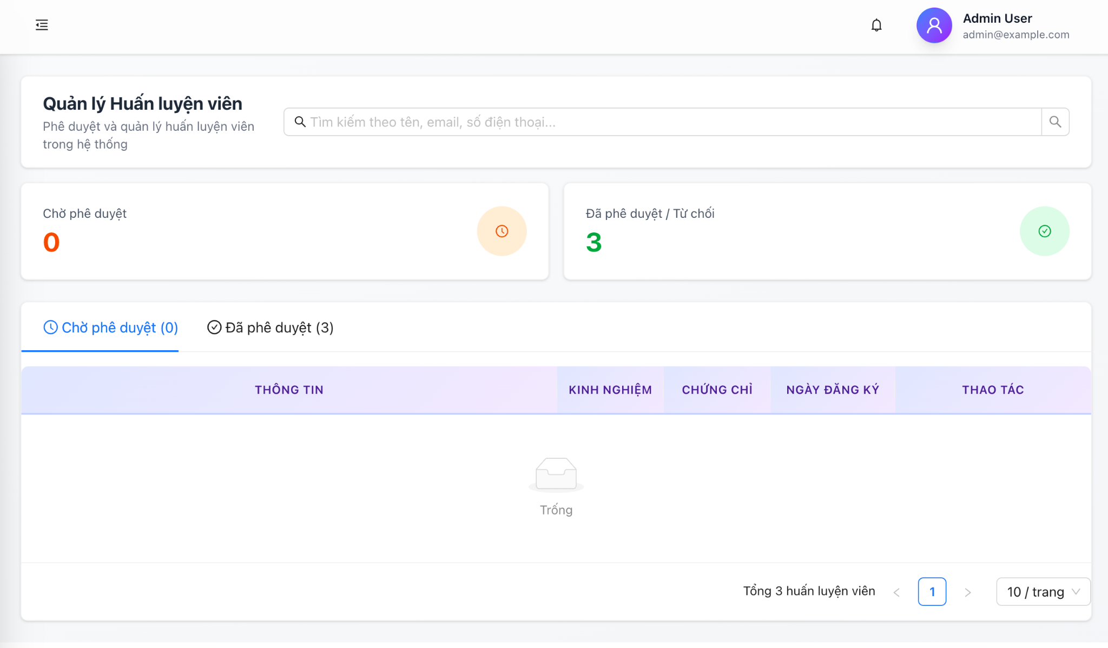

1. Coach Profile Review

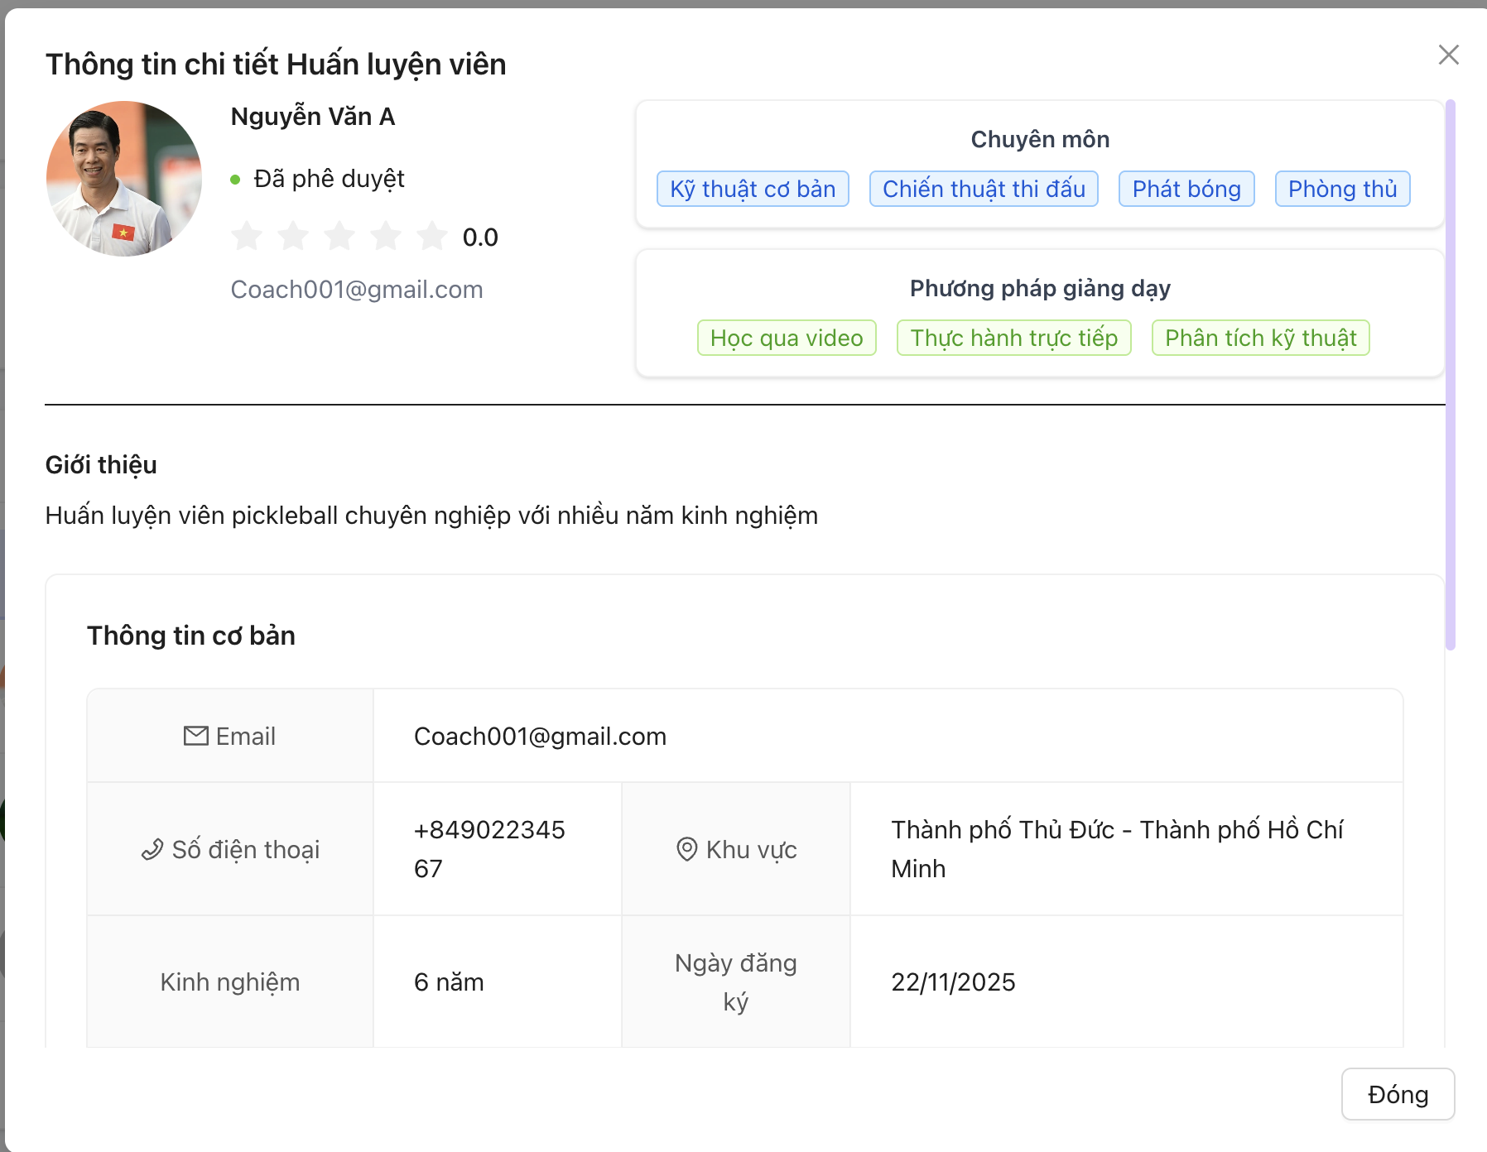

**Function Details**

* View coach profiles in pending tab (Pending status only)
* Confirm approve or confirm reject (enter reason)

**Business Rules**

1. Review timeline

* No deadline require

1. Verification Actions

* **Approve**: Instant account activation
* **Reject**: give reason

**Normal Flow**

1. Admin receives notification: "New coach registration"

2. Navigate to "Chờ phê duyệt" tab

3. Click icon view detail on pending profile

4. Review all sections: - Email verification status - Personal information - Professional qualifications - Credentials (view/download files)

5. Check validation items

6. Make decision: Approve or Reject

**Abnormal Cases**

Blurry/Invalid Credentials or Missing Required Information/personal information

* Reject and give the appropriate reason.

#### 3.2.4 Forgot Password / Reset Password

#### 3.2.5 Update Profile (basic info)

**Function Trigger**

* **Navigation**:
  + User Dashboard → "Hồ sơ" / "Profile" → "Chỉnh sửa" / "Edit"
  + Settings → "Thông tin cá nhân" → "Chỉnh sửa hồ sơ"
* **Actor**: Authenticated User (Learner/Coach)
* **Frequency**: On-demand, as needed

**Function Description**

**Purpose:** Allow users to update their basic personal information (name, phone, email) after registration while maintaining data integrity and verification requirements**.**

**Interface:** Simple form with editable fields for core profile information

**Data Processing:**

1. Validate changed fields
2. Re-verify email/phone if changed
3. Update user record in Postgresql
4. Send confirmation notifications
5. Log profile changes

**Screen Layout**

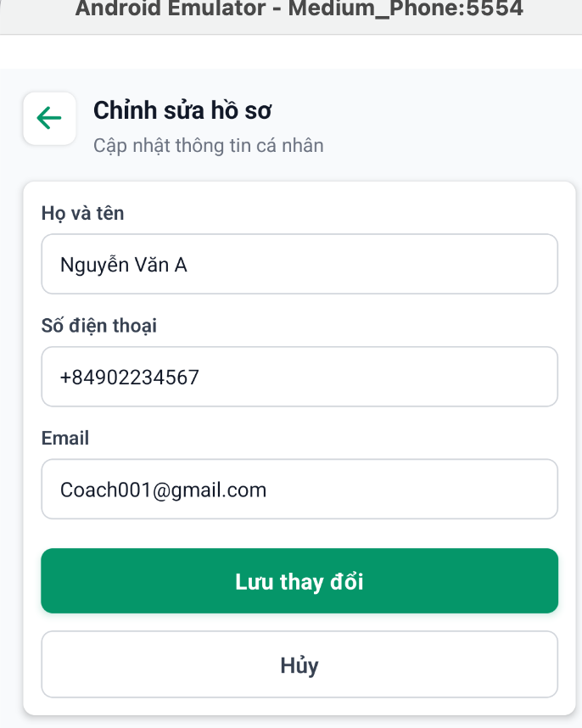

**Function Details**

| **Field** | **Editable** | **Validation** |
| --- | --- | --- |
| Họ và tên | Yes | 2-100 chars, letters & spaces only |
| Số điện thoại | Yes | VN format, unique |
| Email | Yes | Valid format, unique |

**Business Rules**

1. **Name Update**:

* No re-verification needed
* Updates immediately after save
* If coach: Must update bank account name if changed

1. **Phone Update**:

* Updates immediately after save

1. **Email Update**:

* Must be unique in system
* Updates immediately after save

**Normal Flow**

1. User navigates to profile edit

2. Current info pre-filled in form

3. User modifies desired fields

4. Click [Lưu thay đổi]

**Abnormal Cases**

1. Name Too Short

* User enters "A" → Click [Lưu] → Error: "Tên phải có ít nhất 2 ký tự"

1. Phone Already Exists

* User enters existing phone → Click [Lưu] → System checks database → Error: "Số điện thoại đã được sử dụng"

1. Email Already Exists

* User enters existing email → Click [Lưu] → Error: "Email đã tồn tại trong hệ thống"

1. Network Error During Save:

* Click [Lưu] → Network fails → Show spinner (timeout 30s) → Error: "Không thể kết nối. Vui lòng thử lại"

#### 3.2.6 Admin Manage Users

##### 3.2.6.1 Admin View User Information Detail

* **Function Trigger:**
* Triggered: when **Admin** selects  
   **Dashboard → User Management → View Detail**
* Manual action: (on-demand)
* ***Function Description***
* **Actors/Roles**: Admin
* **Purpose:** Enable administrators to access and review comprehensive user profiles, including personal details, account status, and activity history.
* **Interface:** Form-based screen with input fields and exit buttons.
* **Data Processing:**
  + - Show user information.
* ***Screen Layout:***

1. User List

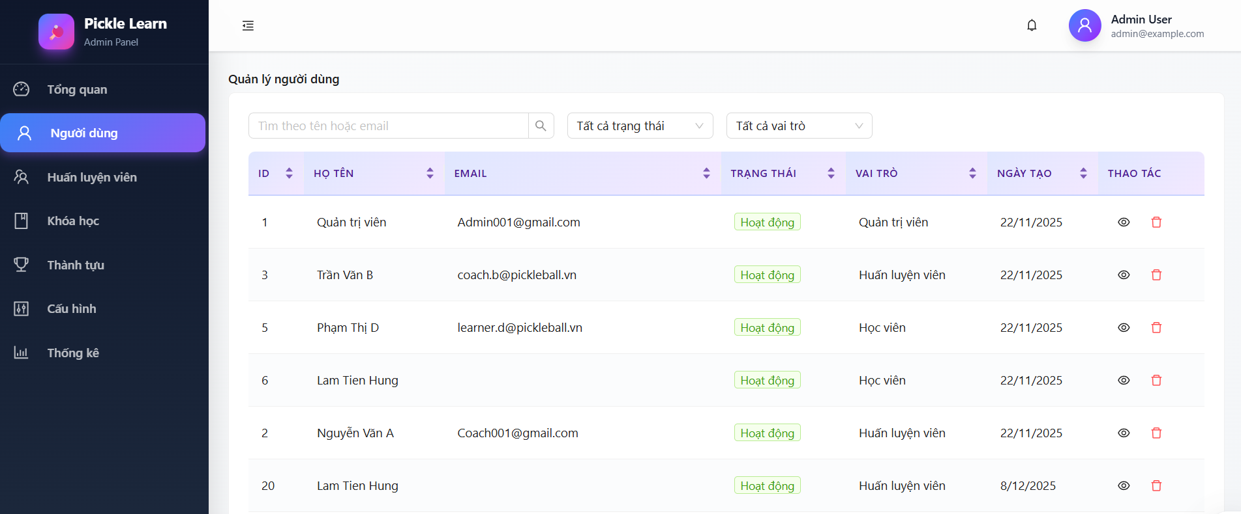

1. User Information Detail

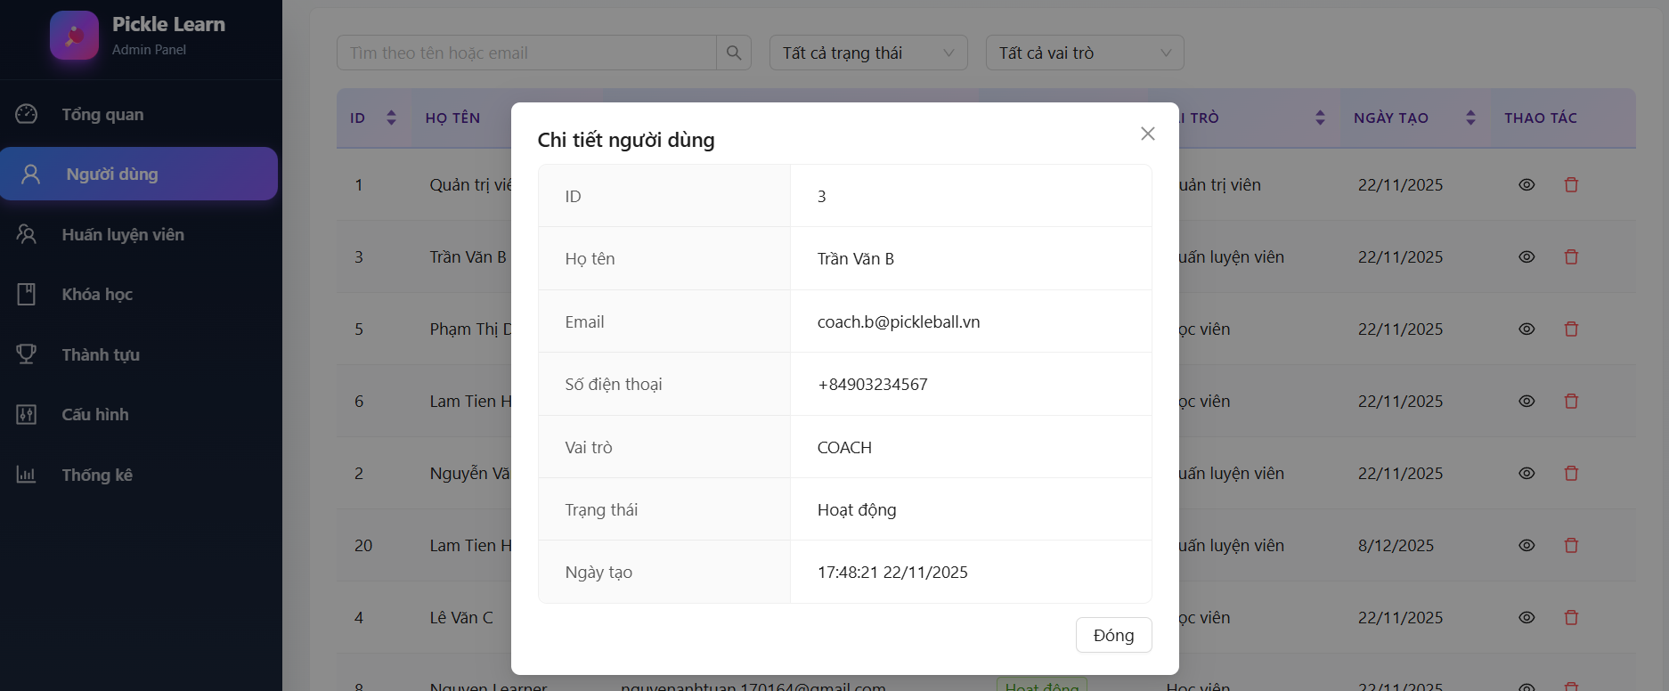

* **Function detail:**
  + The Admin can view detailed information of a specific user.
  + The system displays user information in read-only mode.
  + The Admin accesses this function by selecting a user from the user list and clicking “View Detail”.
  + Displayed information includes:
    - User ID
    - Full Name
    - Email
    - Number phone
    - Role
    - Account Status
    - Created Date
* **Business Rules:**
  + Only users with the Admin role are allowed to access this function.
  + The Admin is not allowed to modify user information on this screen.
  + Sensitive information such as passwords and authentication tokens must not be displayed.
* **Normal Flow:**
  + Admin logs in successfully → navigates to Dashboard home page → selects page user manage → clicks “View Detail” button→ system displays user information in read-only mode.
* **Abnormal Case:**

Case 1 - Not logged in

* Admin not logged in → tries to access Dashboard → system redirects to Login page

Case 2 – System error

* Admin clicks “View Detail” → system fails to retrieve user data → general error message displayed

##### 3.2.6.2 Admin Delete Users

* **Function Trigger:**
* Triggered: when **Admin** selects  
   **Dashboard → User Management → Delete**
* Manual action: (on-demand)
* ***Function Description***
* **Actors/Roles**: Admin
* **Purpose:** To allow the Admin to delete user accounts that violate system policies or rules, prevent blocked users from accessing the system and its features, and help the Admin manage and maintain system security and user behavior. maintain system security and user behavior**.**
* **Interface:** 
  + User Management Page
    - Displays a list of users.
    - Includes a “Delete User” button ( icon ) for each eligible user.
  + Confirmation Popup
    - Prompts the Admin to confirm the delete action.
* **Data Processing:**
  + - Validate admin authorization and role
    - Validate selected user account
    - Check user eligibility for blocking (not an admin account)
    - Update user status to Blocked in the database
* ***Screen Layout:***

1. User List



1. Confirm Delete Popup

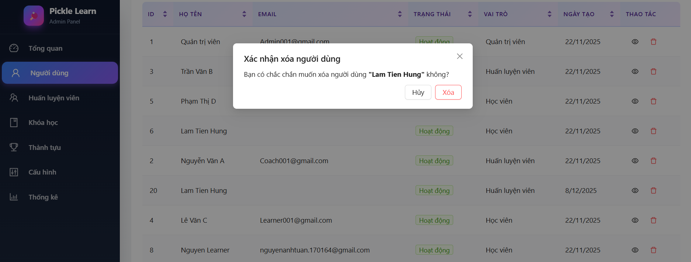

* **Function detail:**
  + The Admin can block a user account in the system.
  + Blocking a user prevents the user from logging in and accessing system features.
  + The Admin selects a user from the user management list and performs the block action.
  + The system updates the user account status to Blocked.
* **Business Rules:**
  + Only users with the Admin role are allowed to block user accounts.
  + Admin accounts cannot be blocked.
  + A blocked user is not allowed to log in or use any system functions.
* **Normal Flow:**
  + Admin logs in successfully → navigates to Dashboard home page → selects User Management page → clicks “Block User” button → confirms the action → system updates user status to Blocked.
* **Abnormal Case:**

Case 1 – User Not Logged In

* User is not logged in → tries to access User Management page → system redirects to Login page.

Case 2 – Unauthorized Role

* Non-admin user logs in → navigates to User Management page → attempts to block a user → access denied message displayed

Case 3 – Blocking Admin Account

* Admin selects an admin account → clicks “Block User” → system displays an error message and does not allow the action.

Case 4 – System Error

* Admin clicks “Block User” → system fails to update user status → general error message displayed

#### 3.6.6.3 Admin views dashboard

Function Trigger

* **Navigation**: Admin logs in → Auto-redirect to dashboard
* **Direct access**: Admin Portal → "Tổng Quan Hệ Thống" menu
* **Actor**: Admin
* **Frequency**: Daily, on-demand

**Function Description**

**Purpose**: Provide administrators with a comprehensive overview of platform metrics, user statistics, course status, and ratings distribution to monitor system health and performance.

**Interface**:

* Key metrics cards (users, coaches, learners, courses, ratings)
* Course status pie chart
* Rating distribution bar chart
* Growth indicators
* Quick stats summaries

**Data Processing**:

* Aggregate user counts from PostgreSQL
* Calculate course statistics by status
* Compute rating distribution
* Calculate growth percentages
* Real-time or cached metrics

**Screen Layout**

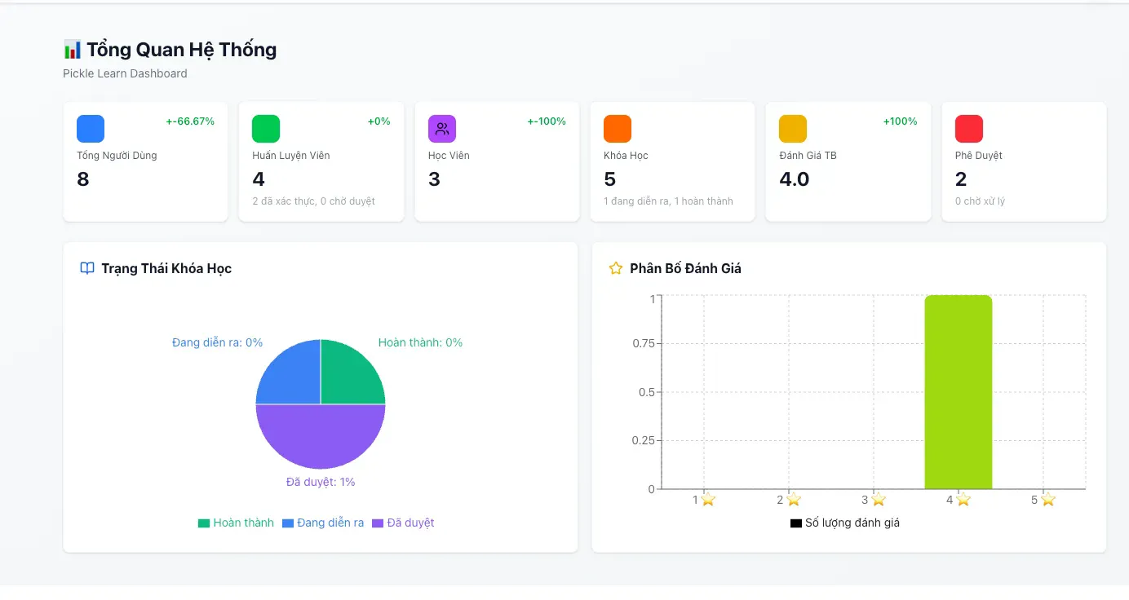

**Function Details**

**Business Rules**

* Count all users in database
* Group by role: learner, coach, admin
* Calculate growth rate

**Normal Flow**

* Admin logs into system -> System authenticates admin -> Redirect to dashboard

**Abnormal Cases**

* API Error Loading Metrics
* Partial Data Load
* Division by Zero (Growth)

#### 3.6.6.4 Admin edit configuration

Function Trigger

* **Navigation**: Admin Portal → "Quản lý Configurations" menu
* **Actor**: Admin
* **Frequency**: As needed for system settings updates

Function Description

**Purpose**: Allow administrators to view, create, edit, and manage system-wide configuration settings that control platform behavior, business rules, and operational parameters.

**Interface**:

* Configuration list table with search/filter
* Create new configuration modal
* Edit configuration modal
* View configuration details

**Data Processing**:

* Store configurations in database (key-value pairs)
* Validate data types (number, string, boolean, JSON)
* Apply changes to system behavior
* Track configuration change history
* Cache for performance

**Screen Layout**

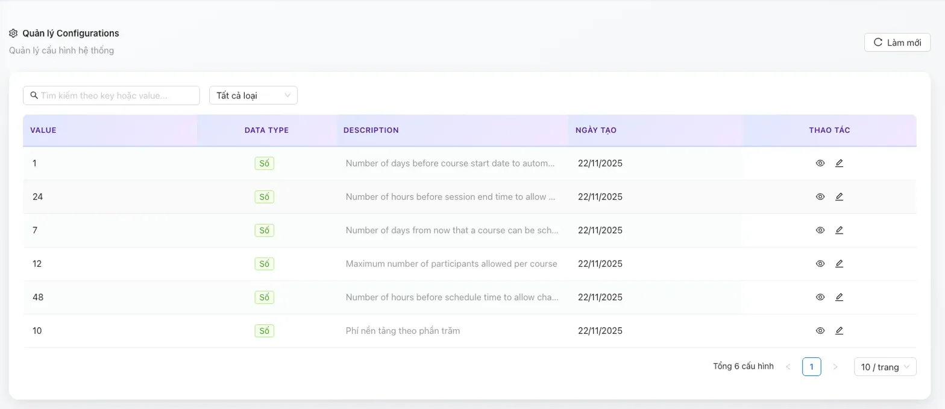

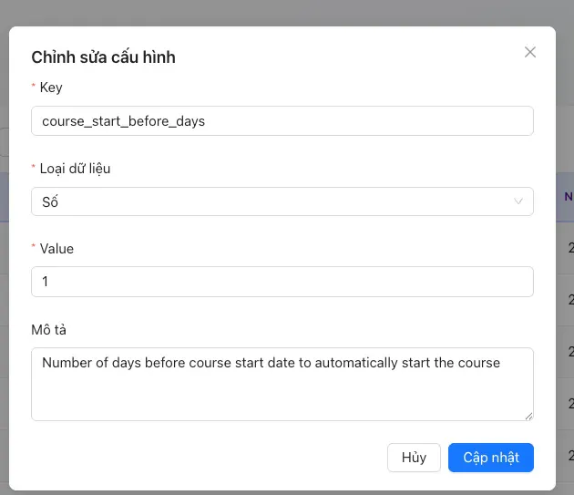

**Function Details**

**Business Rules**

* Key cannot be changed after creation
* Must delete and recreate to change key
* Prevents accidental breaking changes

**Normal Flow**

* Admin navigates to Configurations page -> click edit -> enter value -> click submit

**Abnormal Cases**

* Invalid JSON

### 3.3 Coach Verification Management

#### 3.3.1 Admin Review Coach Verification

* **Function Trigger:**
* Triggered: when Admin selects

**Dashboard → Coach Management → Pending Approval / Approved → View Detail**

* Manual action: (on-demand)
* ***Function Description***
  + **Actors/Roles**: Admin
  + **Purpose:** To allow the Admin to review detailed information of coaches who are pending verification or already verified. This function helps the Admin examine coach profiles, professional information, and certification documents to support verification and management decisions.
  + **Interface:**
  + Coach Management Page
    - Displays a list of coaches grouped by status: Approved/Pending Approval
    - Each coach record includes a “View Detail” icon.
  + Coach Detail Popup
    - Displays full coach profile information.
    - Includes basic information, expertise, teaching methods, experience, and registration status.
  + Certification Section
    - Displays a list of submitted certificates.
    - Each certificate shows summary information (name, level, issue date, expiry date).
    - Includes a “View” button for each certificate.
  + Certificate Image Viewer
    - Displays the uploaded image of the selected certificate.
* **Data Processing:**
  + - Validate admin authentication and role.
    - Retrieve coach profile data based on selected coach ID.
    - Retrieve certification metadata and associated image files.
    - Display coach information and certificate details in the popup interface.
* ***Screen Layout:***

1. ***List coach for Status***

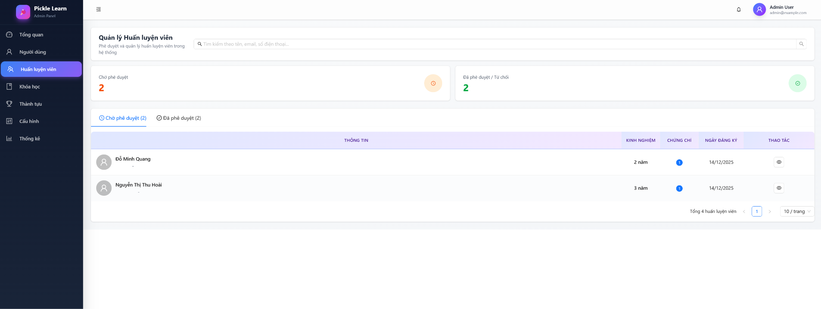

1. ***Detail Coach***

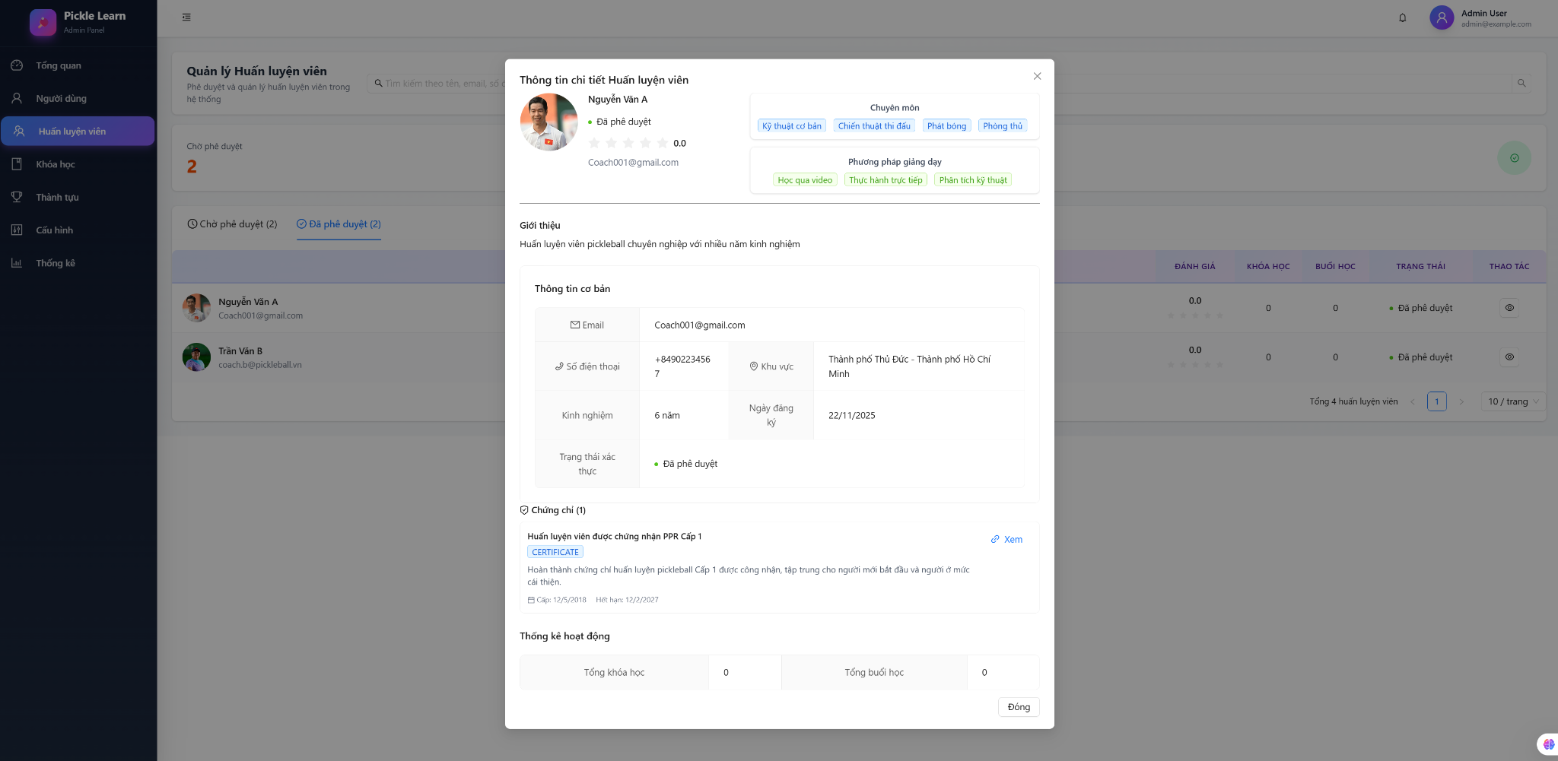

1. **Detail Certificate**



* **Function detail:**
  + The Admin can view a list of coaches filtered by verification status.
  + The Admin can open the detailed profile of a coach by selecting the view detail icon.
  + The system displays complete coach information in a popup window.
  + The Admin can review certification information and view uploaded certificate images.
  + Certificate images are displayed in a separate viewer for clear inspection.
* **Business Rules:**
  + Only users with the Admin role are allowed to access coach verification details.
  + Coach information must be displayed in read-only mode.
  + Certificate images must be associated with the correct coach profile.
  + Only certificates uploaded by the coach are available for review.
* **Normal Flow:**
  + Admin logs in successfully → navigates to Coach Management page → selects Pending Approval or Approved tab → views list of coaches → click”xem chi tiết” icon → system displays coach detail popup → Admin reviews coach information → Admin selects “Xem” on a certificate → system displays certificate image.
* **Abnormal Case:**

**Case 1 – User Not Logged In**

* Admin is not logged in → attempts to access Coach Management page → system redirects to Login page.

**Case 2 – Unauthorized Role**

* Non-admin user logs in → attempts to access coach verification details → system displays access denied message.

**Case 3 – Certificate Image Not Available**

* Admin clicks “View” certificate → certificate image is missing or corrupted → system displays an error message indicating the image cannot be displayed.

**Case 4 – System Error**

* Admin accesses coach detail popup → system encounters an unexpected error → general error message is displayed.

#### 3.3.2 Approve / Reject Coach Request

* **Function Trigger:**
* Triggered: when Admin selects

Dashboard → Coach Management → “chờ phê duyệt” tab → “Xem chi tiết” icon → Approve / Reject

* Manual action: (on-demand)
* ***Function Description***
  + **Actors/Roles**: Admin
  + **Purpose:**To allow the Admin to approve or reject coach verification requests. This function helps ensure that only qualified and verified coaches are allowed to operate in the system by reviewing their information and certification documents before approval.
  + **Interface:**
  + Coach Management – Pending Approval Tab
    - Displays a list of coaches awaiting verification.
    - Each coach record includes a “View Detail” icon.
  + Coach Detail Popup
    - Displays full coach profile information and submitted certificates.
    - Includes two action buttons at the bottom: “phê duyệt” and “từ chỗi”
  + Confirmation Popup
    - Displays a confirmation message for approval or rejection.
    - Includes “Phê duyệt”/”từ chối” and “Hủy” buttons.
* **Data Processing:**
  + - Validate admin authentication and role.
    - Retrieve selected coach profile and certification data.
    - Validate current coach status is Pending Approval in database.
    - Update coach verification status to Approved or Rejected.
    - Trigger system notification to the coach.
* ***Screen Layout:***

1. 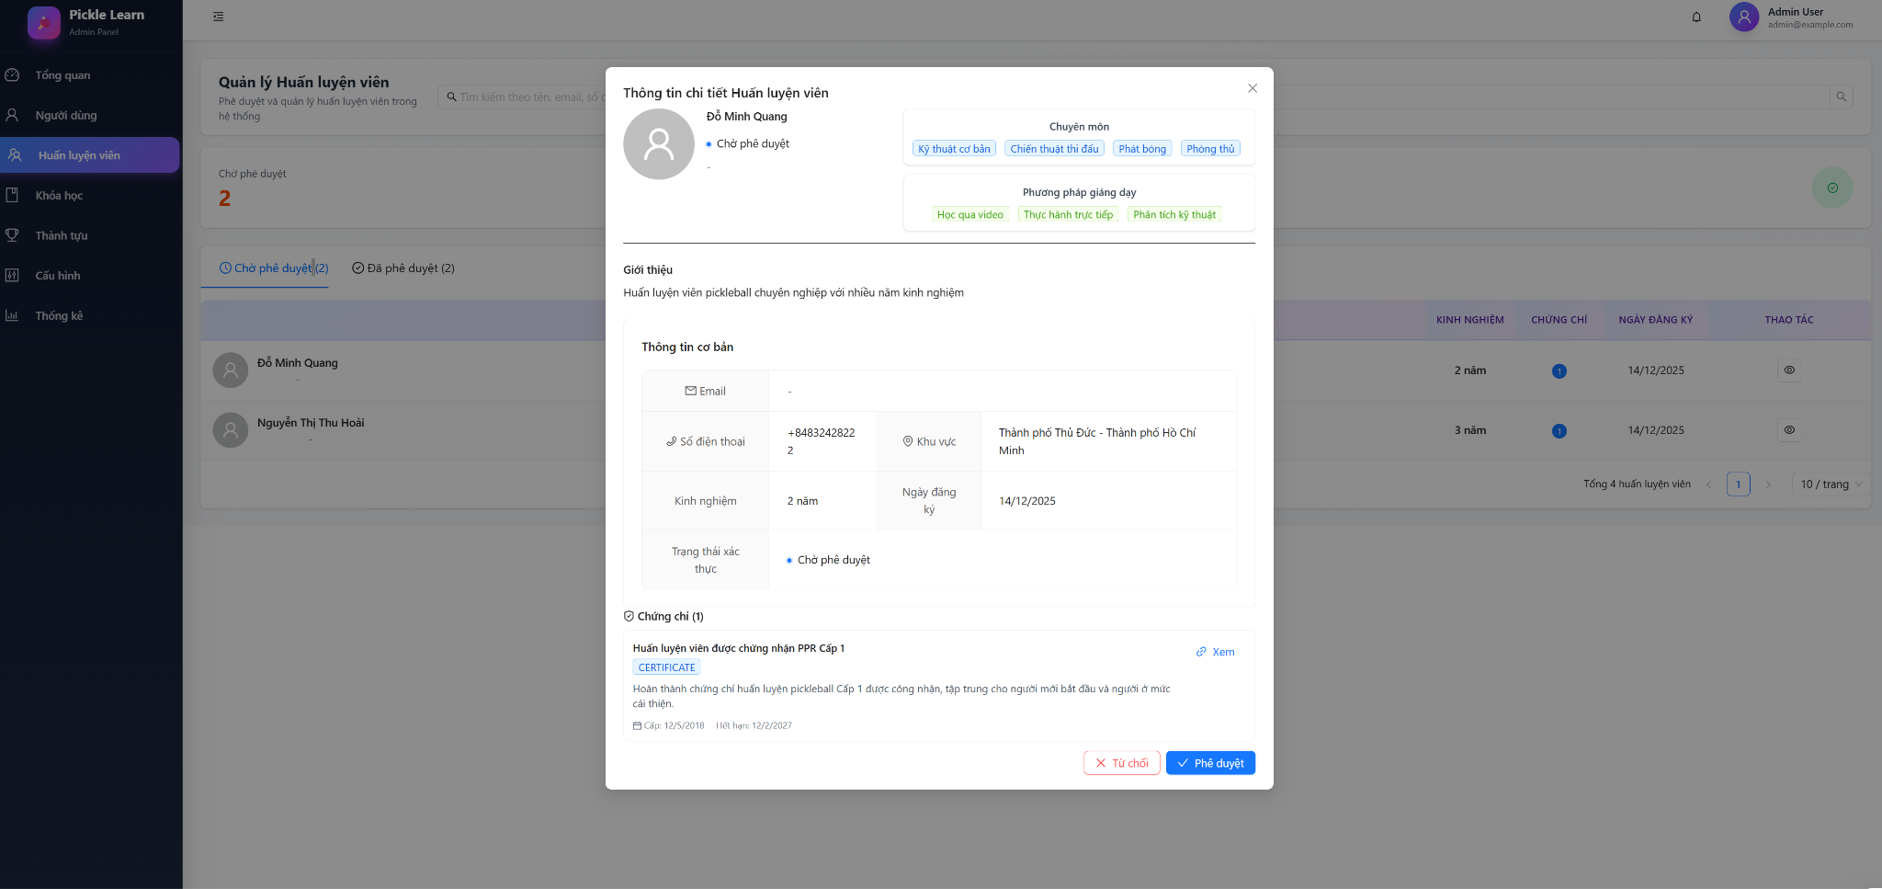

* **Function detail:**
  + The Admin can only approve or reject coaches who are in the pending approval status.
  + The Admin reviews coach information and certificates before making a decision.
  + The system requires confirmation before performing approve or reject actions.
  + After approval or rejection, the coach status is updated and reflected in the system.
* **Business Rules:**
  + Only users with the Admin role are allowed to approve or reject coach requests.
  + Only coaches with Pending Approval status can be approved or rejected.
  + Approved coaches are allowed to access coach features and be visible in the system.
  + Rejected coaches are not allowed to operate as coaches until re-verified.
  + Admin must confirm the action before the system applies any status change.
* **Normal Flow:**
  + Admin logs in successfully → navigates to Coach Management → selects Pending Approval tab → selects a coach → click “xem chi tiết” icon → reviews coach information and certificates → clicks “phê duyệt” or “từ chối” → confirmation popup appears → Admin clicks “từ chối”/”phê duyêjt” → system updates coach verification status.
* **Abnormal Case:**

**Case 1 – User Not Logged In**

* Admin is not logged in → attempts to access Coach Management page → system redirects to Login page.

**Case 2 – Unauthorized Role**

* Non-admin user logs in → attempts to approve or reject a coach → system displays access denied message.

**Case 3 – Invalid Coach Status**

* Admin attempts to approve or reject a coach who is not in Pending Approval status → system displays an invalid action message.

**Case 4 – System Error**

* Admin confirms approval or rejection → system fails to update coach status → general error message is displayed.

### 3.4 Course & Subject Management

#### 3.4.1 Create Course

* **Function Trigger:**
* Triggered: when **Coach** selects Courses → Create Course
* Manual action (on-demand)
* ***Function Description***
  + **Actors/Roles**: Coach, Admin
  + **Purpose:** Allow authorized users to create a new course that can later contain subjects and sessions.
  + **Interface:** Form-based screen with input fields and action buttons
  + **Data Processing:**
    - Collect course information
    - Validate input
    - Store course data in the database with status *Draft* or *Active*
* ***Screen Layout***

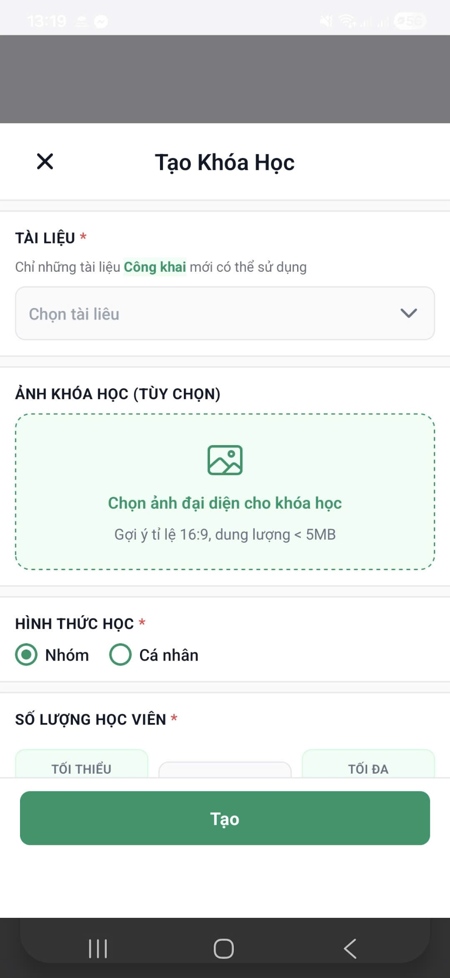

* **Function details**
  + **Data**: Subjects , price, learning format, number of students, location, schedule
  + **Validation:**
* Subject is required and unique
* Price must be ≥ 0
* Max learners must be > 0
  + **Business Rules:**
* Draft courses are not visible to learners
* Only verified coaches can create courses
  + **Normal Case:**
* Coach fills in valid data → clicks “Tạo” → course created successfully
  + **Abnormal Case:**
* Missing required fields → error message displayed
* Duplicate course name → system prompts user to change name

#### 3.4.2 View Course Details

* **Function Trigger:**

Triggered: Learner/Coach → Course List → View Details

* ***Function Description***
  + **Actors/Roles**: Learner, Coach, Admin
  + **Purpose:** Display detailed course information.
  + **Interface:** Display detailed course information
  + **Data Processing:** Fetch course, subject, and session data
* ***Screen Layout***

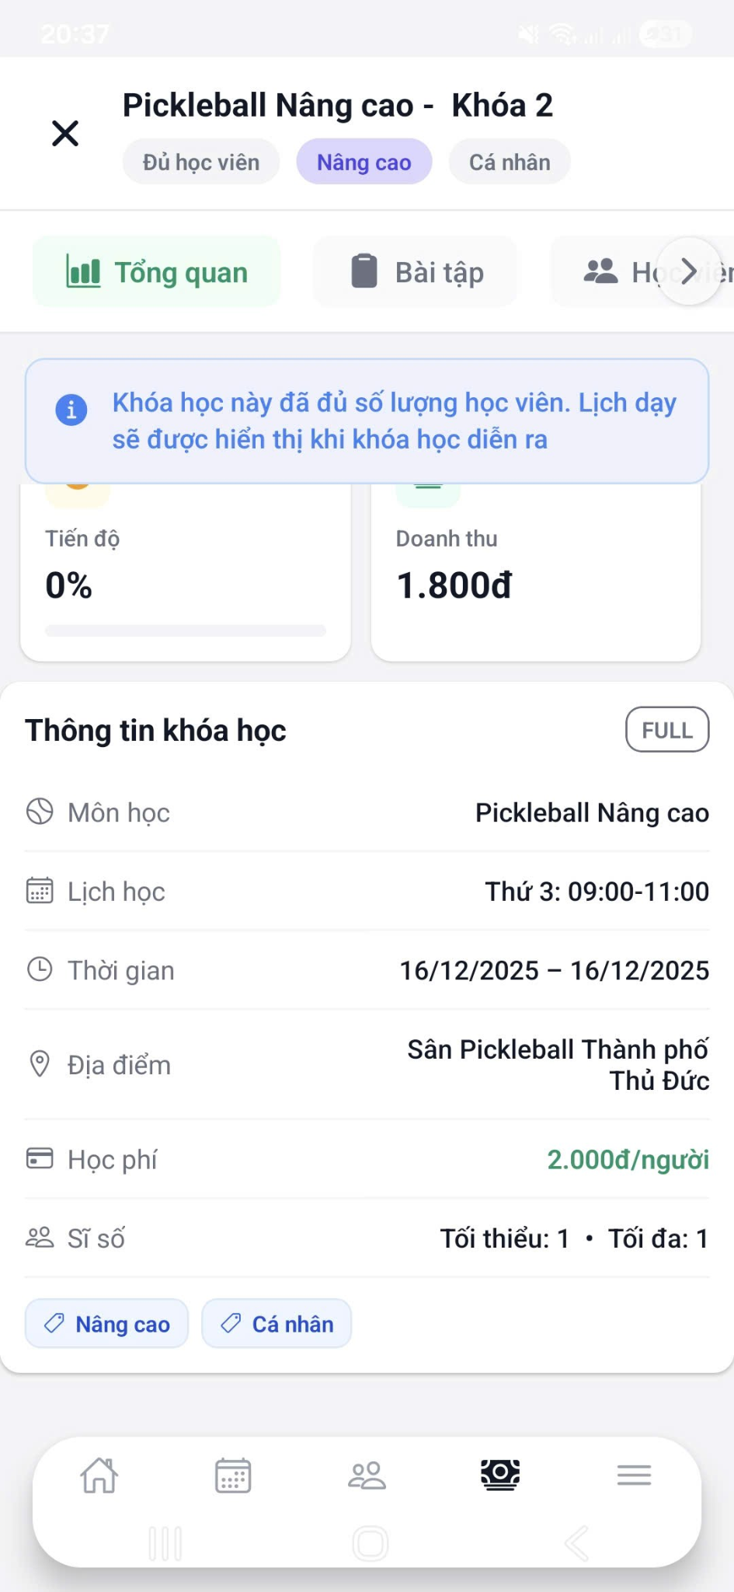

* **Function details**
  + **Business Rules:** Only active courses visible to learners
  + **Abnormal Case:** Course not found → redirect to course list

#### 3.4.3 Assign Subject to Course

* **Function Trigger:**  Course -> Create course → Select subject
* ***Function Description***

**Actors/Roles**: Coach

**Purpose:** Link subjects to a course curriculum

**Interface:** List subject

**Data Processing:** Save course–subject relationships

* ***Screen Layout***

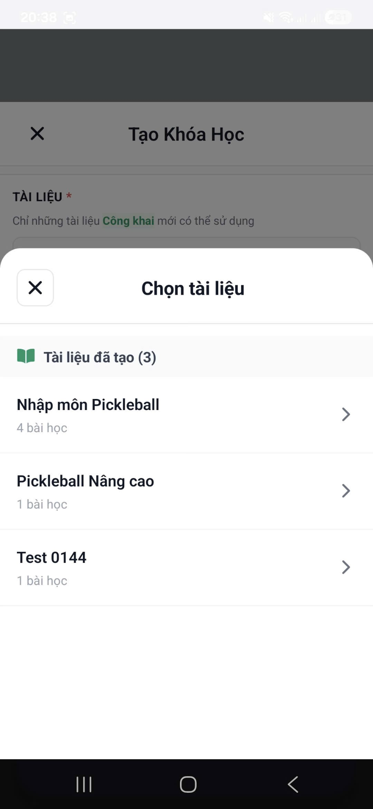

* **Function details**
  + **Business Rules:** Subject can belong to multiple courses
  + **Normal Case:** Subjects assigned successfully
  + **Abnormal Case:** No subject selected → validation error

### 3.5 Lesson & Content Management

#### 3.5.1 Create Lesson

* **Function Trigger**: Triggered when Coach navigates to Content → Subject materials → Subjects → Create Lesson
* **Function Description**

**Actors/Roles:** Coach

**Purpose**: Create a new lesson under a selected subject to structure learning content.

**Interface:** Lesson creation form

**Data Processing:**

* + - Capture lesson information
    - Validate inputs
    - Save lesson record
* **Screen Layout**

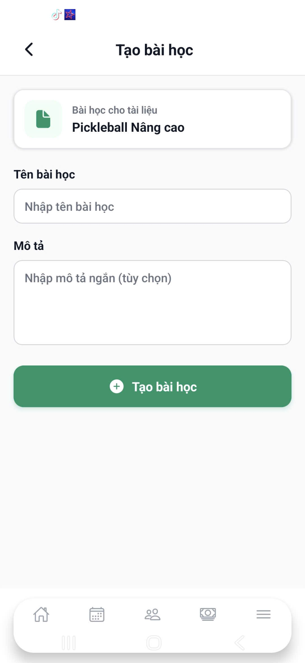

* **Function details**
  + **Data:** Lesson title, description
  + **Validation:**Lesson title is required
* **Business Rules:** Lessons must belong to exactly one subject
* **Normal Case:** Valid input → click “Tạo bài học” → lesson created successfully
* **Abnormal Case:**Missing required fields → error message displayed

#### 3.5.2 Update Lesson

* **Function Trigger**: when Coach selects Lesson → Edit
* **Function Description**

**Actors/Roles:** Coach

**Purpose:** Modify lesson information

**Interface:** Pre-filled editable lesson form

**Data Processing:** Update lesson data after validation

* **Screen Layout**

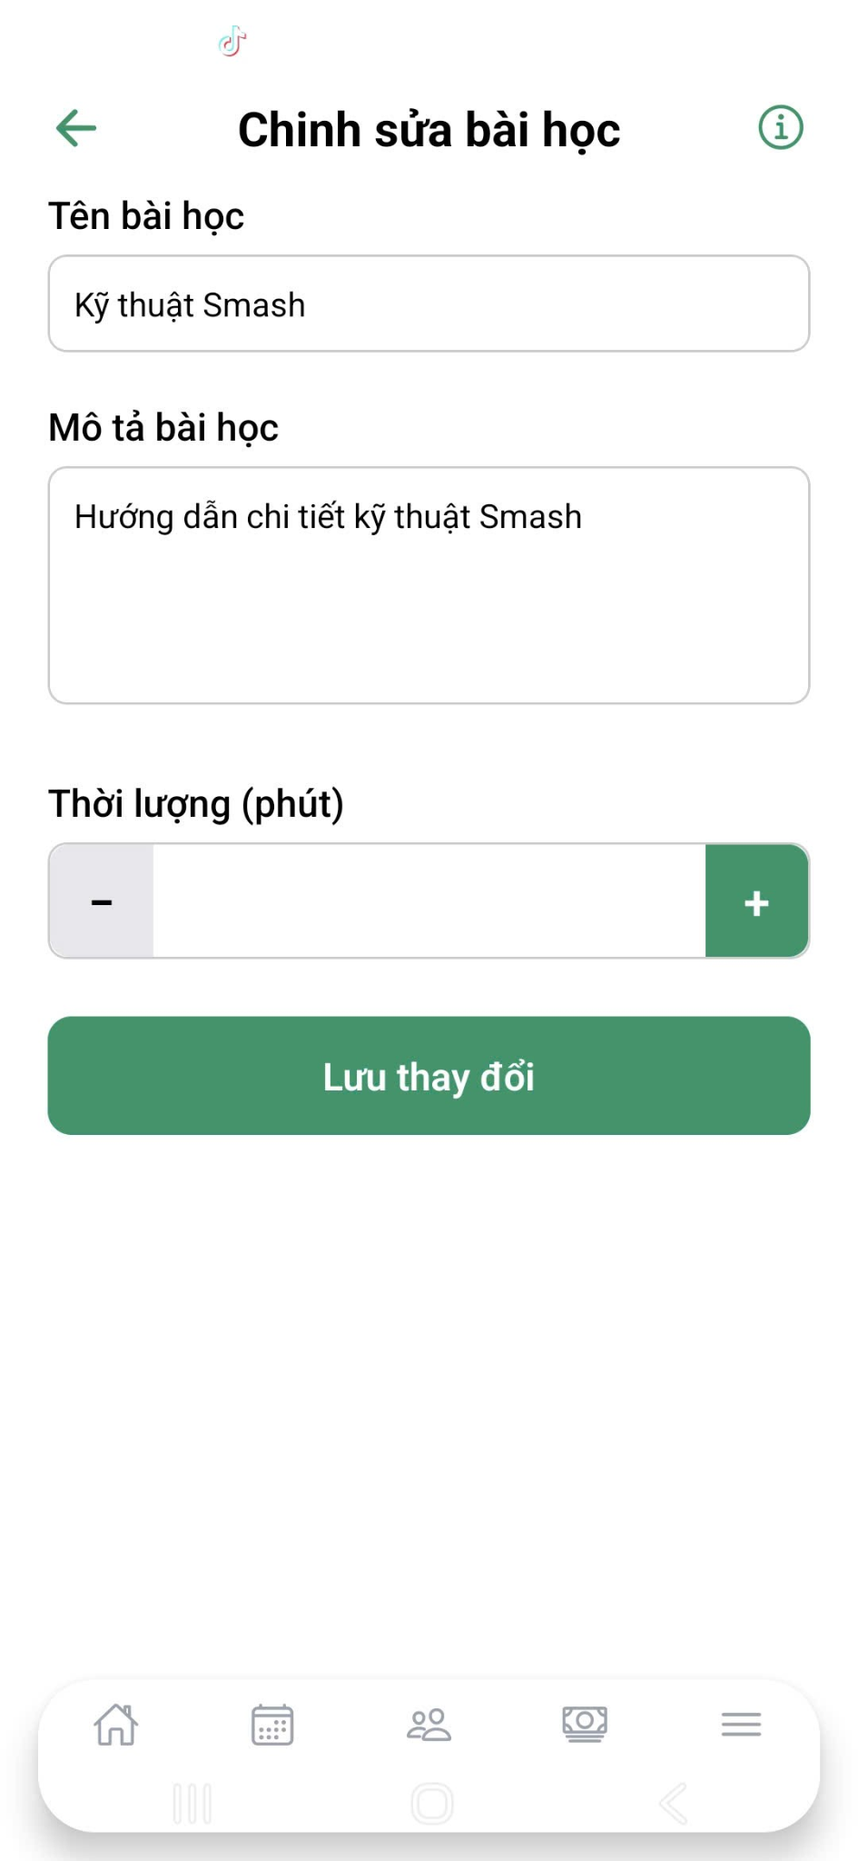

* **Function details**
* **Business Rules:** Published lessons with learner progress cannot change lesson order
* **Normal Case:** Lesson updated successfully
* **Abnormal Case:** Invalid data → error message displayed

#### 3.5.3 Delete Lesson

* **Function Trigger:** when Coach selects Lesson → Delete
* **Function Description**

**Actors/Roles:** Coach

**Purpose:** Remove an unused or draft lesson

**Interface:** Confirmation dialog

**Data Processing:** Soft delete or status change

* **Screen Layout**

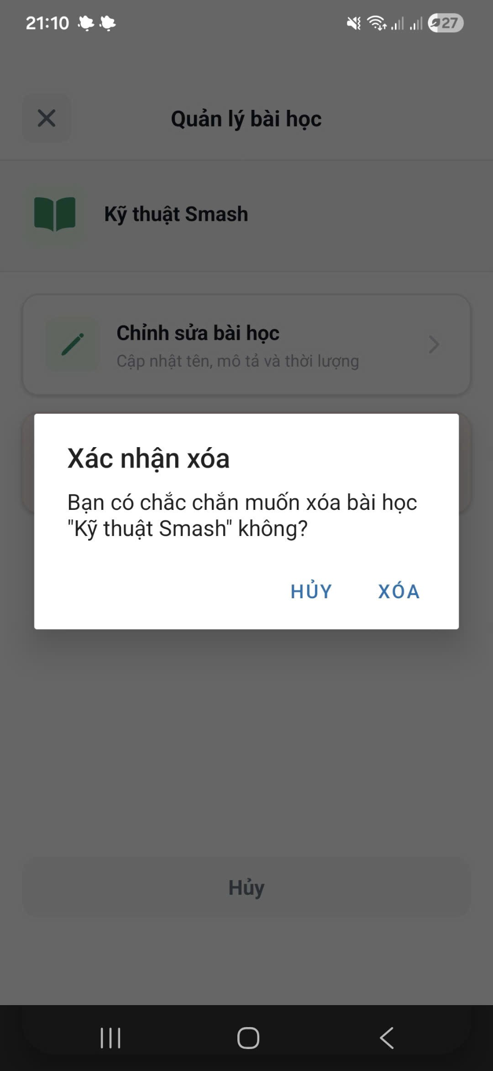

* **Function details**

**Business Rules:** Lessons with completed learner progress cannot be deleted

**Normal Case:** Lesson deleted successfully

**Abnormal Case**: System prevents deletion and shows reason

#### 3.5.4 View Lesson Details

* **Function Trigger**: Learner/Coach → Course → Subject → Lesson
* **Function Description**

**Actors/Roles:** Coach, Learner

**Purpose:** Display lesson content, videos, and related quizzes.

**Interface:** Read-only lesson detail page

**Data Processing**: Fetch lesson and media data

* **Screen Layout**

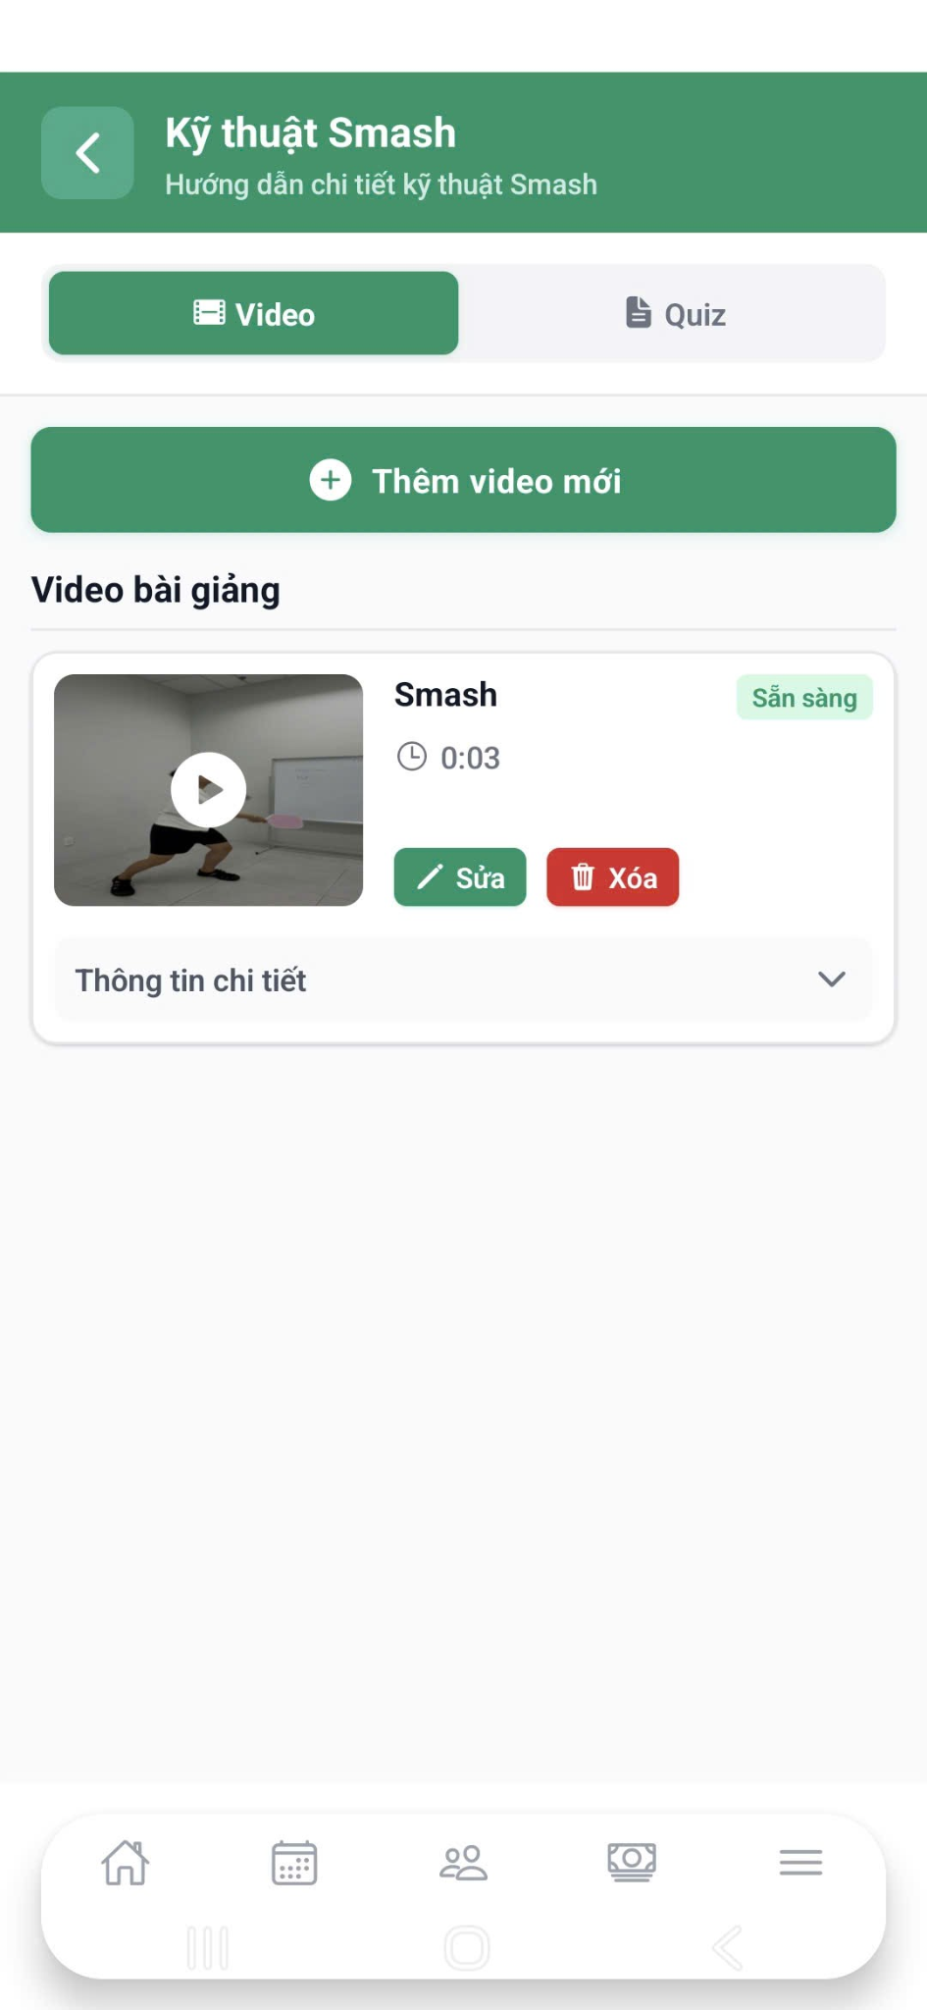

* **Function details**

**Business Rules:** Only published lessons visible to learners

**Abnormal Case:** Lesson unavailable → access denied message

#### 3.5.5 Upload Video

* **Function Trigger:** Lesson -> Video -> Upload video
* **Function Description**

**Actors/Roles:** Coach, Learner

**Purpose:** Upload tutorial videos and practice videos to support your learning.

**Interface:** File upload screen

**Data Processing**:

* Validate file
* Upload to storage (cloud/local)
* Save metadata in database
* **Screen Layout**

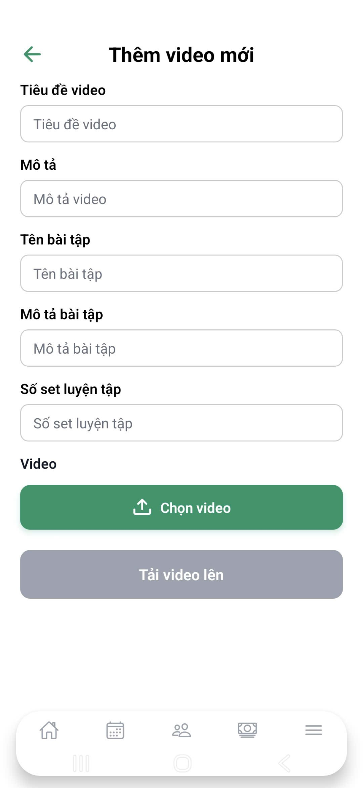

* **Function details**

**Data:** Video file, duration, title, description, name drill

**Validation:**

* Supported formats: MP4
* Max file size enforced

**Business Rules**: Only verified coaches can upload videos

**Normal Case**: upload video successfully

**Abnormal Case**: Unsupported file → upload rejected

#### 3.5.6 Update Video

* **Function Trigger**: Lesson -> Video -> Edit
* **Function Description**

Actors/Roles: Coach, Learner

Purpose: Update video or replace video file

Interface: Video edit form

Data Processing: Replace media file

* **Screen Layout**

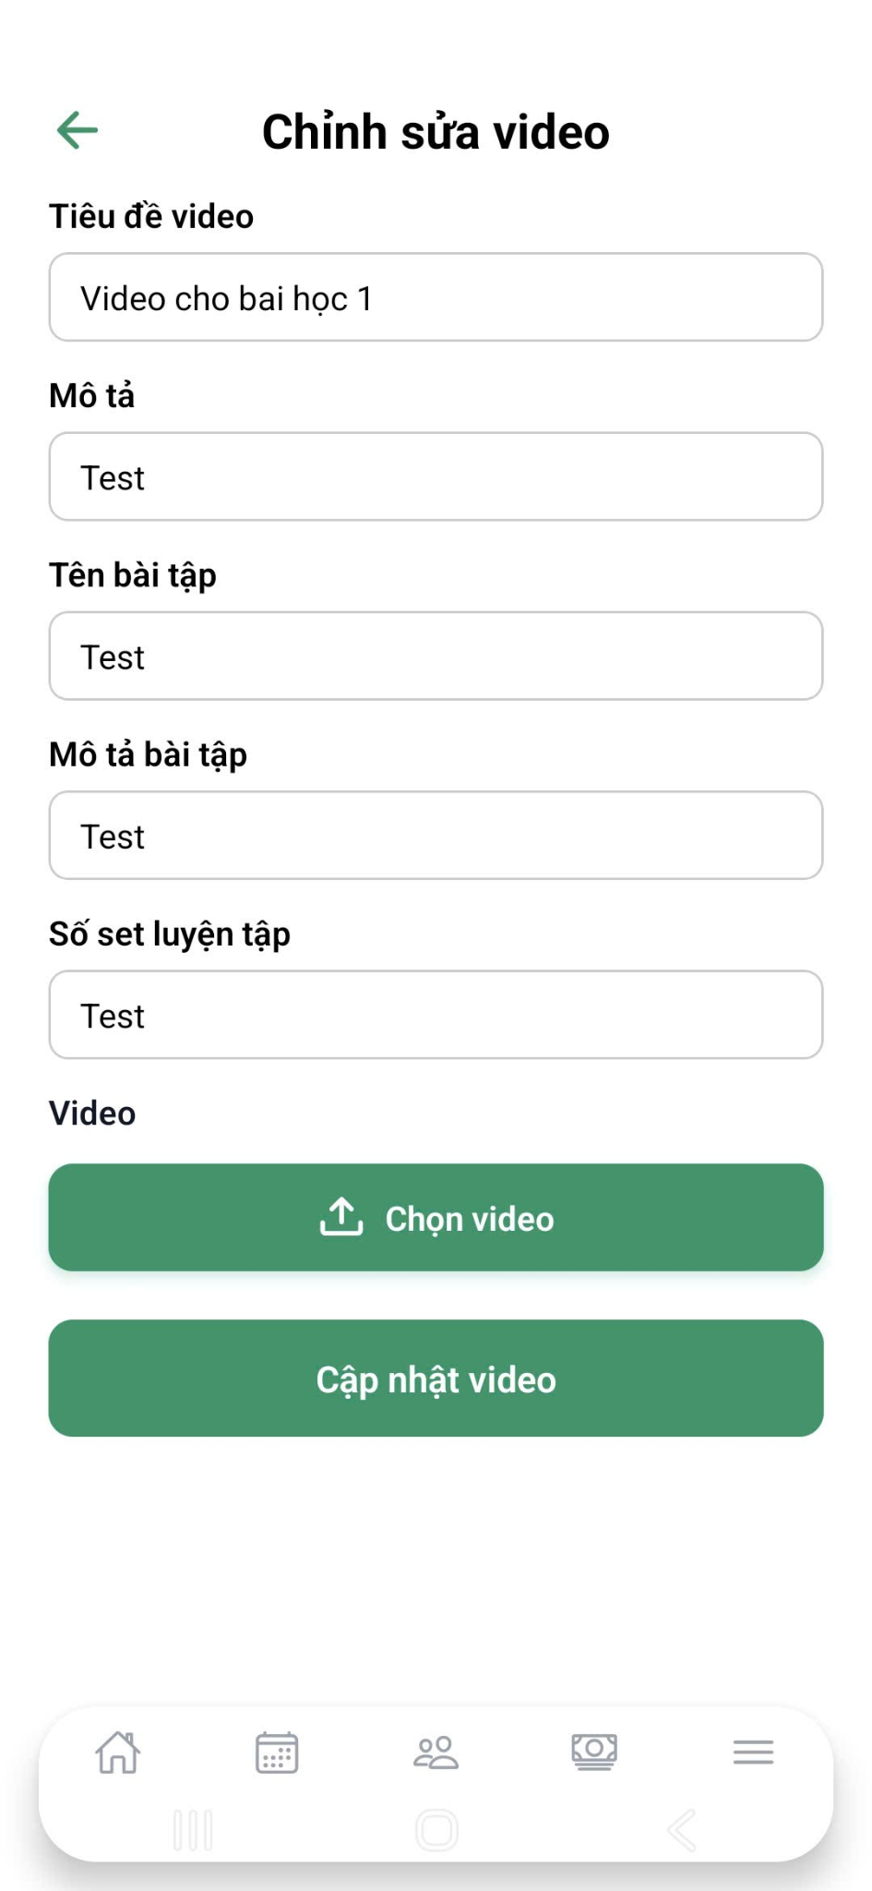

* **Function details**

**Business Rules:** Replacing video does not affect lesson structure

**Normal Case:** Video updated successfully

**Abnormal Case:** Upload interruption → rollback to old video

#### 3.5.7 Delete Video

* **Function Trigger:** Lesson -> Video -> Delete
* **Function Description**

**Actors/Roles:** Coach

**Purpose:** Remove outdated or incorrect instructional videos

**Interface:**  Confirmation dialog

**Data Processing:** Remove video reference and storage file

* **Screen Layout**

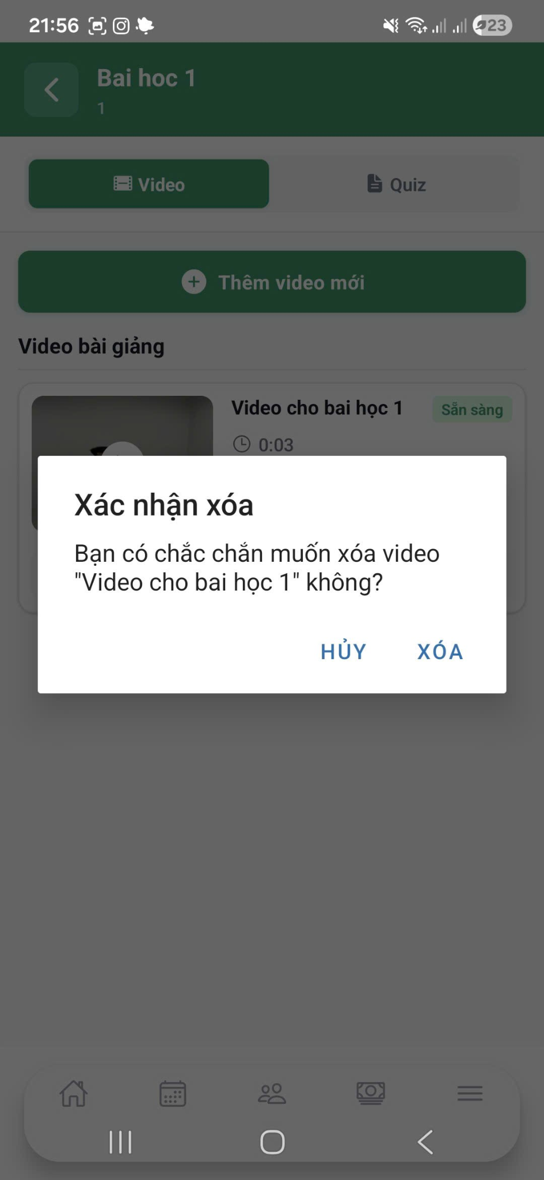

* **Function details**

**Business Rules:** At least one video must exist if lesson is marked as *Video-based*

**Normal Case:** Video deleted successfully

**Abnormal Case:** Deletion blocked due to business rule

### 3.6 Learner Enrollment & Progress Tracking

#### 3.6.1 Enroll into Course

**Function Trigger**

1. **Navigation:**

* Browse Courses → Course Card → Click "Đăng ký"
* Course Details → Click "Đăng ký" button

1. **Actor:** Authenticated Learner
2. **Frequency:** On-demand, when learner wants to join a course

**Function Description**

**Purpose:** Enable learners to register for courses, make payment via PayOS, and gain access to course materials upon successful enrollment.

**Interface:**

* Course catalog with search/filter
* Course details view
* Payment gateway integration (PayOS)
* Enrollment confirmation

**Data Processing:**

* Validate course availability (slots, schedule conflicts)
* Create enrollment record in PostgreSQL
* Process payment via PayOS API
* Hold funds in escrow (Postgresql)
* Grant course access upon payment success
* Send confirmation emails/notifications

**Screen Layout**

1. Course Catalog (Browse)

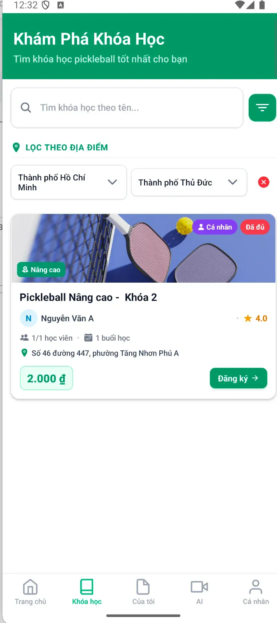

1. Course Details

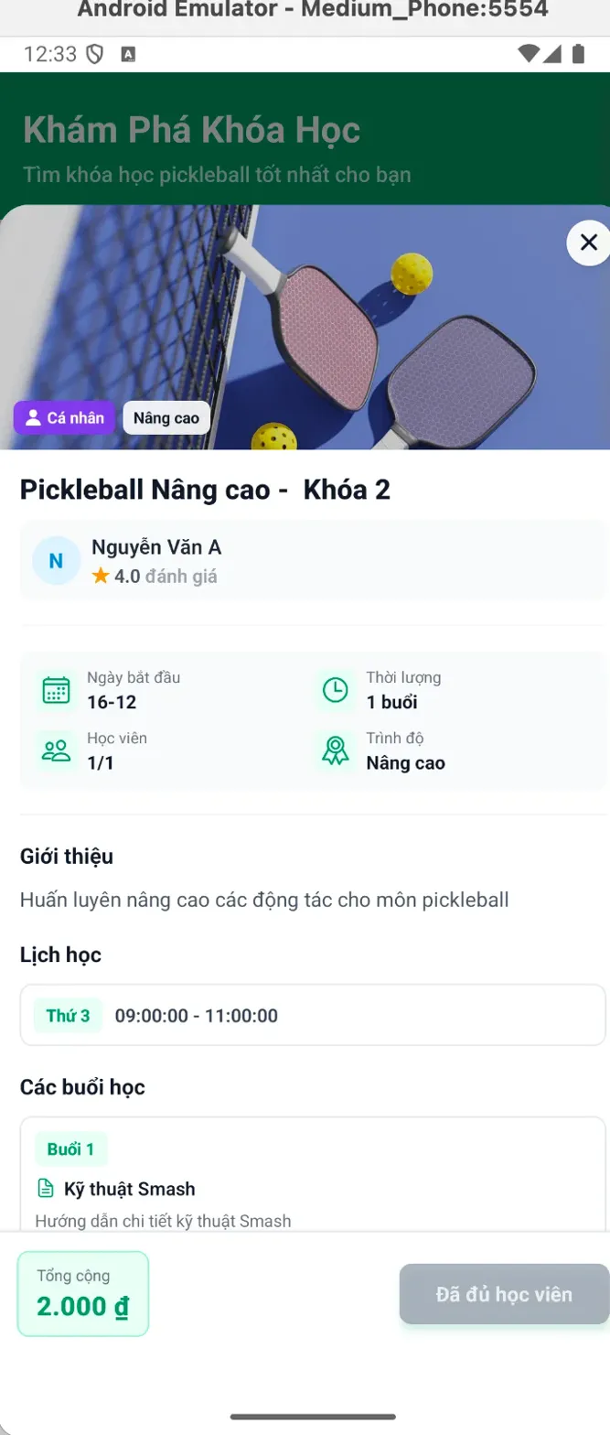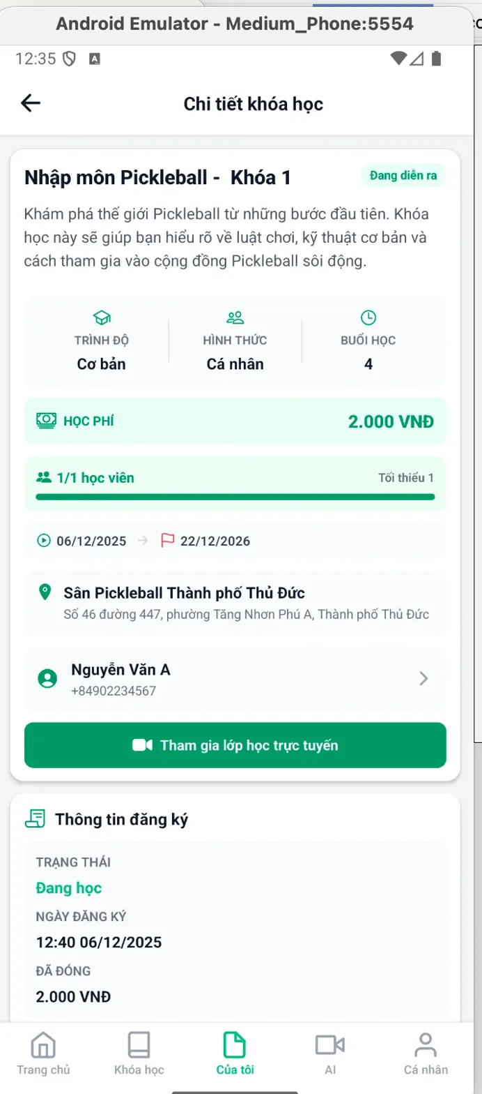

1. Payos with payment gateway

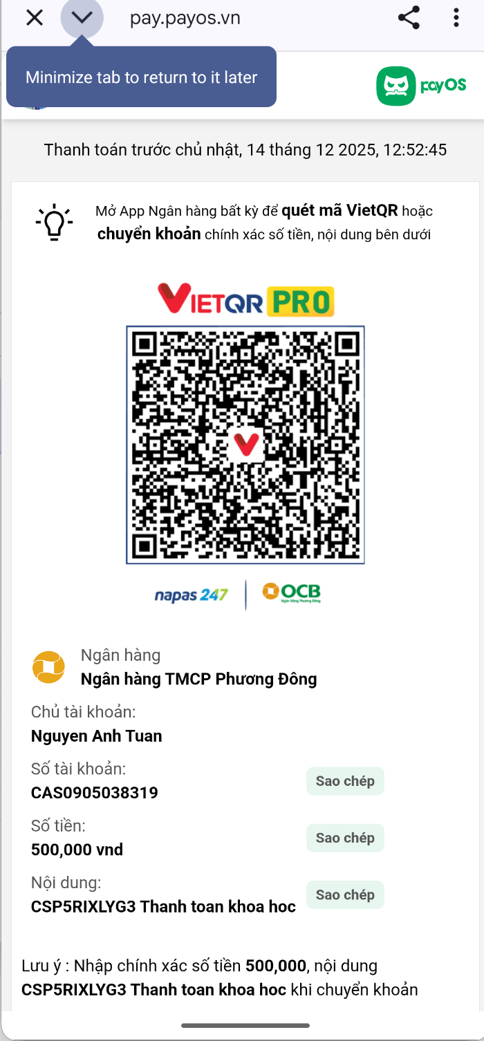

**Function Details**

1.**Business Rules**

* Enrollment Eligibility: users must log in as Learner
* Group Course Rules:
  + Individual Course (1/1): Instant start after payment, no waiting for other students
  + Group Course (e.g., 2-4 students):
    - Min enrollment must be met by start date
    - If min not met → Auto-refund all
    - If min met → Course confirmed

**2. Validation Rules**

| **Check** | **Condition** | **Error** |
| --- | --- | --- |
| Login | User authenticated | "Vui lòng đăng nhập" |
| Course Status | status = "Approved" | "Khóa học chưa được duyệt" |
| Availability | currentEnrollment < maxParticipants | "Đã đủ học viên" |
| Duplicate | Not already enrolled | "Bạn đã đăng ký khóa này" |
| Schedule Conflict | No overlap with other courses | "Trùng lịch với khóa học khác" |
| Payment Amount | amount = course.price | "Số tiền không hợp lệ" |

**Normal Flow**

1. **Browse courses**
   * Search by name, location, skill level
   * Filter by price, schedule, course type
   * View course cards
2. **View course details**
   * Course description
   * Coach profile
   * Schedule & lesson preview
   * Price & enrollment info
3. **Click “Enroll”**
4. **System validation**
   * User is logged in
   * Course is approved
   * Slots are available
   * No schedule conflict
   * Not already enrolled
5. **Payment (PayOS)**
   * Show order summary
   * Select PayOS → Continue
   * Open PayOS gateway (QR + bank transfer)
   * 15-minute payment window
6. **Learner completes payment**
   * Scan QR code or manual bank transfer
7. **PayOS webhook confirmation**
8. **Enrollment processing**
   * Create enrollment (status: Active)
   * Hold funds in escrow
   * Grant course access
   * Update enrollment count
   * Check minimum group requirement
9. **Notifications sent**
   * Email to learner (receipt + course info)
   * Email to coach (new student)
   * SMS (optional)
   * In-app notification
10. **Completion**

* Redirect to **“My Courses”**
* Course status: **In Progress**

Abnormal Cases:

1. **Not Logged In:**

* Click [Đăng ký] → Not authenticated → Redirect to login page → After login: Return to course page → [Đăng ký] button available again

1. **Course Already Full:**

* Click [Đăng ký] → currentEnrollment = maxParticipants → Button disabled, shows "Đã đủ học viên" → Gray out enrollment section → Suggest similar courses

1. **Payment Timeout:**

* PayOS payment window: 15 minutes User doesn't pay in time → Payment expires → Message: "Hết thời gian thanh toán"

#### 3.6.2 Cancel Enrollment

**Function Trigger**

* **Navigation**: My Courses → Course Details → "Hủy khóa học" button
* **Actor**: Enrolled Learner
* **Frequency**: On-demand, before course completion

**Function Description**

Purpose: Allow learners to cancel course enrollment and receive refunds based on cancellation policy.

Interface: Cancel confirmation dialog with refund calculation

Data Processing:

* Calculate refund amount based on progress
* Update enrollment status
* Process refund via PayOS
* Release escrow funds
* Notify coach and admin

**Screen Layout**

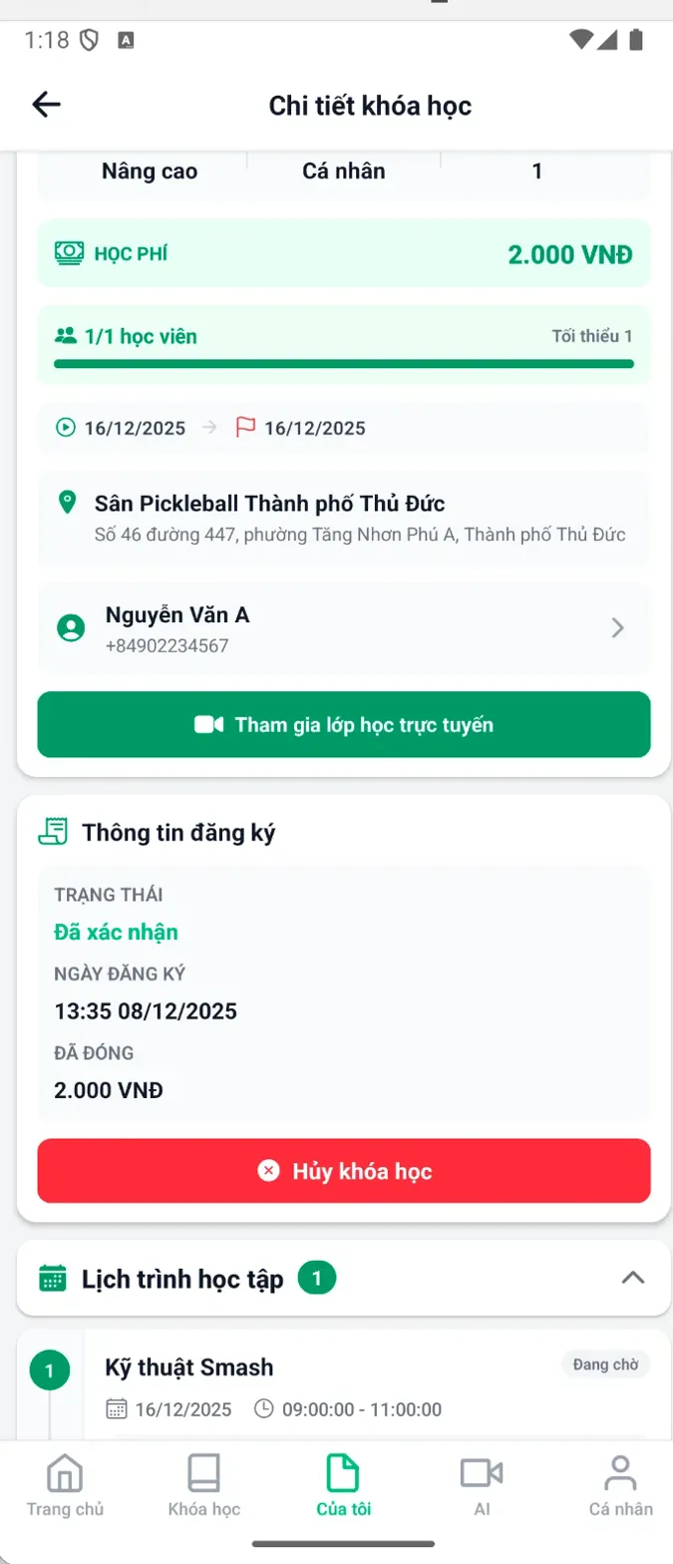

**Function Details**

Before start a lesson, learner will refund 100%

**Business Rules**

|  | Rule definition |
| --- | --- |
| BR-01 | Before course completion, not during active session, enrollment status = "Active" or "Pending" |
| BR-02 | Learners will get a 100% refund if that course has not started yet. |

**Normal Flow**

* Learner browse an available course -> choose view detail -> Add payment (by payos) -> course confirmation

**Abnormal Cases**

1. **Error external third party payment**

* Click [Thanh toán] → payment screen shows error

#### 3.6.3 Track Lesson Completion

**Function Trigger**

* Auto-trigger: When learner completes any lesson activity (video, quiz, practice video)
* Manual check: Learner views "My Courses" → Course Details → Lesson progress
* Actor: Learner (view)
* Frequency: Real-time updates after each activity completion

Function Description

**Purpose:** Automatically track and display individual lesson completion status based on required and optional activities, updating overall course progress in real-time**.**

**Interface:**

* Lesson completion checkmark
* Activity status indicators
* Progress percentage per lesson
* Locked/unlocked lesson states

**Data Processing:**

* Track quiz submission status
* Record practice video submissions
* Calculate lesson completion percentage
* Update course progress
* Unlock next lesson when current complete

**Screen Layout**

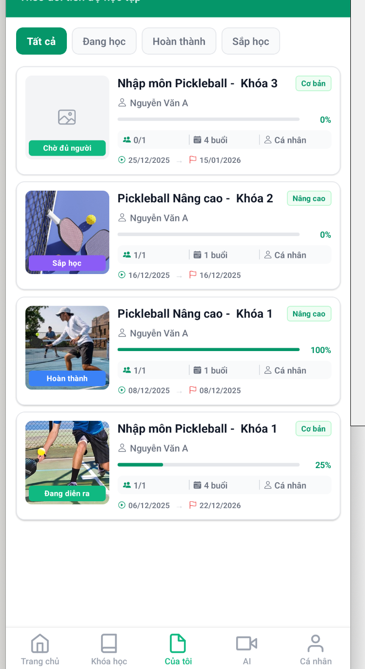

**Function Details**

**Business Rules**

* Completion triggers: "Video complete" event

**Normal Flow**

* Learner enrolls in course -> Learner opens Lesson 1 -> Starts watching video -> watch progress

**Abnormal Cases**

* Video Watch Interrupted
* Network Loss During Progress

#### 3.6.4 Track Course Progress

Function Trigger

* **Navigation**: home page
* **Auto-update**: After each completed activity (video, quiz, session)
* **Actor**: Learner (view), System (calculate)
* **Frequency**: Real-time updates with each learning activity

Function Description

**Purpose**: Display comprehensive progress tracking showing learner's advancement through course materials, including overall completion percentage, individual activity scores, and session attendance.

**Interface**:

* Overall progress percentage with visual bar
* Individual activity scores (AI video, Quiz)
* Session completion tracking
* Achievement badges

**Data Processing**:

* Calculate completion based on required activities
* Track video watch percentage
* Record quiz scores (highest)
* Monitor session attendance
* Update progress in real-time

**Screen Layout**

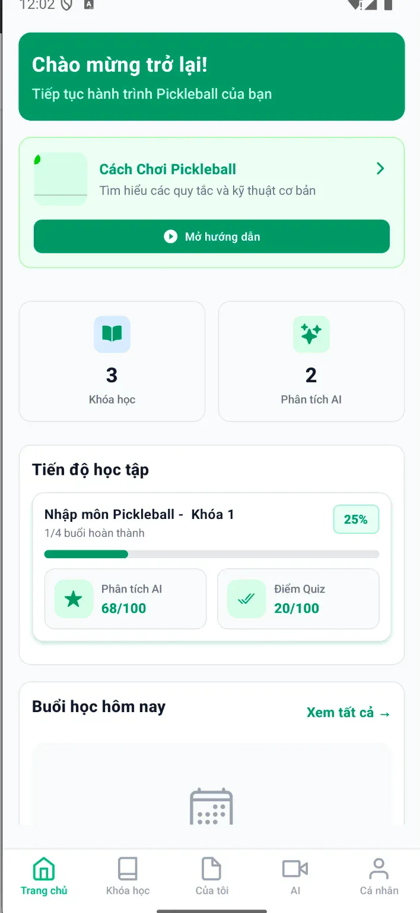

**Function Details**

**Business Rules**

* Marked complete when ALL mandatory activities done
* Must submit answers (any score counts)
* Coach must mark attendance

**Normal Flow**

* Learner open home page -> view course progress

**Abnormal Cases**

* Network fail to fetch

#### 3.6.5 Mark Session Attendance

Function Trigger

* **Navigation**: Coach Dashboard → schedule → Select date → Session List → Click session → Attendance button
* **Actor**: Coach
* **Frequency**: Once per session per learner

**Function Description**

**Purpose**: Enable coaches to record learner attendance for each session, which is critical for progress tracking, payment release, and course completion.

**Interface**:

* Session details view
* Learner list with attendance checkboxes
* Bulk mark options
* Confirmation dialog

**Data Processing**:

* Validate session timing (can't mark before session)
* Update attendance records in PostgreSQL
* Trigger progress calculation
* Release payment if all requirements met
* Send notifications to learners

**Screen Layout**

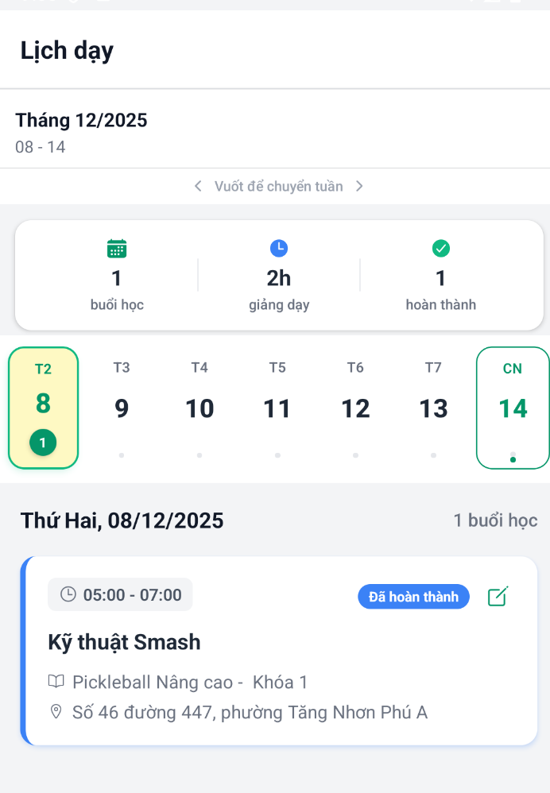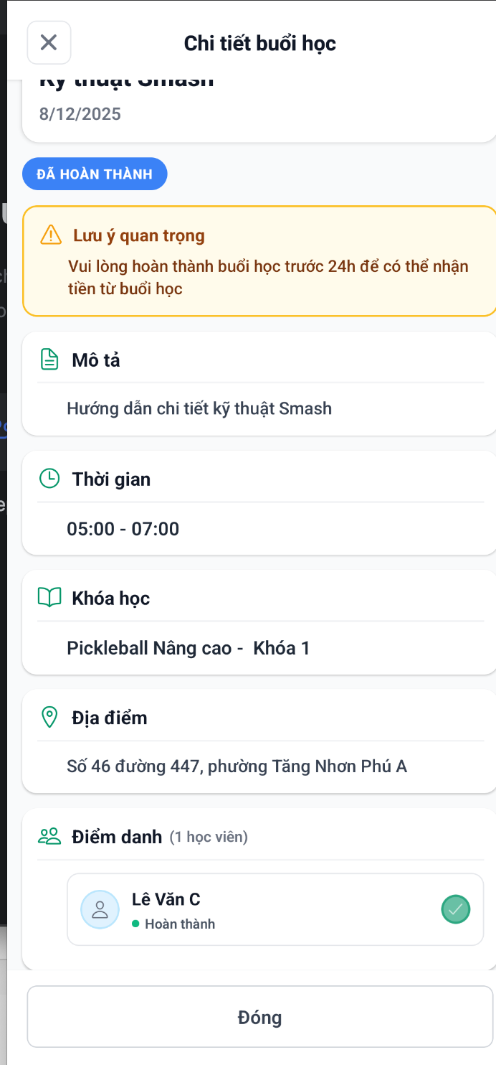

**Function Details**

**Business Rules**

* Cannot mark before session start time
* Coach checks individual learners

**Normal Flow**

* Coach navigate dates -> Coach chooses students -> check attendant

**Abnormal Cases**

* Mark Before Session Starts: Error: "Chưa thể điểm danh"
* Network Error During Save

#### 3.6.6 View guideline

Function Trigger

* **Navigation**:
  + Course/Lesson content → Click "Hướng dẫn" / "Guide" button
  + Video player → Info icon → "Xem hướng dẫn kỹ thuật"
* **Actor**: Learner
* **Frequency**: On-demand, when needing technique reference

**Function Description**

**Purpose**: Provide comprehensive, categorized pickleball technique guidelines including stroke types, movements, basic rules, and common mistakes to help learners understand proper form and gameplay.

**Interface**:

* Categorized guideline sections
* Technique cards with descriptions
* Expandable detail views
* Visual references (optional)

**Data Processing**:

* Load guidelines from static content database
* Filter by category
* Track which guidelines viewed
* Support search functionality

**Screen Layout**

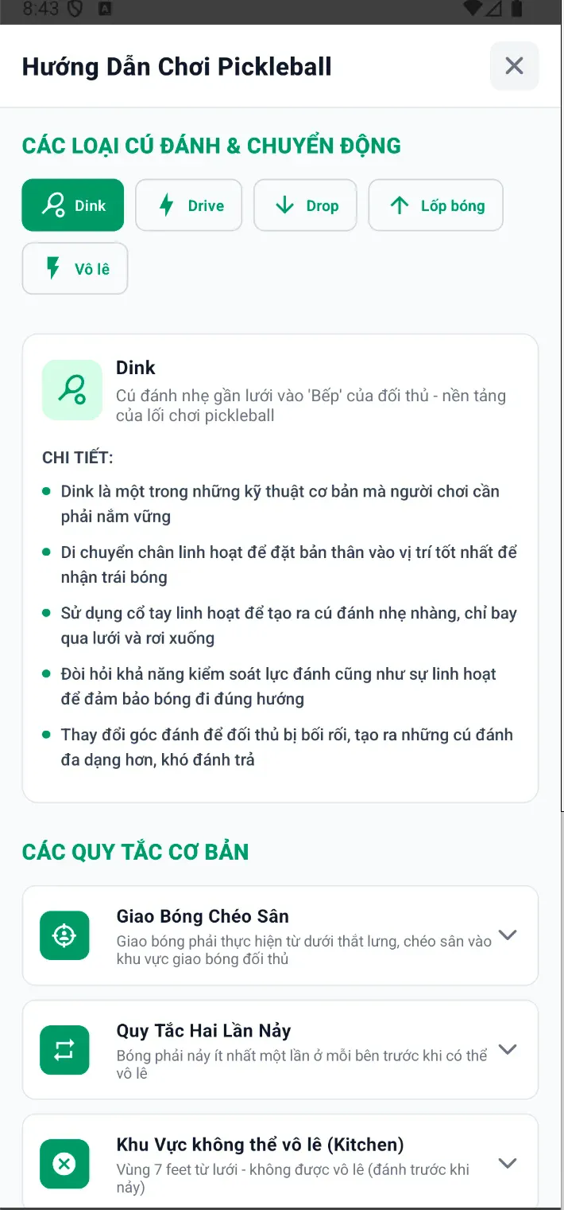

Function Details

Business Rules

* Each Guideline Contains (title, icon, short description, detail explain, step-by-step instruction)

Normal Flow

* User opens guideline viewer in dashboard -> User selects specific guideline -> View guideline details

Abnormal Cases

* No Internet Connection
* Guideline Not Available

### 3.7 AI Video Analysis & Comparison

#### 3.7.1 Upload Practice Video (Learner)

**Function Trigger**

* **Navigation**: My Courses → Course Details → Lesson → "Video" tab → Upload button
* **Condition**: Coach must have marked learner's attendance for the session
* **Actor**: Learner
* **Frequency**: Once per lesson (can resubmit)

**Function Description**

**Purpose:** Enable learners to upload practice videos for AI analysis and coach feedback after attending sessions.

**Interface**:

* Video upload area with record/upload options
* Upload progress indicator
* Video preview before submission
* Submission confirmation

**Data Processing**:

* Validate video format and size
* Upload to bunny cdn
* Create video record in postgresql
* Trigger AI analysis pipeline
* Notify coach of new submission

**Screen Layout**

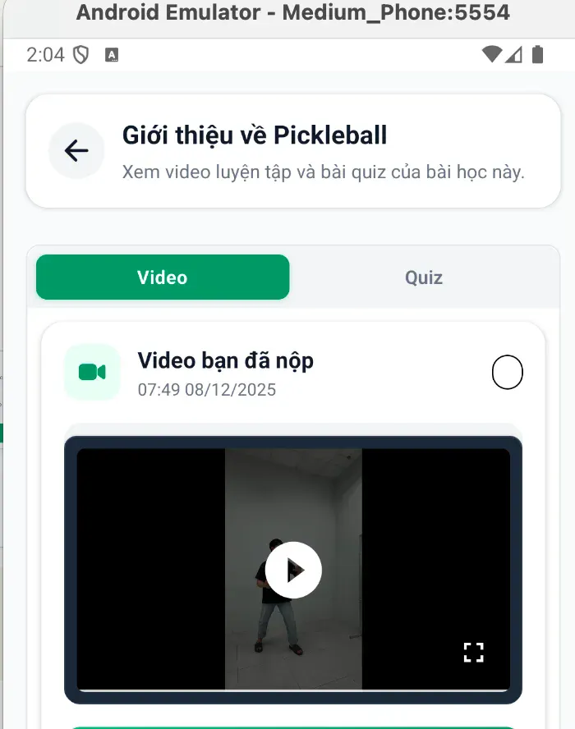

**Function Details**

1. **Business Rules**

|  | Rules definition |
| --- | --- |
| BR-01 | Learner must be enrolled in course, Coach must have marked attendance for session, Session must be completed or in progress |
| BR-02 | One video per lesson, minimum: 4 seconds and maximum: 60 seconds |

1. **Validation Rules**

| **Check** | **Rule** | **Error Message** |
| --- | --- | --- |
| File Format | Extension in [.mp4, .mov, .avi] | "Định dạng không hỗ trợ. Chỉ chấp nhận MP4, MOV, AVI" |
| File Size | File Size | "Video quá lớn. Tối đa 100MB" |
| Duration | Duration | "Video phải từ 10-60 giây" |

1. **Normal Flow**

* Navigate to course -> choose finished lesson -> click update video -> upload file -> send video for coach

1. **Abnormal Cases**

* Not Attended Session: Learner cannot update video for that lesson
* Video too long, short, large: these files will not be uploaded.

#### 3.7.2 Run AI Video Comparison

**Function Trigger**

* Auto-triggered: Immediately after learner uploads practice video
* Manual trigger: Coach/Learner clicks "Phân tích lại" on existing video
* Actor: Coach
* Frequency: Once per video upload (can rerun)

**Function Description**

**Purpose:** Automatically analyze learner's practice video using AI, compare with coach demonstration, and generate technique improvement feedback**.**

**Interface:**

* Processing status indicator
* Split-screen comparison view
* Score breakdown display
* Improvement suggestions

**Data Processing:**

* Extract video frames (30 fps)
* Pose estimation (keypoint detection)
* Movement classification
* Compare with coach demo video
* Generate feedback using Google Gemini API
* Store results in DB

**Screen Layout**

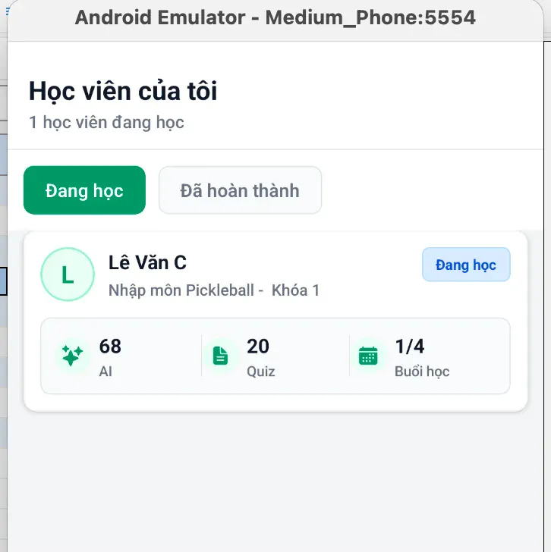

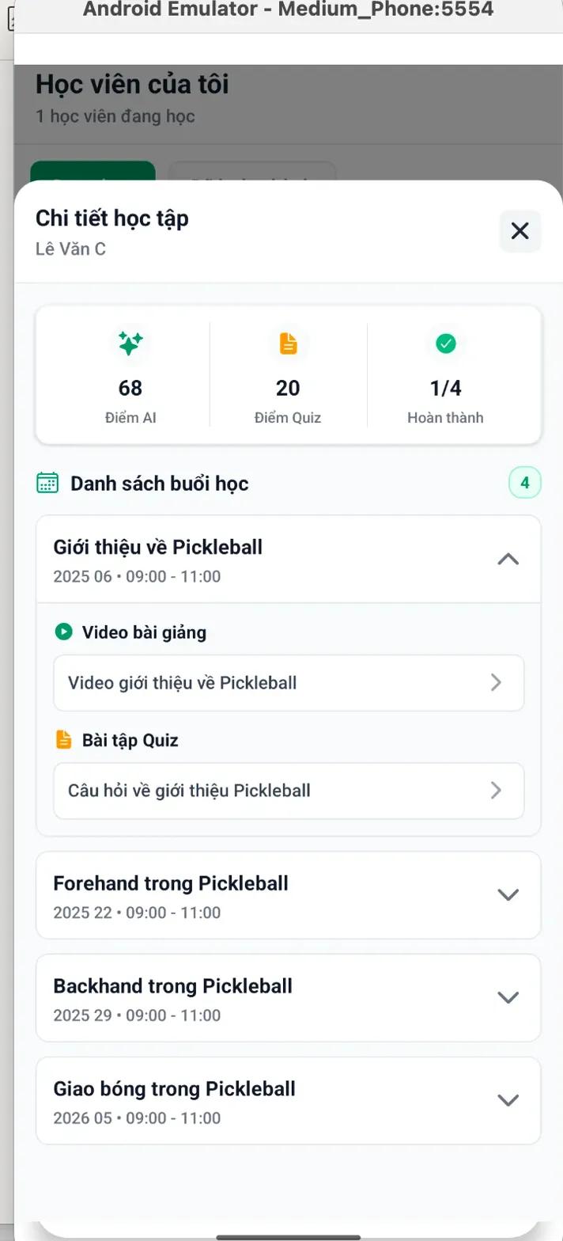

**Function Details**

* **Business Rules:**
  + AI service available
  + Processing Pipeline exactly
  + Scoring Algorithm based on prompting gemini
* **Normal flows:** Coach go to my-student tab to view the lesson today -> Go to video -> click compare videos comparison
* **Abnormal Cases:** Token AI is expired

#### 3.7.3 View AI Feedback (score, posture errors, tips)

**Function Trigger**

* **Navigation**: My Courses → Course Details → Lesson → "Video học viên" → View feedback
* **Notification**: Push/email when AI analysis complete
* **Actor**: Learner (primary), Coach
* **Frequency**: After each video analysis completion

**Function Description**

**Purpose**: Display comprehensive AI-generated feedback including overall score, detailed breakdown, identified issues, strengths, and practice recommendations.

**Interface**

* Score card with rating
* Expandable sections for details
* Visual indicators (✓/✗)
* Practice drill suggestions

**Data Processing:**

* Retrieve analysis results from Postgresql
* Format feedback for display
* Generate comparison highlights
* Track feedback view history

**Screen Layout**

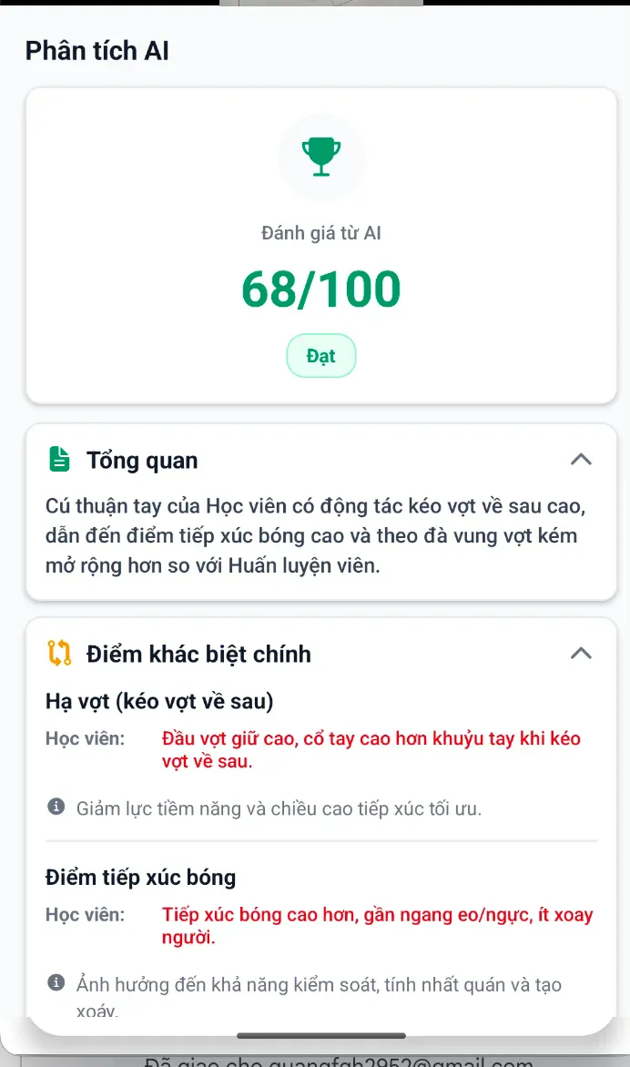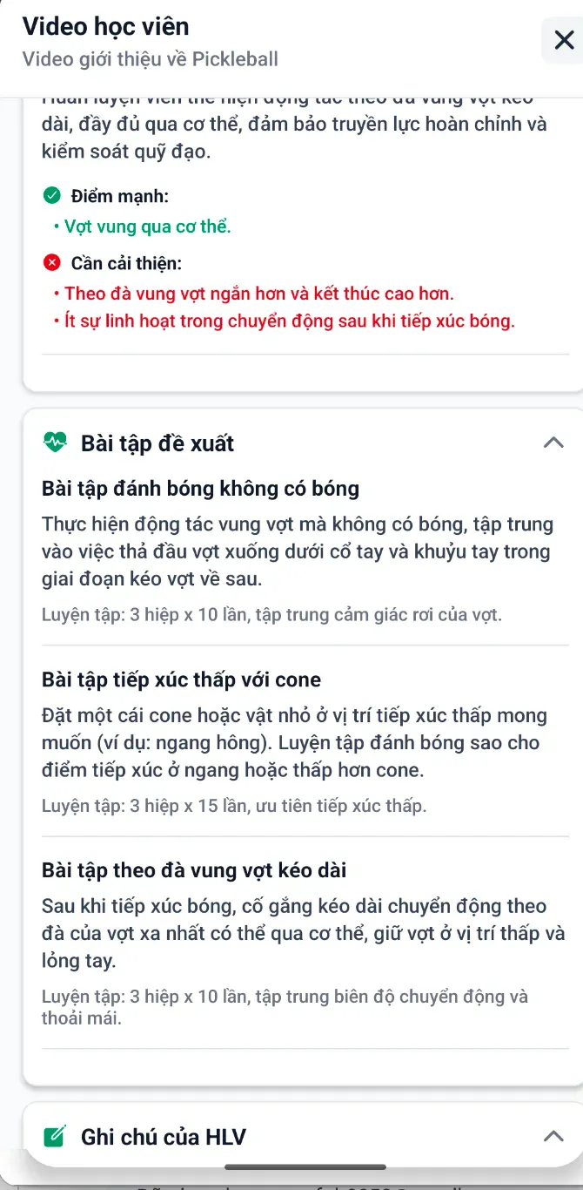

**Function Details**

**Business Rules:**

* Feedback is available after lesson completion
* Shows score (0–100), posture errors, and AI tips
* Data is read-only and AI-generated
* Learners see only their own feedback
* Coaches see feedback of learners in their courses

**Normal flows:**

* Coach go to my-student tab to view the lesson today -> Go to video -> click compare videos comparison -> See the result of AI (if already generate)
* Learner go to my-course tab -> click to course/lesson -> view the assignment and the Ai comparison results

**Abnormal Cases:** Token AI is expired

#### 3.7.4 Coach Feedback on AI Results

**Function Trigger**

* **Navigation:** Coach Dashboard → Student List → View Student Progress → Video Submission
* **Notification:** Alert when learner submits new video
* **Actor:** Coach
* **Frequency:** After each learner video submission

**Function Description**

**Purpose:** Enable coaches to review AI-generated analysis, add personalized feedback, and provide additional guidance to enhance learner improvement**.**

**Interface:**

* View AI analysis results
* Add/edit coach notes section
* Rich text editor for feedback
* Save and notify learner

**Data Processing:**

* Retrieve AI analysis from Postgresql
* Store coach feedback with timestamp
* Update learner notification
* Track coach engagement metrics

**Screen Layout**

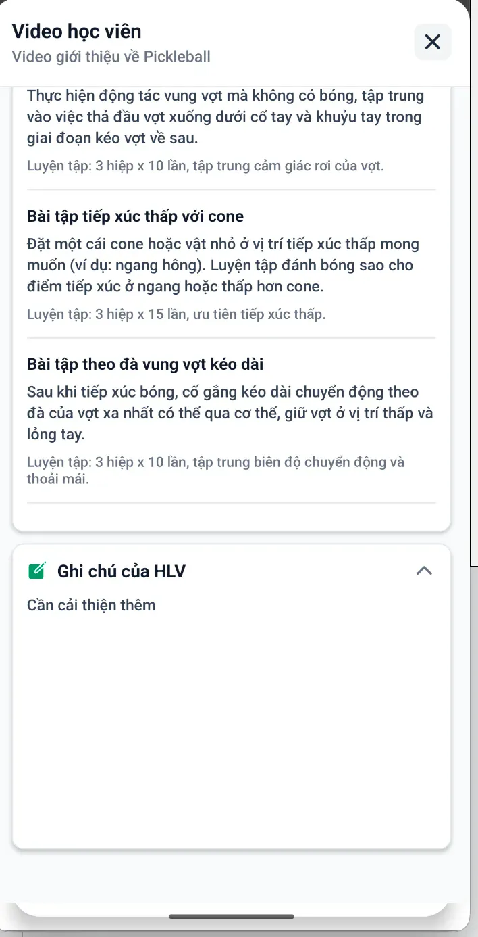

**Business Rules**

* Coach and learner can view AI analysis
* Add/edit notes anytime (max 2000 chars)
* Update last reviewed time

**Normal flows**

* Coach goes to that lesson of a course -> write feedback and submit

**Abnormal Cases:**

* API network error

#### 3.7.4 AI-assisted subject creation

**Function Trigger**

**Navigation**: Coach Dashboard → "Tài liệu của tôi" → "Tạo bằng AI" → Enter prompt → Submit generation request

**Actor**: Coach

**Frequency**: When creating new course content or when needing structured lesson materials with quizzes and videos

**Function Description**

* Purpose: Enable coaches to automatically generate complete course structures (subjects, lessons, quizzes, videos) using AI based on a text prompt, reducing manual content creation time.

**Interface:**

- AI generation request form with prompt input

- Generated content preview with subject details, lessons, quizzes

- Edit and review interface for AI-generated content

- Use/convert button to create actual course from generated content

**Data Processing**:

- Validate prompt input (required, non-empty)

- Send prompt to AI service for content generation

- Store generated content in coach's AI generation library (Postgresql)

- Link generated subject to coach's account

- Track generation status (PENDING/USED)

**Screen Layout**

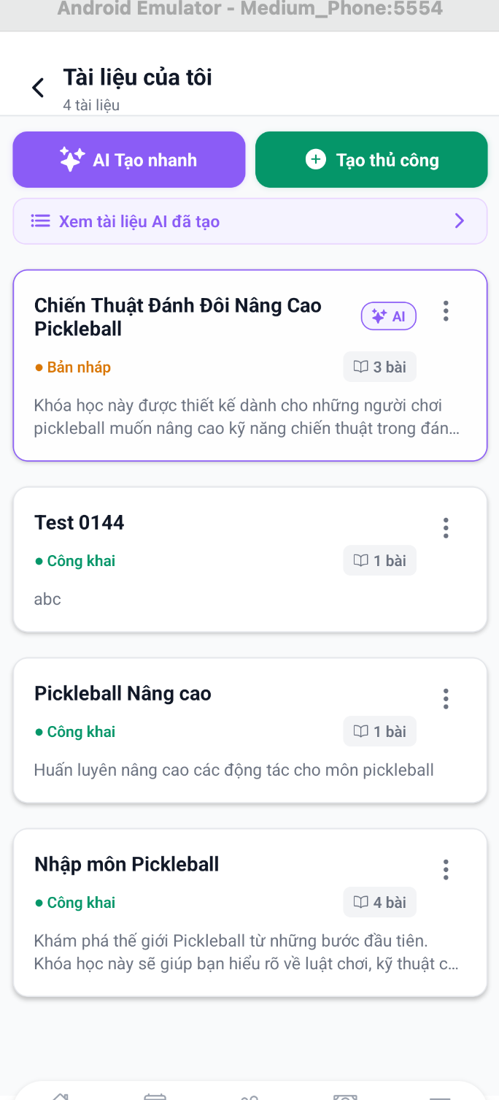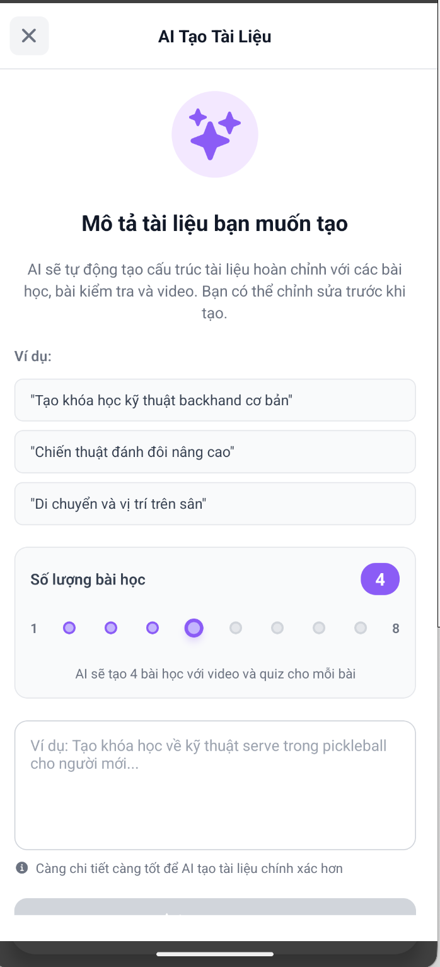

**Function Details**

**Business Rules**:

- The coach must be authenticated and have coach role to access AI generation feature.

- Each AI generation request requires a text prompt describing the desired course content (e.g., "Create a beginner pickleball course with 5 lessons covering basic serves and returns").

- Generated content includes: subject name, description, skill level (BEGINNER/INTERMEDIATE/ADVANCED), multiple lessons (each with video description, drill name, drill description, practice sets), and quizzes (with questions, multiple-choice options, correct answers, explanations).

- AI-generated content has status PENDING until coach uses it to create an actual subject, after which status changes to USED and cannot be regenerated.

- Coaches can edit generated content (subject name, description, level, lesson details) before converting to actual course.

- Each lesson in generated content includes: lesson name, description, lesson number, video details (title, description, tags, drill information), and quiz (title, description, questions with options and explanations).

- Generated content is stored in coach's AI generation library and can be reviewed, edited, or deleted before use.

**Normal Flow**

* Coach navigates to "Tài liệu của tôi" → Clicks "Tạo bằng AI" → Enters descriptive prompt in text field → Submits generation request → System processes AI generation (may take time) → Generated content appears in list with PENDING status → Coach clicks to view generated content → Reviews subject details, lessons, quizzes → Optionally edits content fields → Clicks "Sử dụng" (Use) button → System creates actual subject from generated content → Status changes to USED → Coach can now use subject in course creation

**Abnormal Cases**

- AI generation fails or times out: System displays error message, generation request is not saved, coach can retry with same or modified prompt.

- Generated content exceeds system limits: If AI generates too many lessons or questions, the system truncates to maximum allowed limits, and the coach is notified of truncation.

- Edit conflicts during review: If multiple coaches edit the same generation simultaneously, last save wins, other changes may be lost (rare scenario as generations are coach-specific).

#### 3.8.1 AI overview

**Function Trigger**

* **Navigation**: Learner Dashboard → "Phân tích Video AI" tab
* **Actor**: Learner
* **Frequency**: When learner wants to review all their video analysis results from completed practice sessions

**Function Description**

* **Purpose**: Provide learners with a centralized overview of all AI video analysis results, allowing them to review their performance scores, view analysis history, and access detailed video comparisons from previous practice sessions.
* **Interface**:

- AI analysis overview screen with list of all video analysis records

- Analysis result cards showing course name, session number, score, and date

- Score badges with color-coded indicators (Pass/Warning/Fail)

- Click-to-view detailed analysis with side-by-side video comparison

- Empty state when no analyses exist

- Error handling with retry functionality

**Data Processing**:

- Fetch all AI video comparison results for the current learner user

- Display results sorted by creation date (newest first)

- Calculate and display learner score (0-100 scale)

- Link analysis results to corresponding course and session information

- Validate video URLs before allowing detailed view

**Screen Layout**

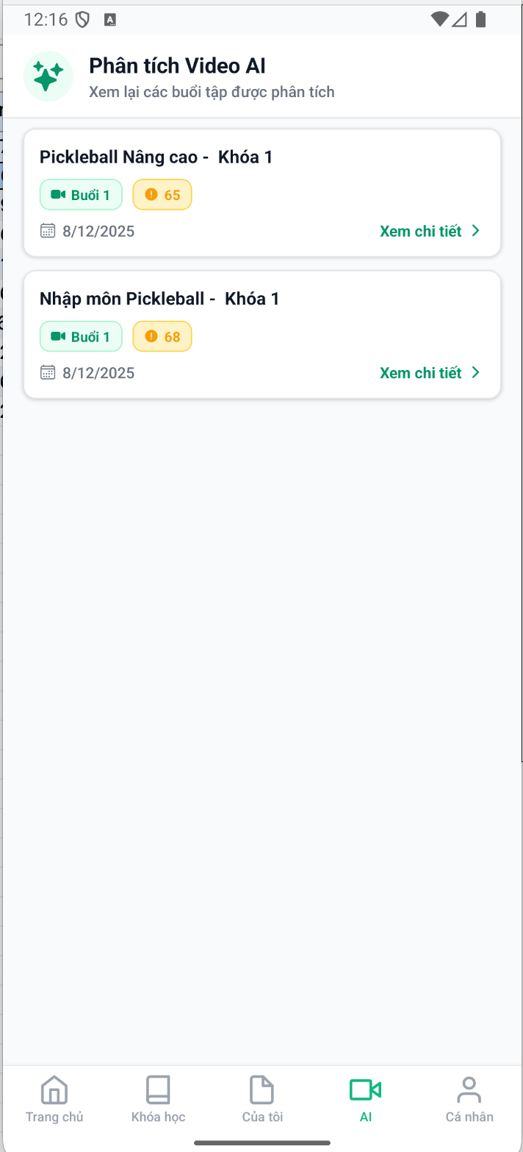

**Function Details**

**Business Rules**:

- Only authenticated learners can access their AI analysis overview.

- Each analysis result is associated with a learner video and a coach reference video from a specific session.

- Analysis results display learner score (0-100), where: score ≥70 is Pass (green), score 50-69 is Warning (yellow), score <50 is Fail (red).

- Analysis results include: summary, key differences, detailed breakdown (preparation, swing/contact, follow-through), recommendation drills, and optional coach notes.

- Learners can only view analyses for videos they have submitted; cannot view other learners' analyses.

- Each analysis result card shows: course/session name, session number badge, score badge with color coding, creation date, and "Xem chi tiết" (View details) link.

- Clicking an analysis card opens detailed view only if both coach video and learner video URLs are available.

- Analysis results are fetched on screen load and can be refreshed manually.

**Normal Flow**

Learner navigates to "Phân tích Video AI" tab → System fetches all AI analysis results for learner → Loading indicator displays → Results list appears showing all analysis cards → Each card displays course name, session badge, score badge (color-coded), date, and "Xem chi tiết" link → Learner clicks on an analysis card → System validates both video URLs exist → Detailed analysis modal opens with side-by-side video player → Learner can view coach video and their video simultaneously → Learner can review AI analysis details (summary, key differences, recommendations, drills) → Learner closes modal to return to overview list

**Abnormal Cases**

- No analysis results found:Empty state displays with message "Chưa có phân tích nào" and instruction to complete practice sessions to receive AI analysis.

- Network error during fetch: Error container displays with error message "Không thể tải dữ liệu phân tích. Vui lòng thử lại" and retry button; learner can click retry to attempt fetch again.

- Session information missing: Session badge shows generic "Buổi tập" text if session number is not available; course name falls back to video title or "Phân tích Video".

- Backend API returns empty array: Empty state displays, no error shown; system treats as normal case (no analyses yet).

- Video URLs invalid or expired: When opening detailed view, if video URLs fail to load, video player component handles error; analysis details may still be viewable.

- Concurrent fetch requests: Multiple simultaneous fetches are prevented by loading state; only one fetch occurs at a time.

- Analysis data partially missing: If some fields (summary, keyDifferents, recommendationDrills) are null, those sections are hidden; available data still displays.

### 3.8 Quiz & Assessment System

#### 3.8.1 Create Quiz

**Function Trigger**

* **Navigation**: Coach Dashboard → "Tài liệu của tôi" → "Tạo thủ công" → Select lesson → "Quiz" tab → "Thêm câu hỏi mới"
* **Actor**: Coach
* **Frequency**: When creating subject content or preparing lesson materials

**Function Description**

**Purpose:** Enable coaches to create quizzes with multiple-choice questions to assess learner understanding of lesson content.

**Interface**:

* Quiz builder form
* Question and answer fields
* Correct answer selector
* Optional explanation field

**Data Processing**:

* Validate quiz structure (min 2 answers, 1 correct)
* Store in coach's content library (Postgresql)
* Link to lesson/subject
* Available for assignment to sessions

**Screen Layout**

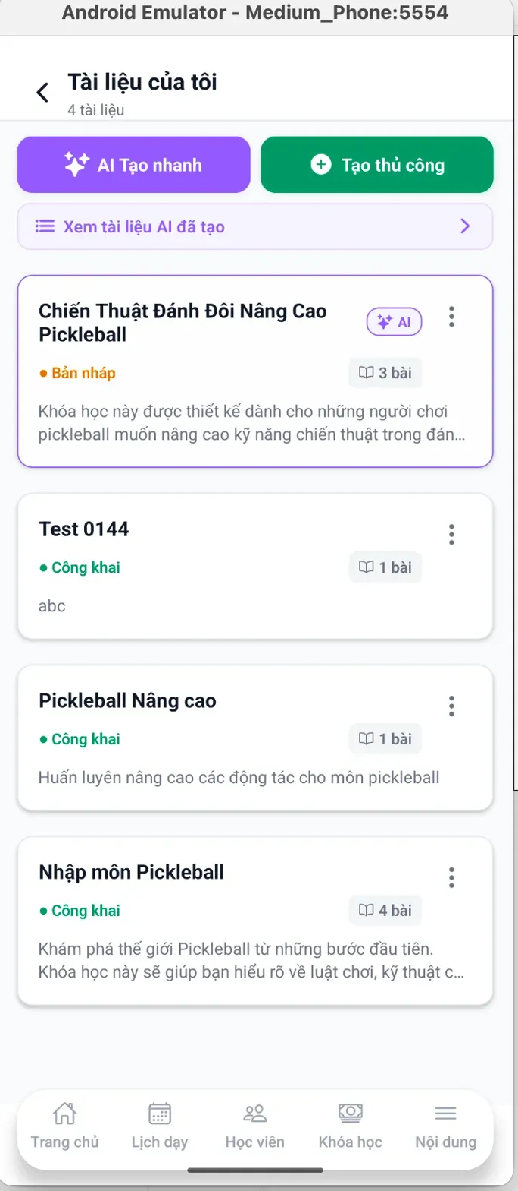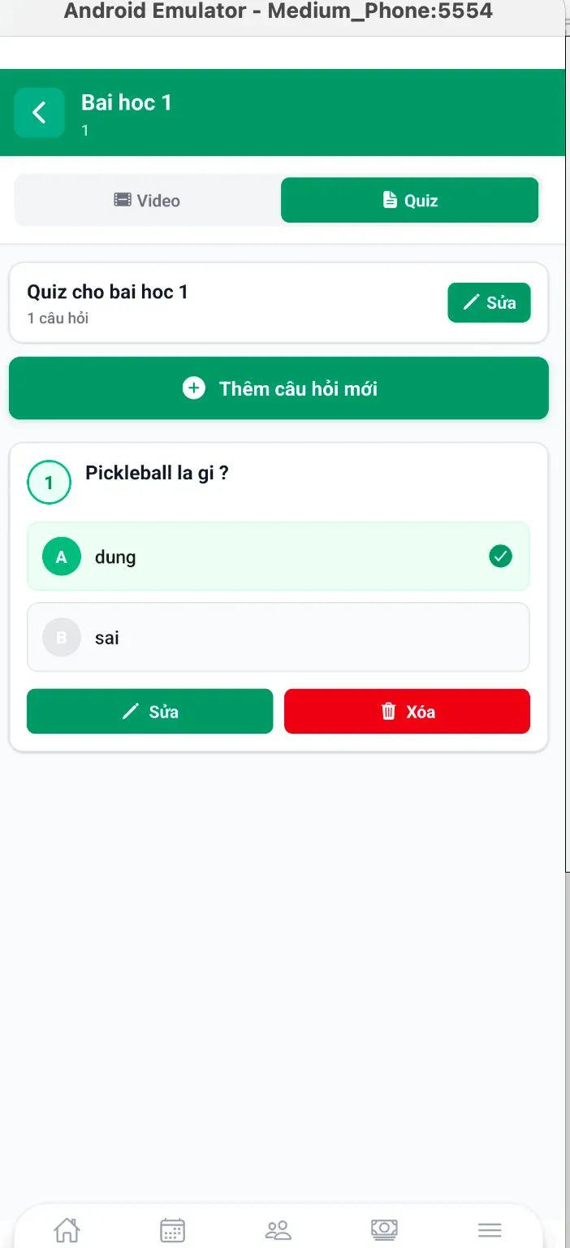

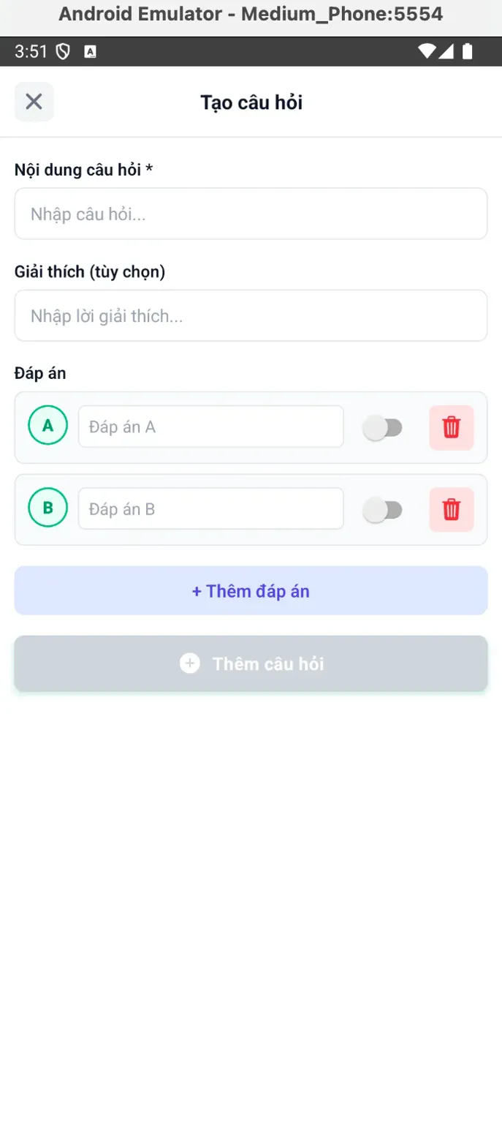

**Function Details**

**Business Rules:**

* The coach must create a subject first.
* Each quiz belongs to a lesson, requires at least 1 question, and a lesson can have multiple quizzes. Quizzes are saved in the coach content library and can be reused across courses.
* Each question has 2–6 answer options, exactly 1 correct answer (single choice), question length 10–500 chars, answer length 1–200 chars, and an optional explanation up to 1000 chars.
* Only one answer can be marked correct at a time; at least one correct answer is required to save. Answers are auto-labeled A–F.

**Normal Flow**

* Coach navigates to subject/lesson -> Clicks "Quiz" tab -> Clicks [+ Thêm câu hỏi mới] -> Form opens: "Tạo câu hỏi" -> Add answer options (default show a or b) -> Toggle correct answer (turns green) -> Review question preview -> Question added to quiz list

**Abnormal Cases**

* Empty Question Text: Error: "Vui lòng nhập nội dung câu hỏi"
* Duplicate Answer Text: Suggest: "Vui lòng nhập đáp án khác nhau"

#### 3.8.2 Update Quiz

**Function Trigger**

* **Navigation**: Coach Dashboard → "Tài liệu của tôi" → Select subject → Lesson → "Quiz" tab → Click "Sửa" on question
* **Actor**: Coach
* **Frequency**: When editing existing quiz questions

**Function Description**

**Purpose:** Enable coaches to modify existing quiz questions, update answers, change correct answer selection, or fix errors.

**Interface:**

* Pre-filled edit form with existing data
* Same structure as create form
* Update button instead of create

**Data Processing:**

* Load existing question data
* Validate changes
* Update in Postgresql
* Maintain version history
* Update linked sessions

**Screen Layout**

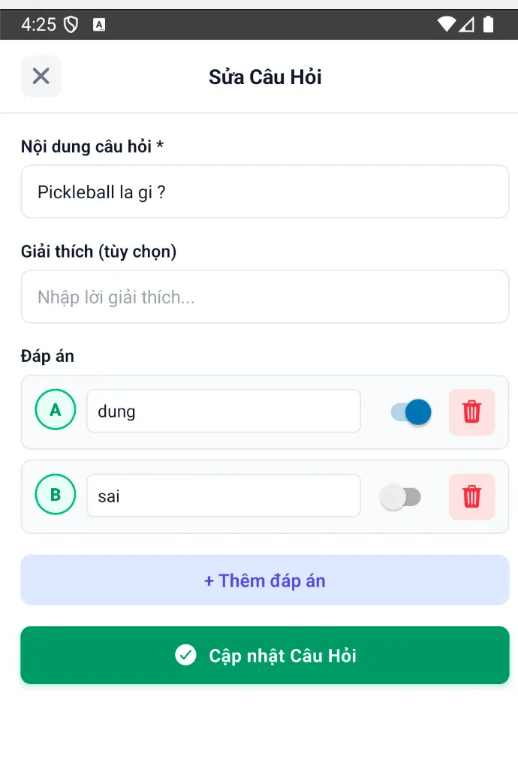

**Function Details**

**Business Rules**

* Only coach who created can edit
* Cannot edit if learners already submitted answers

**Normal Flow**

* Coach views quiz question list -> Clicks [Sửa] on specific quiz -> Clicks [✏️ Sửa] on specific question -> Click update quiz

**Abnormal Cases**

* No Changes Made
* Concurrent Edit Conflict

#### 3.8.3 Delete Quiz

**Function Trigger**

* **Navigation**: Coach Dashboard → "Tài liệu của tôi" → Subject → Lesson → "Quiz" tab → Click "Xóa" on question
* **Actor**: Coach
* **Frequency**: When removing outdated or incorrect quiz questions

**Function Description**

**Purpose:** Enable coaches to permanently delete quiz questions from their content library with appropriate warnings and safeguards

**Interface:**

* Delete button on quiz question
* Confirmation dialog
* Impact warning if quiz in use

**Data Processing**:

* Check if quiz has learner submissions
* hard delete the question
* Update linked sessions

**Screen Layout**

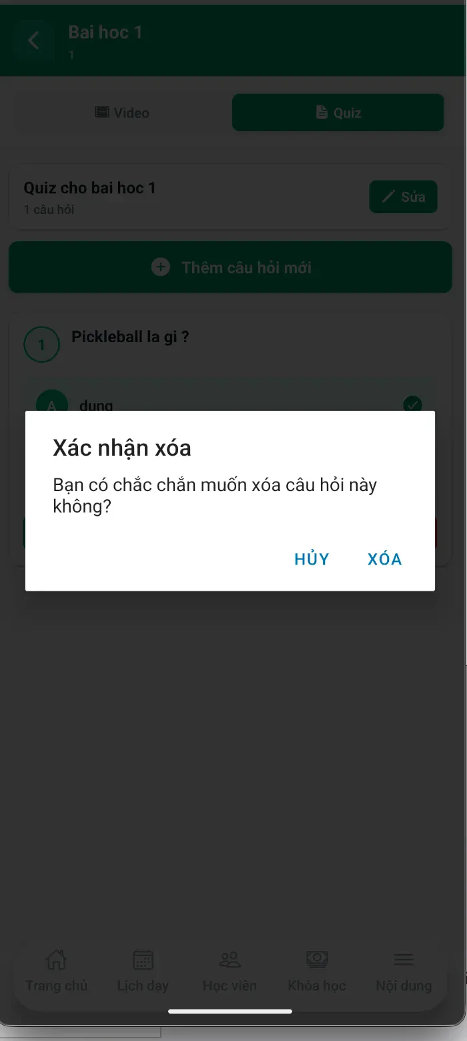

**Function Details**

**Business Rules**

* Only coach who created can delete
* Can delete anytime from content library
* Confirmation required for all deletes

**Normal Flow**

* Coach view list quizzes in a lesson of a subject -> Click on a specific quiz -> Click “Delete” button -> Click confirm button

**Abnormal Cases**

* Last Question in Quiz
* Click delete button → Warning: "Đây là câu hỏi cuối cùng"
* Network Error During Delete
* Click [XÓA] → Network fails

#### 3.8.4 View Quiz

**Function Trigger**

* **Navigation**: My Courses → Course Details → Lesson → "Quiz" tab → Click quiz title
* **Notification**: Alert when new quiz assigned
* **Actor**: Learner
* **Frequency**: When completing lesson quizzes

**Function Description**

**Purpose:** Enable learners to view quiz questions, select answers, submit responses, and receive immediate feedback on their performance**.**

**Interface:**

* Question display with answer options
* Multiple choice selection
* Submit button
* Results page with score and corrections

**Data Processing:**

* Load quiz questions from Postgresql
* Track answer selections
* Calculate score on submission
* Store results and update progress
* Display correct answers with explanations

**Screen Layout**

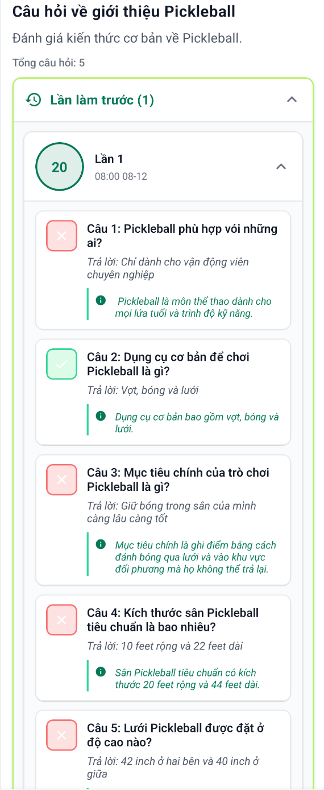

**Function Details**

**Business Rules**

* Learner must be enrolled in course
* Can access quiz unlimited times
* Highest score recorded

**Normal Flow**

* Learner opens lesson -> Clicks "Quiz" tab -> Sees quiz title and question count

**Abnormal Cases**

* Network Disconnection

#### 3.8.7 Start Quiz Attempt (Learner)

**Function Trigger**

* **Navigation**: My Courses → Course Details → Lesson → "Quiz" tab → Click quiz title
* **Actor**: Learner
* **Frequency**: When starting new quiz attempt or retaking quiz

Function Description

**Purpose**: Initialize a new quiz attempt, display questions in sequence, track learner's progress, and manage attempt history.

**Interface**:

* Quiz overview with attempt history
* Question display with navigation
* Answer selection interface
* Progress tracking

**Data Processing**:

* Create new QuizAttempt record
* Load questions in order (or shuffled)
* Track time per question
* Auto-save progress
* Calculate duration

**Screen Layout**

#### 

**Function Details**

**Business Rules**

* Loads all questions at once
* All questions shown in single scrollable view
* Previous attempts visible in dropdown

**Normal Flow**

* Learner opens quiz -> select correct questions -> click submit

**Abnormal Cases**

* Return to In-Progress Quiz
* Network Loss During Start

#### 3.8.9 Auto-Grade Quiz

* **Function Trigger**: Triggered by user action
* **Triggered:** Automatic after quiz submission
* **Function Description:** Automatically grade learner’s quiz based on predefined correct answers.
* **Actors/Roles:** Learner, System
* **Purpose:** Provide instant quiz results without manual grading.
* **Interface:** Quiz result screen
* **Data Processing:**
  + Information:
  + Quiz questions, selected answers, correct answers
  + Input: Learner’s submitted answers
  + Output: Quiz score and pass/fail result
* **Screen Layout:**

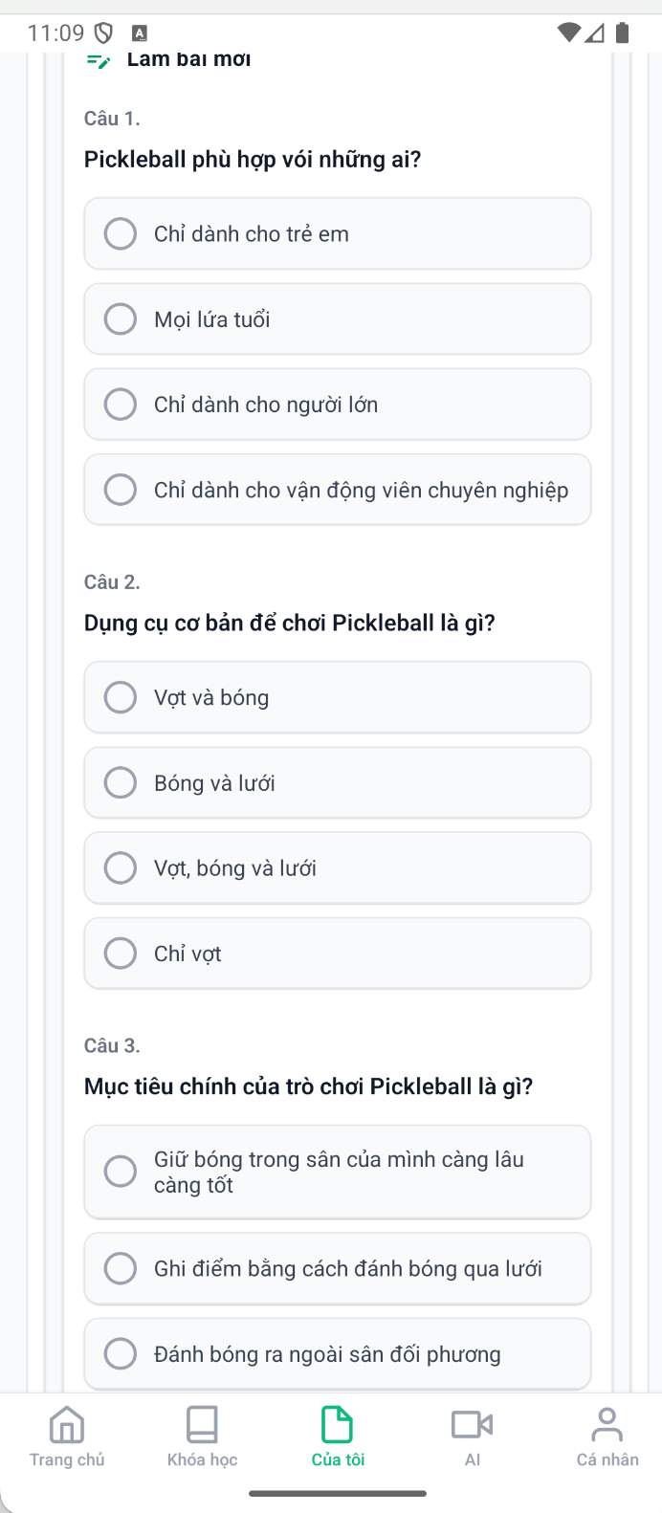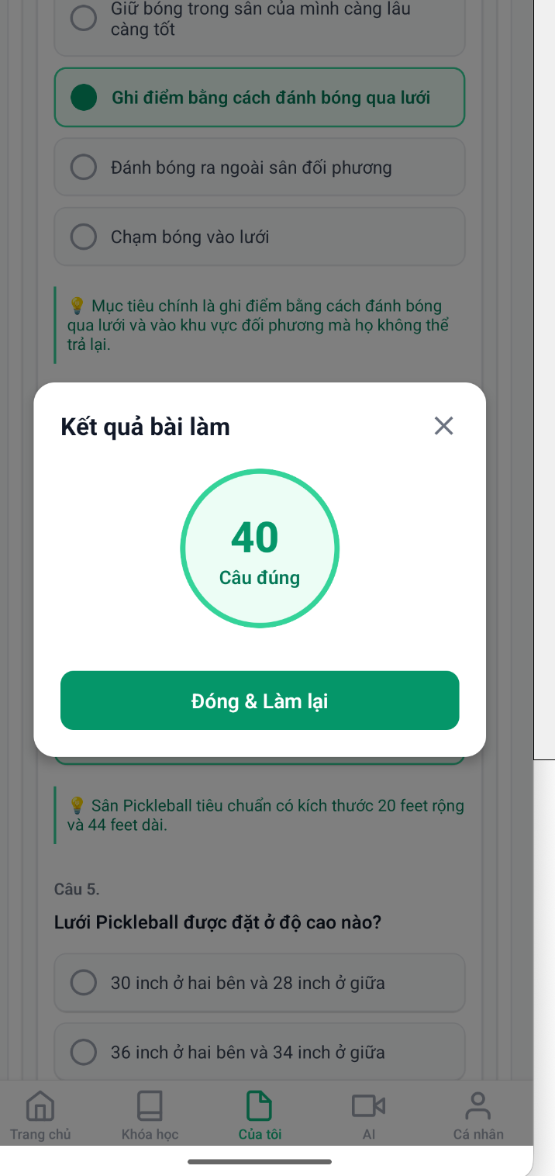

* **Function Detail:**
  + System compares learner answers with correct answers and calculates the score automatically.
* **Business Rules:**
  + Each question has exactly one correct answer
  + Score is calculated immediately after submission
  + Results are read-only for learner
  + No manual override by learner
* **Normal Flow:**
* 1. Learner submits quiz
* 2. System auto-grades answers
* 3. Result is displayed instantly
* **Abnormal Case:**
* - Incomplete submission → prompt learner to answer all questions
* - System error → grading failed message

#### 3.8.10 View Quiz Results

**Function Trigger:** Triggered by user action

**Triggered:** view after finished quiz

**Function Description:** Show previous learner’s answers.

**Actors/Roles:** Learner, System

**Purpose:** Provide instant quiz results when first going to quiz tab.

**Interface:** Quiz result screen

**Data Processing:**

* Information: Quiz previous results
* Input: Learner’s answers
* Output: View score and pass/fail result

**Screen Layout**:

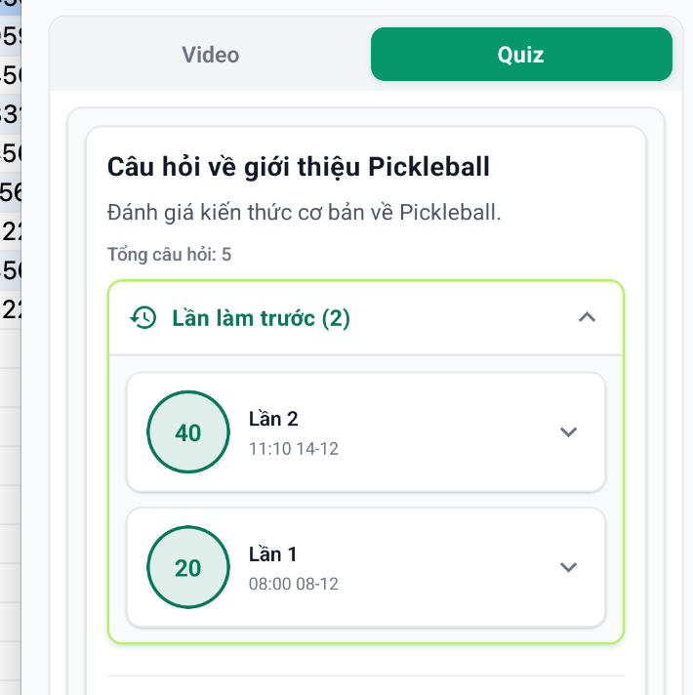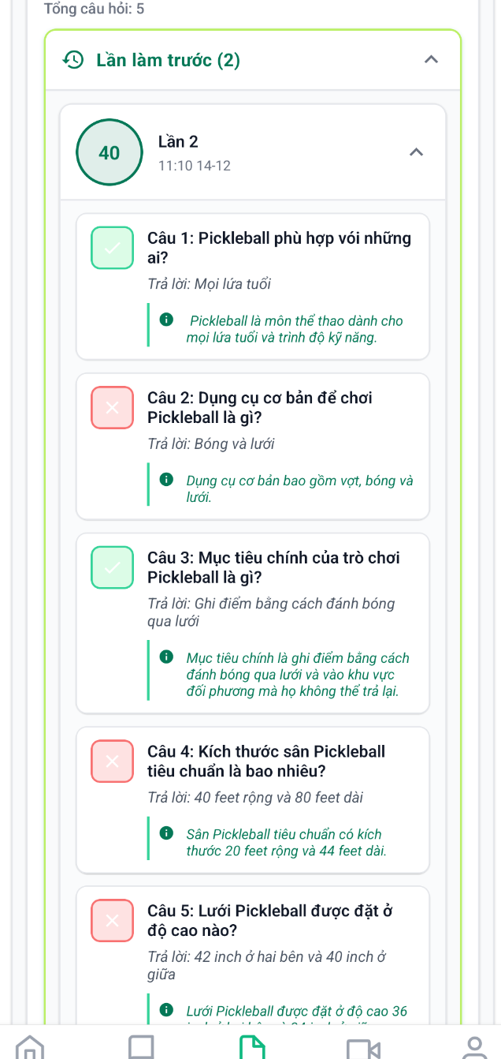

**Function Detail**:.

**Business Rules:**

- Results are shown immediately after quiz submission

- Modal appears automatically with score summary

- Previous attempts are loaded when quiz tab is accessed

- All attempts are displayed in chronological order (newest first)

**Normal Flow:**

- Result modal appears automatically

- Score is displayed in large circular format

- "Câu đúng" label shows number of correct answers

- Modal overlay prevents interaction with background

**Abnormal Case**:

* Network Error During Submission

### 3.9 Feedback & Achievement System

#### 3.9.1 Submit Feedback (Learner for Coach / Course)

* **Function Trigger:**
* Triggered: when Learner selects

**My Courses → Completed Courses → Course Detail → “viết đánh giá” button**

* Manual action: (on-demand)
* **Function Description**
* **Actors/Roles**: Learner
* **Purpose:** To allow learners to submit feedback and ratings for a completed course and its coach.This function helps evaluate course quality and coach performance, collect learner experiences, and support service improvement while ensuring that only eligible learners can provide feedback.
* **Interface:**
  + My Courses
    - Displays a list of courses wich status.
    - Filters for searching for courses
  + Course Detail Page
    - Displays full details of the selected completed course.
  + Feedback Popup
    - Star rating selection.
    - Text area for feedback description and sharing experience.
    - Anonymous feedback option (checkbox).
    - “Gửi phản hồi” button.
  + Notification Message
    - Displays success or error message after submission.
* **Data Processing:**
  + - Validate learner authentication and role.
    - Validate selected course completion status.
    - Validate feedback input (rating value, description content).
    - Process anonymous option selection.
    - Store feedback data in the database.
    - Update course and coach average rating.
* ***Screen Layout:***

1. **list of my courses**

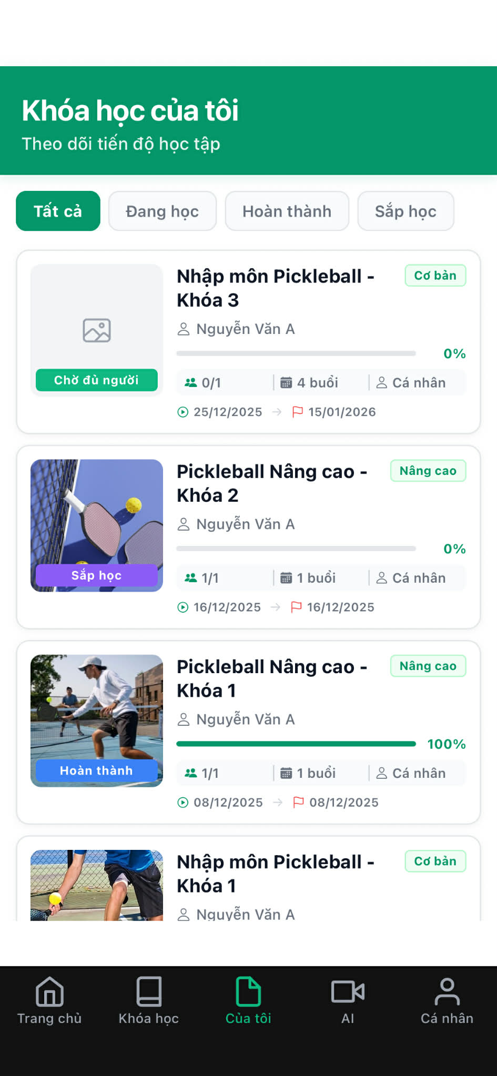

1. **Detail course**

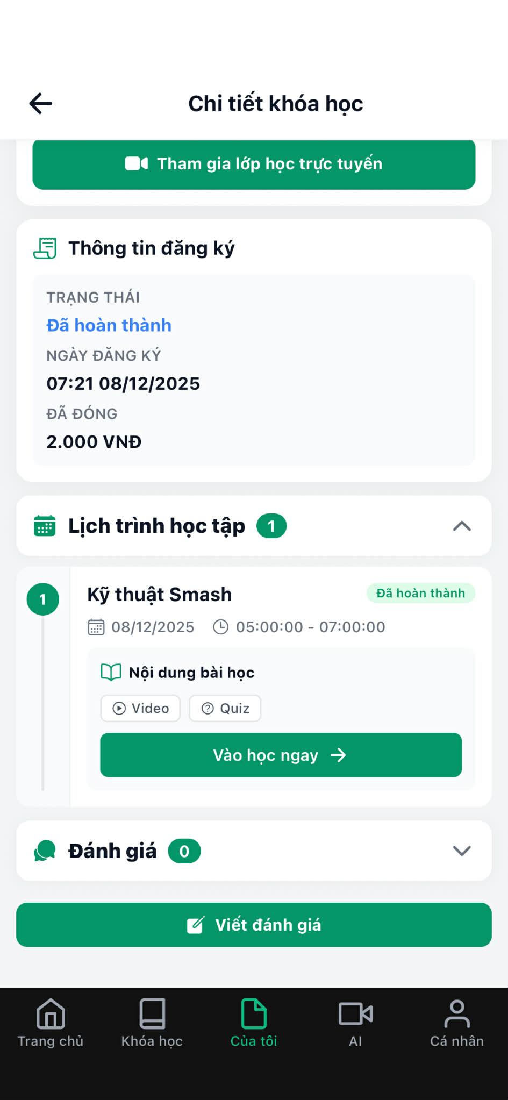

1. **Popup write feedback**

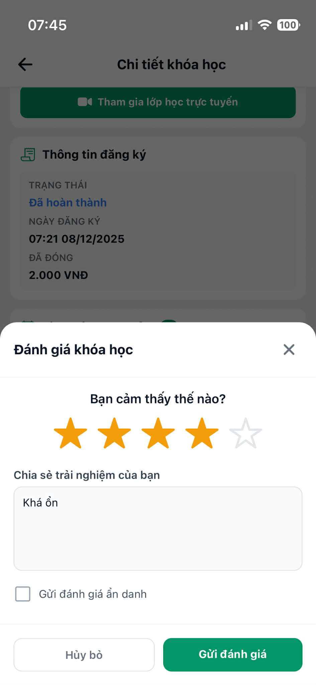

1. **Detail course affter writed feedback**

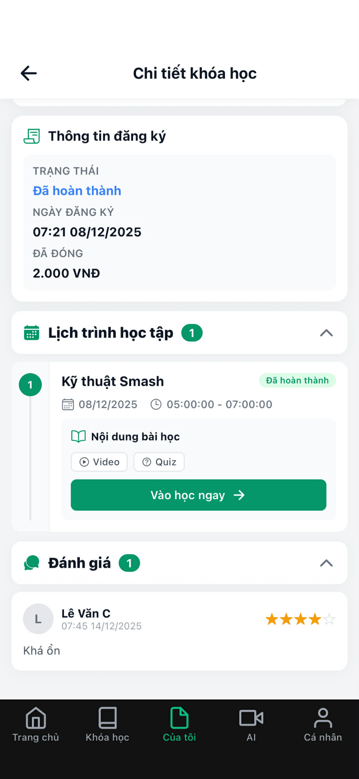

1. **Success notification**

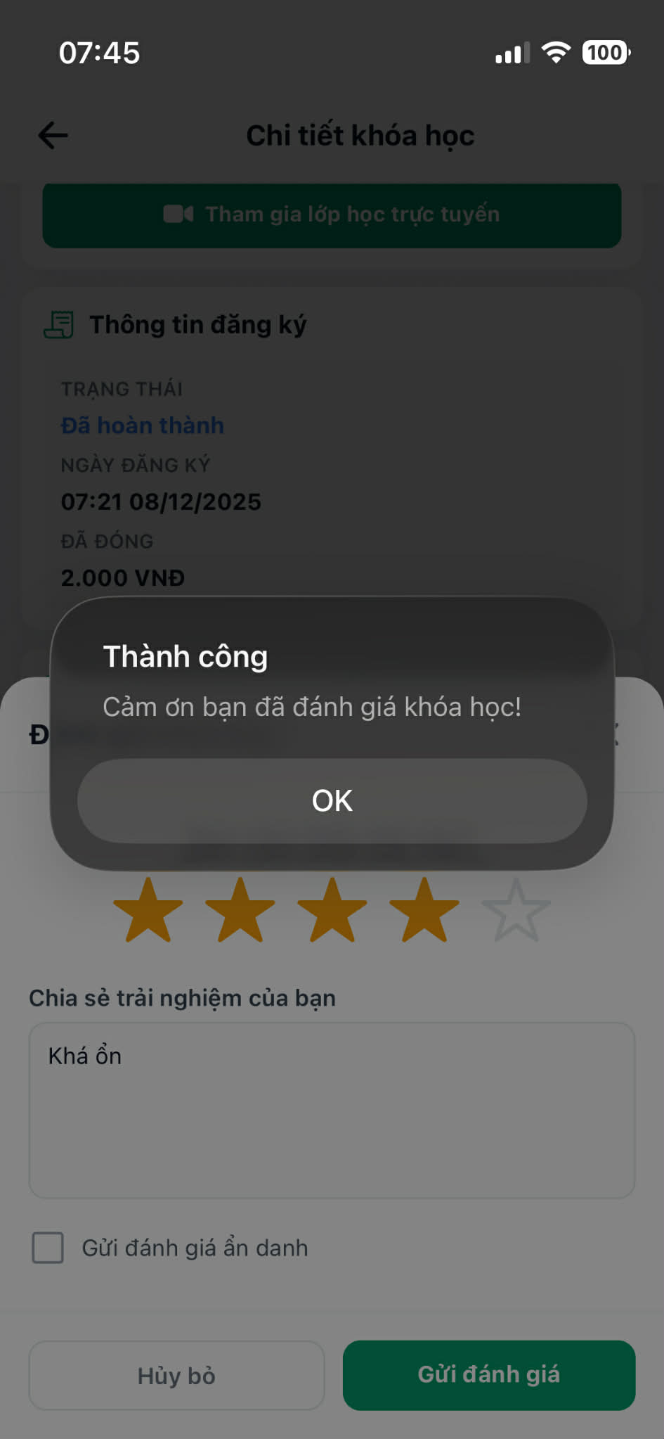

* **Function detail:**
  + The learner can submit feedback only for courses marked as completed.
  + Feedback includes a star rating, written description, and an optional anonymous flag.
  + When anonymous mode is selected, learner identity is hidden from public display.
  + After successful submission, the feedback is stored and linked to the corresponding course and coach.
* **Business Rules:**
  + Only users with the Learner role are allowed to submit feedback.
  + Feedback can only be submitted for completed courses.
  + Each learner can submit feedback only once per completed course.
  + Rating value must be within the defined range (e.g., 1–5 stars).
  + Feedback description must meet minimum content validation rules.
  + Anonymous feedback hides learner identity but is still stored internally for system management.
* **Normal Flow:**
  + Learner logs in successfully → navigates to My Courses → chooses a completed course → views Course Detail page → selects “Write Feedback” → feedback popup appears → learner selects star rating, enters feedback description, optionally selects anonymous mode → clicks “Submit Feedback” → system validates data → system saves feedback → success notification is displayed.
* **Abnormal Case:**

**Case 1 – User Not Logged In**

* Learner is not logged in → attempts to access My Courses → system redirects to Login page.

**Case 2 – Feedback Already Submitted**

* Learner selects a completed course that already has feedback submitted → “Write Feedback” option is not available → system prevents duplicate feedback.

**Case 3 – Invalid Input Data**

* Learner submits feedback without selecting a rating or enters invalid feedback content → system displays input validation error message.

**Case 4 – System Error**

* Learner submits feedback → system fails to store feedback data → general error message is displayed.

#### 3.9.2 View Feedback (Coach)

* **Function Trigger:** when Learner selects

**Course Detail → Coach Avatar / Coach Information Card**

* Triggered: when Learner views coach details from a course information page
* Manual action: (on-demand)
* ***Function Description***
  + **Actors/Roles**: Learner
  + **Purpose:** Allow learners to review coach profiles and feedback in order to evaluate coaching quality and make informed decisions before or after enrolling in a course.
  + **Interface:**
  + Course Detail Page
    - Displays coach avatar and coach information card
    - Coach avatar and information card are clickable
  + Coach Information Page
    - Displays coach profile information
    - Displays expertise and teaching method
    - Displays certifications and achievements
    - Displays feedback and ratings from learners
* **Data Processing:**
  + - Validate learner access permission
    - Retrieve coach profile information
    - Retrieve coach certifications and titles
    - Retrieve feedback and rating data related to the coach
    - Calculate average rating
    - Display feedback list sorted by date
* ***Screen Layout:***

1. ***list of courses***

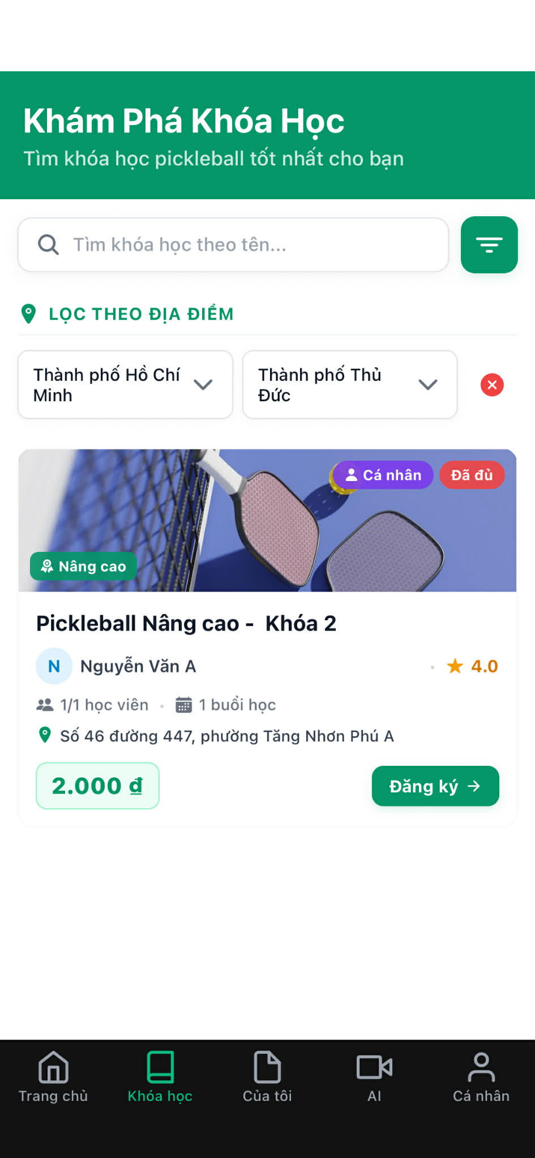

1. **Detail course**

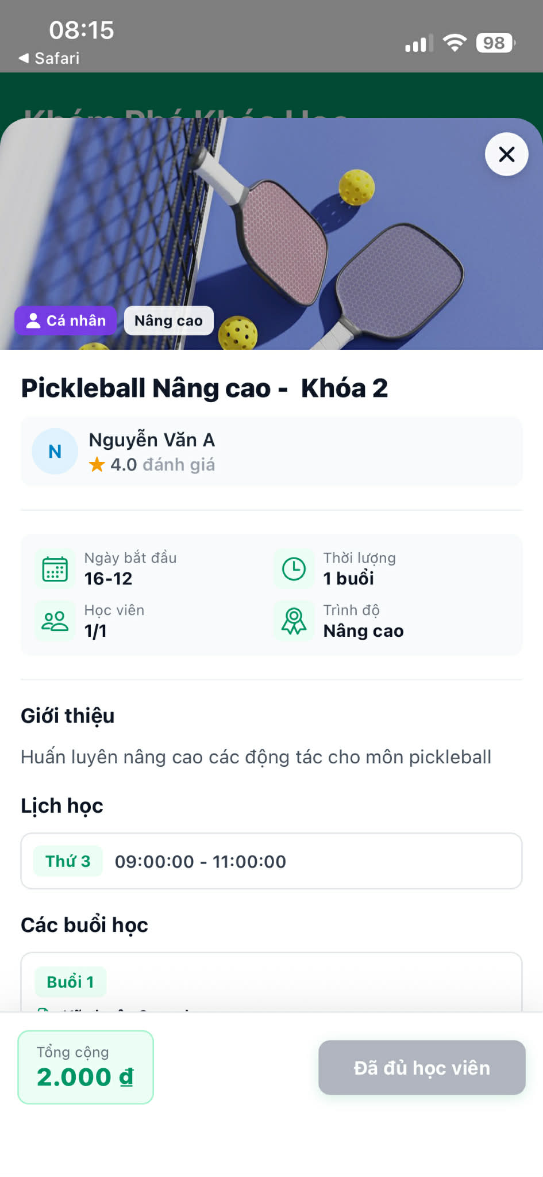

1. ***Detail coach***

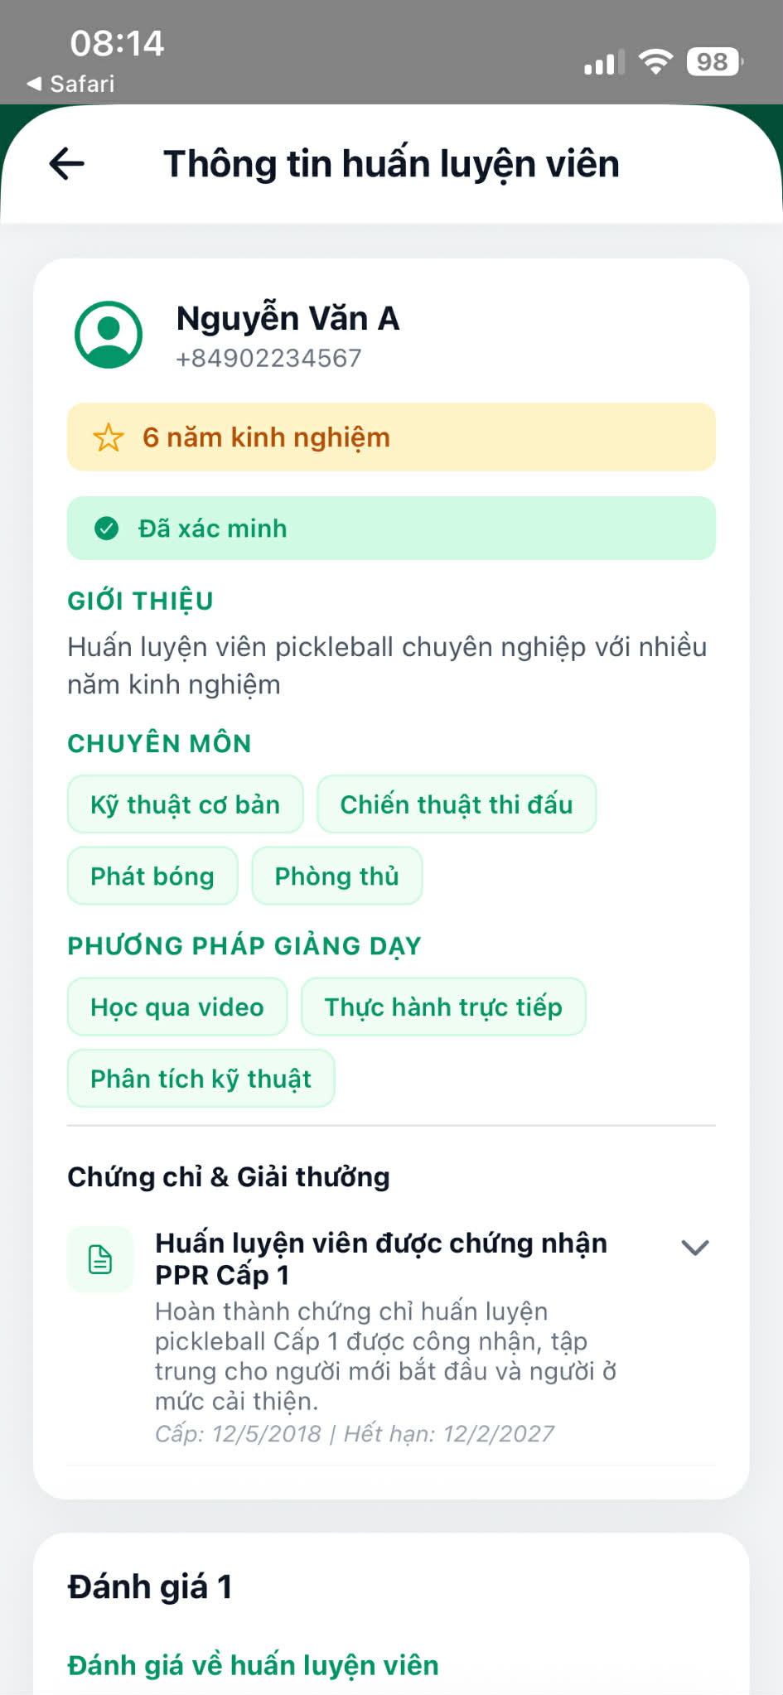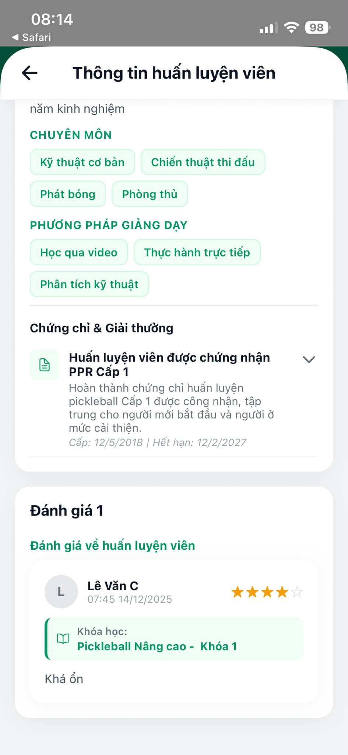

* **Function detail:**
  + Learner can access coach details from any course page.
  + Coach information is displayed in read-only mode.
  + Learner can scroll down to view feedback and ratings.
  + Each feedback entry includes rating, comment, course name, and timestamp.
* **Business Rules:**
  + Feedback content is read-only and cannot be modified by learners.
  + Ratings are displayed using a star-based rating system.
  + Coach profile and feedback must be publicly viewable.
* **Normal Flow:**
  + Learner logs in successfully → navigates to Course Detail page → selects coach avatar or coach information card → system displays Coach Information page → learner scrolls down → system displays feedback and ratings of the coach.
* **Abnormal Case:**

**Case 1 – User Not Logged In**

* User is not logged in → attempts to view coach information → system redirects to Login page

**Case 2 – No Feedback Available**

* Learner views coach information → coach has no feedback → system displays “No feedback available” message

**Case 3 – System Error**

* Learner accesses coach information page → system error occurs → general error message displayed

#### 3.9.3 Generate Achievement Progress

* **Function Trigger:**
* Triggered: Triggered when Admin selects

Dashboard → “Thành tựu” tab → “+ Tạo thành tựu mới” buttobutton

* Frequency: when Admin initiates the creation of a new achievement
* Manual action: (on-demand)
* ***Function Description***
  + **Actors/Roles**: Admin
  + **Purpose:** This function allows the Admin to create a new achievement by defining its name, description, target object, conditions, and status. The system saves the achievement and enables progress tracking for eligible users.
  + **Interface:**
  + Achievement Management Page
    - Displays a list of existing achievements
    - Includes search, filter, and status toggle options
    - Includes a “Create New Achievement” button
  + Create Achievement Popup
    - Input fields for achievement information
    - Condition and Status configuration section
    - “Create Achievement” button
* **Data Processing:**
  + - Validate admin authorization and role
    - Validate achievement input data
    - Validate achievement condition logic
    - Create new achievement record in the database
    - Initialize achievement status and metadata
    - Enable achievement progress tracking
* ***Screen Layout:***

1. Achievement list

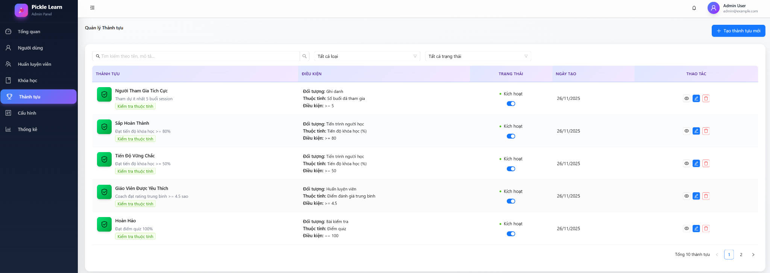

1. new Achievement information popup

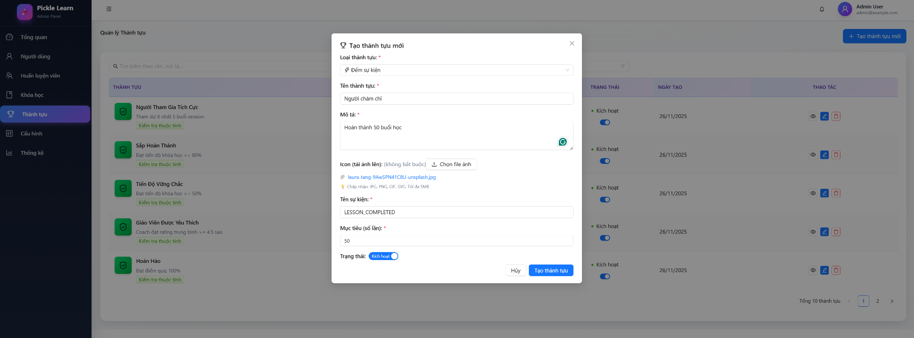

* **Function detail:**
  + Admin can access the achievement management page.
  + Admin can create a new achievement using a popup form.
  + Achievement conditions define how progress is generated.
  + Newly created achievements can be activated or deactivated.
  + Achievement progress is calculated automatically by the system**.**
* **Business Rules:**
  + Only Admin users are allowed to create achievements.
  + The achievement name must be unique.
  + Achievement conditions must be clearly defined and valid.
  + Achievement status can be Active or Inactive.
  + Only active achievements are used for progress tracking**.**
* **Normal Flow:**
  + Admin logs in successfully → navigates to Dashboard home page → selects Achievement Management page → clicks “Create New Achievement” → system displays Create Achievement popup → admin enters achievement information → clicks “Create Achievement” → system validates input → system creates new achievement.
* **Abnormal Case:**

**Case 1 – User Not Logged In**

* Admin is not logged in → attempts to access Achievement Management page → system redirects to Login page

**Case 2 – Unauthorized Role**

* Non-admin user attempts to access Achievement Management → access denied message displayed

**Case 3 – Missing Required Fields**

* Admin submits form with missing or invalid information → validation error message displayed

**Case 4 – Duplicate Achievement Name**

* Admin enters an existing achievement name → system displays duplicate name error message

**Case 5 – System Error**

* Admin submits create achievement request → system fails to save achievement → general error message displayed

#### 3.9.4 Award Achievements Automatically

* **Function Trigger:**
* Triggered: When user performs an action (e.g. joins session, completes lesson, submits quiz)
* Frequency: Triggered automatically by the system when predefined achievement conditions are met.
* Manual action: None (system-triggered)
* ***Function Description***
  + **Actors/Roles**: System (Backend)
  + **Affected users**: Learner
  + **Purpose:** To automatically calculate, track, and award achievements based on user activities and progress, ensuring fairness, consistency, and real-time recognition without requiring manual administration.
  + **Interface:**
  + No direct user interface.
  + This function is executed in the backend as a background or event-driven process.
* **Data Processing:**
  + - Detect user activity or progress update
    - Identify applicable active achievements
    - Evaluate achievement conditions
    - Award achievement to eligible user
    - Update achievement progress and status
    - Store awarded achievement record
    - Log achievement award action
* **Function detail:**
  + Achievements are evaluated automatically by the system.
  + Each user’s progress is tracked continuously.
  + Achievements are awarded immediately once conditions are met.
  + Duplicate achievement awards are prevented.
  + The system supports multiple achievement evaluation types:
  + Achievement Evaluation Types:

**Type 1 – Event Counting**

* Counts the number of times a specific event occurs
* Example: Attend at least 5 sessions

**Type 2 – Consecutive Streak**

* Tracks continuous actions over a period
* Example: Complete lessons 7 days in a row

**Type 3 – Attribute Validation**

* Checks whether a user attribute meets a condition
* Example: Course completion percentage ≥ 80%
* **Business Rules:**
  + Only active achievements are evaluated.
  + Each achievement can be awarded only once per user.
  + Achievement conditions must be evaluated accurately and consistently.
  + Achievement evaluation must not affect system performance.
  + Awarded achievements cannot be manually revoked**.**
* **Normal Flow:**
  + User performs an activity or progress is updated → system detects the event → system evaluates achievement conditions → system awards achievement → achievement status updated → achievement appears in user profile.
* **Abnormal Case:**

**Case 1 – Duplicate Achievement**

* System detects an already awarded achievement → skips awarding process

**Case 2 – System Processing Error**

* System encounters an error during evaluation → error logged → retry or fallback mechanism applied

#### 3.9.5 View Earned Achievements (Learner)

* **Function Trigger:**
* Triggered: Triggered when Learner selects

**Profile → Achievements**

* Frequency: when Learner accesses the Achievements section from the Profile menu
* Manual action: (on-demand)
* ***Function Description***
  + **Actors/Roles**: learner
  + **Purpose:** Allow Learners to track their achievement progress, view completed milestones, and stay motivated by monitoring ongoing and earned achievements.
  + **Interface:**
  + Profile Page
    - Includes a menu list with the Achievements option
  + Achievements Page
    - Summary section showing: Number of achievements earned, achievements in progress, Overall completion percentage.
    - Tab filters: All, Earned, In Progress
  + Achievement list with progress indicators
* **Data Processing:**
  + - Validate learner authentication
    - Retrieve learner achievement data
    - Calculate achievement progress percentage
    - Retrieve earned and in-progress achievements
    - Display achievement status and progress
* ***Screen Layout:***

1. **Tab filters: All**

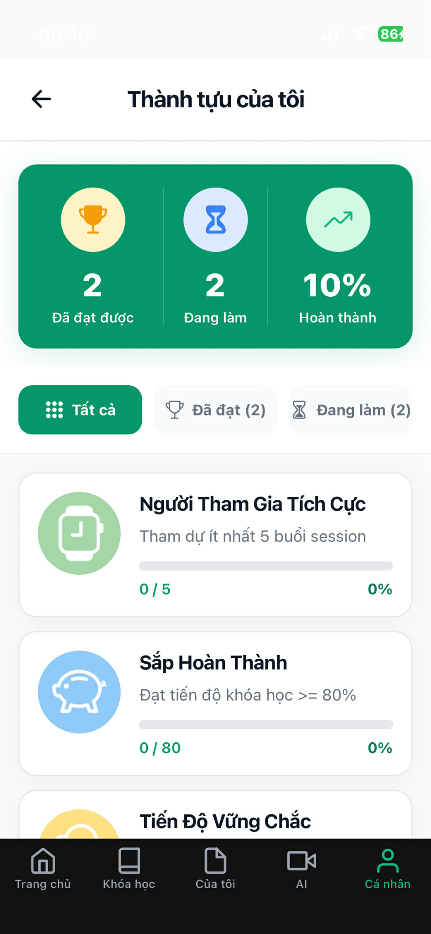

1. **Tab filters:** Earned
2. **Tab filters:**  In Progress

* **Function detail:**
  + Learners can access the achievements page from the Profile tab.
  + Learners can view all achievements assigned to their account.
  + Achievements are categorized as Earned or In Progress.
  + Progress indicators show completion status for each achievement.
  + Achievement data is updated automatically by the system.
* **Business Rules:**
  + Only Learner accounts can access this function.
  + Each achievement can only be earned once.
  + Achievement progress is calculated automatically by the system.
  + Learners cannot modify achievement data.
* **Normal Flow:**
  + Learner logs in successfully → navigates to Profile tab → selects Achievements → system displays achievement summary → system displays list of earned and in-progress achievements
* **Abnormal Case:**

**Case 1 – User Not Logged In**

* **Learner is not logged in → attempts to access Achievements page → system redirects to Login page**

**Case 2 – Unauthorized Role**

* **Non-learner user attempts to access Achievements → access denied message displayed**

**Case 3 – System Error**

* **System fails to retrieve achievement data → general error message displayed**

### 3.10 Notification & Error Handling

#### 3.10.1 Send System Notification

Function Trigger

* **Auto-trigger**: Various system events (enrollment, payment, session reminders, achievements, etc.)
* **Manual trigger**: Admin sends broadcast notifications
* **Actor**: System (automated), Admin (manual)
* **Frequency**: Event-driven, real-time

Function Description

**Purpose**: Automatically send timely notifications to users across multiple channels (push, in-app) to inform them of important events, reminders, and updates.

**Interface**:

* Push notifications on mobile/web
* In-app notification center

**Data Processing**:

* Event detection and routing
* User preference checking
* Delivery confirmation tracking
* Click-through tracking

**Screen Layout**

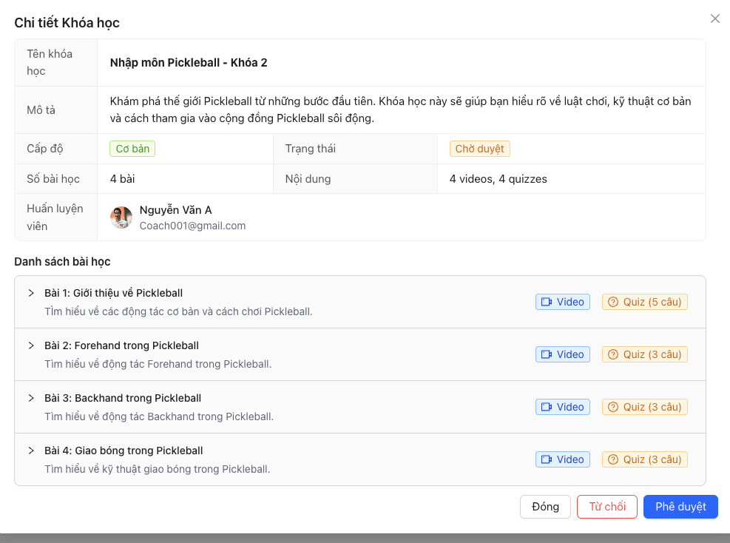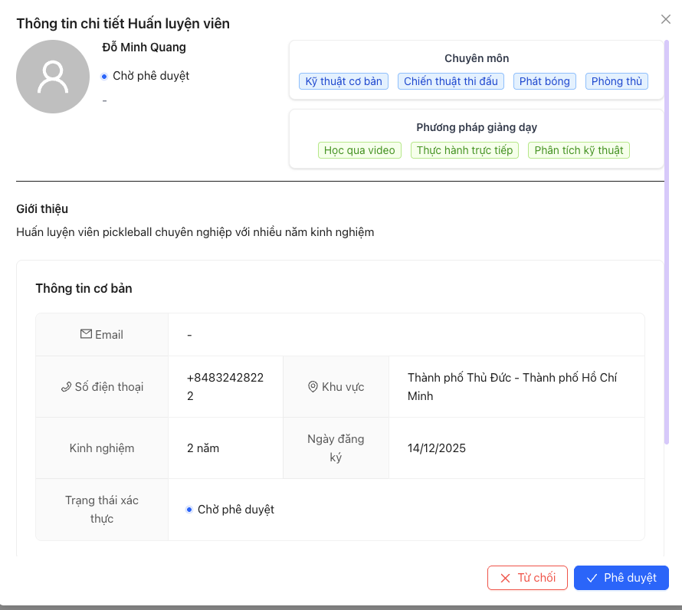

Function Details

Business Rules

* Verification reminder to Coach
* Send notification course approve/reject to Coach

Normal Flow

* Open course or coach tabs -> approve or reject ones -> notification sends to Coach

Abnormal Cases

* Device Offline
* Internet connection error

#### 3.10.2 Read / Mark Notification

Function Trigger

* **Navigation**:
  + Tap notification bell icon → Notification list
  + Tap individual notification → Mark as read + Navigate
  + Swipe actions for bulk operations
* **Actor**: Admin
* **Frequency**: On-demand, when checking notifications

Function Description

**Purpose**: Allow users to view, read, and manage their notifications, automatically marking them as read when opened and navigating to relevant content.

**Interface**:

* Notification list with unread indicators
* Tap to read and navigate
* Mark as read/unread actions
* Clear all option

**Data Processing**:

* Update read status in Postgresql
* Decrement badge count
* Sync across devices
* Track engagement metrics
* Deep link navigation

**Screen Layout**

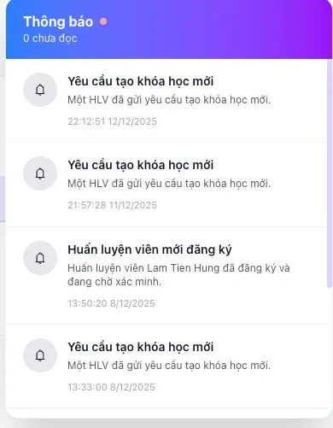

**Function Details**

**Business Rules**

* When user taps notification
* When detail modal opens
* When navigates to target content

**Normal Flow**

* Admin opens web -> click to notification icon -> click to mark (it will navigate to that page and show up a popup to approve or reject)

**Abnormal Cases**

* Network Offline When Marking Read

#### 3.10.3 Display Alerts to Users

Function Trigger

* **Auto-trigger**: Critical system events, confirmations needed
* **Manual trigger**: Admin broadcasts important announcements
* **Actor**: System (automated), Admin (manual)
* **Frequency**: Event-driven, as needed

Function Description

**Purpose**: Display immediate, attention-requiring alerts to users for critical information, confirmations, warnings, errors, and important announcements that need acknowledgment or action.

**Interface**:

* Modal dialogs (blocking)
* Toast messages (non-blocking)
* Banner alerts (persistent)
* Action sheets (choices)

**Data Processing**:

* Priority-based display
* User acknowledgment tracking
* Auto-dismiss timers
* Action logging

**Screen Layout**

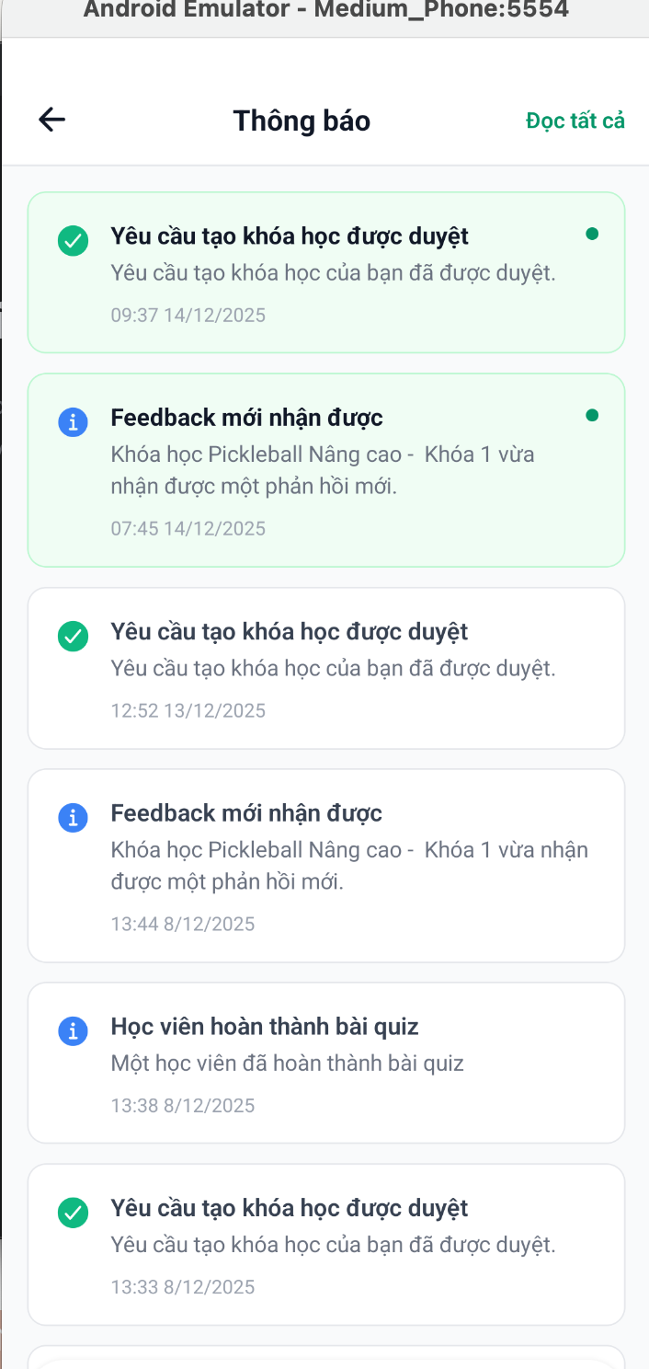

**Function Details**

**Business Rules**

* User must interact to dismiss
* Appear at top or bottom

Normal Flow

* Once admin handle course or coach -> learner or coach receive notification

### 3.11 Location & Court Management

#### 3.11.1 View Available Courts

* **Function Trigger:** Manual action by Coach or Admin
* ***Function Description***
* **Actors/Roles**: Coach, Admin
* **Purpose:** Allows Coach/Admin to view courts available for booking based on date, time, and location.
* **Interface:** Court list / calendar view
* **Data Processing:**
  + - *Input: date, time range, location*
    - *Processing: filter courts by availability and status*
    - *Output: list of available courts with details*
* ***Screen Layout:***

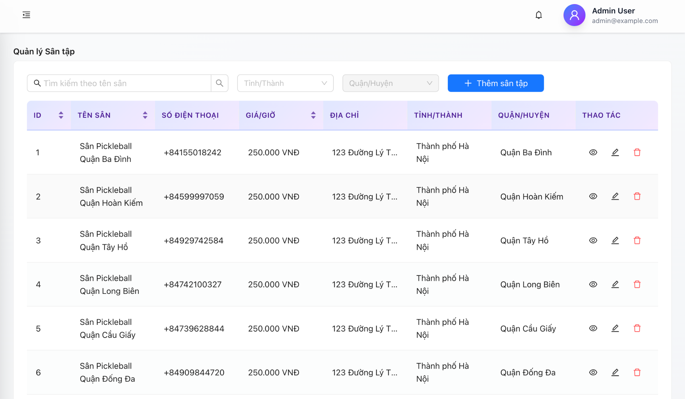

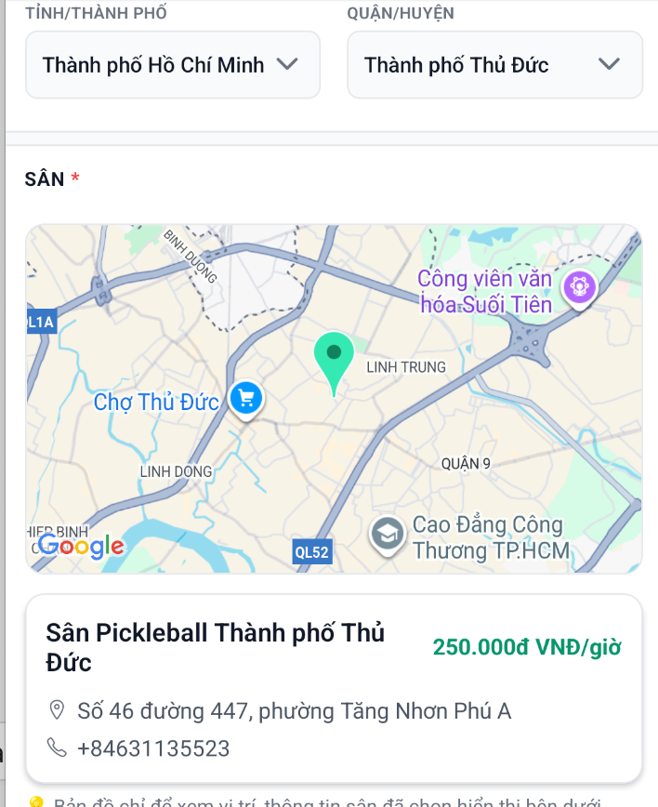

1. **Function detail:**

* **Business Rules:**
  + Only active courts are shown
  + Courts already booked are marked unavailable
* **Normal Flow:**
  + User opens “View Courts”
  + System displays available courts
* **Abnormal Case:**
  + No courts available → show empty state message

#### 3.11.2 Search Courses by Location

* **Function Trigger:**
* Triggered: when user selects the Location filter in the Courses tab

**Course → “LỌC THEO ĐỊA ĐIỂM” filter**

* Frequency : Triggered when user enters a location in the course search filter
* Manual action: (on-demand)
* ***Function Description***
* **Actors/Roles**: Learner
* **Purpose:** To help users easily find courses that are geographically convenient by filtering courses based on nearby training
* **Interface:**
  + Courses Page
    - Search bar
    - Location filter input (text input)
    - Course list displaying filtered results
* **Data Processing:**
  + - Validate user input location
    - Retrieve courses with registered training locations
    - Display matching course results
* ***Screen Layout:***

1. **List of courses not filtered by location**

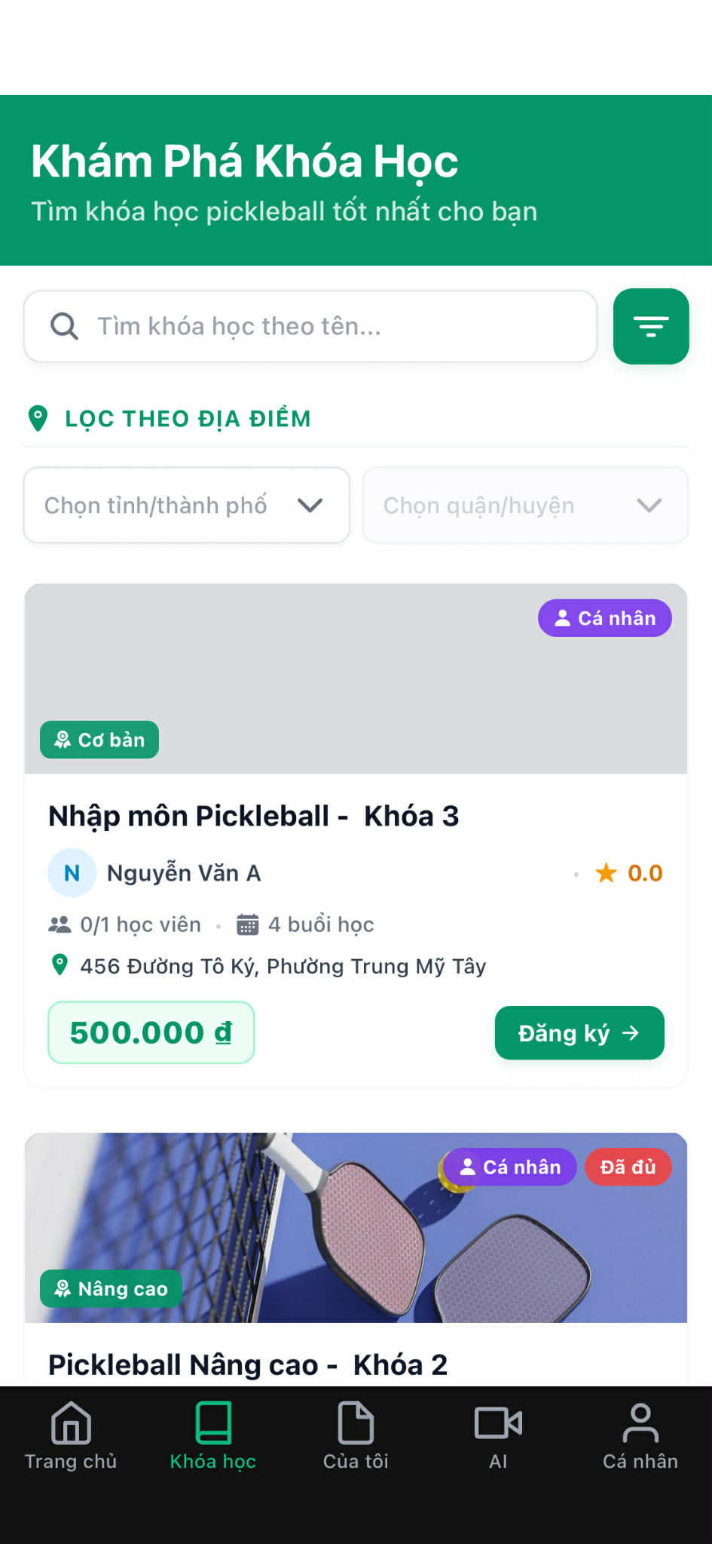

1. **Filter interface**

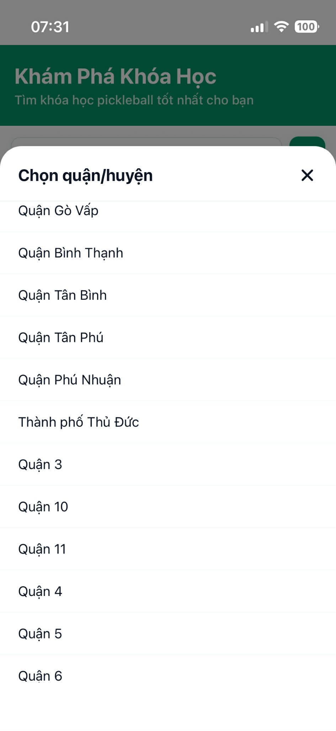

1. **List of courses filtered by location**

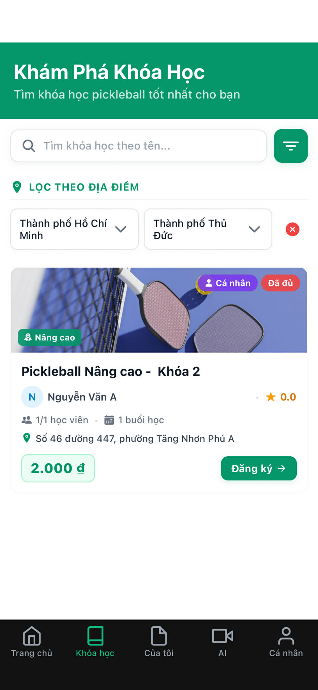

* **Function detail:**
  + Users can access the course search feature from the Courses tab.
  + Users can enter or select a desired location.
  + The system filters courses based on nearby training venues.
  + Filtered results are updated and displayed in the course list.
* **Business Rules:**
  + Only courses with registered training locations can be filtered by location.
  + Location-based search uses predefined distance criteria.
  + Courses outside the selected location range are not displayed.
* **Normal Flow:**
  + **User logs in successfully → navigates to Courses tab → enters a desired location in the location filter → system filters courses → system displays nearby courses.**
* **Abnormal Case:**

**Case 1 – User Not Logged In**

* User is not logged in → attempts to access Courses tab → system redirects to Login page

**Case 2 – Invalid Location Input**

* User enters an invalid or unsupported location → system displays validation error message

**Case 3 – No Matching Courses**

* **User enters a valid location** → no courses found nearby → system displays “No courses found” message

**Case 4 – System Error**

* System fails to process location filtering → general error message displayed

### 3.12 Payment, Wallet & Withdrawal

#### 3.12.1 Pay for Course Enrollment

**Function Trigger:**

**Triggered:** Manual action

**Function Description:** Allow Learners to pay for course enrollment via VietQR bank transfer.

**Actors/Roles:** Learner

**Purpose:** Complete course enrollment by collecting payment securely.

**Interface:** Course detail screen → Payment screen (Payos)

**Data Processing**:

* Information: Course price, payment order, VietQR transaction data
* Input:Payment confirmation via bank transfer (QR scan or manual transfer)
* Output: Payment status (Pending / Paid / Failed)

**Screen Layout:**

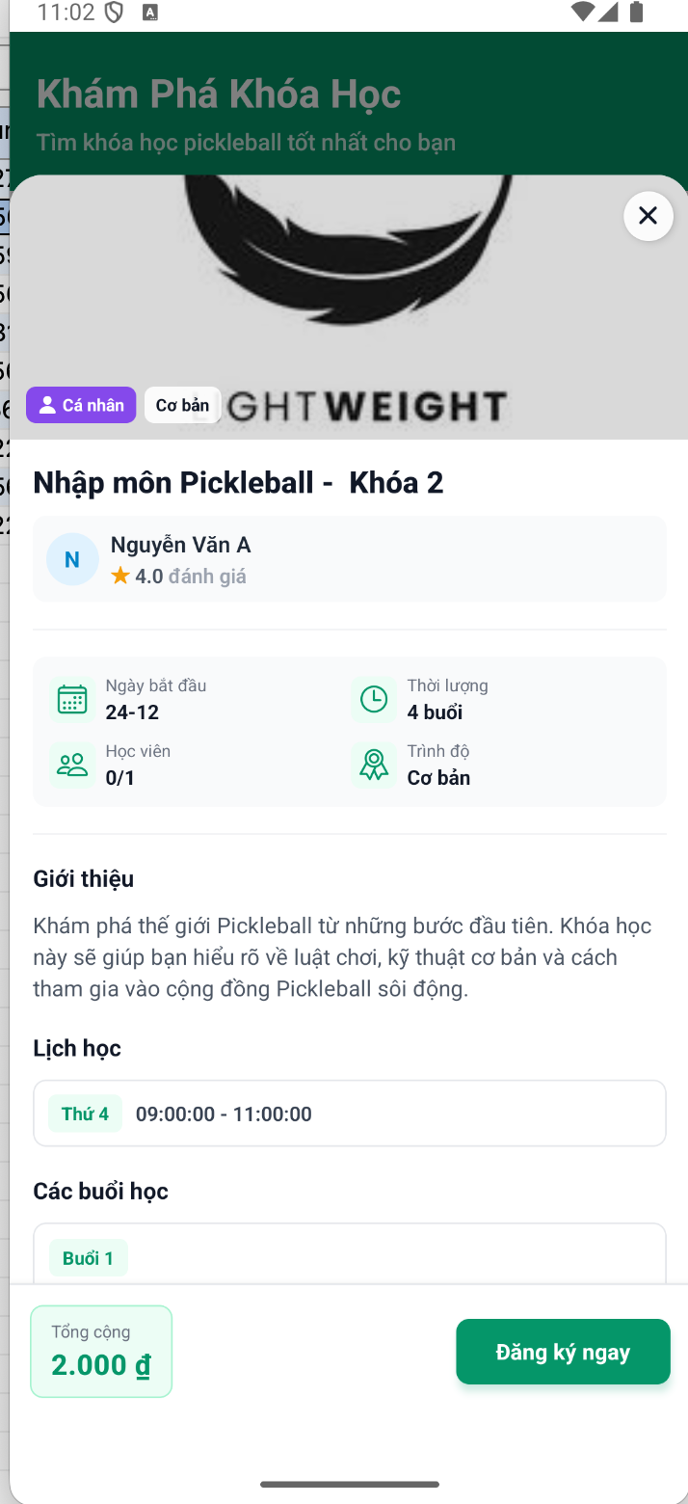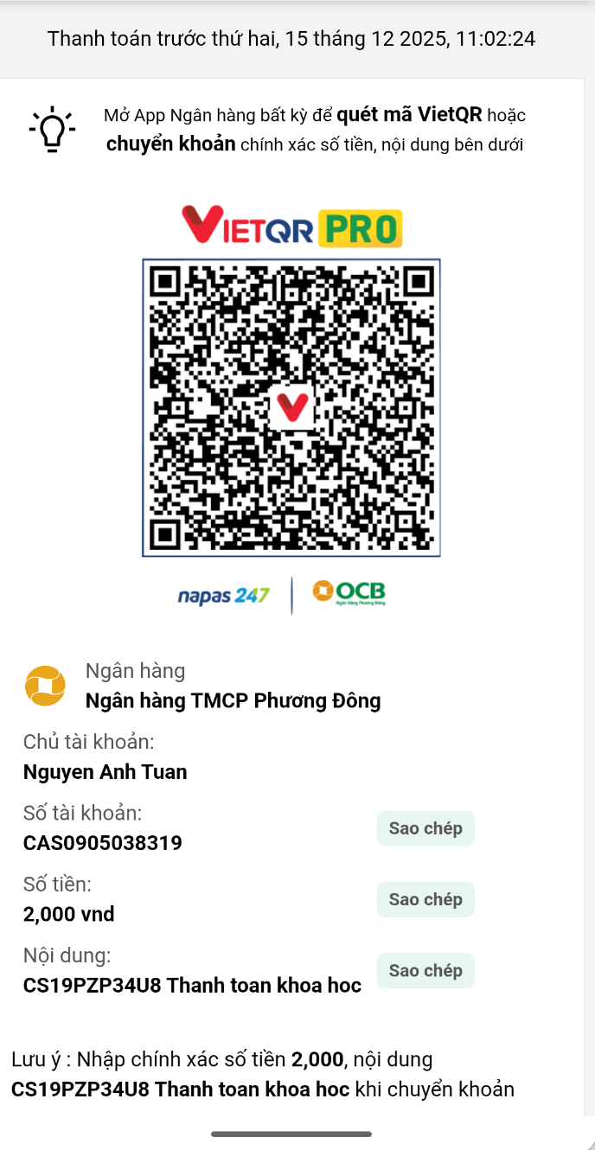

**Function Detail**:

**Business Rules:**

- Payment must be completed before enrollment is activated

- Transfer amount and content must match the order

- Payment has a limited valid time window

- Enrollment is confirmed only after payment verification

**Normal Flow:**

1. Learner clicks “Enroll Now”

2. System shows payment details and VietQR

3. Learner completes bank transfer

4. System verifies payment

5. Enrollment is activated

**Abnormal Case**:

- Payment timeout → order expires

- Incorrect amount or content → payment pending/manual review

- Payment failed → enrollment not created

#### 3.12.2 View Payment History

**Function Trigger**: Triggered by user action

**Triggered**: Manual action

**Function Description**: Allow user to view wallet balance and transaction history.

**Actors/Roles:** Learner, Coach

**Purpose:** Help user track payment, income, and withdrawal transactions.

**Interface:** Wallet screen

**Data Processing:**

* Information:Wallet balance, transaction records
* Input: None (view-only)
* Output: Transaction list with status

**Screen Layout:**

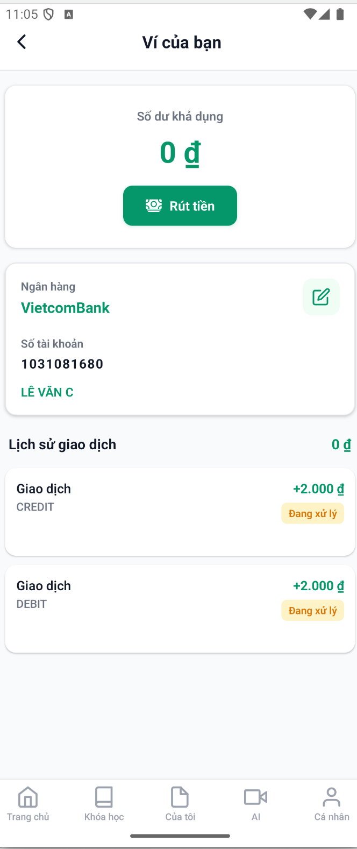

**Function Detail:**

System retrieves wallet balance and transaction history sorted by latest first.

**Business Rules:**

- Balance reflects only completed transactions

- Pending transactions do not affect available balance

- Transaction data is read-only

**Normal Flow:**

1. User opens Wallet

2. System displays balance and payment history

**Abnormal Case:**

- No transactions → show empty state

- Data load error → show error message

#### 3.12.3 Wallet Transactions

* **Function Trigger:**
* Triggered: when Coach or Learner accesses the Wallet Transactions page
* Manual action: (on-demand)
* ***Function Description***
* **Actors/Roles**: Coach, Learner
* **Purpose:** To allow Coach and Learner users to track wallet balance changes and transaction history, and to support Admin monitoring and auditing of wallet activities.
* **Interface:**
  + Wallet Transactions Page:
    - Displays current wallet balance.
    - Transaction List.
  + Transaction List:
    - Shows transaction type, amount, date, and status.
* **Data Processing:**
  + - Validate user authorization and role.
    - Retrieve wallet information from the database.
    - Retrieve wallet transaction records.
    - Calculate current wallet balance based on completed transactions
* ***Screen Layout:***
* **Function detail:**
  + Coach and Learner can view their own wallet transaction history.
  + Wallet balance is updated and displayed based on transaction records.
  + Transactions are displayed in chronological order (latest first).
* **Business Rules:**
  + Only Coach and Learner accounts have wallets.
  + Users can only view transactions related to their own wallet.
  + Admin is not allowed to modify wallet data.
  + Pending and failed transactions must be clearly indicated.
* **Normal Flow - Coach:**
  + Coach logs in successfully → navigates to home page → selects Menu page→ selects Wallet and Transactions → system retrieves wallet data → system displays wallet balance and transaction hispage.
* **Normal Flow - Learner:**
  + Learner logs in successfully → navigates to home page → selects Profile page→ selects Wallet and Transactions → system retrieves wallet data → system displays wallet balance and transaction hispage.
* **Abnormal Case:**

**Case 1 – User Not Logged In:**

* + User is not logged in → tries to access Wallet page → system redirects to Login page.

**Case 2 – Unauthorized Role**

* User without wallet role logs in → attempts to access Wallet Transactions → access denied message display.

**Case 3 – System Error**

* User accesses Wallet Transactions → system fails to retrieve wallet data → general error message display.

#### 3.12.4 Withdrawal Request

* **Function Trigger:**
* Triggered: when Coach selects

**Home Page→ Menu→ *Wallet* → Withdrawal Request**

* Manual action: (on-demand)
* ***Function Description***
* **Actors/Roles**: Coach, Leaner
* **Purpose:** To allow Coaches, Learners to withdraw their available wallet balance to a registered bank account in a secure and controlled manner.
* **Interface:**
  + Coach Wallet Page
    - Displays current wallet balance
    - Displays bank account information form
    - Includes a “Withdraw” button
  + Withdrawal Form
    - Bank account information fields
    - Withdrawal amount input field
    - “Confirm Withdrawal” button
* **Data Processing:**
  + - Validate coach authorization and role
    - Validate and update bank account information
    - Validate withdrawal amount
    - Check wallet balance availability
    - Create withdrawal request record
    - Deduct withdrawal amount from available balance
    - Update wallet transaction history
* ***Screen Layout:***
* **Function detail:**
  + Coach can update bank account information before making a withdrawal request.
  + Coach can request a withdrawal by entering the desired amount.
  + The system validates the withdrawal request before processing.
  + A success message is displayed after the withdrawal request is submitted.
* **Business Rules:**
  + Only Coach accounts are allowed to request withdrawals.
  + Withdrawal amount must be greater than zero.
  + Withdrawal amount must not exceed the available wallet balance.
  + Bank account information must be provided before submitting a withdrawal request.
  + Withdrawal requests are processed in Pending status before completion.
* **Normal Flow:**
  + Coach/Learner logs in successfully → navigates to home page → navigates to Menu/Profile page → select wallet and transction → updates bank account information → enters withdrawal amount → clicks “Confirm Withdrawal” → system validates request → system submits withdrawal request → system displays withdrawal success message.
* **Abnormal Case:**

**Case 1 – User Not Logged In**

* Coach is not logged in → attempts to access Wallet page → system redirects to Login page

**Case 2 – Missing Bank Information**

* Coach attempts to withdraw without bank account information → system displays error message

**Case 3 – Insufficient Balance**

* Coach enters withdrawal amount greater than available balance → system displays error message

**Case 4 – Invalid Withdrawal Amount**

* Coach enters invalid amount (zero or negative) → system displays validation error message

**Case 5 – System Error**

* Coach submits withdrawal request → system fails to process request → general error message displayed

#### 3.12.5 View Session Earnings

**Function Trigger**:

**Triggered**:

Manual action

**Function Description**:

* Allow Coach to view earnings generated from completed teaching sessions.
* Actors/Roles: Coach, Admin

**Purpose:** Help coach track income history and session-based earnings.

**Interface:** Earnings / Transaction History screen

**Data Processing:**

* Information:
* Session earnings records (amount, session type, timestamp)

**Screen Layout**:

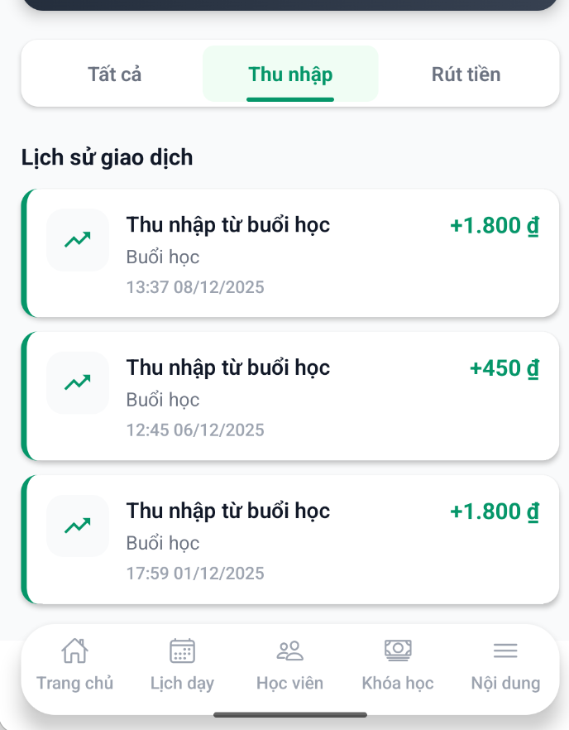

**Function Detail:**

* System fetches and displays session earning records sorted by latest first.

**Business Rules:**

- Only completed sessions generate earnings

- Amount is read-only

- Income displayed as positive value

- Time shown in local timezone

**Normal Flow:**

1. Coach opens Earnings screen

2. Selects "Income" tab

3. System displays session earnings list

**Abnormal Case:**

- No earnings available → show empty state

- Data load failure → show error message

## 4. Non-Functional Requirements

### 4.1 External Interfaces

This section ensures that the PICKLE-LEARN system communicates properly with users and with external hardware/software components.  
External systems include:

* AI Analysis Service (Gemini) for video comparison, movement classification, suggest learning materials and learning progress improvements.
* Cloud Storage (BunnyCDN) for media files.
* Payment Gateway (PayOS) for secure transactions.
* Mobile & Web clients (React Native & NextJS).
* Authentication Services (JWT/OAuth2).

The system must support secure, reliable, and standards-based communication with all external interfaces.

### 4.2 Quality Attributes

#### 4.2.1 Usability

##### 4.2.1.1 Training Time

* Normal users (learners): proficient within 4 hours.
* Coaches (power users): proficient within 2 hours.

##### 4.2.1.2 Task Times

* Logging in & accessing dashboard: ≤ 30 seconds
* Booking an coaching course: ≤ 2 minutes
* Uploading a video for AI analysis: ≤ 2 minutes
* Triggering new AI-assisted learning materials creation: <=2 minutes
* Triggering new AI-assisted learning progress improvement: <= 2 minutes

##### 4.2.1.3 Conformance to Standards

* Follows Material Design, React Native UI best practices, and WCAG accessibility guidelines.
* Interfaces must be simple, consistent, and intuitive across iOS, Android, and Web.

#### 4.2.2 Reliability

* Availability: The system should have an availability of 99.9%, ensuring it is accessible to users for at least 99.9% of the time during its operational hours.
* Mean Time Between Failures (MTBF): The system's MTBF should be at least 10,000 hours, indicating the average time between two consecutive system failures.
* Mean Time To Repair (MTTR): The system should be repaired and restored to full functionality within 4 hours of failure occurrence.
* Accuracy: The system's output should maintain a precision of all video duration shown at second.
* Maximum Bugs or Defect Rate: The maximum acceptable bugs or defects rate should not exceed 0.1 bugs per thousand lines of code (0.1 bugs/KLOC). Bugs should be categorized as minor, significant, or critical, with critical bugs defined as those resulting in a complete loss of data or functionality.

#### 4.2.3 Performance

##### 4.2.3.1 Response Time:

* Average response time for a transaction: The system should respond to user requests within 3 seconds on average.
* Maximum response time for a transaction: No transaction should take longer than 10 seconds to complete.
* Average response time for AI related transactions: The system should respond to user AI related requests within 15 seconds on average
* Maximum response time for AI related transactions: No AI related transaction should take longer than 30 seconds to complete.

##### 4.2.3.2 Throughput:

* The system should support a throughput of at least 100 valuation requests per hour during peak usage periods.

##### 4.2.3.3 Capacity:

* The system should be able to accommodate a minimum of 100 simultaneous users or valuation requests without experiencing performance degradation.

##### 4.2.3.4 Degradation Modes:

* In the event of system degradation, such as hardware failure or network issues, the system should automatically switch to a degraded mode where basic functionalities remain accessible, such as submitting valuation requests and accessing existing reports.

##### 4.2.3.5 Resource Utilization:

The system should effectively utilize hardware resources such as memory, disk space, and network bandwidth, ensuring efficient performance without exceeding specified resource limits.

#### 4.2.4 Supportability

##### 4.2.4.1 Coding Standards:

* The system should adhere to industry-standard coding practices and guidelines, such as consistent code formatting, meaningful variable names, and proper documentation for all code modules.

##### 4.2.4.2 Naming Conventions:

* Standardized naming conventions should be followed for all system components, ensuring clarity and consistency throughout the codebase.

##### 4.2.4.3 Class Libraries:

* Utilize established class libraries and frameworks where applicable to promote code reusability and streamline development efforts.

##### 4.2.4.4 Maintenance Access:

* System administrators should have secure and reliable access to perform routine maintenance tasks, including software updates, database backups, and system configurations.
* Provide user-friendly maintenance utilities and tools to facilitate system troubleshooting, monitoring, and performance optimization.

#### 4.2.5 Design Constraints

##### 4.2.5.1 Software Languages

* Backend: NestJS - TypeScript
* Mobile App: React Native - TypeScript
* Web Admin Portal: NextJS - TypeScript

##### 4.2.5.2 Architectural Constraint

###### 4.2.5.1 System Architecture Design

* Presentation layer (Mobile/Web)
* Router layer (API)
* Service layer (Business Login)
* Data access layer ( PostgreSQL)

#### 4.2.6 On-line User Documentation and Help System Requirements

Built-in help center accessible inside all apps (Learner, Coach, Admin).

Must include:

* Tutorials
* Context-sensitive help based on current screen or action.
* Documentation must be updated with system changes or new features.

#### 4.2.7 Purchased Components

* Payment Gateway (PayOS)
* Cloud Storage (Bunny CDN)
* AI Analysis Platform: Google Studio AI

#### 4.2.8 Interfaces

##### 4.2.8.1 User Interfaces

* Mobile App on iOS & Android (React Native)
* Web Admin Portal (Next.js)
* Supports video upload, progress dashboards, scheduling

##### 4.2.8.2 Hardware Interfaces

* Standard server hardware (cloud-hosted)

##### 4.2.8.3 Software Interfaces

* AI Analysis Platform (Google Studio AI): Used for pose estimation, compare video techniques, suggest learning materials and learning progress improvements
* Cloud Storage (Bunny CDN): Storing user videos, coach materials, thumbnails
* Payment Gateway (PayOS): Secure transaction processing for bookings
* Databases: PostgreSQL – structured data such as courses, transactions
* The PICKLE-LEARN system will communicate with external platforms and devices using standard network protocols such as **HTTP/HTTPS** for all API requests between the mobile apps, web admin portal, backend services, and AI analysis modules.
* The system will integrate with **email notification services** to deliver account verification messages, booking confirmations, session reminders, and system alerts to learners, coaches, and administrators.
* The platform will also support **real-time communication technologies**, including **WebSocket services**, to provide instant updates such as new booking requests, schedule changes, coach availability updates, AI analysis completion alerts.

#### 4.2.9 Licensing Requirements

* The software will be licensed under a proprietary license agreement, granting users the right to use the software in accordance with the terms and conditions specified in the license agreement.
* Licensing enforcement mechanisms will be implemented to ensure compliance with the terms of the license agreement and prevent unauthorized use or distribution of the software.
* Users will be required to purchase valid licenses for accessing and using the software, with licensing options tailored to different user categories (e.g., individual users, enterprise users).
* Usage restrictions may include limitations on the number of concurrent users, the scope of permitted use (e.g., personal or commercial use), and restrictions on modification or redistribution of the software.
* Compliance with licensing requirements will be monitored and enforced through license key validation mechanisms and periodic audits of user license agreements

#### 4.2.10 Legal, Copyright, and Other Notices

* All system components are copyrighted.
* Trademarks belong to their respective owners.
* Disclaimer: system is provided “as-is”.
* Limitations of liability apply for data loss or service interruption.
* Patent notice: AI components may use patented algorithms.
* Users must comply with legal and data privacy regulations (GDPR, local laws)

#### 4.2.11 Applicable Standards

* Regulatory Standards: The software must comply with all relevant legal and regulatory standards governing the cosmetic and pharmaceutical retail industry, including regulations related to consumer protection, data privacy (e.g., GDPR), and healthcare product information management.
* Quality Standards: The software development process should adhere to industry-standard quality management practices, such as those outlined in ISO 9001:2015, to ensure consistent delivery of high-quality software products and services.
* Industry Standards: The software should conform to best practices in cosmetic retail and dermatological consultation, following guidelines from reputable organizations (e.g., FDA for cosmetic labeling in applicable regions, COSMOS for organic cosmetic standards).
* Interoperability Standards: Where applicable, the software should support interoperability with other systems (e.g., supplier platforms, payment gateways) by adhering to standard web protocols and APIs (e.g., W3C guidelines, RESTful API conventions).
* Internationalization Standards: The software should support internationalization requirements, including multilingual support and localization features, to accommodate users from diverse geographical regions.
* Operating System Compliance: The software should be compatible with commonly used operating systems, including Windows, macOS, and Linux, following operating system compliance guidelines and best practices.

## 5. Requirement Appendix

### 5.1 Business Rules

| **ID** | **Rule Definition** |
| --- | --- |
| BR-01 | Before coach can create course, his/here profile must be verified by admin |
| BR-02 | The system has a platform-fee configuration (default: 10%) for each learner pays for course enrollment |
| BR-03 | All user accounts must have at least one contact method (email or phone number) |
|  | System support email sent and OTP via phone number for verification |
| BR-04 | All user accounts must be authenticated using secure login methods and 256-bit encryption for sensitive data. |
| BR-05 | When creating new course, coach must specific the start date after at least 7 days from the current date |
| BR-06 | Only course approved by admin can has enrollments from learners |
| BR-07 | Course with “Group” learning format has maximum 12 learners |
| BR-08 | Course will be automatically marked as “On Going” before 1 day compares to the course start date |
| BR-09 | Learner can only cancel course before 1 day compares to the course start date |
| BR-10 | Coach must check learner attendances and marks session as “Completed” before 24 hours from the session end time to receive session earning |
| BR-11 | Coach can only change the session schedule before 48 hours |
| BR-12 | After an attended session, learner can access learning materials (video and quiz) |
| BR-13 | Configuration parameters (like platform fee,...) should be changeable by authorized admins without code changes. |
| BR-14 | Deleted records are soft‑deleted (flagged as inactive) instead of being physically removed, to preserve history. |

### 5.2 Common Requirements

### 5.2.1 Security Requirements

**CR-01** – All user authentication processes must use secure password hashing and token-based sessions.

**CR-02** – Sensitive data such as passwords, payment information, and identity documents must be encrypted using at least 256-bit encryption.

**CR-03** – The system must enforce role-based access control (RBAC) for Coach, Learner, and Admin accounts.

### 5.2. Performance Requirements

**CR-04** – Page load time should not exceed 3 seconds under normal network conditions.

**CR-06** – AI features requests must be processed within an acceptable time window (≤ 30 seconds on average).

### 5.3 Application Messages List

### 

| **#** | **Message code** | **Message Type** | **Context** | **Content** |
| --- | --- | --- | --- | --- |
| 1 | MSG.001 | Toast Error | Đăng nhập với thông tin không chính xác | *Không tìm thấy tài khoản* |
| 2 | MSG.002 | Toast Error | Mật khẩu không khớp khi đăng nhập | *Mật khẩu không chính xác* |
| 3 | MSG.003 | Toast Error | Truy cập không được phép | Không có quyền truy cập |
| 4 | MSG.004 | Toast Error | Số điện thoại đã được xác minh | *Số điện thoại đã được xác minh* |
| 5 | MSG.005 | Toast Error | Mã xác minh không hợp lệ | *Mã xác minh không hợp lệ* |
| 6 | MSG.006 | Toast Success | Xác minh số điện thoại thành công | *Xác minh số điện thoại thành công* |
| 7 | MSG.007 | Toast Success | Xác minh email thành công | *Xác minh email thành công* |
| 8 | MSG.008 | Toast Success | Đăng ký thành công | *Đăng ký thành công* |
| 9 | MSG.009 | Toast Error | Người dùng đã tồn tại | *Người dùng đã tồn tại* |
| 10 | MSG.010 | Toast Error | Không tìm thấy người dùng | *Không tìm thấy người dùng* |
| 11 | MSG.011 | Toast Error | Email đã tồn tại | *Email đã tồn tại* |
| 12 | MSG.012 | Toast Error | Số điện thoại đã tồn tại | *Số điện thoại đã tồn tại* |
| 13 | MSG.013 | Toast Error | Không tìm thấy tỉnh thành | *Không tìm thấy tỉnh thành* |
| 14 | MSG.014 | Toast Error | Không tìm thấy quận huyện | *Không tìm thấy quận huyện* |
| 15 | MSG.015 | Toast Error | Quận huyện không thuộc tỉnh thành | *Quận huyện không thuộc tỉnh thành* |
| 16 | MSG.016 | Toast Success | Cập nhật hồ sơ thành công | *Cập nhật hồ sơ thành công* |
| 17 | MSG.017 | Toast Error | Email tồn tại khi đăng ký huấn luyện viên | *Email đã tồn tại* |
| 18 | MSG.018 | Toast Error | Số điện thoại tồn tại khi đăng ký huấn luyện viên | *Số điện thoại đã tồn tại* |
| 19 | MSG.019 | Toast Error | Không tìm thấy vai trò huấn luyện viên | *Không tìm thấy vai trò huấn luyện viên* |
| 20 | MSG.020 | Toast Error | Không tìm thấy chứng chỉ cơ sở | *Không tìm thấy chứng chỉ cơ sở* |
| 21 | MSG.021 | Toast Success | Đăng ký huấn luyện viên thành công | *Đăng ký huấn luyện viên thành công* |
| 22 | MSG.022 | Toast Success | Cập nhật hồ sơ huấn luyện viên thành công | *Cập nhật hồ sơ thành công* |
| 23 | MSG.023 | Toast Error | Cập nhật huấn luyện viên yêu cầu xác minh | *Cập nhật hồ sơ yêu cầu xác minh lại* |
| 24 | MSG.024 | Toast Success | Xác minh huấn luyện viên thành công | *Xác minh huấn luyện viên thành công* |
| 25 | MSG.025 | Toast Success | Từ chối huấn luyện viên | *Từ chối xác minh huấn luyện viên* |
| 26 | MSG.026 | Toast Error | Không tìm thấy khóa học | *Không tìm thấy khóa học* |
| 27 | MSG.027 | Toast Error | Không tìm thấy sân tập | *Không tìm thấy sân tập* |
| 28 | MSG.028 | Toast Error | Xung đột lịch học | *Lịch học bị trùng: {dayOfWeek} {startTime} - {endTime}* |
| 29 | MSG.029 | Toast Error | Ngày bắt đầu quá sớm | *Ngày bắt đầu khóa học phải cách ngày hiện tại ít nhất {days} ngày* |
| 30 | MSG.030 | Toast Error | Không tìm thấy chủ đề | *Không tìm thấy chủ đề* |
| 31 | MSG.031 | Toast Error | Tài liệu khóa học chưa đầy đủ | *Tài liệu khóa học chưa đầy đủ* |
| 32 | MSG.032 | Toast Error | Quá nhiều lịch học | *Số lượng lịch học {scheduleLength} không thể lớn hơn số buổi học {lessonCount}* |
| 33 | MSG.033 | Toast Error | Tỷ lệ lịch/buổi học không hợp lệ | *Số buổi học của khóa: {lessonCount} không phù hợp với lịch đã chọn {scheduleLength}* |
| 34 | MSG.034 | Toast Error | Xung đột lịch với lịch hiện có | *Lịch vào {dayOfWeek} {startTime} - {endTime} bị trùng với lịch đã có* |
| 35 | MSG.035 | Toast Success | Đã gửi yêu cầu tạo khóa học | *Đã gửi yêu cầu tạo khóa học* |
| 36 | MSG.036 | Toast Success | Đã gửi yêu cầu cập nhật khóa học | *Đã gửi yêu cầu cập nhật khóa học* |
| 37 | MSG.037 | Toast Error | Không tìm thấy yêu cầu | *Không tìm thấy yêu cầu* |
| 38 | MSG.038 | Toast Error | Yêu cầu không ở trạng thái chờ duyệt | *Yêu cầu không được chờ duyệt* |
| 39 | MSG.039 | Toast Error | Khóa học chưa có buổi học | *Khóa học chưa có buổi học nào* |
| 40 | MSG.040 | Toast Success | Phê duyệt khóa học thành công | *Phê duyệt khóa học thành công* |
| 41 | MSG.041 | Toast Success | Từ chối khóa học | *Từ chối khóa học* |
| 42 | MSG.042 | Toast Error | Không thể hủy khóa học (trạng thái không đúng) | *Khóa học không thể hủy* |
| 43 | MSG.043 | Toast Error | Không thể hủy sau khi bắt đầu | *Không thể hủy khóa học* |
| 44 | MSG.044 | Toast Success | Huấn luyện viên hủy khóa học thành công | *Hủy khóa học thành công* |
| 45 | MSG.045 | Toast Error | Không tìm thấy đăng ký | *Không tìm thấy đăng ký* |
| 46 | MSG.046 | Toast Error | Trạng thái đăng ký không hợp lệ | *Trạng thái đăng ký không hợp lệ* |
| 47 | MSG.047 | Toast Success | Học viên hủy khóa học thành công | *Hủy khóa học thành công* |
| 48 | MSG.048 | Toast Error | Không thể bắt đầu khóa học chưa được phê duyệt | *Không thể bắt đầu khóa học chưa được phê duyệt* |
| 49 | MSG.049 | Toast Error | Cần ít nhất một buổi học | *Bạn phải có ít nhất 1 buổi học* |
| 50 | MSG.050 | Toast Error | Thiếu tham số ngày tháng | *Yêu cầu startDate và endDate* |
| 51 | MSG.051 | Toast Error | Định dạng ngày không hợp lệ | *startDate hoặc endDate không hợp lệ* |
| 52 | MSG.052 | Toast Error | Khoảng ngày không hợp lệ | *endDate phải bằng hoặc sau startDate* |
| 53 | MSG.053 | Toast Error | Lỗi server | *Lỗi server* |
| 54 | MSG.054 | Toast Error | Không tìm thấy buổi học | *Buổi học không tồn tại* |
| 55 | MSG.055 | Toast Error | Buổi học chưa được lên lịch | *Buổi học chưa được lên lịch* |
| 56 | MSG.056 | Toast Error | Buổi học chưa kết thúc | *Buổi học chưa kết thúc* |
| 57 | MSG.057 | Toast Error | Phải kiểm tra điểm danh tất cả học viên | *Phải kiểm tra điểm danh cho tất cả học viên đã đăng ký* |
| 58 | MSG.058 | Toast Error | Giá trị cấu hình không hợp lệ | *Giá trị cấu hình không hợp lệ* |
| 59 | MSG.059 | Toast Success | Hoàn thành buổi học thành công | *Hoàn thành buổi học thành công* |
| 60 | MSG.060 | Toast Error | Vai trò người dùng không hợp lệ | *Vai trò người dùng không hợp lệ cho buổi học* |
| 61 | MSG.061 | Toast Error | Khóa học chưa sẵn sàng để đăng ký | *Khóa học chưa sẵn sàng để đăng ký* |
| 62 | MSG.062 | Toast Error | Đã đăng ký khóa học | *Bạn đã đăng ký khóa học này rồi* |
| 63 | MSG.063 | Toast Error | Lỗi đăng ký khóa học | *Lỗi đăng ký khóa học* |
| 64 | MSG.064 | Toast Success | Tạo liên kết thanh toán thành công | *Tạo liên kết thanh toán thành công* |
| 65 | MSG.065 | Toast Success | Xác nhận thanh toán thành công | *Xác nhận thanh toán thành công* |
| 66 | MSG.066 | Toast Info | Thanh toán bị hủy | *Thanh toán bị hủy* |
| 67 | MSG.067 | Toast Error | Không tìm thấy môn học | *Không tìm thấy môn học* |
| 68 | MSG.068 | Toast Success | Tạo bài học thành công | *Tạo bài học thành công* |
| 69 | MSG.069 | Toast Error | Không tìm thấy bài học | *Không tìm thấy bài học* |
| 70 | MSG.070 | Toast Success | Cập nhật bài học thành công | *Cập nhật bài học thành công* |
| 71 | MSG.071 | Toast Success | Xóa bài học thành công | *Xóa bài học thành công* |
| 72 | MSG.072 | Toast Success | Khôi phục bài học thành công | *Khôi phục bài học thành công* |
| 73 | MSG.073 | Toast Error | Không tìm thấy bài học (video) | *Không tìm thấy bài học* |
| 74 | MSG.074 | Toast Error | Không tìm thấy buổi học (video) | *Không tìm thấy buổi học* |
| 75 | MSG.075 | Toast Error | Không tìm thấy video | *Không tìm thấy video* |
| 76 | MSG.076 | Toast Error | Bài học đã có video | *Bài học đã có video rồi* |
| 77 | MSG.077 | Toast Error | Buổi học đã có video | *Buổi học đã có video rồi* |
| 78 | MSG.078 | Toast Error | Không thể cập nhật quiz | *Không thể cập nhật quiz* |
| 79 | MSG.079 | Toast Error | Không thể xóa video có buổi học | *Không thể xóa video đang được sử dụng* |
| 80 | MSG.080 | Toast Error | Người dùng chưa đăng ký khóa học | *Bạn chưa đăng ký khóa học này* |
| 81 | MSG.081 | Toast Error | Khóa học chưa bắt đầu | *Khóa học chưa bắt đầu* |
| 82 | MSG.082 | Toast Error | Đã gửi đánh giá rồi | *Bạn đã gửi đánh giá rồi* |
| 83 | MSG.083 | Toast Success | Gửi đánh giá thành công | *Gửi đánh giá thành công* |
| 84 | MSG.084 | Toast Error | Không tìm thấy đánh giá | *Không tìm thấy đánh giá hoặc không có quyền truy cập* |
| 85 | MSG.085 | Toast Success | Cập nhật đánh giá thành công | *Cập nhật đánh giá thành công* |
| 86 | MSG.086 | Toast Success | Tạo ví thành công | *Tạo ví thành công* |
| 87 | MSG.087 | Toast Error | Không tìm thấy ví | *Không tìm thấy ví* |
| 88 | MSG.088 | Toast Success | Cập nhật ví thành công | *Cập nhật ví thành công* |
| 89 | MSG.089 | Toast Error | Ví không tồn tại | *Ví không tồn tại* |
| 90 | MSG.090 | Toast Error | Số dư không đủ | *Không đủ số dư* |
| 91 | MSG.091 | Toast Success | Rút tiền thành công | *Rút tiền thành công* |
| 92 | MSG.092 | Toast Success | Tạo chứng chỉ thành công | *Tạo chứng chỉ thành công* |
| 93 | MSG.093 | Toast Error | Không tìm thấy chứng chỉ | *Chứng chỉ không tồn tại* |
| 94 | MSG.094 | Toast Success | Cập nhật chứng chỉ thành công | *Cập nhật chứng chỉ thành công* |
| 95 | MSG.095 | Toast Success | Xóa chứng chỉ thành công | *Xóa chứng chỉ thành công* |
| 96 | MSG.096 | Toast Error | Không tìm thấy thông báo | *Không tìm thấy thông báo* |
| 97 | MSG.097 | Toast Error | Không tìm thấy người dùng (thông báo) | *Không tìm thấy người dùng* |
| 98 | MSG.098 | Push Notification | Học viên đăng ký khóa học | *Học viên đăng ký khóa học* |
| 99 | MSG.099 | Push Notification | Đăng ký thành công | *Đăng ký khóa học thành công* |
| 100 | MSG.100 | Push Notification | Khóa học sắp bắt đầu | *Khởi động khóa học* |
| 101 | MSG.101 | Push Notification | Khóa học đã bắt đầu | *Khóa học đã bắt đầu* |
| 102 | MSG.102 | Push Notification | Thanh toán thành công | *Xác nhận thanh toán thành công* |
| 103 | MSG.103 | Push Notification | Thanh toán bị hủy | *Thanh toán bị hủy* |
| 104 | MSG.104 | Push Notification | Phân tích AI hoàn tất | *Video của bạn đã được phân tích bởi AI và HLV* |
| 105 | MSG.105 | Toast Error | Không tìm thấy điểm danh | *Không tìm thấy thông tin điểm danh* |
| 106 | MSG.106 | Toast Success | Lấy thông tin điểm danh thành công | *Lấy thông tin điểm danh thành công* |
| 107 | MSG.107 | Toast Success | Lấy tiến độ học tập thành công | *Lấy thông tin tiến độ học tập thành công* |
| 108 | MSG.108 | Toast Error | Không tìm thấy tiến độ học tập | *Không tìm thấy thông tin tiến độ học tập* |
| 109 | MSG.109 | Toast Success | Phân tích AI tiến độ thành công | *Phân tích tiến độ học tập thành công* |
| 110 | MSG.110 | Toast Error | Loại phân tích không hợp lệ | *Loại phân tích không hợp lệ* |
| 111 | MSG.111 | Toast Success | Phân tích hoàn tất | *Phân tích hoàn tất thành công* |
| 112 | MSG.112 | Toast Error | Không tìm thấy video học viên | *Không tìm thấy video học viên* |
| 113 | MSG.113 | Toast Error | Không tìm thấy video huấn luyện viên | *Không tìm thấy video* |
| 114 | MSG.114 | Toast Success | Tạo thành tích thành công | *Tạo thành tích thành công* |
| 115 | MSG.115 | Toast Error | Không tìm thấy thành tích | *Không tìm thấy thành tích* |
| 116 | MSG.116 | Toast Success | Cập nhật thành tích thành công | *Cập nhật thành tích thành công* |
| 117 | MSG.117 | Toast Success | Xóa thành tích thành công | *Xóa thành tích thành công* |
| 118 | MSG.118 | Toast Success | Kích hoạt thành tích thành công | *Kích hoạt thành tích thành công* |
| 119 | MSG.119 | Toast Success | Vô hiệu hóa thành tích thành công | *Vô hiệu hóa thành tích thành công* |
| 120 | MSG.120 | Toast Success | Lấy dữ liệu tổng quan thành công | *Lấy tổng quan dashboard thành công* |
| 121 | MSG.121 | Toast Success | Lấy phân tích doanh thu thành công | *Lấy phân tích doanh thu thành công* |
| 122 | MSG.122 | Toast Success | Lấy thống kê khóa học thành công | *Lấy thống kê khóa học thành công* |
| 123 | MSG.123 | Toast Success | Lấy thống kê người dùng thành công | *Lấy thống kê người dùng thành công* |
| 124 | MSG.124 | Inline Error | Trường bắt buộc để trống | *Trường này là bắt buộc* |
| 125 | MSG.125 | Inline Error | Định dạng email không hợp lệ | *Định dạng email không hợp lệ* |
| 126 | MSG.126 | Inline Error | Vượt quá độ dài tối đa | *Vượt quá độ dài tối đa {max_length}* |
| 127 | MSG.127 | Inline Error | Yêu cầu email | *Email là bắt buộc* |
| 128 | MSG.128 | Inline Error | Yêu cầu họ tên | *Họ tên là bắt buộc* |
| 129 | MSG.129 | Inline Error | Yêu cầu mật khẩu | *Mật khẩu là bắt buộc* |
| 130 | MSG.130 | Inline Error | Yêu cầu token | *Token là bắt buộc* |
| 131 | MSG.131 | Inline Error | Yêu cầu trình độ kỹ năng | *Trình độ kỹ năng là bắt buộc* |
| 132 | MSG.132 | Inline Error | Yêu cầu mục tiêu học tập | *Mục tiêu học tập là bắt buộc* |
| 133 | MSG.133 | Inline Error | Yêu cầu tỉnh thành | *ID tỉnh thành là bắt buộc* |
| 134 | MSG.134 | Inline Error | Yêu cầu quận huyện | *ID quận huyện là bắt buộc* |
| 135 | MSG.135 | Inline Error | Yêu cầu loại thiết bị | *Loại thiết bị là bắt buộc* |
| 136 | MSG.136 | Inline Error | Định dạng mật khẩu không hợp lệ | *Mật khẩu phải có 8-20 ký tự* |
| 137 | MSG.137 | Toast Error | Định dạng video không hợp lệ | *Định dạng không hợp lệ. Định dạng cho phép: mp3, mp4, avi, flv, wmv, mov, mkv* |
| 138 | MSG.138 | Toast Error | Định dạng hình ảnh không hợp lệ | *Định dạng không hợp lệ. Định dạng cho phép: jpeg, jpg, png, gif* |
| 139 | MSG.139 | Toast Error | Không tìm thấy tệp | *Không tìm thấy tệp: {filePath}* |
| 140 | MSG.140 | Toast Error | Không tìm thấy thư mục | *Không tìm thấy thư mục: {folderPath}* |
| 141 | MSG.141 | System Log | Kiểm tra khóa học cần bắt đầu | *Kiểm tra khóa học cần bắt đầu* |
| 142 | MSG.142 | System Log | Kiểm tra khóa học cần hủy | *Kiểm tra khóa học cần hủy* |
| 143 | MSG.143 | Push Notification | Khóa học chưa được phê duyệt | *Khóa học chưa được phê duyệt kịp thời* |
| 144 | MSG.144 | Push Notification | Không đủ học viên | *Khóa học không đủ học viên để bắt đầu* |
| 145 | MSG.145 | Push Notification | Khóa học bị từ chối | *Khóa học bị từ chối phê duyệt* |
| 146 | MSG.146 | Inline | Không có kết quả tìm kiếm | *Không có kết quả tìm kiếm* |
| 147 | MSG.147 | Toast Success | Thao tác thành công | *Thao tác thành công* |
| 148 | MSG.148 | Toast Error | Thao tác thất bại | *Thao tác thất bại* |
| 149 | MSG.149 | Toast Error | Lỗi server | *Lỗi server nội bộ* |
| 150 | MSG.150 | Toast Error | Yêu cầu không hợp lệ | *Yêu cầu không hợp lệ* |

### 5.4 Other Requirements…

# IV. Software Design Description

## 1. System Design

### 1.1 System Architecture

#### 1.1.1 Architecture Diagram

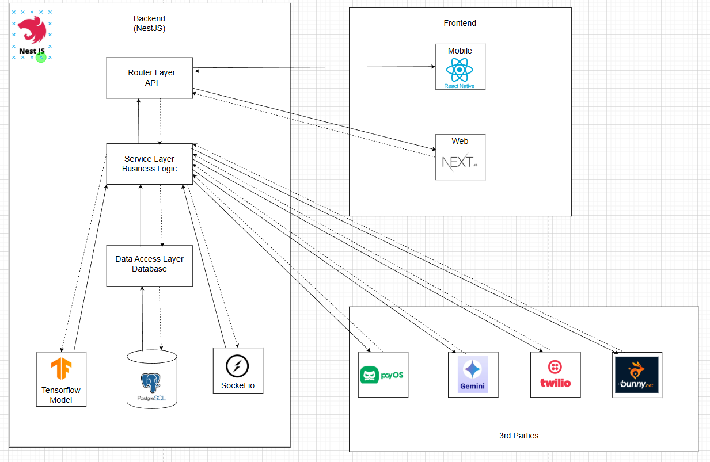

#### 1.1.2 Component Explanation

| **Component** | **Technology/Pattern** | **Function Description** |
| --- | --- | --- |
| API (Router Layer) | NestJS | The API (router layer) exposes all backend capabilities to the frontend and third‑party services through RESTful endpoints. It is responsible for request routing, input validation, authentication/authorization checks, and transforming external requests into calls to the business logic layer. |
| Business Logic (Service Layer) | NestJS | The business logic (service layer) implements the core rules and workflows of the platform, such as fee calculation, permission checks, and orchestration of calls to the database, TensorFlow model, and external services. It acts as the main coordination layer: it interprets API requests, applies business rules, and produces responses that the router layer returns to clients. |
| Data Access Layer | NestJS | The data access layer provides an abstraction over the database, offering repository or DAO interfaces for reading and writing application data. It centralizes SQL/ORM logic, manages connections and transactions, and ensures that higher layers never access the database directly, improving maintainability and security. |
| Socket.io module | WebSocket | Real‑time communication layer embedded in the API service.  Used for features such as real‑time notifications (session updates, payment status). |
| Tensorflow model | Tensorflow | The TensorFlow model is an AI/ML component deployed on the backend that receives input data from the service layer and returns pose estimations. |
| Database | PostgreSQL (via TypeORM) | Primary data store for users, courses, lessons, sessions, attendance, payments metadata, and messaging history.  Only the API talks to the database; all reads/writes go through NestJS so business rules and validations are enforced. |
| Well app | NextJS | Web application used by coaches and learners to access all platform features (course browsing, sessions, messaging, dashboards).  Communicates only with the API over HTTPS; it never talks directly to external services or the database. |
| Mobile app | React-native | Native-like mobile client with similar features to the web app (session calendar, attendance, chats, notifications). |
| BunnyCDN | External Service | Stores and delivers static and media content (course videos, thumbnails, files) with low latency worldwide.  The API manages uploads and signed URLs, while clients stream or download media through BunnyCDN. |
| PayOS | External Service | The third-party payment gateway integration. Used for processing all online payment transactions initiated by users within the application |
| Twilio | External Service | A communication platform used for features requiring SMS messaging (e.g., 2FA, notifications) or voice communication. |
| Gemini service | External Service | External AI service used for features like automated feedback, content generation (lesson summaries, quiz hints), or analytics.  The API forwards relevant data (e.g., learner performance, questions) and returns AI-generated responses to the clients. |

### 1.2 Package Diagram

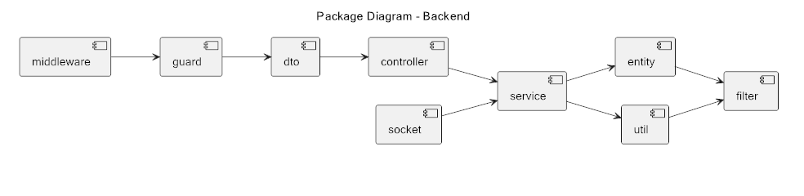

***Package Descriptions***

| **No** | **Package** | **Description** |
| --- | --- | --- |
| 01 | Middleware | Middleware is executed before the main request handling and used for logging requests |
| 02 | Guard | Guards determine whether a request is allowed to proceed:  Authentication (JWT guard, OAuth guard)  Role-based access  Permission checks |
| 03 | DTO | DTOs define the shape of incoming and outgoing data:  Validate request body/query parameters  Enforce consistent data structure  Provide typing for data exchanged with controllers/services |
| 04 | Controller | The controller handles HTTP routes:  Receives validated DTO data  Maps routes to service methods  Returns API responses  Does not contain business logic |
| 05 | Service | This is the core business logic layer.  Apply business rules  Handle use cases  Coordinate repository/entity/util/filter interactions  Optionally communicate with sockets |
| 06 | Socket | Handles WebSocket or real-time interactions. |
| 07 | Entity | Represents database models or ORM objects (TypeORM, Sequelize, Prisma). |
| 08 | Util | Utility helpers shared across modules |
| 09 | Filter | Filters manage how data is returned to the client.  Response transformation/filtering  Error handling  Sanitizing output fields  Logging filters |

## 2. Database Design

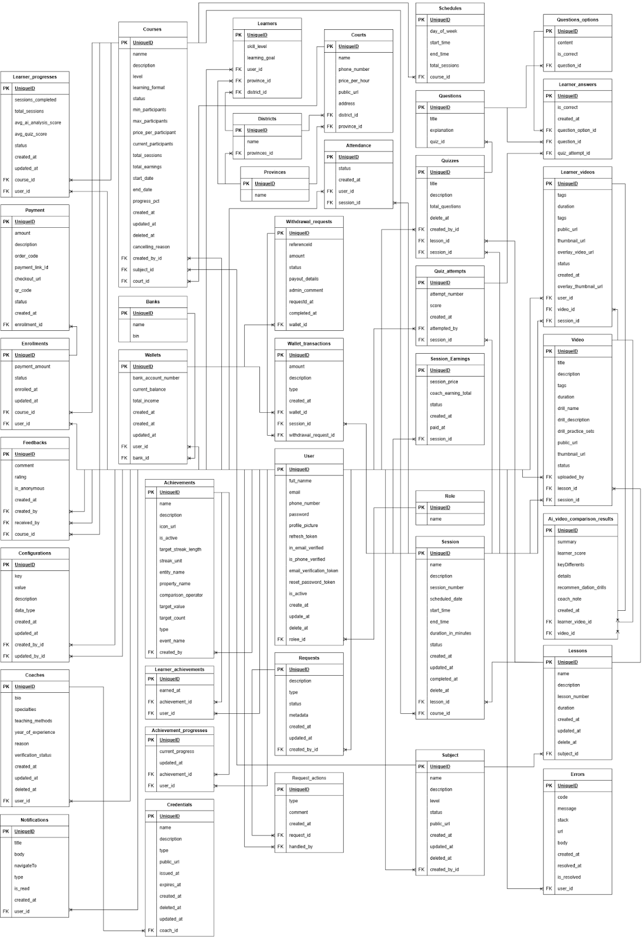

**Table Descriptions**

| **No** | **Table** | **Description** |
| --- | --- | --- |
| 01 | Roles | A list of user roles (permissions) within the system (e.g., Admin, Coach, Learner).  - **Primary keys**: id  - **Foreign keys**: None |
| 02 | Notifications | Stores system notifications sent to individual users.  - **Primary keys**: id  - **Foreign keys**: user_id (The recipient of the notification) |
| 03 | Credentials | Stores system notifications sent to individual users.  - **Primary keys**: id  - **Foreign keys**: user_id (The recipient of the notification) |
| 04 | Coach | Detailed profile information for Coaches, including experience and verification status.  - **Primary keys**: id  - **Foreign keys**: user_id (1:1 link to users - the user account) |
| 05 | Request_actions | Logs actions (Approve/Reject) performed on a specific request (requests).  - **Primary keys**: id  - **Foreign keys**: handled_by (The user who handled the action), request_id (The request being processed) |
| 06 | Requests | Stores various requests within the system (e.g., course approval request, coach verification).  - **Primary keys**: id  - **Foreign keys**: created_by (The user who submitted the request) |
| 07 | Schedules | Recurring class/session schedules (by day of the week and time) for a specific Course.  - **Primary keys**: id  - **Foreign keys**: course_id (The course the schedule belongs to) |
| 08 | Attendances | Records the attendance status (Present, Absent, Late) of a user in a specific session.  - **Primary keys**: id  - **Foreign keys**: user_id (The user), session_id (The session) |
| 09 | Learner_videos | Stores information about videos uploaded by learners (used for AI analysis, grading).  - **Primary keys**: id  - **Foreign keys**: user_id (The user who uploaded it), session_id (Associated session), video_id (Associated template/drill video) |
| 10 | AI_video_comparison_results | Stores the results of AI analysis and comparison between a learner's video and a template video.  - **Primary keys**: id  - **Foreign keys**: learner_video_id (The learner's video), video_id (The template video) |
| 11 | Videos | Information about instructional/template videos uploaded by coaches or admins.  - **Primary keys**: id  - **Foreign keys**: uploadedById (The user who uploaded it), lesson_id (Associated lesson), session_id (Associated session) |
| 12 | Subjects | A list of main Subjects or Topics for courses.  - **Primary keys**: id  - **Foreign keys**: createdById (The user who created the subject) |
| 13 | Lessons | Smaller lessons that make up a main subject (subjects).  - **Primary keys**: id  - **Foreign keys**: subject_id (The subject containing the lesson) |
| 14 | Quizzes | Information about Quizzes related to a lesson or session.  - **Primary keys**: id  - **Foreign keys**: createdById (The user who created the quiz), lesson_id (Associated lesson), session_id (Associated session) |
| 15 | Question_options | The choices/options for a question within a Quiz.  - **Primary keys**: id  - **Foreign keys**: question_id (The question containing the options) |
| 16 | Questions | The content of questions within a Quiz.  - **Primary keys**: id  - **Foreign keys**: quiz_id (The Quiz containing the question) |
| 17 | Learner_answers | Records a learner's answer to each question during a quiz attempt.  - **Primary keys**: id  - **Foreign keys**: question_id, quiz_attempt_id (The quiz attempt), question_option_id (The selected option) |
| 18 | Quiz_attempts | Records details of each time a learner attempts a quiz (attempt number, score).  - **Primary keys**: id  - **Foreign keys**: attempted_by (The user who took the quiz), session_id (Associated session) |
| 19 | Wallet_transactions | Logs all incoming/outgoing transactions (Credit/Debit) for a user's wallet.  - **Primary keys**: id  - **Foreign keys**: wallet_id (The wallet), session_id (Session related to the transaction), withdrawal_request_id (Associated withdrawal request) |
| 20 | Session_earnings | Tracks the earnings generated by a coach from a specific session.  - **Primary keys**: id  - **Foreign keys**: session_id (The session) |
| 21 | Sessions | Detailed information about individual classes or sessions within a Course (courses).  - **Primary keys**: id  - **Foreign keys**: course_id (The course), lesson_id (The lesson) |
| 22 | Payments | Stores payment transaction information for course enrollments  - **Primary keys**: id  - **Foreign keys**: enrollment_id (The related enrollment record) |
| 23 | Enrollments | Records a learner's enrollment in a specific Course.  - **Primary keys**: id  - **Foreign keys**: course_id (The course), user_id (The enrolling user) |
| 24 | Feedbacks | Records user ratings and comments (feedback) about a Course.  - **Primary keys**: id  - **Foreign keys**: created_by (The user giving feedback), received_by (The user receiving feedback), course_id (The course) |
| 25 | Learner_progresses | Tracks a learner's overall progress within a specific Course.  - **Primary keys**: id  - **Foreign keys**: user_id (The learner), course_id (The course) |
| 26 | Video_conferences | Stores channel information for live video conference meetings/sessions.  - **Primary keys**: id  - **Foreign keys**: None |
| 27 | Courses | Detailed information about courses offered on the platform (price, capacity, status).  - **Primary keys**: id  - **Foreign keys**: created_by (The creator/coach), subject_id (The subject), video_conference_id (The video conference channel), court_id (The location/court) |
| 28 | Courts | A list of physical locations/courts (e.g., tennis courts) used for sessions.  - **Primary keys**: id  - **Foreign keys**: province_id, district_id (Location address) |
| 29 | Districts | A list of Districts/Counties  - **Primary keys**: id  - **Foreign keys**: province_id (The Province/City it belongs to) |
| 30 | Provinces | A list of Provinces/Cities.  - **Primary keys**: id  - **Foreign keys**: None |
| 31 | Learners | Detailed profile information for Learners, including skill level and learning goals.  - **Primary keys**: id  - **Foreign keys**: user_id (1:1 link to users - the user account), province_id, district_id (Learner's location) |
| 32 | Learner_achievements | Records the achievements earned by a user.  - **Primary keys**: id  - **Foreign keys**: achievement_id (The achievement), user_id (The user who earned it ) |
| 33 | Achievements | A catalog of system Achievements and the conditions required to earn them.  - **Primary keys**: id  - **Foreign keys**: created_by (The user who defined the achievement) |
| 34 | Achievement_progress | Tracks a user's current progress toward unfinished achievements.  - **Primary keys**: id  - **Foreign keys**: achievement_id (The achievement being tracked), user_id (The user) |
| 35 | Configurations | Stores general system settings/configurations (key-value pairs).  - **Primary keys**: id  - **Foreign keys**: created_by, updated_by (The users who created/updated the configuration) |
| 36 | User | The central table storing basic account information for all system users.  - **Primary keys**: id  - **Foreign keys**: role_id (The user's role) |
| 37 | Banks | A list of supported Bank information.  - **Primary keys**: id  - **Foreign keys**: None |
| 38 | Wallets | User's digital wallet information (current balance, total income).  - **Primary keys**: id  - **Foreign keys**: userId (The user who owns the wallet), bank_id (The linked bank) |
| 39 | Withdrawal_requests | Records requests from users to withdraw money from their wallet.  - **Primary keys**: id  - **Foreign keys**: wallet_id (The wallet making the request) |
| 40 | Ai Learner Progress Analyses | Stores the results of AI-assisted learning progress improvement for learners  - **Primary keys**: id  - **Foreign keys**: user_id (The user who trigger AI-assisted), learner_progress_id (The learner progress which user want to generate from) |
| 41 | AI Subject Generation | Stores the results of AI-assisted subject generation for coaches  - **Primary keys**: id  - **Foreign keys**: requested_by (The user who trigger AI-assisted), created_subject_id (The id of subject created from AI-assisted subject generation) |

## 3. Detailed Design

### 3.1 Login

#### 3.1.1 Class Diagram

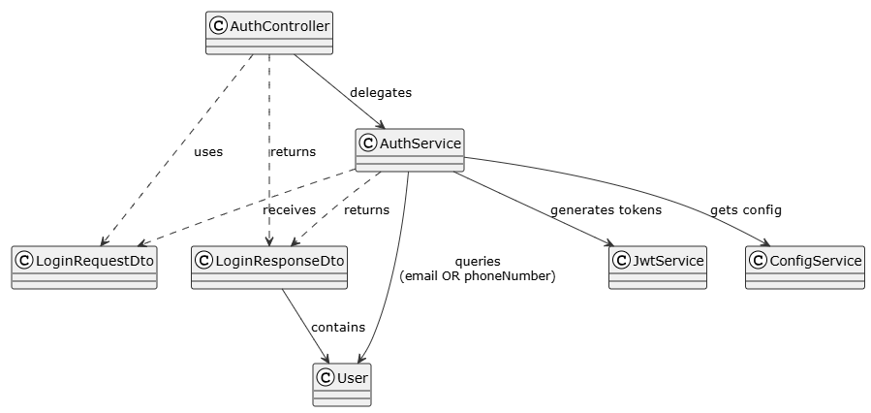

##### **Class: AuthController**

| **No** | **Method** | **Description** |
| --- | --- | --- |
| 01 | login(data: LoginRequestDto): Promise<CustomApiResponse<LoginResponseDto>> | * Validates input * Delegates to AuthService.login * Returns access & refresh tokens plus user data. |

##### **Class: AuthService**

| **No** | **Method** | **Description** |
| --- | --- | --- |
| 01 | login(data: LoginRequestDto): Promise<CustomApiResponse<LoginResponseDto>> | * Queries active, verified user by email or phone * Verifies password and signs access & refresh tokens, hashes and persists refresh token; * Updates last login; emits `user.login`. |
| 02 | refreshNewAccessToken(refreshToken: string): Promise<CustomApiResponse<{ accessToken: string }>> | * Verifies refresh token against stored hash * Issues a new access token |

##### **Class: LoginRequestDto**

| **No** | **Method** | **Description** |
| --- | --- | --- |
| - | None | * DTO carrying `email?`, `phoneNumber?`, and `password` |

##### **Class: LoginResponseDto**

| **No** | **Method** | **Description** |
| --- | --- | --- |
| - | None | * DTO returning `accessToken`, `refreshToken`, and `user` |

##### **Class: JwtService**

| **No** | **Method** | **Description** |
| --- | --- | --- |
| 01 | signAsync(payload, options): Promise<string> | * Signs a JWT with provided payload and options. |

##### **Class: ConfigService**

| **No** | **Method** | **Description** |
| --- | --- | --- |
| 01 | get(key: string): any | * Retrieves configuration value (e.g., JWT secrets) |

##### **Class: User**

| **No** | **Method** | **Description** |
| --- | --- | --- |
| - | None | * Entity representing user |

#### 3.1.2 Login

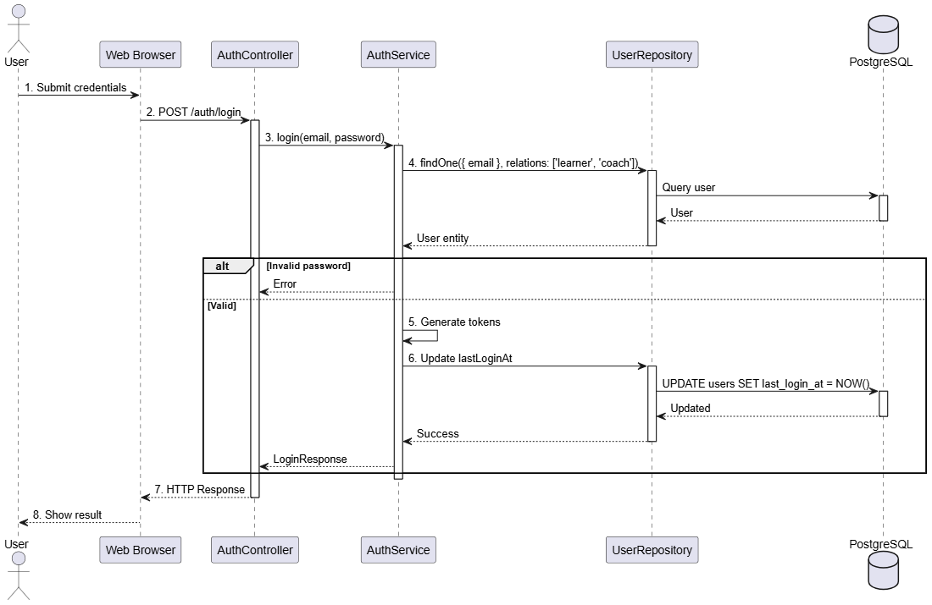

### 3.2 Register Learner

#### 3.2.1 Class Diagram

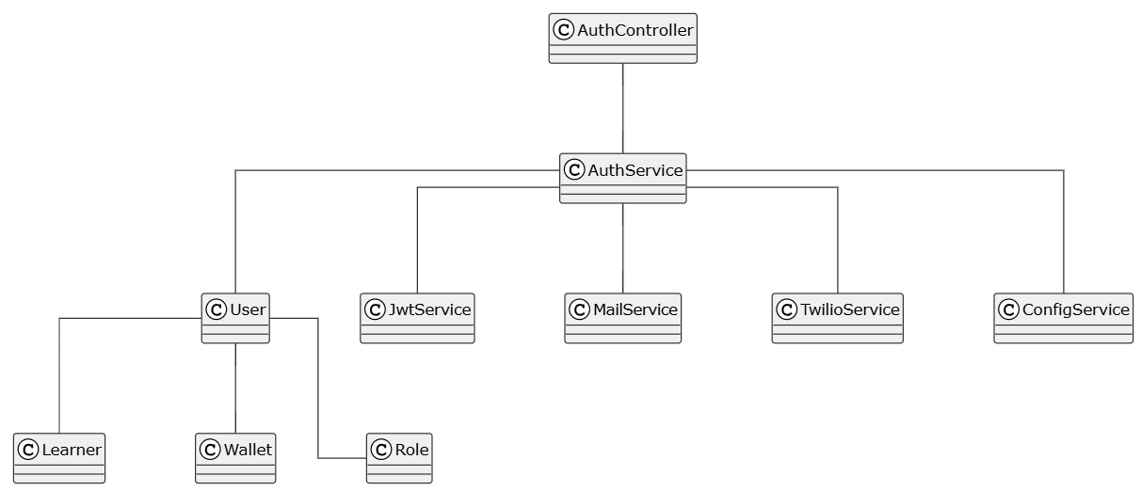

##### **Class: AuthController**

| **No** | **Method** | **Description** |
| --- | --- | --- |
| 01 | register(data: RegisterRequestDto): Promise<CustomApiResponse<RegisterResponseDto>> | * Delegates to `AuthService.register` |

##### **Class: AuthService**

| **No** | **Method** | **Description** |
| --- | --- | --- |
| 01 | register(data: RegisterRequestDto): Promise<CustomApiResponse<RegisterResponseDto>> | * Validates uniqueness; hashes password; persists new user |

##### **Class: RegisterRequestDto**

| **No** | **Method** | **Description** |
| --- | --- | --- |
| - | None | * DTO carrying `fullName`, `email?`, `phoneNumber?`, `password`, `province`, `district`, and `learner: CreateLearnerDto` |

##### **Class: TwilioService**

| **No** | **Method** | **Description** |
| --- | --- | --- |
| 01 | sendSMS(to: string): Promise<any> | * Triggers SMS verification via Twilio Verify service. |
| 02 | verifyPhoneNumber(phoneNumber: string, code: string): Promise<any> | * Checks the verification code for the given phone number |

##### **Class: CreateLearnerDto**

| **No** | **Method** | **Description** |
| --- | --- | --- |
| - | None | * DTO carrying `skillLevel` and `learningGoal` (both `PickleballLevel`) |

##### **Class: Learner**

| **No** | **Method** | **Description** |
| --- | --- | --- |
| - | None | * Entity representing user’s learner profile |

##### **Class: Wallet**

| **No** | **Method** | **Description** |
| --- | --- | --- |
| - | None | * Entity representing user’s wallet |

##### **Class: User (Reference in 3.1.1 Login Class Diagram)**

##### **Class: ConfigService** **(Reference in 3.1.1 Login Class Diagram)**

##### **Class: JwtService (Reference in 3.1.1 Login Class Diagram)**

#### 3.2.2 Register Learner

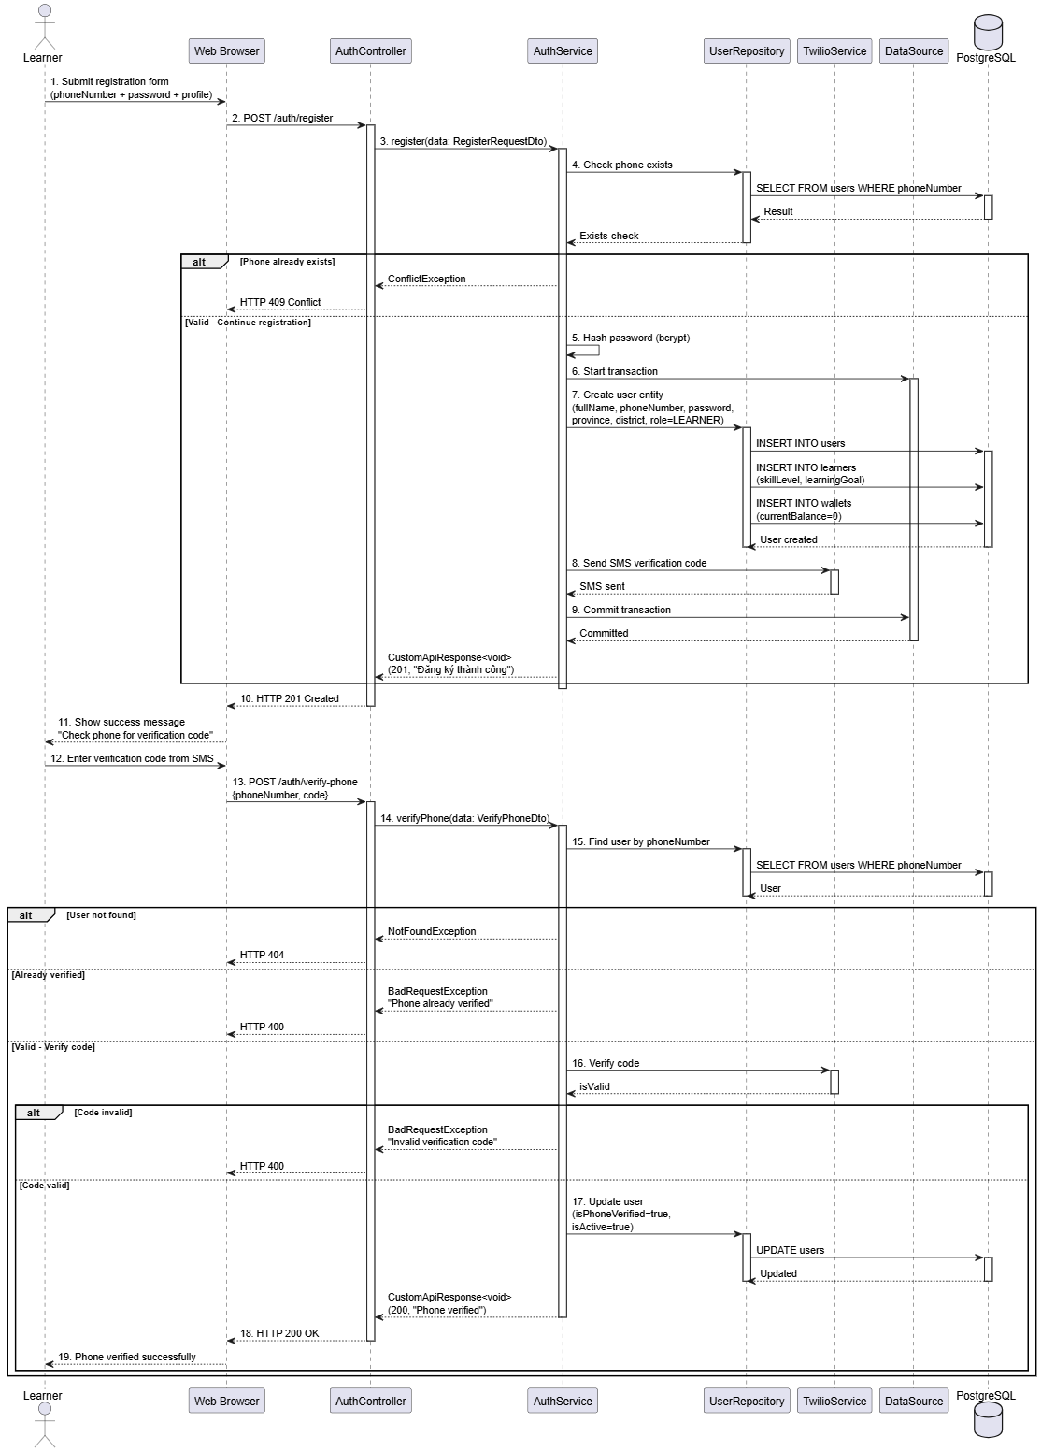

### 3.3 Register Coach

#### 3.3.1 Class Diagram

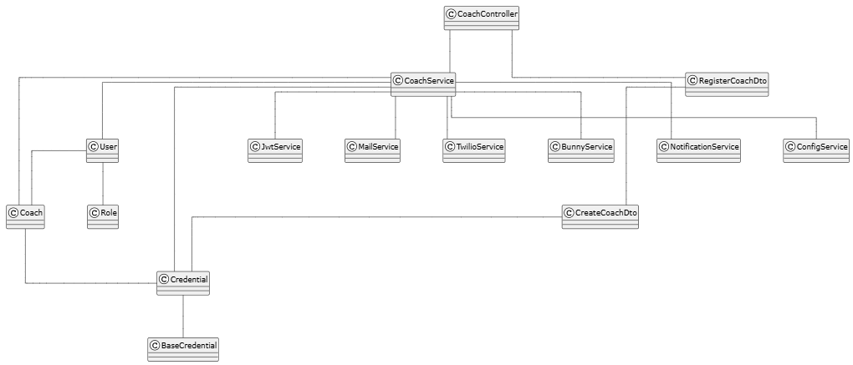

##### **Class: CoachController**

| **No** | **Method** | **Description** |
| --- | --- | --- |
| 01 | register(data: RegisterCoachDto, files: File[]): Promise<CustomApiResponse<void>> | Validates input; handles file uploads; delegates to CoachService.registerCoach |

##### **Class: CoachService**

| **No** | **Method** | **Description** |
| --- | --- | --- |
| 01 | register(data: RegisterCoachDto, files: File[]): Promise<CustomApiResponse<void>> | Creates user account with coach role; uploads credentials; sends verification email/SMS; notifies admins |

##### **Class: RegisterCoachDto**

| **No** | **Method** | **Description** |
| --- | --- | --- |
| - | None | DTO carrying fullName email? phoneNumber? password province district and coach: CreateCoachDto |

##### **Class: CreateCoachDto**

| **No** | **Method** | **Description** |
| --- | --- | --- |
| - | None | DTO carrying bio specialties teachingMethods yearOfExperience and credentials array |

##### **Class: BunnyService**

| **No** | **Method** | **Description** |
| --- | --- | --- |
| 01 | uploadToStorage(options): Promise<string> | Creates user account with coach role; uploads credentials; sends verification email/SMS; notifies admins |
| 02 | Uploads file to Bunny CDN; returns public URL"  "BunnyService",02,"deleteFile(path): Promise<void> | Deletes file from storage |

##### **Class: NotificationService**

| **No** | **Method** | **Description** |
| --- | --- | --- |
| 01 | sendNotification(data): Promise<void> | Sends notification to specific user |
| 02 | sendNotificationToAdmins(data): Promise<void> | Sends notification to all admin users |

##### **Class: Coach**

| **No** | **Method** | **Description** |
| --- | --- | --- |
| - | None | * Entity representing user’s coach profile |

##### **Class: Credential**

| **No** | **Method** | **Description** |
| --- | --- | --- |
| - | None | * Entity representing coach’s credentials |

##### **Class: Base Credential**

| **No** | **Method** | **Description** |
| --- | --- | --- |
| - | None | * Entity representing base credential, where coach’s credential inherit from |

##### **Class: JwtService (Reference in 3.1.1 Login Class Diagram)**

##### **Class: ConfigService (Reference in 3.1.1 Login Class Diagram)**

##### **Class: User (Reference in 3.1.1 Login Class Diagram)**

##### **Class: Role (Reference in 3.1.1 Login Class Diagram)**

##### **Class: MailService (Reference in 3.2.1 Register Learner Class Diagram)**

##### **Class: TwilioService (Reference in 3.2.1 Register Learner Class Diagram)**

#### 3.3.2 Register Coach

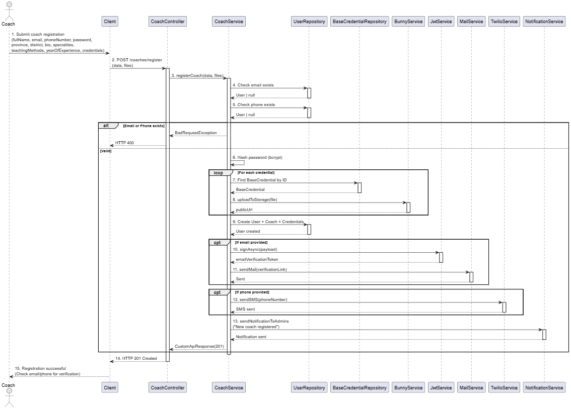

### 3.4 Verify Coach Profile

#### 3.4.1 Class Diagram

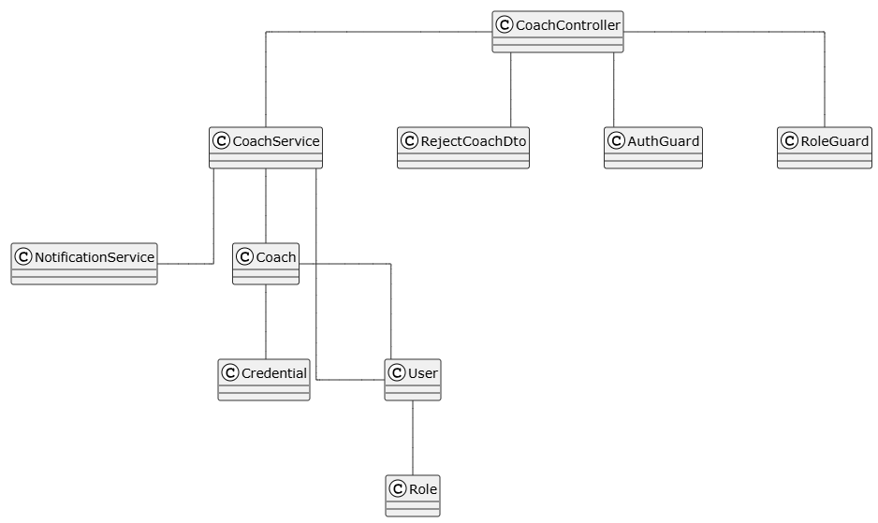

##### **Class: CoachController**

| **No** | **Method** | **Description** |
| --- | --- | --- |
| 01 | findAll(pagination, sort, filter): Promise<PaginateObject<Coach>> | Retrieves all coaches with pagination and filtering |
| 02 | findOne(id: number, isUser: boolean): Promise<Coach> | Retrieves a single coach by ID with relations |
| 03 | verify(id: number): Promise<{message: string}> | Admin verifies coach profile; sets status to VERIFIED (Admin only) |
| 04 | reject(id: number, body: RejectCoachDto): Promise<{message: string}> | Admin rejects coach profile with optional reason (Admin only) |

##### **Class: CoachService**

| **No** | **Method** | **Description** |
| --- | --- | --- |
| 01 | findAll(pagination, sort, filter): Promise<PaginateObject<Coach>> | Retrieves paginated list of coaches |
| 02 | findOne(id: number, isUser: boolean): Promise<Coach> | Retrieves coach with user credentials and baseCredential relations |
| 03 | verifyCoach(coachId: number): Promise<CustomApiResponse<void>> | Sets coach verificationStatus to VERIFIED; activates user if inactive; sends success notification |
| 04 | rejectCoach(coachId: number, reason?: string): Promise<CustomApiResponse<void>> | Sets coach verificationStatus to REJECTED; sends notification with reason |

#### 3.4.2 Approve Coach Profile

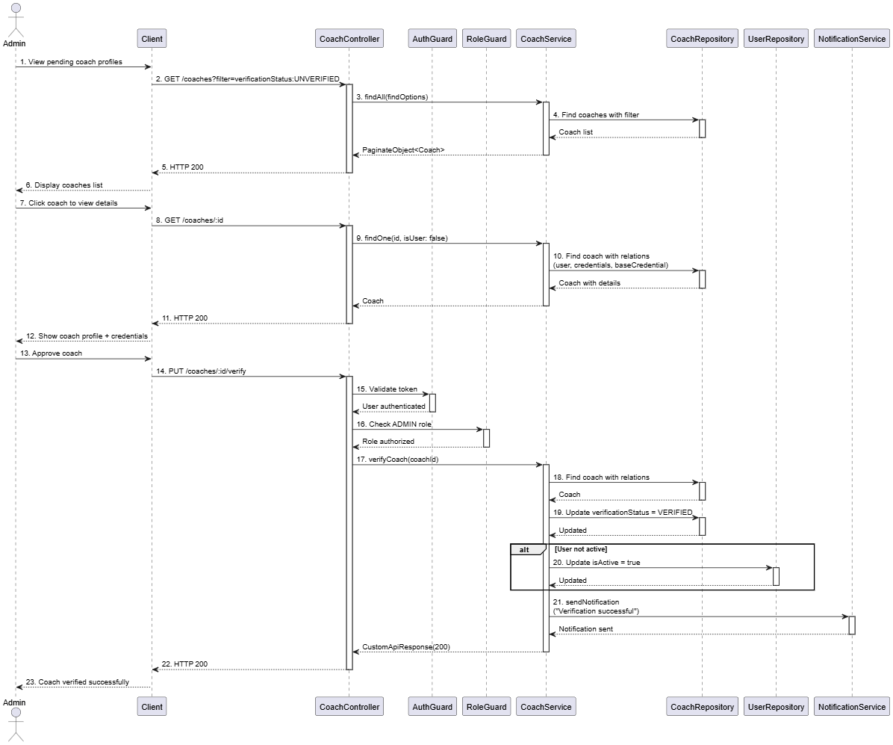

#### 3.4.3 Reject Coach Profile

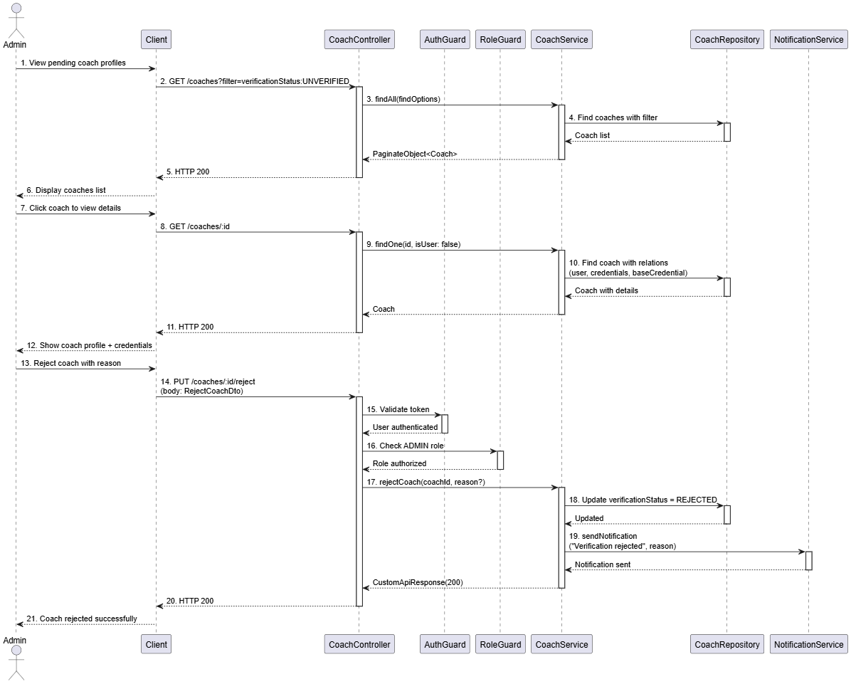

### 3.5 Manage Configuration

#### 3.5.1 Class Diagram

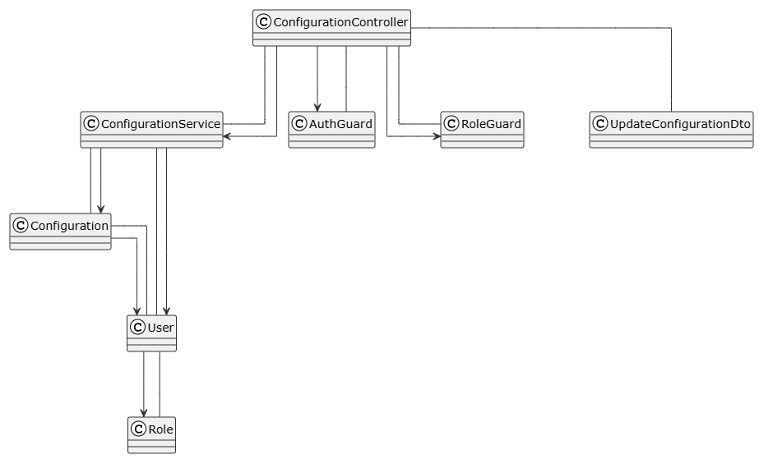

##### **Class: ConfigurationController**

| **No** | **Method** | **Description** |
| --- | --- | --- |
| 01 | findAll(pagination, sort, filter): Promise<PaginateObject<Configuration>> | Retrieves all configurations with pagination and filtering |
| 02 | findOne(key: string): Promise<CustomApiResponse<Configuration>> | Retrieves a specific configuration by key |
| 03 | updateConfiguration(id: number, data: UpdateConfigurationDto): Promise<CustomApiResponse<void>> | Updates an existing configuration (Admin only) |

##### **Class: ConfigurationService**

| **No** | **Method** | **Description** |
| --- | --- | --- |
| 01 | findAll(pagination, sort, filter): Promise<PaginateObject<Configuration>> | Retrieves all configurations with pagination and filtering |
| 02 | findOne(key: string): Promise<CustomApiResponse<Configuration>> | Finds configuration by key |
| 03 | updateConfiguration(id: number, data: UpdateConfigurationDto): Promise<CustomApiResponse<void>> | Updates configuration; sets updatedBy to current user; returns 404 if not found |

##### **Class: AuthGuard**

| **No** | **Method** | **Description** |
| --- | --- | --- |
| 01 | canActivate(context): boolean | Validates JWT token and authenticates user |

##### **Class: RoleGuard**

| **No** | **Method** | **Description** |
| --- | --- | --- |
| 01 | canActivate(context): boolean | Checks if user has required role (ADMIN) |

##### **Class: UpdateConfigurationDto**

| **No** | **Method** | **Description** |
| --- | --- | --- |
| 01 | canActivate(context): boolean | Checks if user has required role (ADMIN) |

##### **Class: Configuration**

| **No** | **Method** | **Description** |
| --- | --- | --- |
| - | None | * Entity representing system configuration |

##### **Class: User (Reference in 3.2.1 Login Class Diagram)**

##### **Class: Role (Reference in 3.2.1 Login Class Diagram)**

#### 3.5.2 View Configuration

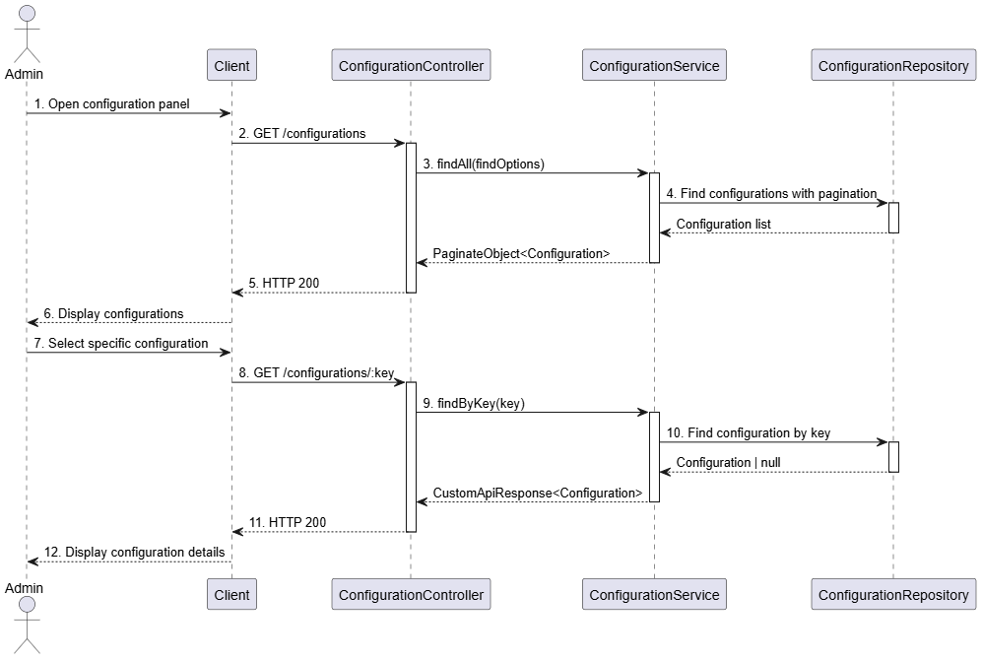

#### 3.5.3 Update Configuration

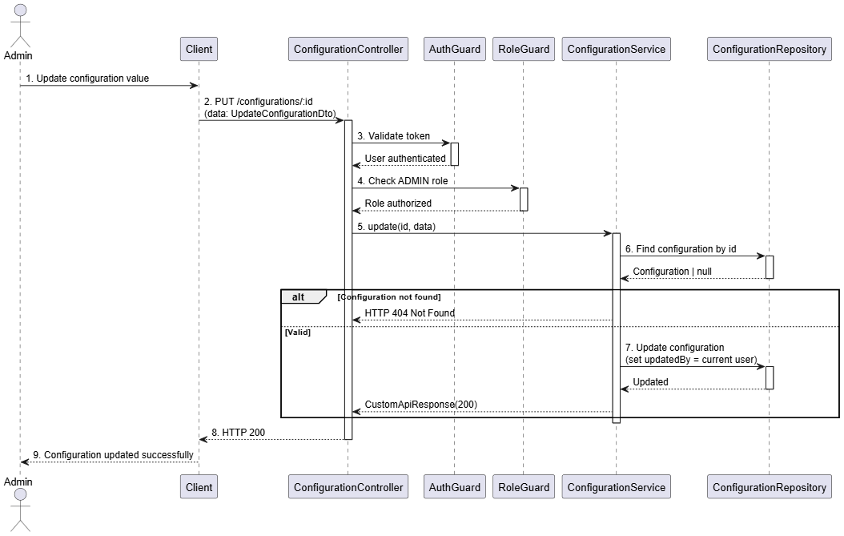

### 3.6 Manage Course

#### 3.6.1 Class Diagram

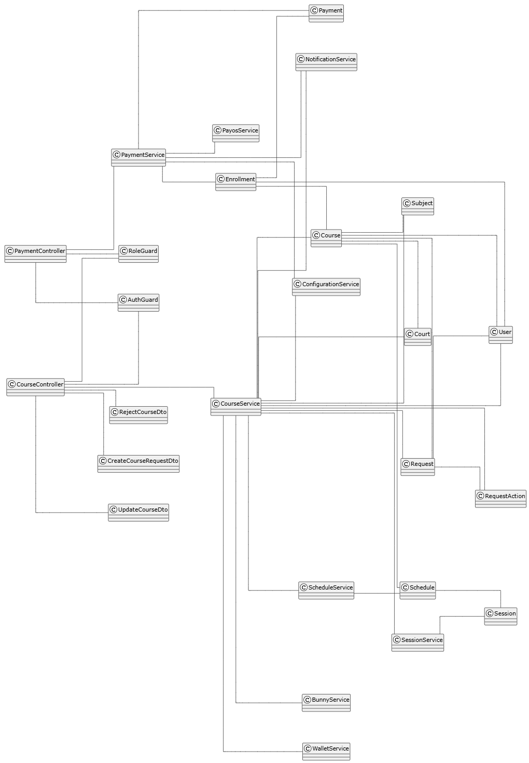

##### **Class: CourseController**

| **No** | **Method** | **Description** |
| --- | --- | --- |
| 01 | findAll(pagination, sort, filter): Promise<PaginateObject<Course>> | Retrieves all courses with pagination sorting and filtering |
| 02 | findOne(id: number): Promise<Course> | Retrieves single course by ID with full relations (sessions quiz video enrollments subject schedules court) |
| 03 | getAvailableCourses(page, size, name?, level?, province?, district?): Promise<PaginateObject<Course>> | Public endpoint: retrieves available courses (APPROVED READY_OPENED FULL) with optional filters |
| 04 | getCoursesForCoach(page, size): Promise<PaginateObject<Course>> | Coach-only: retrieves courses created by authenticated coach (AuthGuard) |
| 05 | getCoursesForLearner(page, size): Promise<PaginateObject<Course>> | Learner-only: retrieves courses where authenticated user is enrolled (AuthGuard) |
| 06 | createCourse(subjectId, data: CreateCourseRequestDto, file?): Promise<CustomApiResponse> | Coach creates course creation request; validates subject schedules court (Coach only AuthGuard + RoleGuard) |
| 07 | updateCourseCreationRequest(id, data: UpdateCourseDto, file?): Promise<CustomApiResponse> | Coach updates PENDING_APPROVAL request; validates ownership (Coach only AuthGuard + RoleGuard) |
| 08 | approveCourseCreationRequest(id): Promise<CustomApiResponse> | Admin approves request; creates Course with schedules and sessions (Admin only AuthGuard + RoleGuard) |
| 09 | rejectCourseCreationRequest(id, reason: string): Promise<CustomApiResponse> | Admin rejects request with reason; sends notification (Admin only AuthGuard + RoleGuard) |

##### **Class: CourseService**

| **No** | **Method** | **Description** |
| --- | --- | --- |
| 01 | findAll(findOptions): Promise<PaginateObject<Course>> | Retrieves paginated list of courses using base TypeORM helper |
| 02 | findOne(id: number): Promise<Course> | Retrieves course with full relations in transaction (sessions quiz video enrollments user subject schedules court province district) |
| 03 | getAvailableCourses(page, size, name?, level?, province?, district?): Promise<PaginateObject<Course>> | Retrieves courses where status IN (APPROVED READY_OPENED FULL) with optional name/level/location filters |
| 04 | findCoachCourses(page, size): Promise<PaginateObject<Course>> | Retrieves courses WHERE createdBy = userId with schedules and court relations |
| 05 | findLearnerCourses(page, size): Promise<PaginateObject<Course>> | Retrieves courses WHERE enrollment.user = userId AND enrollment.status IN (CONFIRMED LEARNING PENDING_GROUP DONE UNPAID) |
| 06 | createCourseCreationRequest(subjectId, data, file?): Promise<CustomApiResponse> | Validates: court exists schedules no overlaps startDate >= configMinDays subject PUBLISHED with lessons having video+quiz scheduleCount <= lessonCount lessonCount divisible by scheduleCount no schedule conflicts; uploads file to Bunny; creates Request with metadata; notifies admin |
| 07 | updateCourseCreationRequest(id, data, file?): Promise<CustomApiResponse> | Finds PENDING_APPROVAL request; validates ownership; validates court/schedules/startDate if provided; uploads file to Bunny; merges metadata; updates request |
| 08 | approveCourseCreationRequest(id): Promise<CustomApiResponse> | Finds PENDING_APPROVAL request; extracts metadata; creates Course with status=APPROVED; creates schedules via ScheduleService; generates sessions via SessionService; updates request status=APPROVED; creates RequestAction type=APPROVED; notifies coach |
| 09 | rejectCourseCreationRequest(id, reason): Promise<CustomApiResponse> | Finds PENDING_APPROVAL request; updates status=REJECTED with rejectionReason; creates RequestAction type=REJECTED; notifies coach with reason |

##### **Class: ScheduleService**

| **No** | **Method** | **Description** |
| --- | --- | --- |
| 01 | createSchedules(course, schedules): Promise<Schedule[]> | Creates schedule records for given course |
| 02 | checkScheduleConflicts(coachId, schedules, startDate): Promise<boolean> | "Validates coach doesn't have overlapping schedules at given times |

##### **Class: SessionService**

| **No** | **Method** | **Description** |
| --- | --- | --- |
| 01 | generateSessionsFromSchedule(course): Promise<Session[]> | Generates session records based on course schedules startDate endDate and lesson count |

##### **Class: PayOSService**

| **No** | **Method** | **Description** |
| --- | --- | --- |
| 01 | createPayment(data): Promise<PaymentResult> | Initiates a payment transaction with PayOS and returns the result |
| 02 | verifyPayment(paymentId): Promise<boolean> | Verifies the status of a payment transaction with PayOS |

##### **Class: CreateCourseRequestDto**

| **No** | **Method** | **Description** |
| --- | --- | --- |
| - | None | DTO carrying name description level learningFormat startDate minParticipants maxParticipants pricePerParticipant schedules courtId |

##### **Class: UpdateCourseDto**

| **No** | **Method** | **Description** |
| --- | --- | --- |
| - | None | DTO carrying optional fields for updating course creation request |

##### **Class: UpdateCourseDto**

| **No** | **Method** | **Description** |
| --- | --- | --- |
| - | None | DTO carrying reason for rejecting course creation request |

##### **Class: Course**

| **No** | **Method** | **Description** |
| --- | --- | --- |
| - | None | Entity representing course with status level learningFormat dates participants price publicUrl googleMeetLink |

##### **Class: Schedule**

| **No** | **Method** | **Description** |
| --- | --- | --- |
| - | None | Entity representing course schedule with dayOfWeek startTime endTime totalSessions |

##### **Class: Session**

| **No** | **Method** | **Description** |
| --- | --- | --- |
| - | None | Entity representing course session with sessionNumber scheduleDate times status quiz video |

##### **Class: Subject**

| **No** | **Method** | **Description** |
| --- | --- | --- |
| - | None | Entity representing pickleball subject with lessons; must be PUBLISHED for course creation |

##### **Class: Court**

| **No** | **Method** | **Description** |
| --- | --- | --- |
| - | None | Entity representing pickleball court location with address pricing province district |

##### **Class: Request**

| **No** | **Method** | **Description** |
| --- | --- | --- |
| - | None | Entity representing approval request with type metadata status rejectionReason processedAt |

##### **Class: RequestAction**

| **No** | **Method** | **Description** |
| --- | --- | --- |
| - | None | Entity representing action taken on request (APPROVED or REJECTED) with actionBy and reason |

##### **Class: Enrollment**

| **No** | **Method** | **Description** |
| --- | --- | --- |
| - | None | Entity representing learner enrollment in course with status paymentAmount enrolledAt |

##### **Class: AuthGuard (Reference in 3.5.1 Manage Configuration Class Diagram)**

##### **Class: RoleGuard (Reference in 3.5.1 Manage Configuration Class Diagram)**

##### **Class: NotificationService (Reference in 3.2.1 Register Learner Class Diagram)**

##### **Class: WalletService (Reference in 3.15.1 Manage Wallet Class Diagram)**

#### 3.6.2 Learner View Course

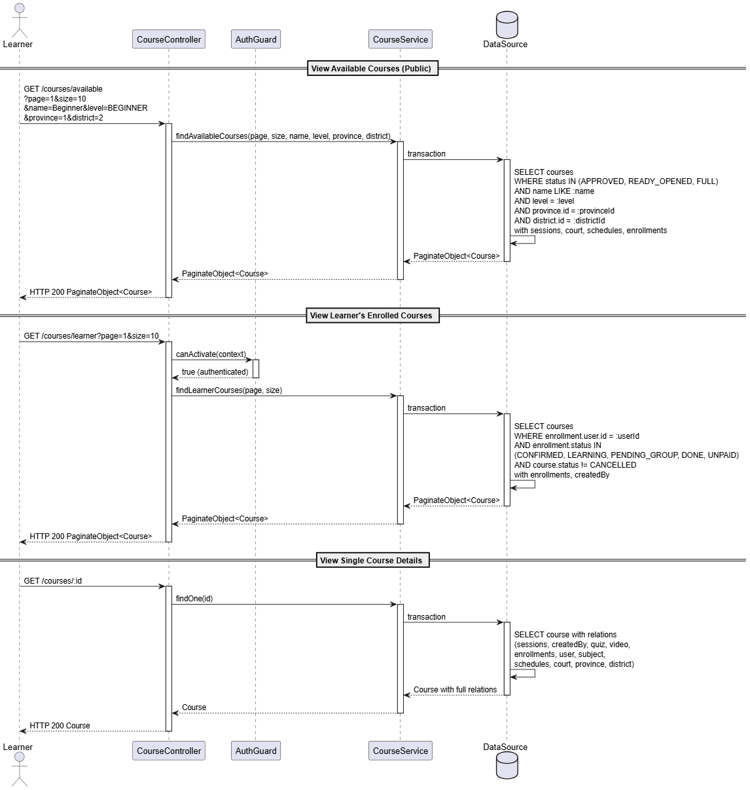

#### 3.6.3 Coach View Course

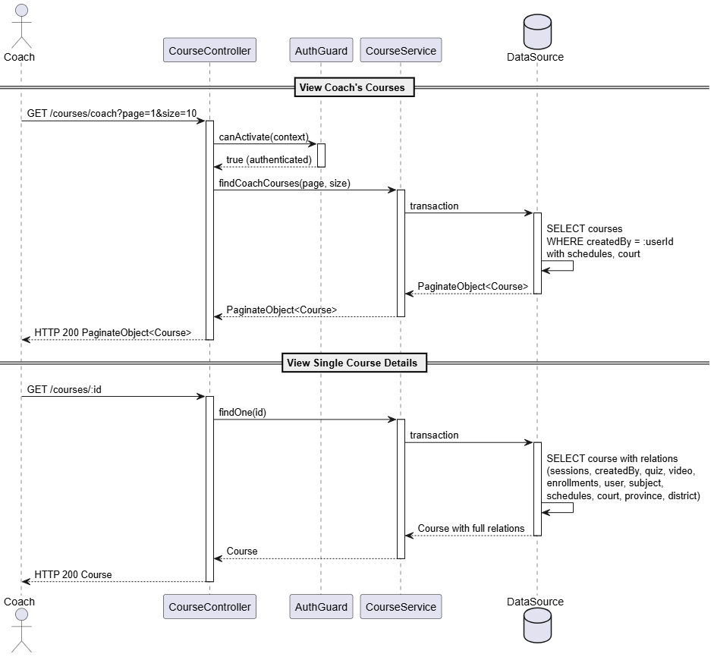

#### 3.6.2 Admin View Course

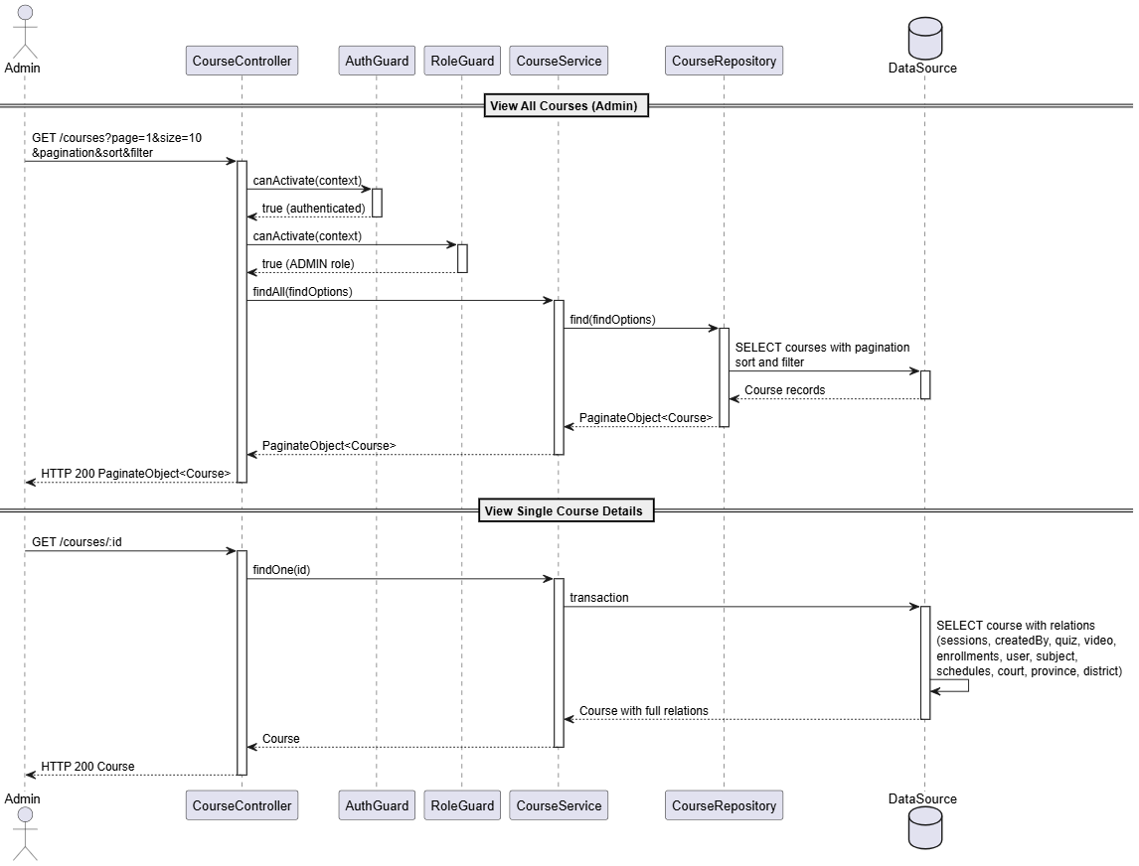

#### 

#### 3.6.3 Create Course

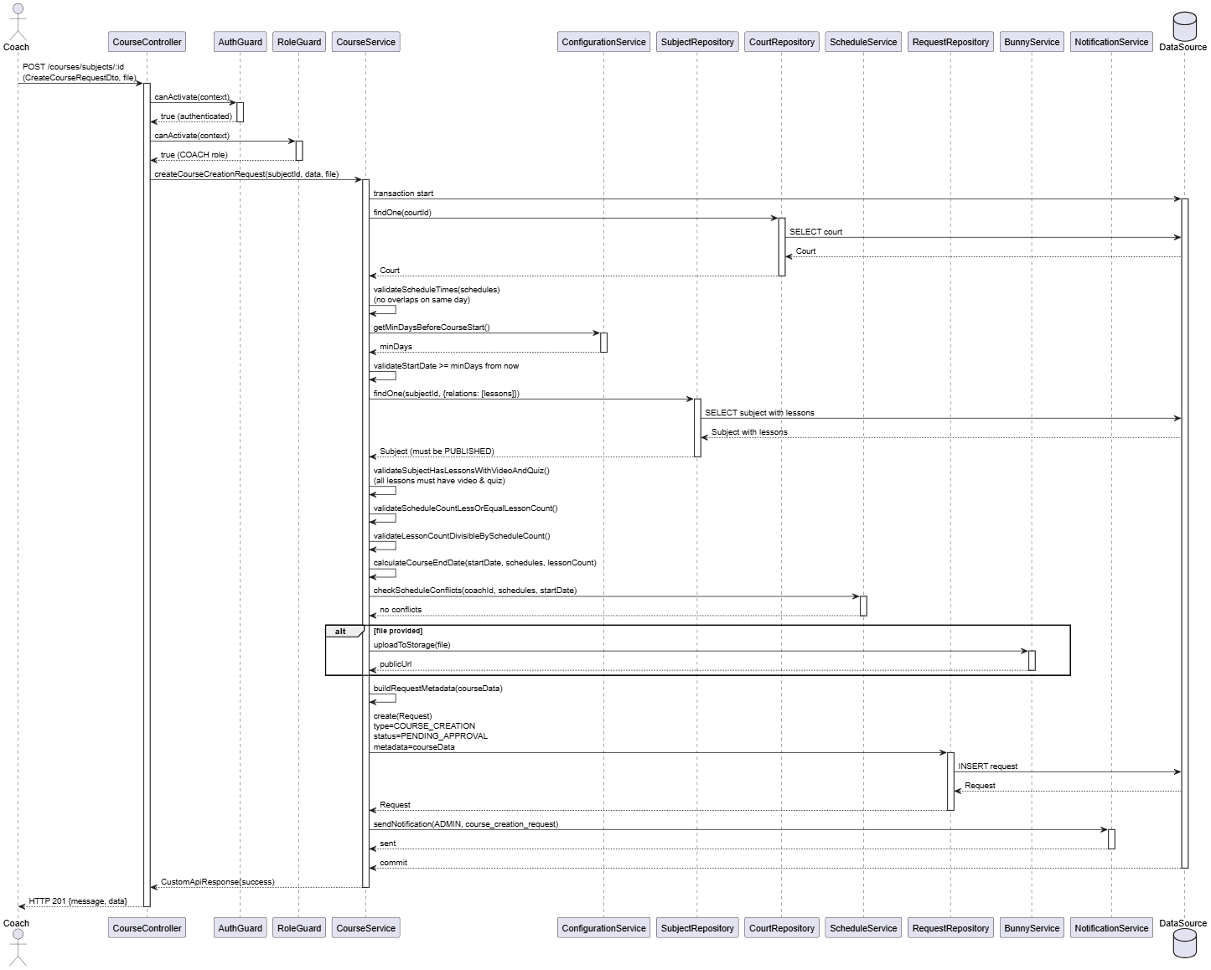

#### 3.6.4 Update Course

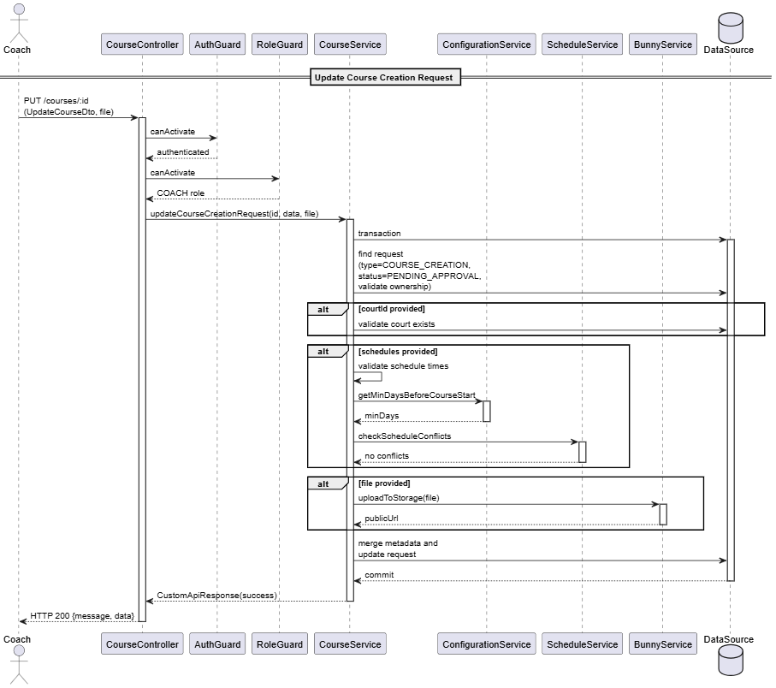

#### 3.6.5 Approve Course

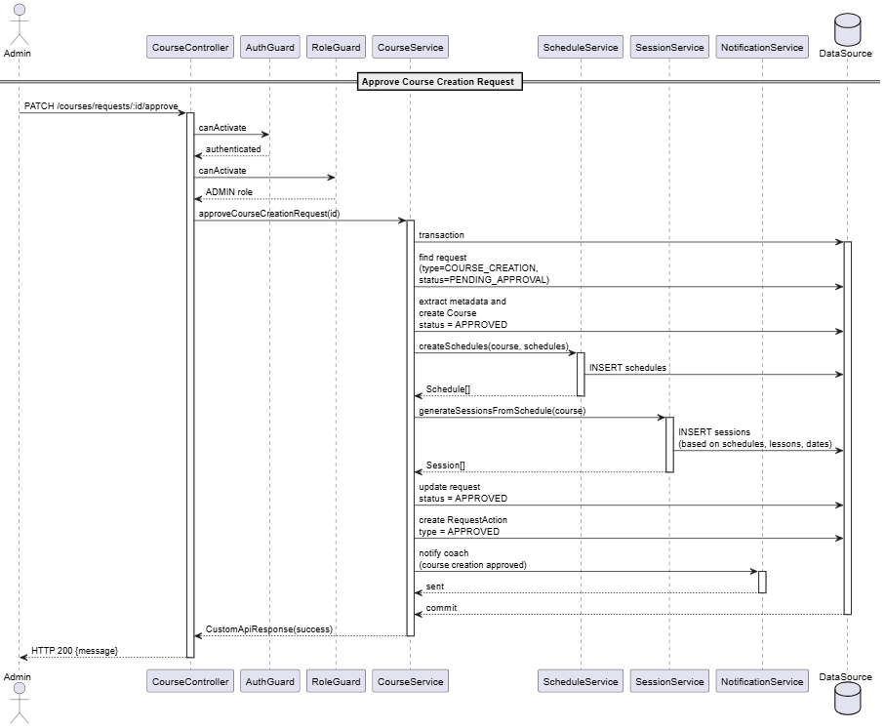

#### 3.6.6 Reject Course

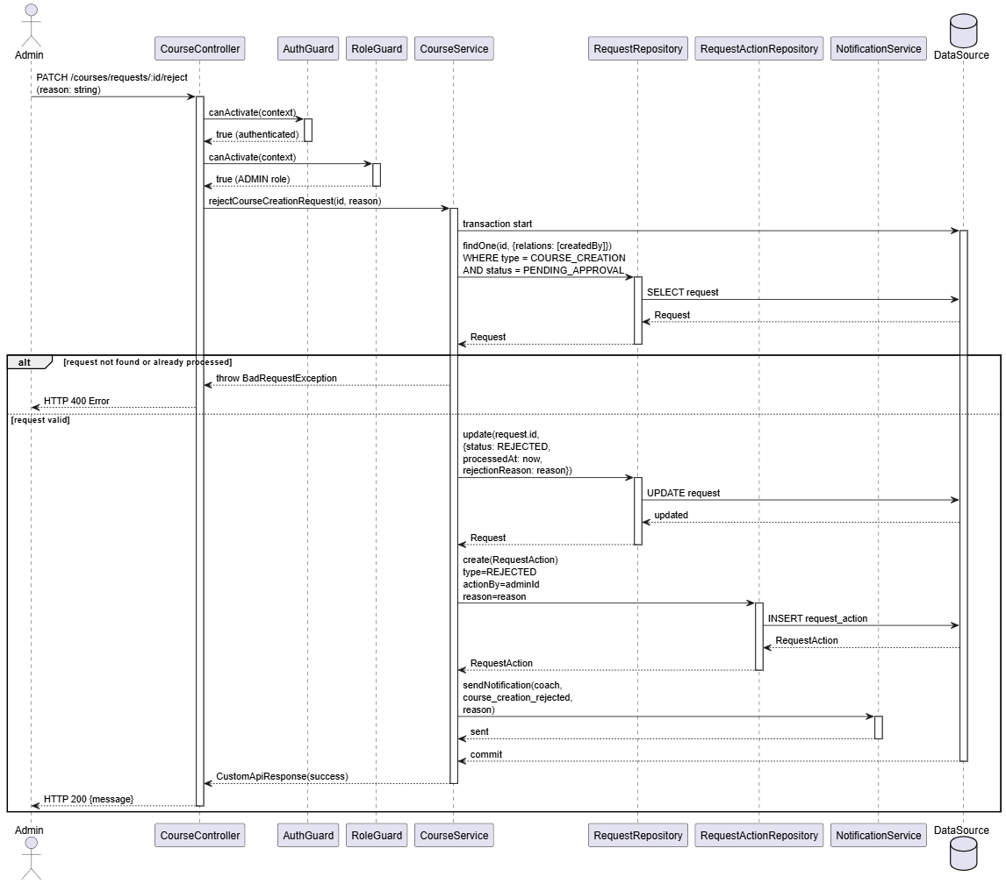

#### 3.6.7 Learner Enrolls Course

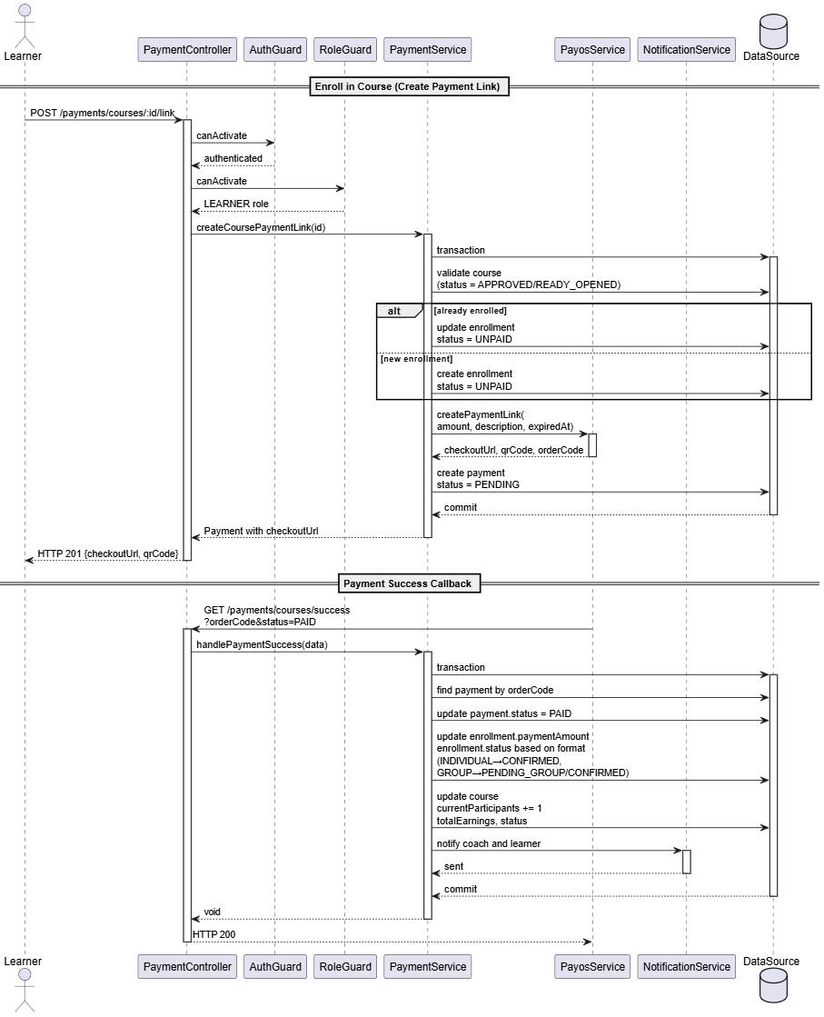

#### 3.6.8 Learner Cancel Course

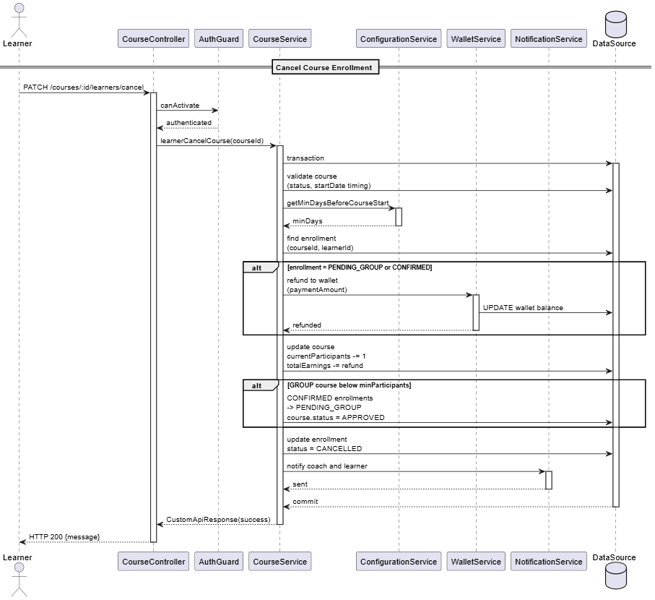

#### 3.6.9 Learner submit feedback

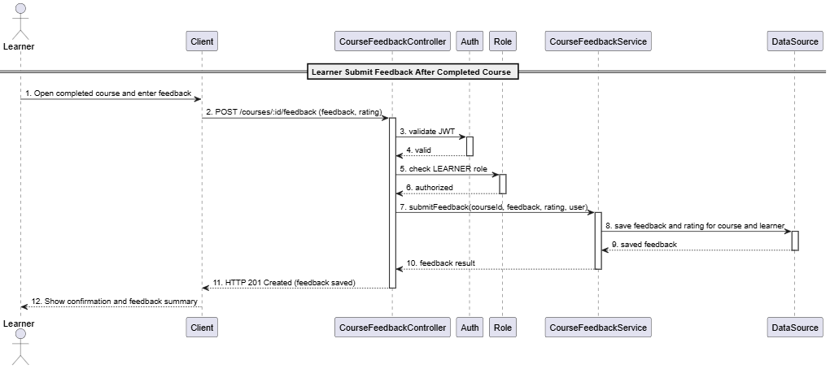

### 3.7 Mange achievement

#### 3.7.1 Class Diagram

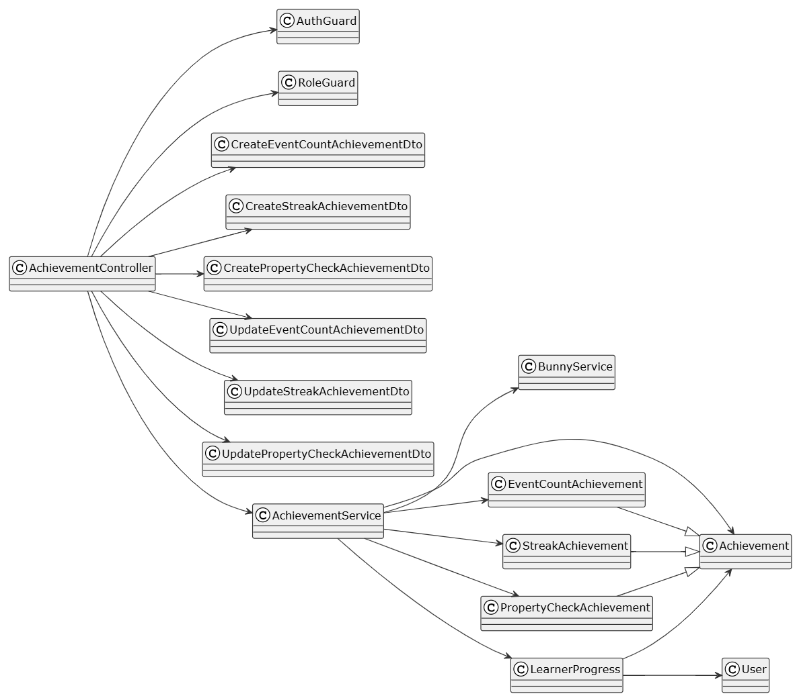

##### **Class: AchievementController**

| **No** | **Method** | **Description** |
| --- | --- | --- |
| 01 | findAll(findOptions): Promise<PaginateObject<Achievement>> | Retrieves all achievements with pagination and filtering (Admin only AuthGuard + RoleGuard) |
| 02 | findOne(id: number): Promise<Achievement> | Retrieves single achievement by ID with relations (Admin only AuthGuard + RoleGuard) |
| 03 | createEventCount(data: CreateEventCountAchievementDto, icon?: File): Promise<CustomApiResponse> | Creates EVENT_COUNT achievement; uploads icon to Bunny if provided (Admin only AuthGuard + RoleGuard) |
| 04 | createStreak(data: CreateStreakAchievementDto, icon?: File): Promise<CustomApiResponse> | Creates STREAK achievement; uploads icon to Bunny if provided (Admin only AuthGuard + RoleGuard) |
| 05 | createPropertyCheck(data: CreatePropertyCheckAchievementDto, icon?: File): Promise<CustomApiResponse> | Creates PROPERTY_CHECK achievement; uploads icon to Bunny if provided (Admin only AuthGuard + RoleGuard) |
| 06 | updateEventCount(id: number, data: UpdateEventCountAchievementDto, icon?: File): Promise<CustomApiResponse> | Updates EVENT_COUNT achievement; uploads new icon if provided (Admin only AuthGuard + RoleGuard) |
| 07 | updateStreak(id: number, data: UpdateStreakAchievementDto, icon?: File): Promise<CustomApiResponse> | Updates STREAK achievement; uploads new icon if provided (Admin only AuthGuard + RoleGuard) |
| 08 | updatePropertyCheck(id: number, data: UpdatePropertyCheckAchievementDto, icon?: File): Promise<CustomApiResponse> | Updates PROPERTY_CHECK achievement; uploads new icon if provided (Admin only AuthGuard + RoleGuard) |
| 09 | delete(id: number): Promise<CustomApiResponse> | Soft deletes achievement by setting deletedAt (Admin only AuthGuard + RoleGuard) |
| 10 | activate(id: number): Promise<CustomApiResponse> | Sets achievement isActive to true (Admin only AuthGuard + RoleGuard) |
| 11 | deactivate(id: number): Promise<CustomApiResponse> | Sets achievement isActive to false (Admin only AuthGuard + RoleGuard) |

##### **Class: AchievementService**

| **No** | **Method** | **Description** |
| --- | --- | --- |
| 01 | findAll(findOptions): Promise<PaginateObject<Achievement>> | Retrieves paginated list of achievements with filtering using base TypeORM helper |
| 02 | findOne(id: number): Promise<Achievement> | Retrieves achievement by ID with relations; throws if not found |
| 03 | createEventCount(data: CreateEventCountAchievementDto, icon?: File): Promise<CustomApiResponse> | Uploads icon to BunnyService if provided; creates EventCountAchievement with name description eventName targetCount |
| 04 | createStreak(data: CreateStreakAchievementDto, icon?: File): Promise<CustomApiResponse> | Uploads icon to BunnyService if provided; creates EventCountAchievement with name description eventName targetCount |
| 05 | createPropertyCheck(data: CreatePropertyCheckAchievementDto, icon?: File): Promise<CustomApiResponse> | Uploads icon to BunnyService if provided; creates PropertyCheckAchievement with name description eventName entityName propertyName comparisonOperator targetValue |
| 06 | updateEventCount(id: number, data: UpdateEventCountAchievementDto, icon?: File): Promise<CustomApiResponse> | Finds achievement; uploads new icon if provided; updates fields; saves achievement |
| 07 | updateStreak(id: number, data: UpdateStreakAchievementDto, icon?: File): Promise<CustomApiResponse> | Finds achievement; uploads new icon if provided; updates fields; saves achievement |
| 08 | updatePropertyCheck(id: number, data: UpdatePropertyCheckAchievementDto, icon?: File): Promise<CustomApiResponse> | Finds achievement; uploads new icon if provided; updates fields; saves achievement |
| 09 | delete(id: number): Promise<CustomApiResponse> | Soft deletes achievement by setting deletedAt timestamp |
| 10 | activate(id: number): Promise<CustomApiResponse> | Finds achievement; sets isActive = true; saves achievement |
| 11 | deactivate(id: number): Promise<CustomApiResponse> | Finds achievement; sets isActive = false; saves achievement |

##### **Class: CreateEventCountAchievementDto**

| **No** | **Method** | **Description** |
| --- | --- | --- |
| - | None | DTO carrying name description eventName targetCount isActive for creating EVENT_COUNT achievement |

##### **Class: CreateStreakAchievementDto**

| **No** | **Method** | **Description** |
| --- | --- | --- |
| - | None | DTO carrying name description eventName targetStreakLength streakUnit isActive for creating STREAK achievement |

##### **Class: CreatePropertyCheckAchievementDto**

| **No** | **Method** | **Description** |
| --- | --- | --- |
| - | None | DTO carrying name description eventName entityName propertyName comparisonOperator targetValue isActive for creating PROPERTY_CHECK achievement |

##### **Class: UpdateEventCountAchievementDto**

| **No** | **Method** | **Description** |
| --- | --- | --- |
| - | None | DTO carrying optional fields for updating EVENT_COUNT achievement |

##### **Class: UpdateStreakAchievementDto**

| **No** | **Method** | **Description** |
| --- | --- | --- |
| - | None | DTO carrying optional fields for updating STREAK achievement |

##### **Class: UpdatePropertyCheckAchievementDto**

| **No** | **Method** | **Description** |
| --- | --- | --- |
| - | None | DTO carrying optional fields for updating PROPERTY_CHECK achievement |

##### **Class: Achievement**

| **No** | **Method** | **Description** |
| --- | --- | --- |
| - | None | Base entity for achievements with id name description iconUrl isActive createdAt createdBy |

##### **Class: EventCountAchievement**

| **No** | **Method** | **Description** |
| --- | --- | --- |
| - | None | Achievement type tracking event count with eventName targetCount |

##### **Class: StreakAchievement**

| **No** | **Method** | **Description** |
| --- | --- | --- |
| - | None | Achievement type tracking consecutive events with eventName targetStreakLength streakUnit |

##### **Class: PropertyCheckAchievement**

| **No** | **Method** | **Description** |
| --- | --- | --- |
| - | None | Achievement type checking entity property with eventName entityName propertyName comparisonOperator targetValue |

##### **Class: BunnyService (Reference in 3.3.1 Register Coach Class Diagram)**

##### **Class: User (Reference in 3.1.1 Login Class Diagram)**

##### **Class: AuthGuard (Reference in 3.5.1 Manage Configuration Class Diagram)**

##### **Class: RoleGuard (Reference in 3.5.1 Manage Configuration Class Diagram)**

##### **Class: LearnerProgress (Reference in 3.13.1 Manage Learner Progress Class Diagram)**

#### 3.7.2 View Achievement

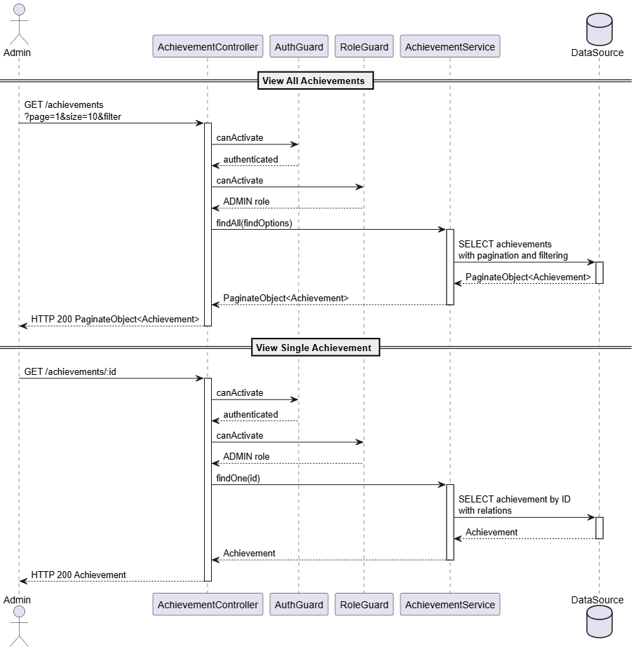

#### 3.7.3 Create Achievement

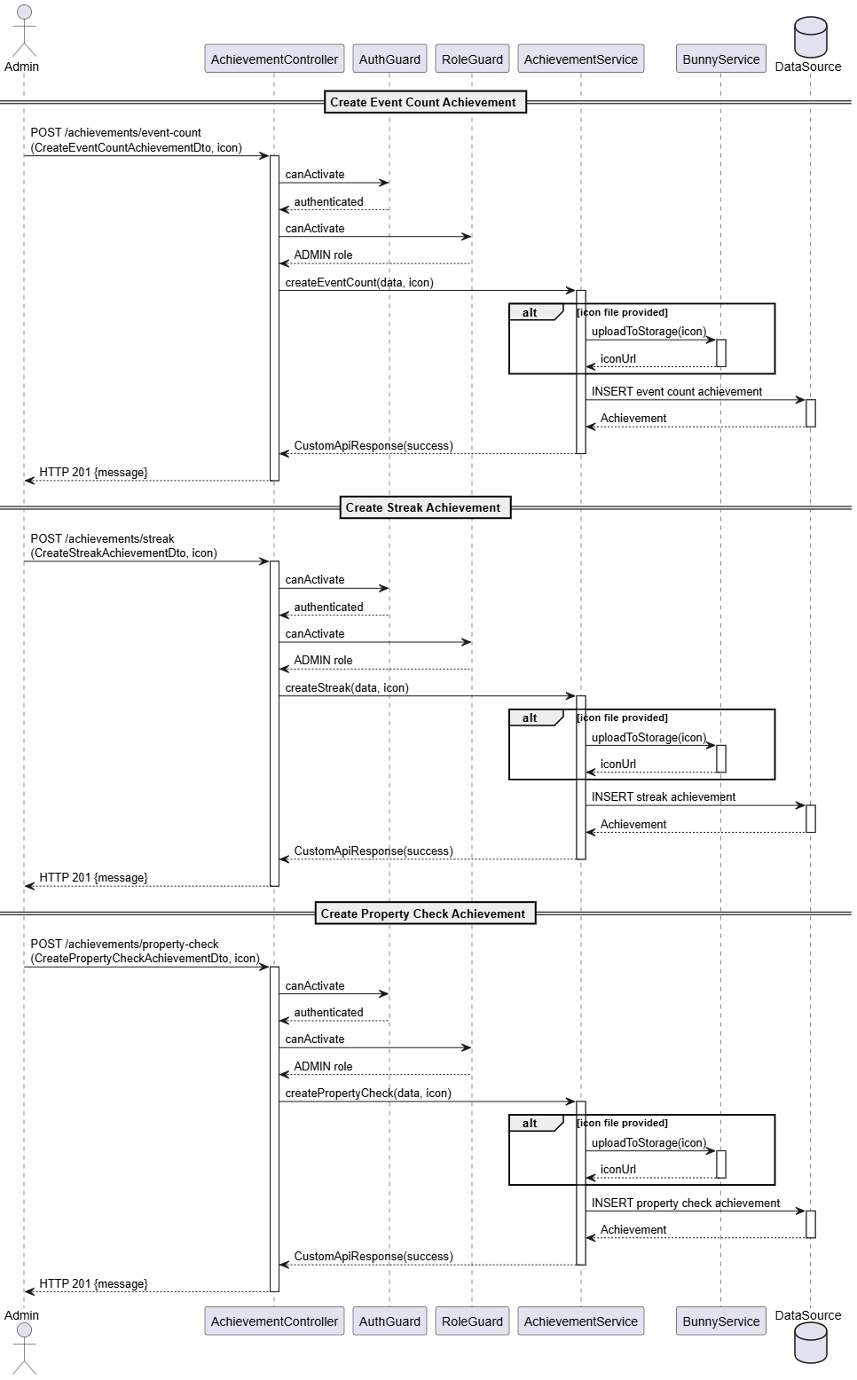

#### 3.7.2 Update Achievement

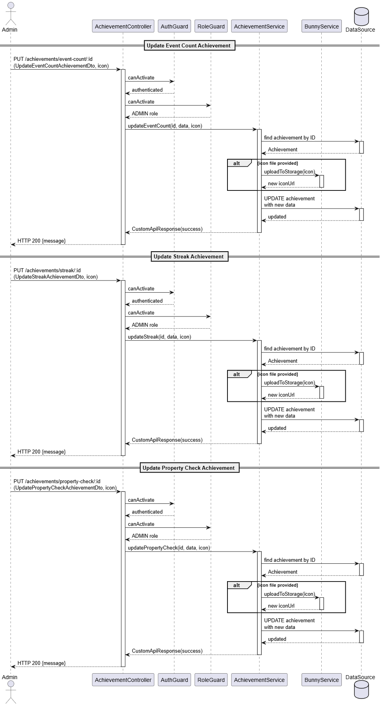

#### 3.7.2 Delete Achievement

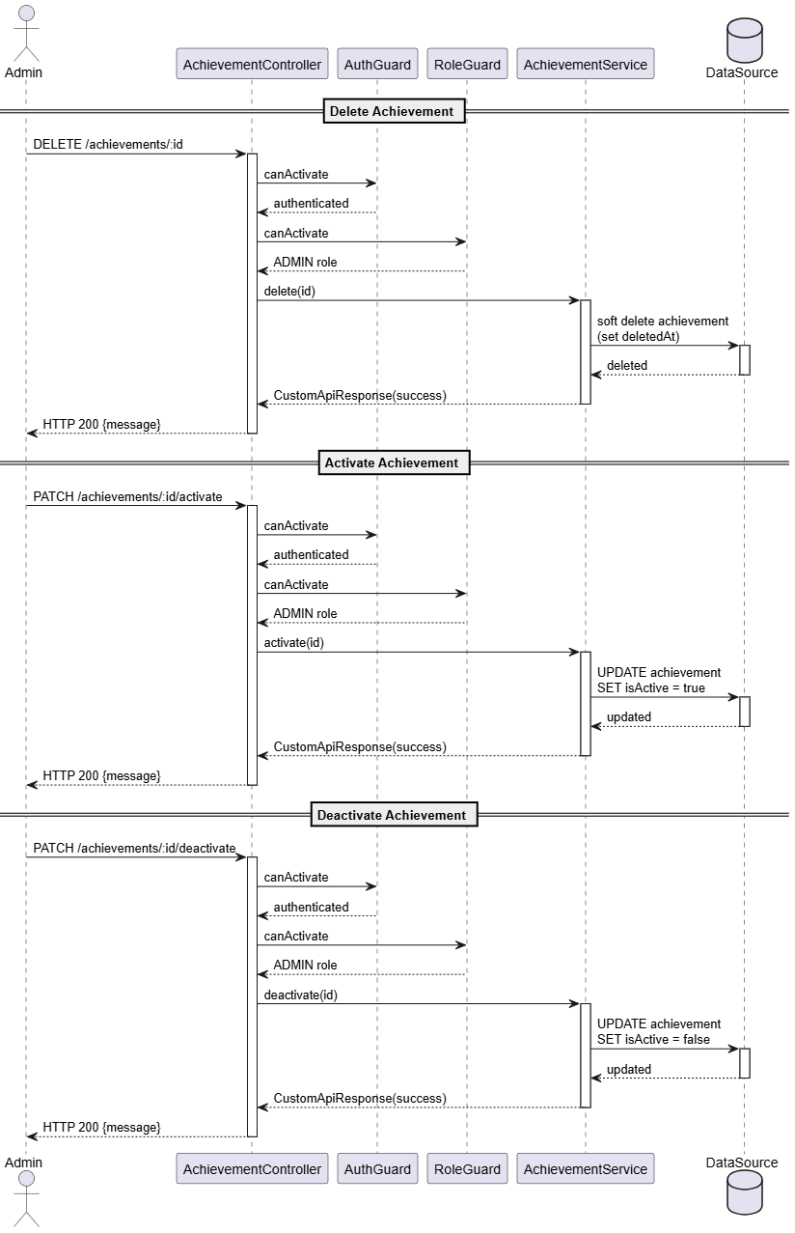

### 3.8 Manage Subject

#### 3.8.1 Class Diagram

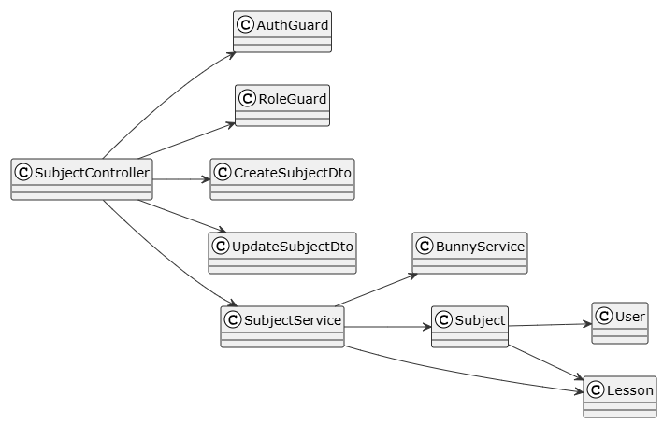

##### **Class: SubjectController**

| **No** | **Method** | **Description** |
| --- | --- | --- |
| 01 | findAll(pagination, sort, filter): Promise<PaginatedResponse<Subject>> | Retrieves all subjects with pagination sorting and filtering (Coach only AuthGuard + RoleGuard) |
| 02 | findOne(id: number): Promise<Subject> | Retrieves single subject by ID with relations (lessons) (Coach only AuthGuard + RoleGuard) |
| 03 | create(data: CreateSubjectDto, file:Express.Multer.File): Promise<Response> | Coach creates subject with optional icon upload; status defaults to DRAFT (Coach only AuthGuard + RoleGuard) |
| 04 | update(id: number, data: UpdateSubjectDto): Promise<Response> | Coach updates subject; validates ownership; validates lessons if publishing (Coach only AuthGuard + RoleGuard) |
| 05 | delete(id: number): Promise<Response> | Coach soft deletes subject; validates ownership (Coach only AuthGuard + RoleGuard) |

##### **Class: SubjectService**

| **No** | **Method** | **Description** |
| --- | --- | --- |
| 01 | findAll(findOptions): Promise<PaginatedResponse<Subject>> | Retrieves paginated list of subjects from DataSource with optional filters |
| 02 | findOne(id): Promise<Subject> | Retrieves subject with lessons relation from DataSource |
| 03 | create(data, file?): Promise<Response>" | Uploads icon to Bunny if provided; inserts subject into DataSource with status=DRAFT and createdBy=currentUser |
| 04 | update(id, data): Promise<Response> | Selects subject with lessons from DataSource; validates ownership (createdBy == currentUser); if status changing to PUBLISHED validates all lessons have video and quiz; updates subject in DataSource |
| 05 | delete(id): Promise<Response> | Selects subject from DataSource; validates ownership (createdBy == currentUser); updates subject SET deletedAt=NOW() in DataSource |

##### **Class: CreateSubjectDto**

| **No** | **Method** | **Description** |
| --- | --- | --- |
| - | None | DTO carrying name description level (BEGINNER INTERMEDIATE ADVANCED) |

##### **Class: UpdateSubjectDto**

| **No** | **Method** | **Description** |
| --- | --- | --- |
| - | None | DTO carrying name description level lessons (with name description lessonNumber video quiz) |

##### 

##### **Class: Subject**

| **No** | **Method** | **Description** |
| --- | --- | --- |
| - | None | Entity representing pickleball subject with name description level status publicUrl createdBy lessons createdAt updatedAt deletedAt |

##### 

##### **Class: Lesson**

| **No** | **Method** | **Description** |
| --- | --- | --- |
| - | None | Entity representing lesson belonging to subject with title video quiz |

##### 

##### **Class: User (Reference in 3.1.1 Login Class Diagram)**

##### **Class: BunnyService (Reference in 3.3.1 Register Coach Class Diagram)**

##### **Class: AuthGuard (Reference in 3.5.1 Manage Configuration Class Diagram)**

##### **Class: RoleGuard (Reference in 3.5.1 Manage Configuration Class Diagram)**

#### 3.8.2 View Subject

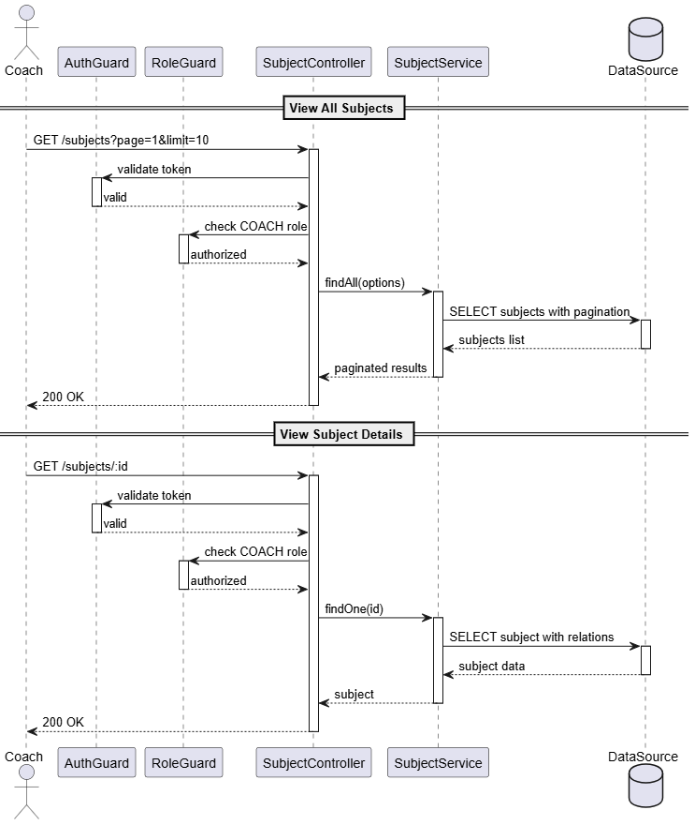

#### 3.8.3 Create Subject

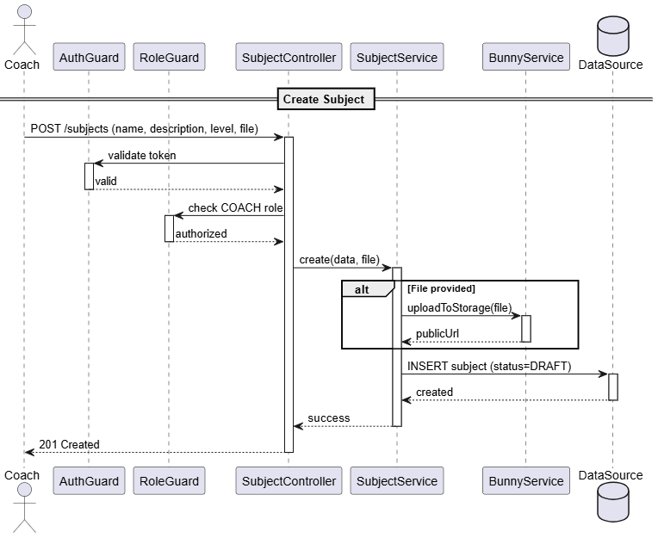

#### 3.8.4 Update Subject

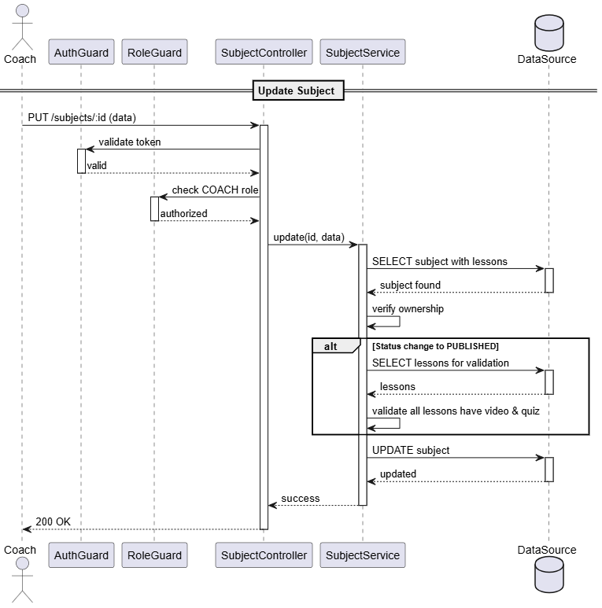

#### 3.8.5 Delete Subject

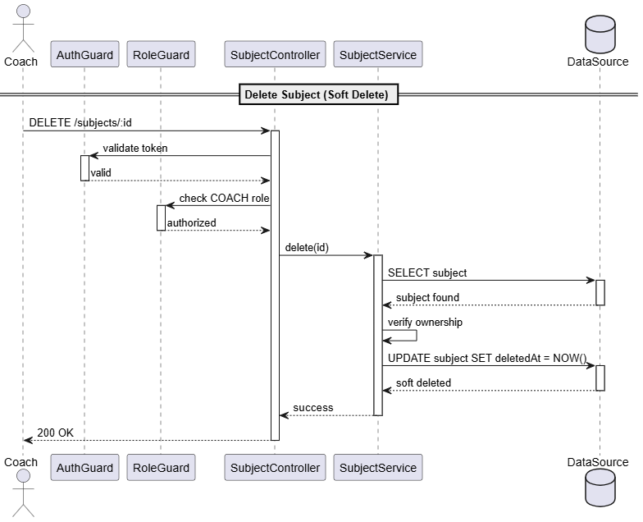

### 3.9 Manage AI-assisted Subject Generation

#### 3.9.1 Class Diagram

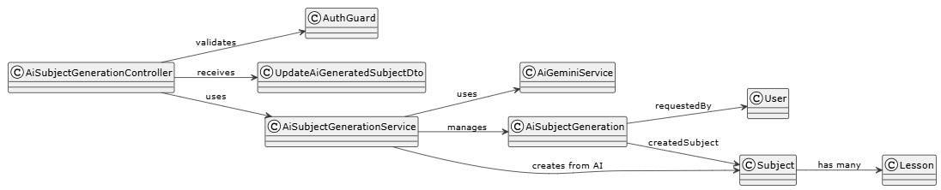

##### **Class: AiSubjectGenerationController**

| **No** | **Method** | **Description** |
| --- | --- | --- |
| 01 | findAll(pagination, sort, filter): Promise<PaginatedResponse<AiSubjectGeneration>> | Retrieves all AI subject generations with pagination sorting and filtering (Coach only AuthGuard) |
| 02 | findOne(id: number): Promise<AiSubjectGeneration> | Retrieves single AI generation by ID; validates ownership (Coach only AuthGuard) |
| 03 | create(prompt: string): Promise<AiSubjectGeneration> | Coach generates subject using AI with text prompt via Gemini API (Coach only AuthGuard) |
| 04 | useGeneratedSubject(id: number): Promise<Response> | Coach converts PENDING AI generation to actual Subject entity with status=DRAFT (Coach only AuthGuard) |
| 05 | update(id: number, data: UpdateAiGeneratedSubjectDto): Promise<Response> | Coach updates PENDING AI generation; validates ownership and PENDING status (Coach only AuthGuard) |
| 06 | delete(id: number): Promise<Response> | Coach soft deletes AI generation; validates ownership (Coach only AuthGuard) |

##### **Class: AiSubjectGeneration**

| **No** | **Method** | **Description** |
| --- | --- | --- |
| - | None | Entity representing AI-generated subject with prompt (text input) generatedData (AiSubjectGenerationResponse JSON) status (PENDING or USED) requestedBy (User relation) createdSubject (Subject relation nullable) createdAt updatedAt deletedAt |

##### **Class: AiSubjectGenerationService**

| **No** | **Method** | **Description** |
| --- | --- | --- |
| 01 | findAll(findOptions): Promise<PaginatedResponse<AiSubjectGeneration>> | Retrieves paginated list of AI generations from DataSource with optional filters |
| 02 | findOne(id): Promise<AiSubjectGeneration> | Retrieves AI generation with requestedBy relation from DataSource; validates ownership (requestedBy == currentUser) |
| 03 | create(prompt): Promise<AiSubjectGeneration> | Calls AiGeminiService.generateSubjectFromPrompt with prompt; creates AiSubjectGeneration record with status=PENDING generatedData from AI response and requestedBy=currentUser; saves to DataSource; returns saved entity |
| 04 | saveNewSubject(id): Promise<Response> | Transaction: Selects AI generation from DataSource; validates ownership and not USED; creates Subject entity with isAIGenerated=true name description level lessons from generatedData status=DRAFT and createdBy=requestedBy; inserts Subject; updates AI generation status=USED and links createdSubject; commits transaction |
| 05 | update(id, data): Promise<Response> | Selects AI generation with requestedBy and createdSubject from DataSource; validates ownership (requestedBy == currentUser); checks status != USED (throw error if USED); validates each quiz question has exactly 1 correct answer (throw error if not); updates generatedData with new name description level and lessons (with video and quiz); saves to DataSource |
| 06 | delete(id): Promise<Response> | Selects AI generation with requestedBy from DataSource; validates ownership (requestedBy == currentUser); soft deletes by setting deletedAt=NOW() in DataSource |

##### **Class: UpdateAiGeneratedSubjectDto**

| **No** | **Method** | **Description** |
| --- | --- | --- |
| - | None | DTO carrying name description level lessons (array with name description lessonNumber video object with title description tags drillName drillDescription drillPracticeSets and quiz object with title description questions array with title explanation options array with content isCorrect) |

##### **Class: Subject (Reference in 3.8.1 Manage Subject Class Diagram)**

##### **Class: Lesson (Reference in 3.8.1 Manage Subject Class Diagram)**

##### **Class: AuthGuard (Reference in 3.5.1 Manage Configuration Class Diagram)**

##### **Class: RoleGuard(Reference in 3.5.1 Manage Configuration Class Diagram)**

#### 3.9.2 View AI-assisted Subject Generation

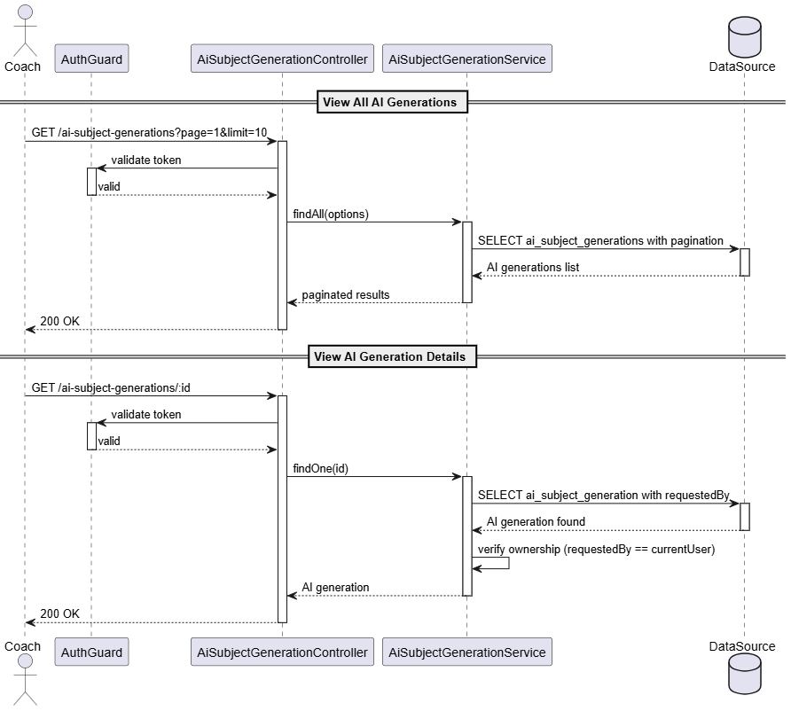

#### 3.9.3 Create AI-assisted Subject Generation

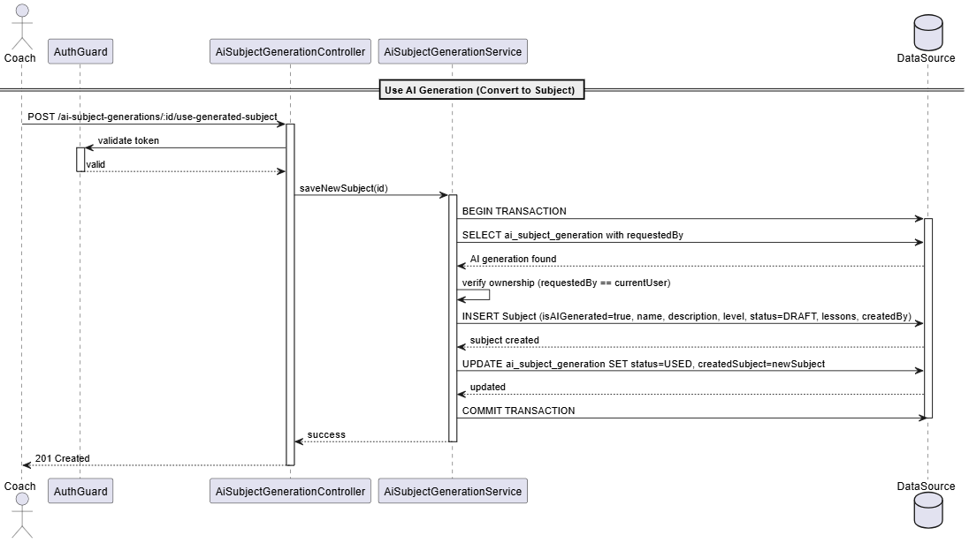

#### 3.9.4 Update AI-assisted Subject Generation

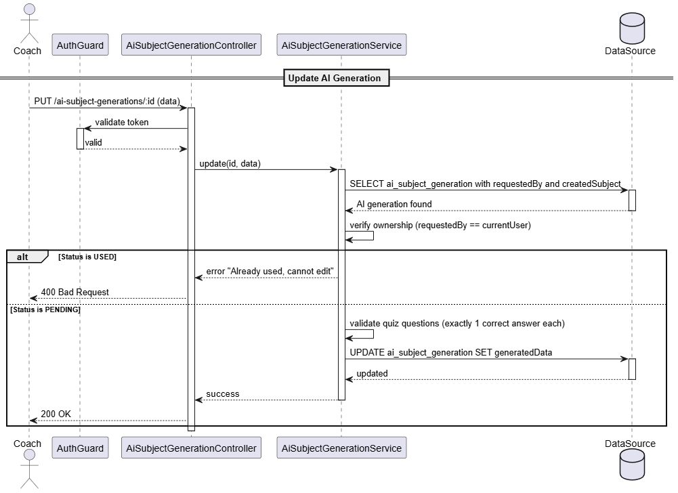

#### 3.9.5 Generate AI-assisted Subject Generation

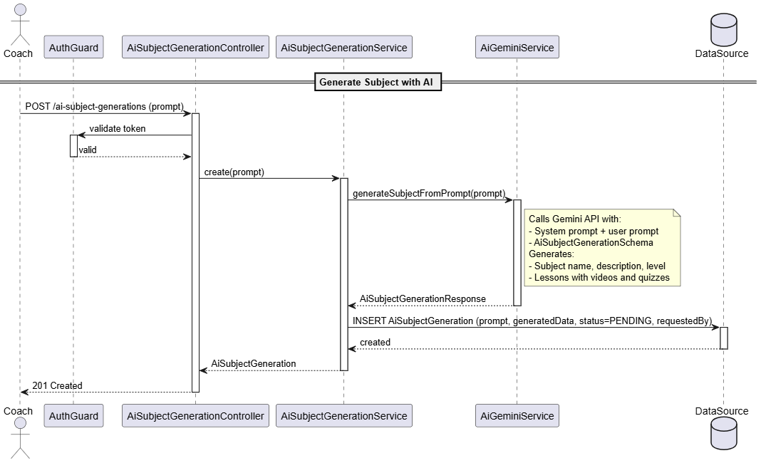

#### 3.9.6 Delete AI-assisted Subject Generation

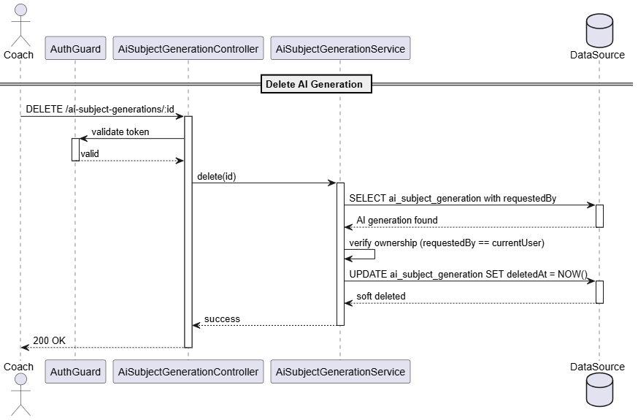

### 3.10 Manage Lesson

#### 3.10.1 Class Diagram

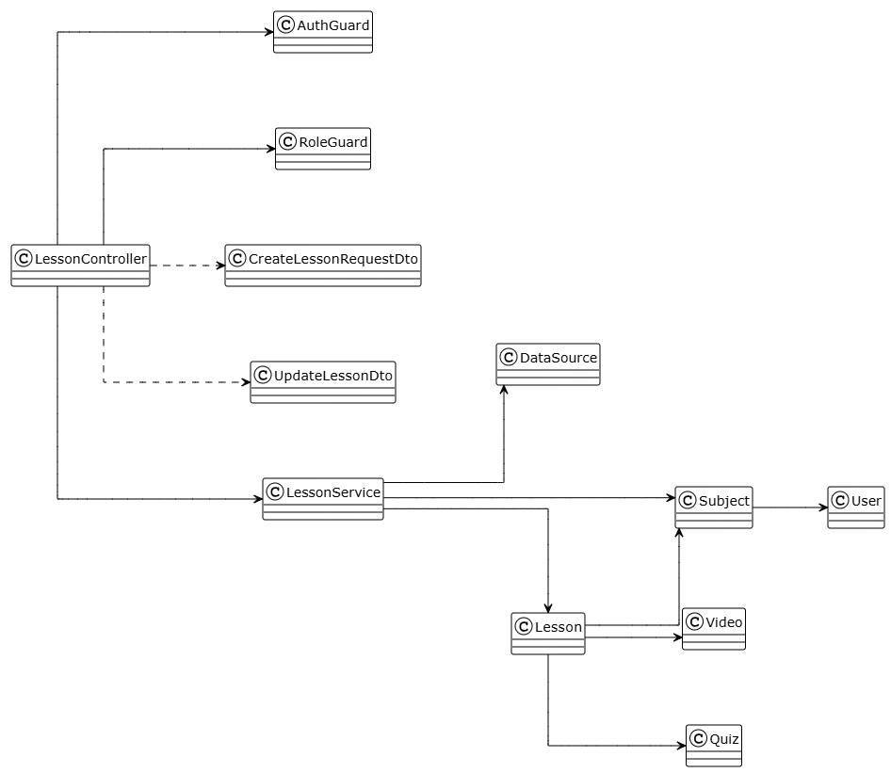

##### **Class: LessonController**

| **No** | **Method** | **Description** |
| --- | --- | --- |
| 01 | findAllBySubjectId(id, pagination, sort, filter) | Get all lessons by subject ID with pagination, sorting, filtering |
| 02 | findAllByCourseId(id, pagination, sort, filter) | Get all lessons by course ID with pagination, sorting, filtering |
| 03 | createSubject(id, data) | Create new lesson for subject with auto lessonNumber (COACH only) |
| 04 | update(id, data) | Update existing lesson properties (COACH only) |
| 05 | delete(id) | Soft delete lesson by ID (COACH only) |

##### **Class: LessonService**

| **No** | **Method** | **Description** |
| --- | --- | --- |
| 01 | findAllBySubjectId(id, pagination, sort, filter) | Get all lessons by subject ID with pagination, sorting, filtering |
| 02 | findAllByCourseId(id, pagination, sort, filter) | Get all lessons by course ID with pagination, sorting, filtering |
| 03 | createSubject(id, data) | auto-assign lessonNumber (count + 1), create lesson |
| 04 | update(id, data) | update lesson properties |
| 05 | delete(id) | soft delete lesson |

##### **Class: CreateLessonRequestDto**

| **No** | **Method** | **Description** |
| --- | --- | --- |
| - | None | Input for creating lessons. Fields: name (string), description (string, optional), duration (number, optional) |

##### **Class: UpdateLessonDto**

| **No** | **Method** | **Description** |
| --- | --- | --- |
| - | None | Input for updating lessons. All fields optional: name?, description?, duration?. |

##### **Class: Lesson**

| **No** | **Method** | **Description** |
| --- | --- | --- |
| - | None | Represents a lesson in a subject. Properties: id, name, description, duration, lessonNumber, subject (Subject), video (Video), quiz (Quiz), createdAt, updatedAt, deletedAt. |

##### **Class: Subject**

| **No** | **Method** | **Description** |
| --- | --- | --- |
| - | None | Represents a subject containing lessons. Properties: id, name, description, level, status, lessons (Lesson[]), createdBy (User) |

##### **Class: Video**

| **No** | **Method** | **Description** |
| --- | --- | --- |
| - | None | Optional video associated with lesson. Properties: id, title, publicUrl, lesson. |

##### **Class: Quiz**

| **No** | **Method** | **Description** |
| --- | --- | --- |
| - | None | Optional quiz associated with lesson. Properties: id, title, questions, lesson. |

#### 3.10.2 View Lesson

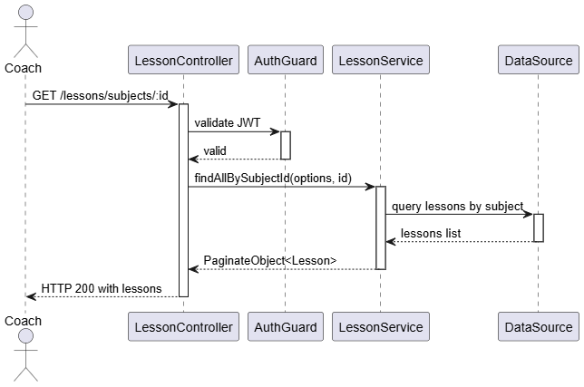

#### 3.10.3 Create Lesson

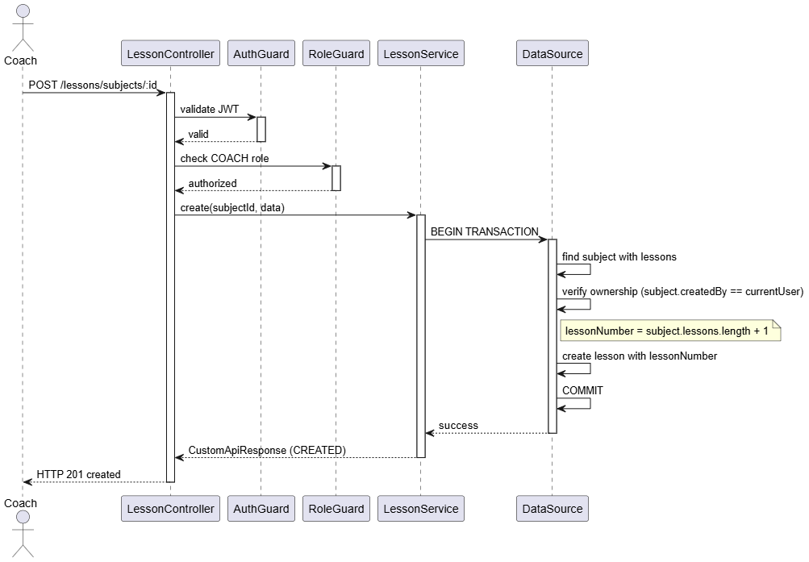

#### 3.10.4 Update Lesson

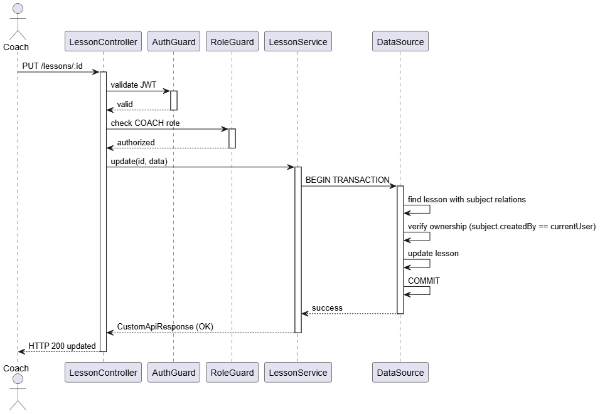

#### 3.10.5 Delete Lesson

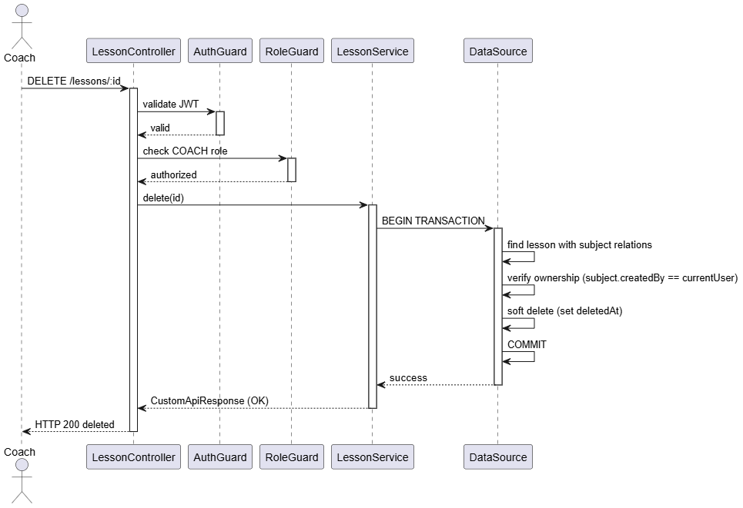

### 3.11 Manage Quiz

#### 3.11.1 Class Diagram

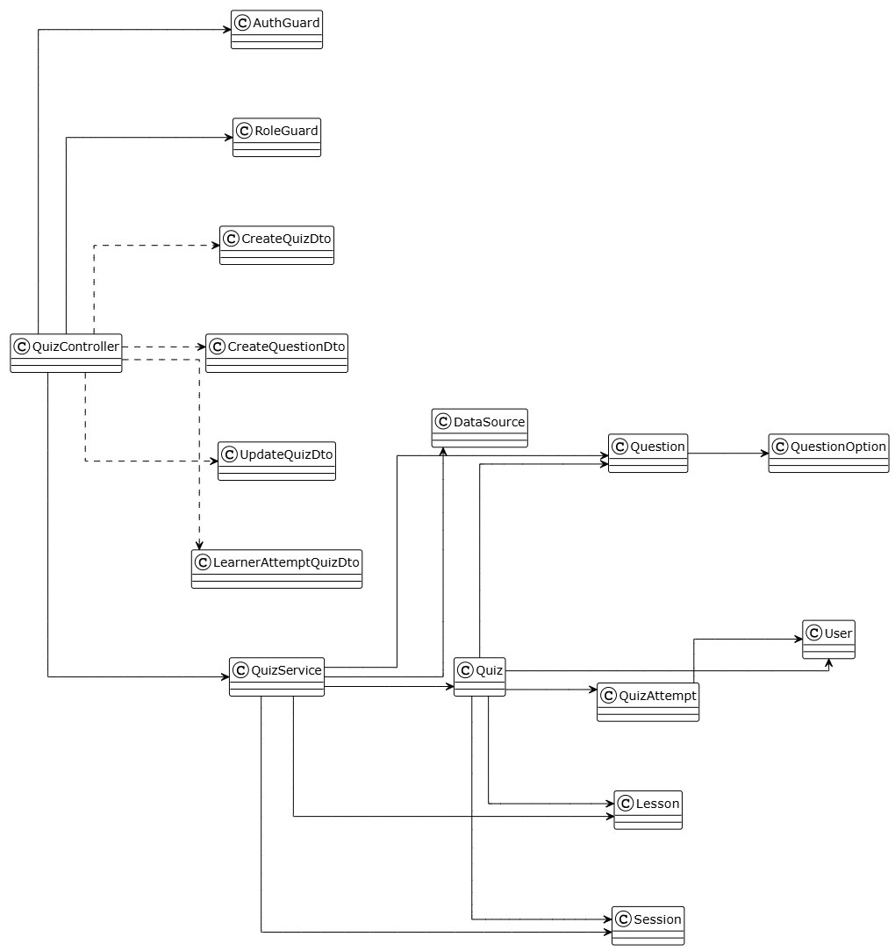

##### **Class: QuizController**

| **No** | **Method** | **Description** |
| --- | --- | --- |
| 01 | getQuizByLesson(id) | Get all quizzes by lesson ID |
| 02 | getQuizBySession(id) | Get all quizzes by session ID |
| 03 | getQuizAttemptsByQuiz(id) | Get all quiz attempts for a quiz (COACH/ADMIN) |
| 04 | getQuizAttemptsByQuizAndUser(id, userId) | Get quiz attempts by quiz ID and user ID |
| 05 | createLessonQuiz(id, data) | Create new lesson quiz with questions (COACH only) |
| 06 | createSessionQuiz(id, data) | Create new session quiz with questions (COACH only, session quiz only) |
| 07 | addQuestionsToQuiz(id, data) | Add new question to existing quiz (COACH only, lesson quiz only) |
| 08 | update(id, data) | Update quiz properties (COACH only, lesson quiz only) |
| 09 | updateQuestionInQuiz(id, questionId, data) | Update question in quiz (COACH only, lesson quiz only) |
| 10 | delete(id) | Soft delete quiz by ID (COACH only, lesson quiz only) |
| 11 | deleteQuestionFromQuiz(questionId) | Delete question from quiz (COACH only, lesson quiz only) |
| 12 | learnerAttemptQuiz(id, data) | Learner attempts quiz and submits answers (LEARNER only) |

##### **Class: QuizService**

| **No** | **Method** | **Description** |
| --- | --- | --- |
| 01 | getQuizByLesson(id) | Query quizzes by lesson ID with questions/options |
| 02 | getQuizBySession(id) | Query quizzes by session ID with questions/options |
| 03 | findQuizAttempts(quizId) | Find all attempts for a quiz |
| 04 | findQuizAttemptsByUser(quizId, userId) | Find quiz attempts by specific user |
| 05 | createLessonQuiz(id, data) | Verify lesson ownership, create quiz with questions and options |
| 06 | createSessionQuiz(id, data) | Verify session ownership, create quiz with questions and options (session quiz only) |
| 07 | createQuestion(quizId, data) | Add question with options, validate at least one correct answer (lesson quiz only) |
| 08 | update(id, data) | Update quiz properties and questions (lesson quiz only) |
| 09 | updateQuestionInQuiz(id, questionId, data) | Update question and options, validate correct answer exists (lesson quiz only) |
| 10 | delete(id) | Delete question and cascade options (lesson quiz only) |
| 11 | deleteQuestion(questionId) | Delete question and cascade options (lesson quiz only) |
| 12 | learnerAttemptQuiz(quizId, data) | Create quiz attempt, calculate score, update learner progress |

##### **Class: CreateQuizDto**

| **No** | **Method** | **Description** |
| --- | --- | --- |
| - | None | Input for creating quiz. Fields: title (string), description (string), passingScore (number), timeLimit (number), questions (CreateQuestionDto[]) |

##### **Class: CreateQuestionDto**

| **No** | **Method** | **Description** |
| --- | --- | --- |
| - | None | Input for creating questions. Fields: questionText (string), questionType (enum), order (number), points (number), options (CreateQuestionOptionDto[]) |

##### **Class: UpdateQuizDto**

| **No** | **Method** | **Description** |
| --- | --- | --- |
| - | None | Input for updating quiz. All fields optional: title?, description?, passingScore?, timeLimit?, questions (UpdateQuestionDto[]) |

##### **Class: LearnerAttemptQuizDto**

| **No** | **Method** | **Description** |
| --- | --- | --- |
| - | None | Input for learner quiz attempt. Fields: answers (array of {questionId, selectedOptions}) |

##### **Class: Quiz**

| **No** | **Method** | **Description** |
| --- | --- | --- |
| - | None | Represents a quiz for a lesson or session. Properties: id, title, description, passingScore, timeLimit, questions (Question[]), lesson (Lesson), session (Session), attempts (QuizAttempt[]), createdBy (User), createdAt, updatedAt, deletedAt. |

##### **Class: Question**

| **No** | **Method** | **Description** |
| --- | --- | --- |
| - | None | Represents a question in a quiz. Properties: id, questionText, order, options (QuestionOption[]), quiz (Quiz). |

##### **Class: QuestionOption**

| **No** | **Method** | **Description** |
| --- | --- | --- |
| - | None | Represents an answer option for a question. Properties: id, optionText, isCorrect, order, question (Question). |

##### **Class: QuizAttempt**

| **No** | **Method** | **Description** |
| --- | --- | --- |
| - | None | Represents a learner's attempt at a quiz. Properties: id, quiz (Quiz), learner (User), score, answers (JSON), passed, attemptedAt, completedAt. |

#### 3.11.2 View Quiz

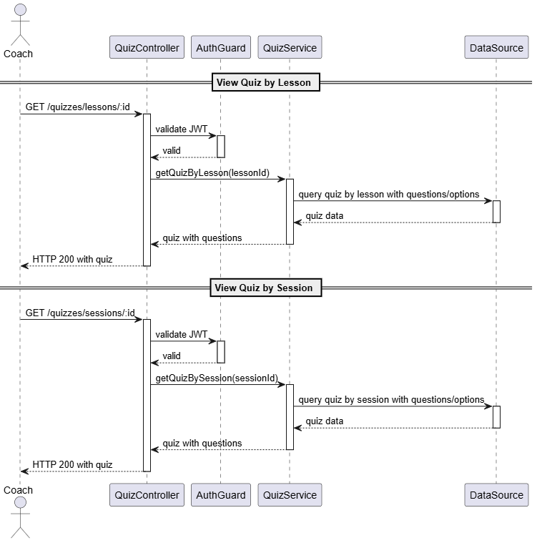

#### 3.11.3 Create Quiz

#### 

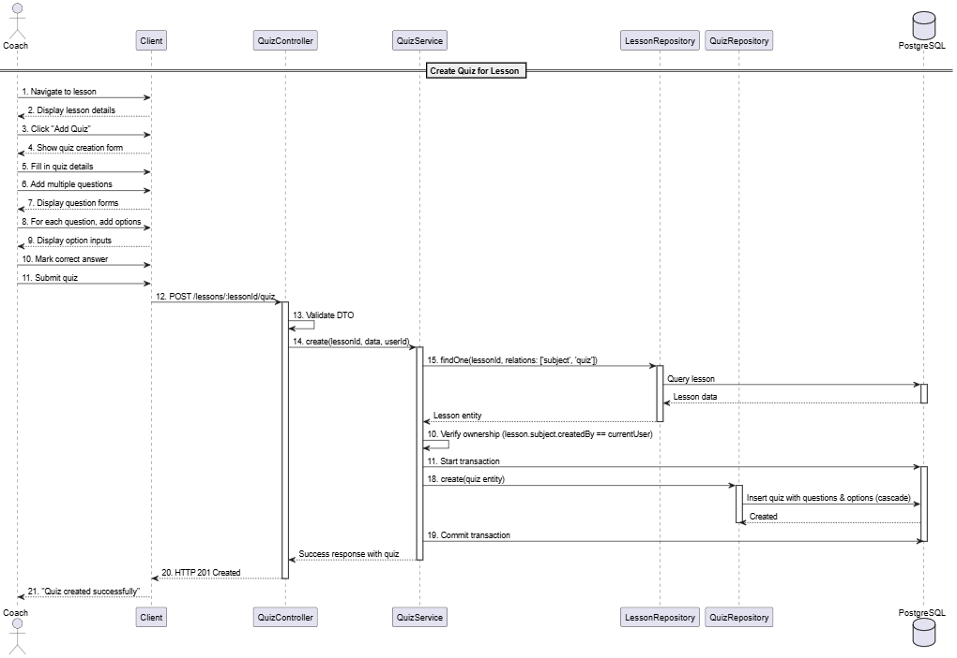

#### 3.11.4 Update Quiz

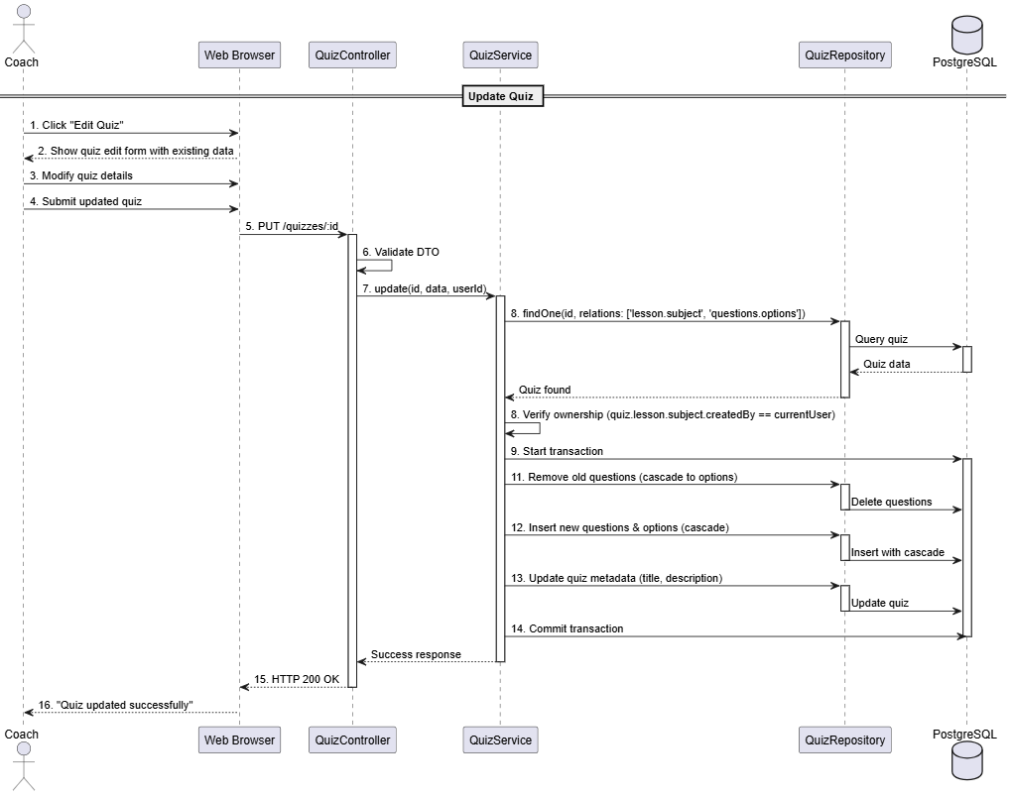

#### 3.11.5 Delete Quiz

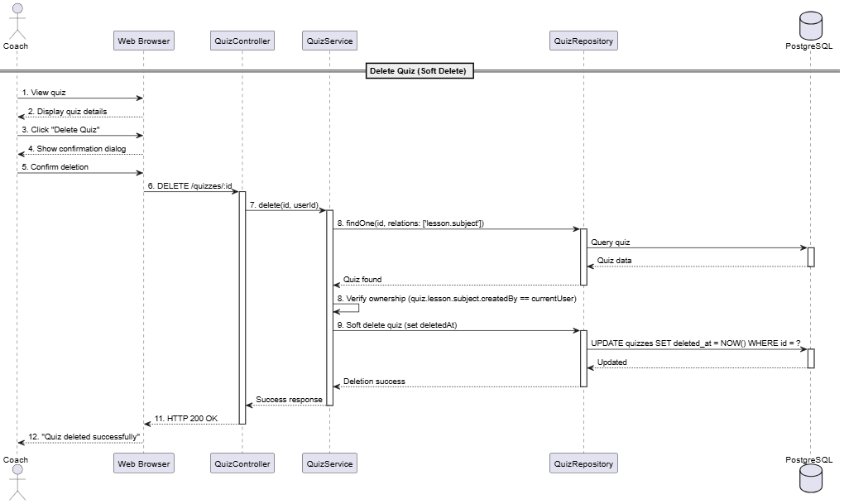

#### 3.12.6 View Attempted Quiz



#### 3.12.7 Attempt Quiz

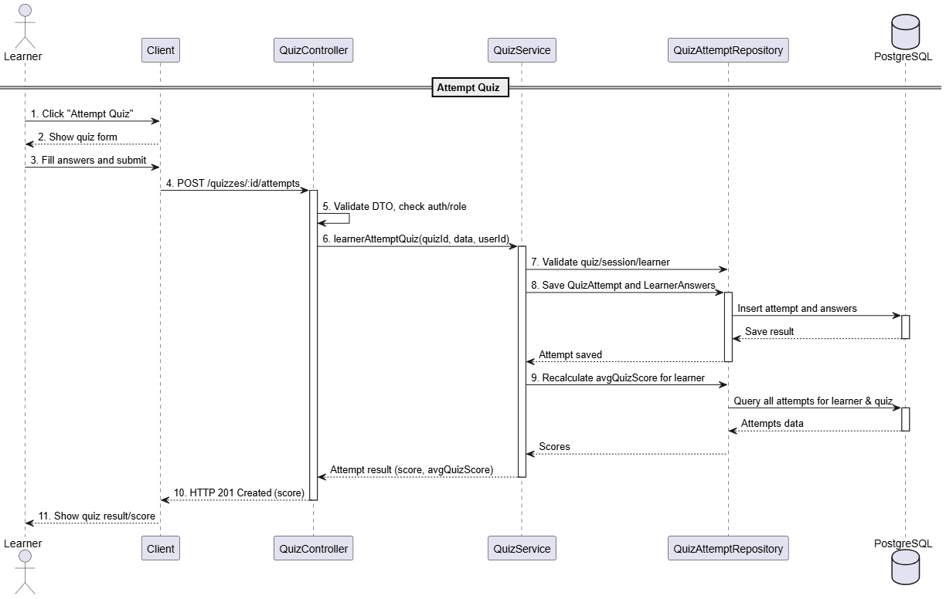

### 

### 3.12 Manage Video

#### 3.12.1 Class Diagram

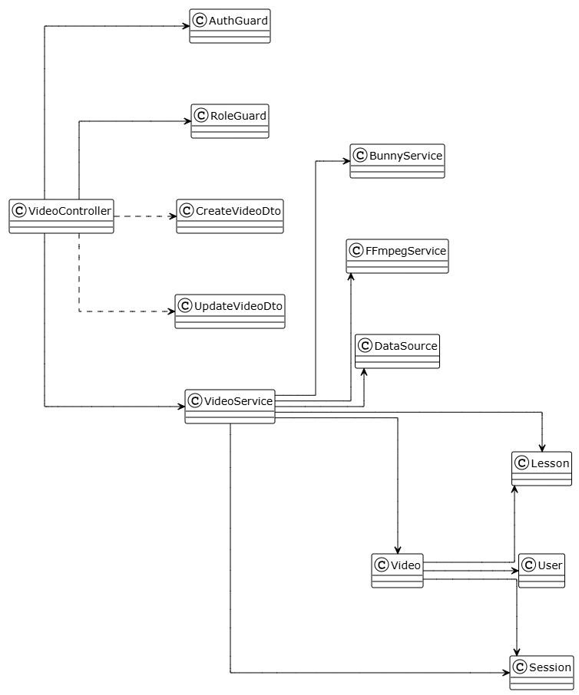

##### **Class: VideoController**

| **No** | **Method** | **Description** |
| --- | --- | --- |
| 01 | getVideosByLesson(id) | Get all videos by lesson ID with pagination |
| 02 | getVideosBySession(id) | Get all videos by session ID with pagination |
| 03 | getVideoById(id) | Get single video details by ID |
| 04 | createLessonVideo(id, videoFile, data) | Create new lesson video with file upload (COACH only) |
| 05 | uploadSessionVideo(id, videoFile, data) | Create new session video with file upload (COACH only, session video only) |
| 06 | updateVideo(id, data, videoFile?) | Update existing video with optional file replacement (COACH only, lesson video only) |
| 07 | deleteVideo(id) | Soft delete video by ID (COACH only, lesson video only) |

##### **Class: VideoController**

| **No** | **Method** | **Description** |
| --- | --- | --- |
| 01 | getVideoByLesson(lessonId) | Query videos by lesson ID, return list with relations |
| 02 | getVideoBySession(sessionId) | Query videos by session ID, return list with relations |
| 03 | getVideoById(id) | Find single video by ID with relations |
| 04 | createLessonVideo(lessonId, data, file) | Upload to Bunny CDN, extract metadata with FFmpeg, create video record |
| 05 | createSessionVideo(sessionId, data, file) | Upload to Bunny CDN, extract metadata with FFmpeg, create video record (session video only) |
| 06 | updateVideo(id, data, file?) | Optionally replace file on Bunny CDN, update video record (lesson video only) |
| 07 | deleteVideo(id) | Soft delete video (set deletedAt) (lesson video only) |

##### **Class: CreateVideoDto**

| **No** | **Method** | **Description** |
| --- | --- | --- |
| - | None | Input for creating video. Fields: title (string), description (string), drillName (string), drillDescription (string), drillPracticeSets (number) |

##### **Class: UpdateVideoDto**

| **No** | **Method** | **Description** |
| --- | --- | --- |
| - | None | Input for updating video. All fields optional: title?, description?, drillName?, drillDescription?, drillPracticeSets?. |

##### 

##### **Class: FfmpegService**

| **No** | **Method** | **Description** |
| --- | --- | --- |
| 01 | createVideoThumbnail(filePath, outputDes) | Extract video thumbnail from video file path |
| 02 | getVideoFileDuration(filePath: string) | Extract video duration from video file path |

##### **Class: Video**

| **No** | **Method** | **Description** |
| --- | --- | --- |
| - | None | Represents a video associated with a lesson or session. Properties: id, title, description, duration, publicUrl, thumbnailUrl, drillName, drillDescription, drillPracticeSets, status (PENDING/READY/PUBLISHED/REJECTED), uploadedBy (User), lesson (Lesson), session (Session), createdAt, updatedAt, deletedAt. |

##### 

#### 3.12.2 Create Video



#### 3.12.3 Update Video

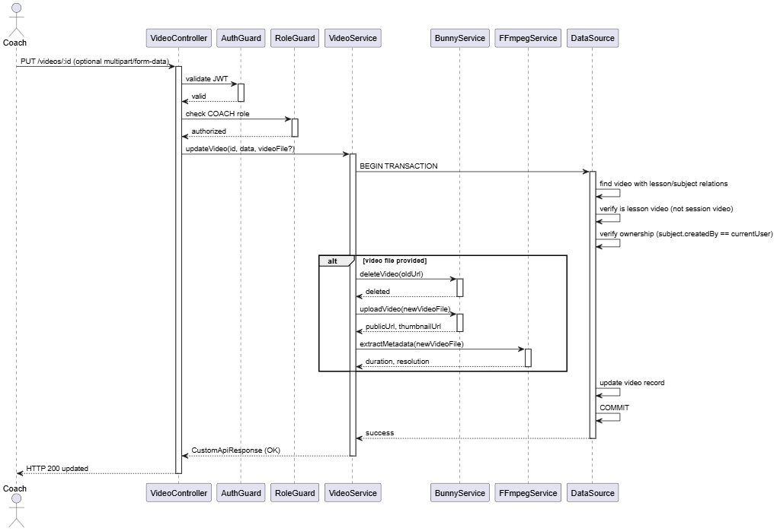

#### 3.12.4 Delete Video

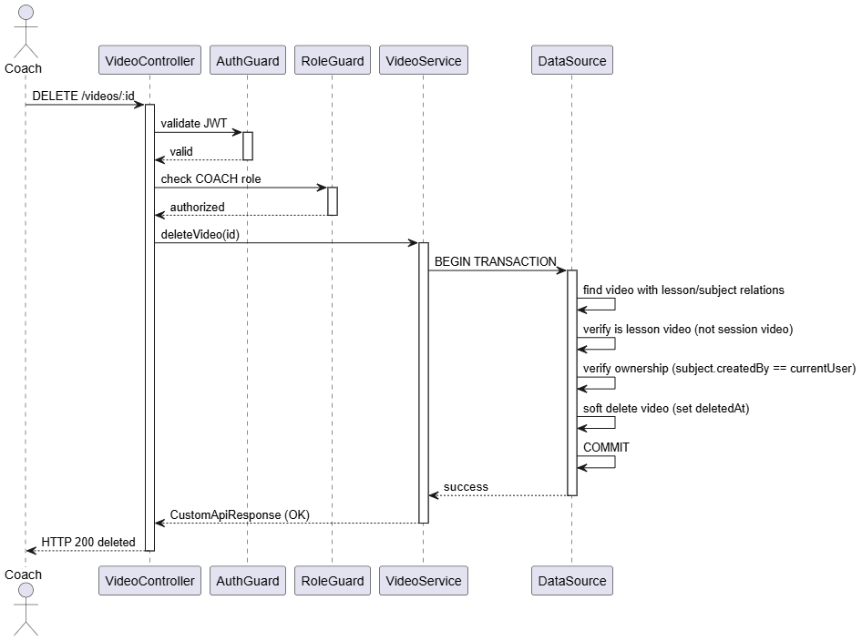

#### 3.12.5 View Video

#### 3.12.6 Learner Submit Video

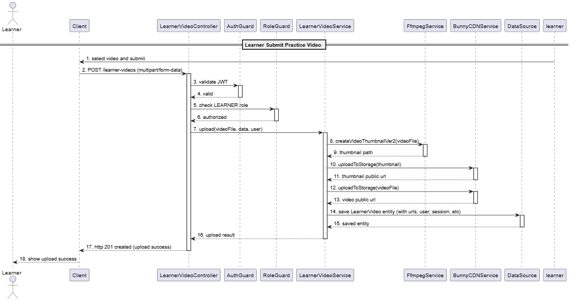

#### 3.12.7 Coach Trigger AI Comparison for learner video

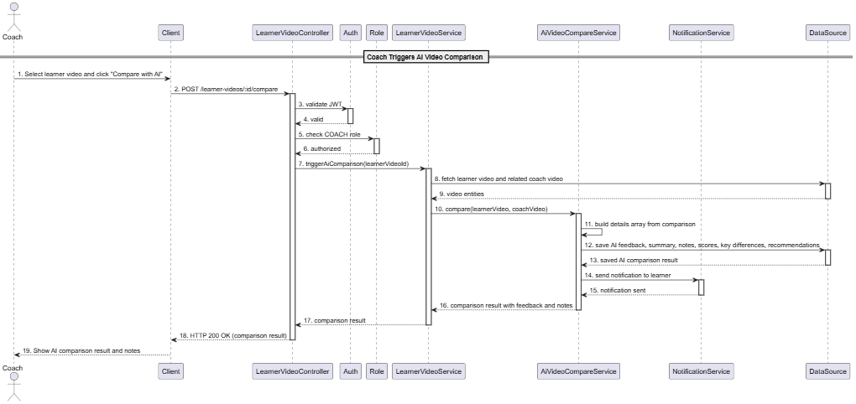

#### 3.12.8 Coach save note with AI feedback for learner video

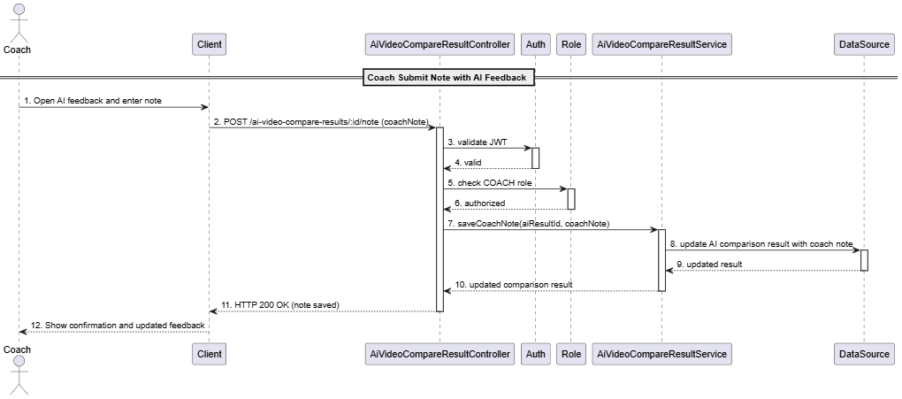

### 3.13 Manage Session

#### 3.13.1 Class Diagram

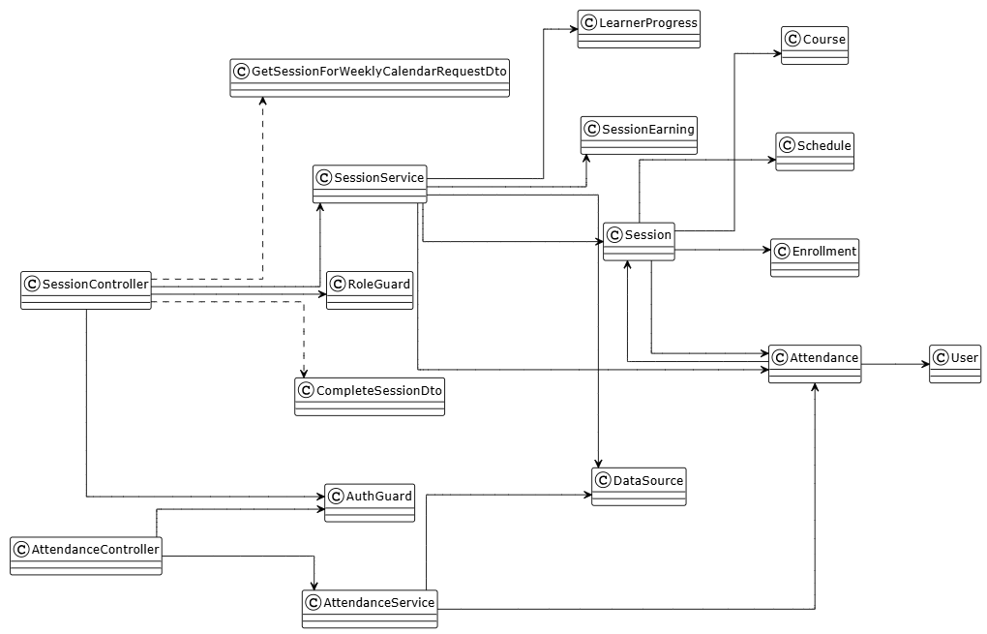

##### **Class: SessionController**

| **No** | **Method** | **Description** |
| --- | --- | --- |
| 01 | getSessionsByCourseId(courseId) | Get all sessions by course ID (COACH/LEARNER) |
| 02 | getSessionById(id) | Get single session details by ID (COACH/LEARNER) |
| 03 | getWeeklyCalendarSessions(data) | Get weekly calendar sessions for authenticated user (COACH/LEARNER) |
| 04 | completeSession(id, data) | Complete session and take attendance (COACH only) |

##### **Class: SessionService**

| **No** | **Method** | **Description** |
| --- | --- | --- |
| 01 | findByCourseId(courseId) | Query all sessions by course ID with relations |
| 02 | findOne(id) | Find single session by ID with relations (course, schedule, attendances, enrollments) |
| 03 | getSessionsForWeeklyCalendar(data) | Get sessions for weekly calendar view filtered by date range and user |
| 04 | completeSession(id, data) | Validate status, create attendance records, update progress, create earnings |

##### **Class: AttendanceController**

| **No** | **Method** | **Description** |
| --- | --- | --- |
| 01 | coachGetLearnerAttendance(sessionId, learnerId) | Get learner attendance for specific session |

##### **Class: AttendanceService**

| **No** | **Method** | **Description** |
| --- | --- | --- |
| 01 | getLearnerAttendance(sessionId, learnerId | Find attendance record for learner in specific session |

##### **Class: CompleteSessionDto**

| **No** | **Method** | **Description** |
| --- | --- | --- |
| - | None | Input for completing the session. Fields: attendances (array of {learnerId, status}) |

##### **Class: GetSessionForWeeklyCalendarRequestDto**

| **No** | **Method** | **Description** |
| --- | --- | --- |
| - | None | Input for weekly calendar query. Fields: startDate (Date), endDate (Date), userId? (number) |

##### **Class: Session**

| **No** | **Method** | **Description** |
| --- | --- | --- |
| - | None | Represents a session in a course schedule. Properties: id, name, description, sessionNumber, scheduleDate, startTime, endTime, durationInMinutes, status (PENDING/SCHEDULED/IN_PROGRESS/COMPLETED/CANCELLED), course (Course), schedule (Schedule), attendances (Attendance[]), enrollments (Enrollment[]). |

##### **Class: Attendance**

| **No** | **Method** | **Description** |
| --- | --- | --- |
| - | None | Represents learner attendance for a session. Properties: id, attendanceStatus (PRESENT/ABSENT/EXCUSED), session (Session), user (User), createdAt, updatedAt. |

##### **Class: Course**

| **No** | **Method** | **Description** |
| --- | --- | --- |
| - | None | Represents a course containing sessions. Properties: id, name, description, startDate, endDate, level, learningFormat, status, sessions (Session[]), schedules (Schedule[]), createdBy (User). |

##### **Class: Schedule**

| **No** | **Method** | **Description** |
| --- | --- | --- |
| - | None | Represents recurring schedule template for course. Properties: id, dayOfWeek, startTime, endTime, course (Course), sessions (Session[]). |

##### **Class: Enrollment**

| **No** | **Method** | **Description** |
| --- | --- | --- |
| - | None | Represents learner enrollment in course. Properties: id, course (Course), learner (User), status, enrolledAt. |

##### **Class: LearnerProgress**

| **No** | **Method** | **Description** |
| --- | --- | --- |
| - | None | Tracks learner progress in course. Properties: id, enrollment (Enrollment), sessionsCompleted, lastSessionDate. |

##### **Class: SessionEarning**

| **No** | **Method** | **Description** |
| --- | --- | --- |
| - | None | Records coach earnings from completed session. Properties: id, session (Session), coach (User), amount, createdAt. |

#### 3.13.2 View Session Calendar

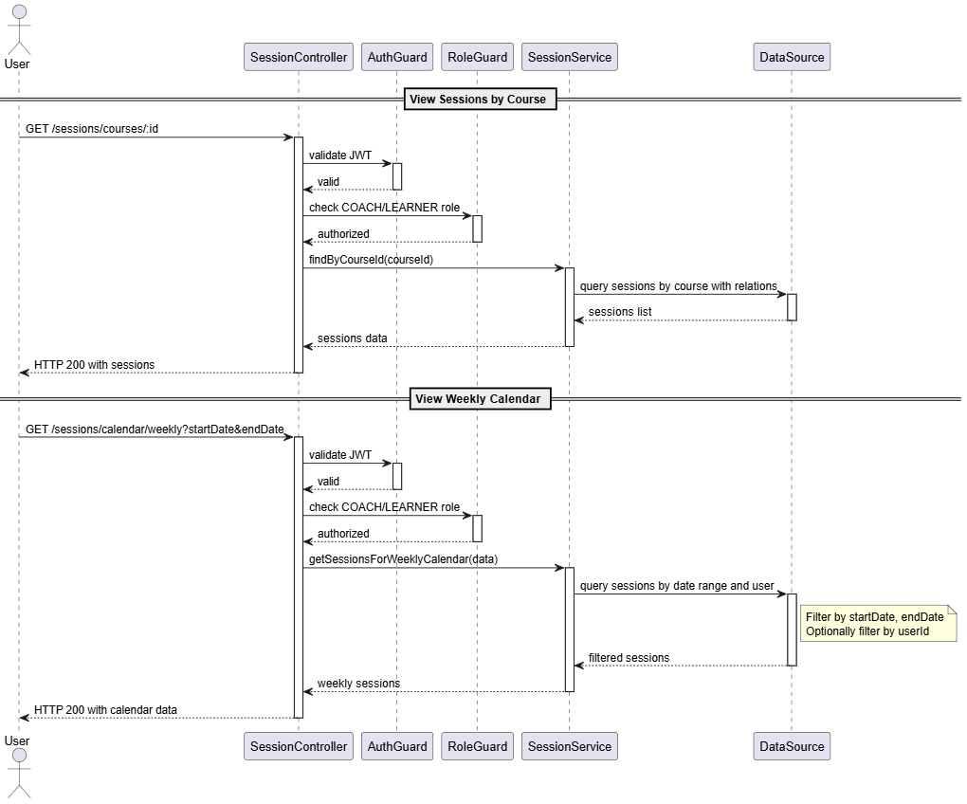

#### 3.13.2 View Session

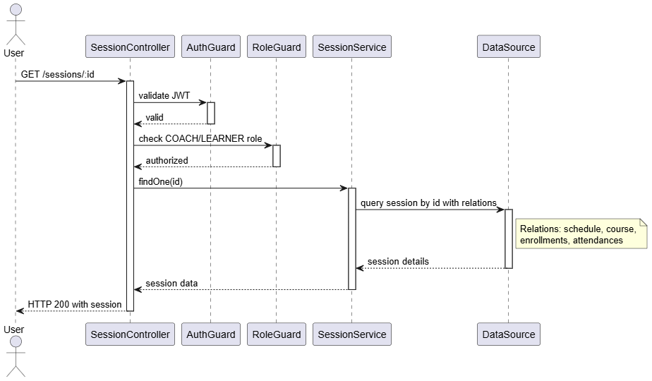

#### 3.13.3 Complete and take attendances

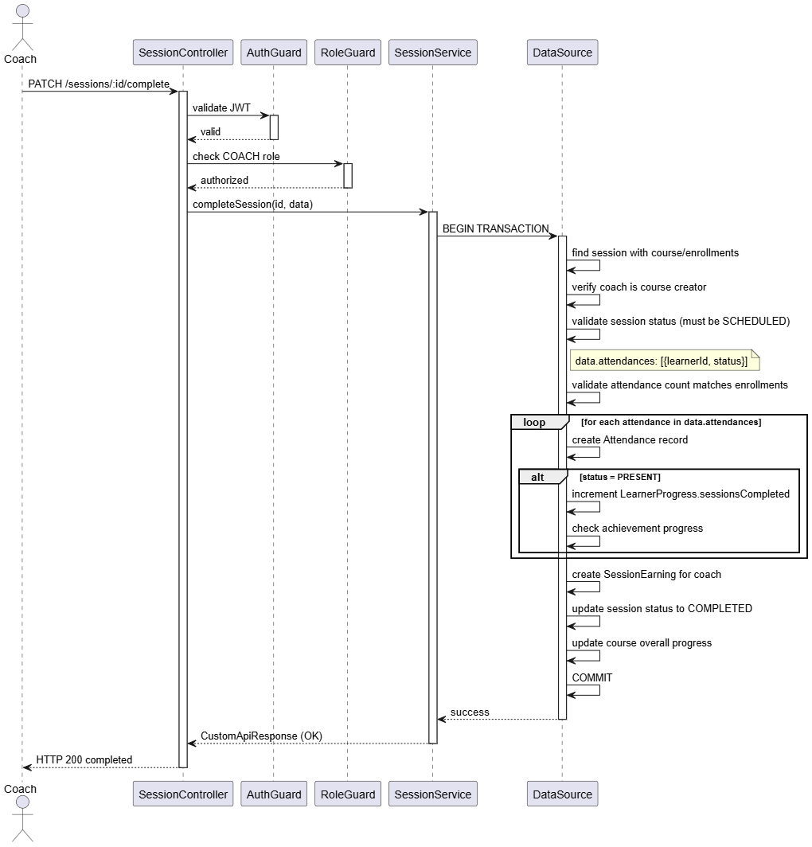

### 3.14 Manage Learner Progress

#### 3.14.1 Class Diagram

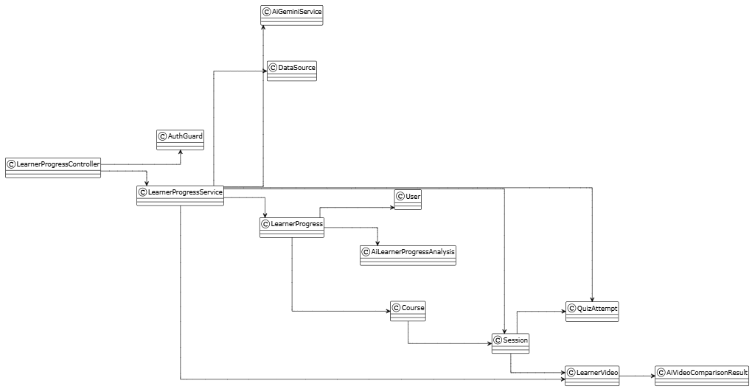

##### **Class: LearnerProgressController**

| **No** | **Method** | **Description** |
| --- | --- | --- |
| 01 | findAll(pagination, sort, filter) | Get all learner progresses with pagination, sorting, filtering |
| 02 | getProgressForCourse(courseStatus) | Get learner progresses for coach's courses filtered by course status |
| 03 | getLearnerProgressDetails(userId, courseId) | Get detailed learner progress for specific user and course with all relations |
| 04 | getAiLearnerProgressAnalysis(learnerProgressId) | Generate AI-powered analysis and recommendations for learner progress |

##### **Class: LearnerProgressService**

| **No** | **Method** | **Description** |
| --- | --- | --- |
| 01 | findAll(findOptions) | Query all learner progresses with pagination, sorting, filtering |
| 02 | getProgressForCourse(courseStatus) | Query progresses filtered by course status and coach ownership |
| 03 | getLearnerProgressDetails(userId, courseId) | Fetch detailed progress with course, sessions, videos, quizzes, attempts |
| 04 | getAiLearnerProgressAnalysis(learnerProgressId) | Aggregate progress data, call AI service, save analysis, update metrics |

##### **Class: AiGeminiService**

| **No** | **Method** | **Description** |
| --- | --- | --- |
| 01 | generateProgressAnalysis(progressData) | Call Gemini API to analyze learner progress and generate personalized recommendations |

##### **Class: LearnerProgress**

| **No** | **Method** | **Description** |
| --- | --- | --- |
| - | None | Tracks learner progress in a course. Properties: id, sessionsCompleted, totalSessions, avgAiAnalysisScore, avgQuizScore, canGenerateAIAnalysis, status (IN_PROGRESS/COMPLETED/DROPPED), user (User), course (Course), aiLearnerProgressAnalyses (AiLearnerProgressAnalysis[]), createdAt, updatedAt. |

##### **Class: AiVideoComparisonResult**

| **No** | **Method** | **Description** |
| --- | --- | --- |
| - | None | AI comparison of learner video vs coach video. Properties: id, learnerVideo (LearnerVideo), score, feedback. |

##### **Class: AiLearnerProgressAnalysis**

| **No** | **Method** | **Description** |
| --- | --- | --- |
| - | None | Stores AI-generated progress analysis. Properties: id, learnerProgress (LearnerProgress), analysis (JSON), recommendations (JSON), generatedAt. |

#### 3.14.2 View all learner progresses

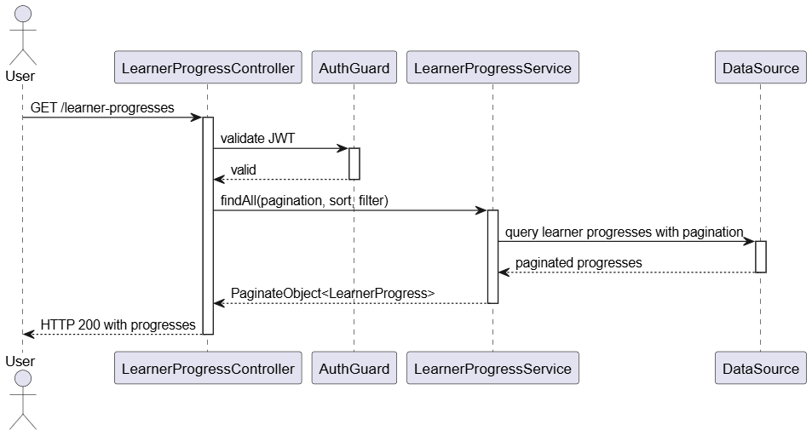

#### 3.14.3 View by course

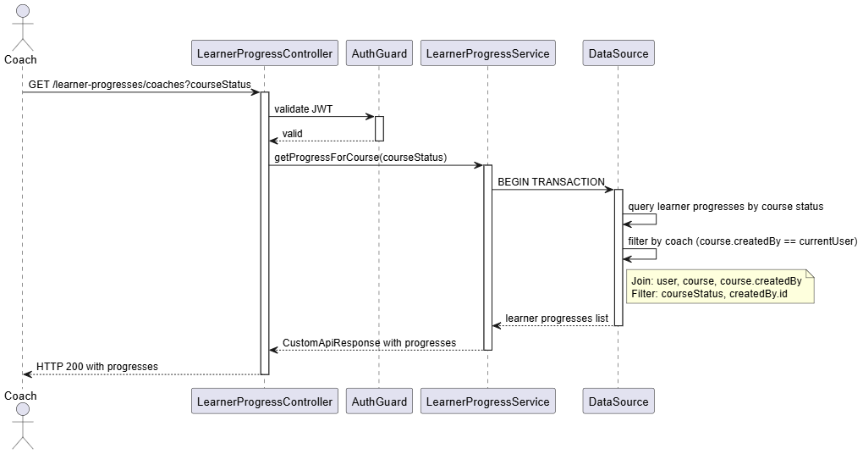

#### 3.14.4 View details

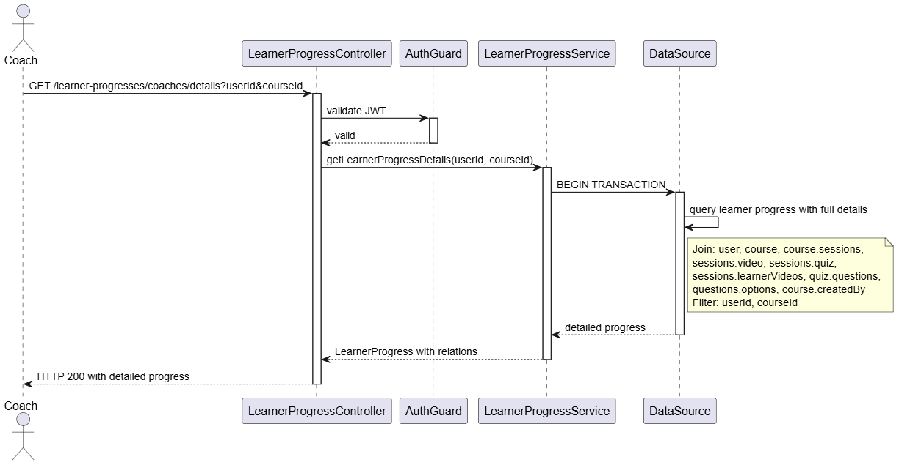

#### 3.14.5 Generate AI-assisted learning progress improvement

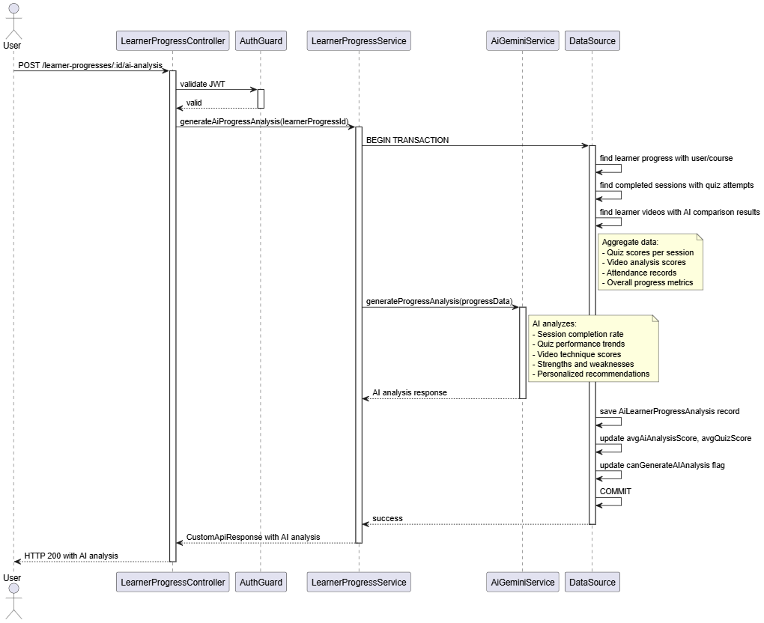

### 3.15 Manage Wallet

#### 3.15.1 Class Diagram

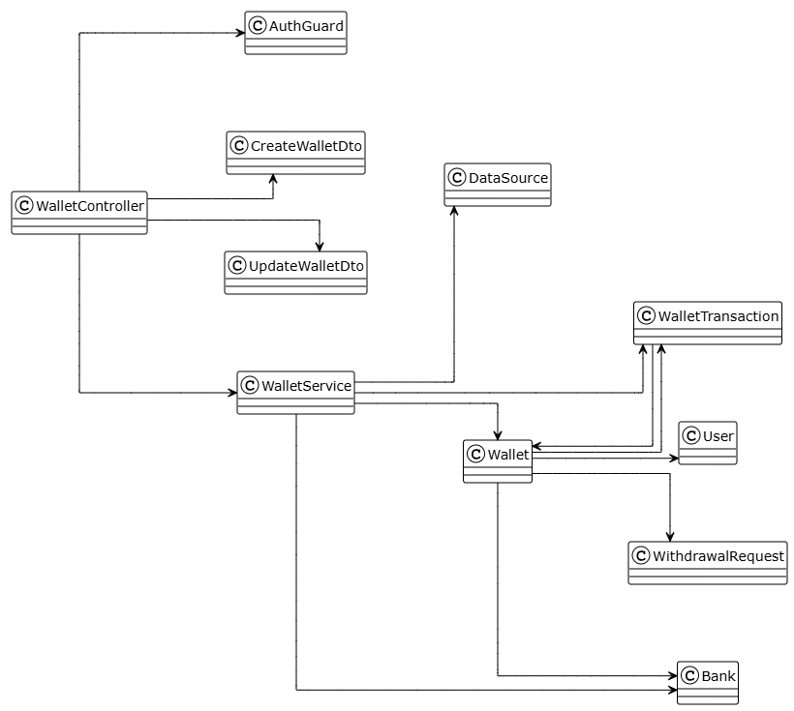

##### **Class: WalletController**

| **No** | **Method** | **Description** |
| --- | --- | --- |
| 01 | findAll(pagination, sort, filter) | Get all wallets for authenticated user with pagination, sorting, filtering |
| 02 | findBanks() | Get list of all available banks |
| 03 | findByUserId() | Get wallet by current user ID with relations |
| 04 | findOne(id) | Get specific wallet by ID with relations |
| 05 | create(CreateWalletDto) | Create new wallet for authenticated user |
| 06 | update(id, UpdateWalletDto) | Update existing wallet for authenticated user |
| 07 | requestWithdrawal(amount) | Request withdrawal from user's wallet |

##### **Class: WalletService**

| **No** | **Method** | **Description** |
| --- | --- | --- |
| 01 | findAll(pagination, sort, filter) | Query all wallets with pagination, sorting, filtering |
| 02 | findBanks() | Query all banks from database |
| 03 | findByUserId() | Find wallet by current user ID with relations (bank, transactions, withdrawalRequests) |
| 04 | findOne(id) | Find wallet by ID with relations (user, bank, transactions) |
| 05 | create(CreateWalletDto) | Create wallet with bank and account number |
| 06 | update(id, UpdateWalletDto) | Update wallet bank information |
| 07 | handleWithdrawalRequest(amount) | Process withdrawal, deduct balance, create DEBIT transaction |
| 08 | handleWalletTopUp(userId, amount) | Add funds to wallet, create CREDIT transaction, update income |

##### **Class: CreateWalletDto**

| **No** | **Method** | **Description** |
| --- | --- | --- |
| - | None | Properties: bankId (number), bankAccountNumber (string) |

##### **Class: UpdateWalletDto**

| **No** | **Method** | **Description** |
| --- | --- | --- |
| - | None | Properties: bankId (number, optional), bankAccountNumber (string, optional) |

##### **Class: Wallet**

| **No** | **Method** | **Description** |
| --- | --- | --- |
| - | None | User's wallet for managing balance. Properties: id, bankAccountNumber, currentBalance (default 0), totalIncome (default 0), user (OneToOne User), bank (ManyToOne Bank), transactions (OneToMany WalletTransaction), withdrawalRequests (OneToMany WithdrawalRequest), createdAt, updatedAt. |

##### **Class: WalletTransaction**

| **No** | **Method** | **Description** |
| --- | --- | --- |
| - | None | Records all wallet transactions. Properties: id, amount, description, type (CREDIT/DEBIT enum), wallet (ManyToOne Wallet), session (ManyToOne Session), withdrawalRequest (ManyToOne WithdrawalRequest), createdAt. |

##### **Class: Bank**

| **No** | **Method** | **Description** |
| --- | --- | --- |
| - | None | Available banks for linking. Properties: id, name, bin (bank identification number), wallets (OneToMany Wallet). |

##### **Class: WithdrawalRequest**

| **No** | **Method** | **Description** |
| --- | --- | --- |
| - | None | Withdrawal request records. Properties: id, wallet (ManyToOne Wallet), amount, status, walletTransactions (OneToMany WalletTransaction). |

#### 3.15.2 View by user

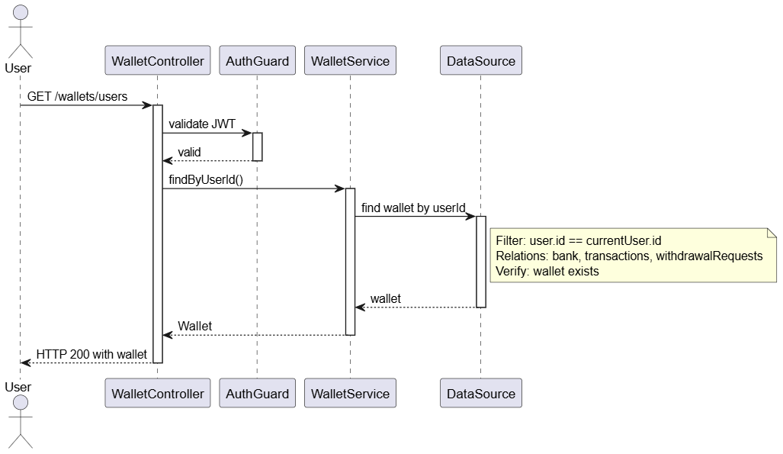

#### 3.15.3 View all

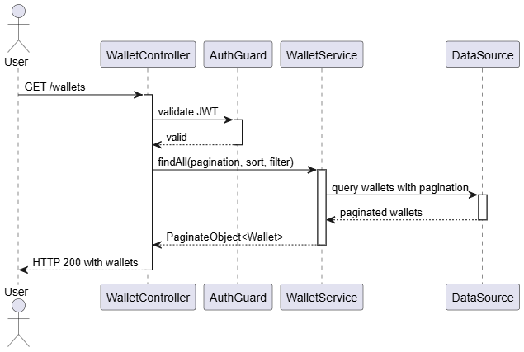

#### 3.15.4 View details

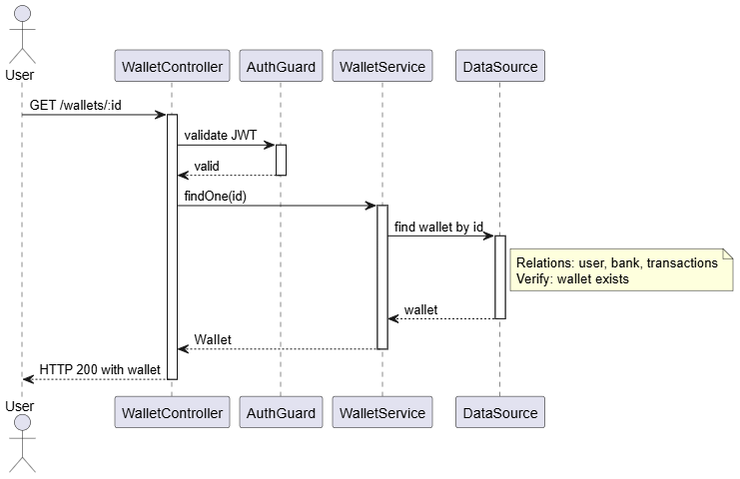

#### 3.15.5 Withdrawal

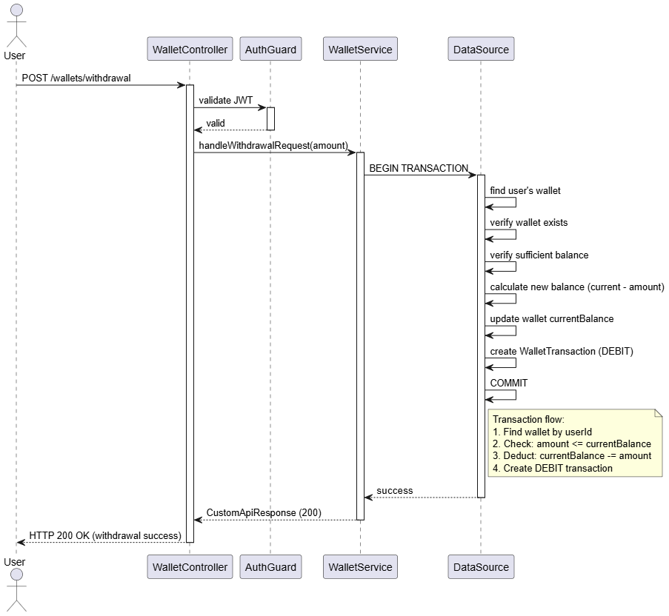

#### 3.15.6 Update wallet

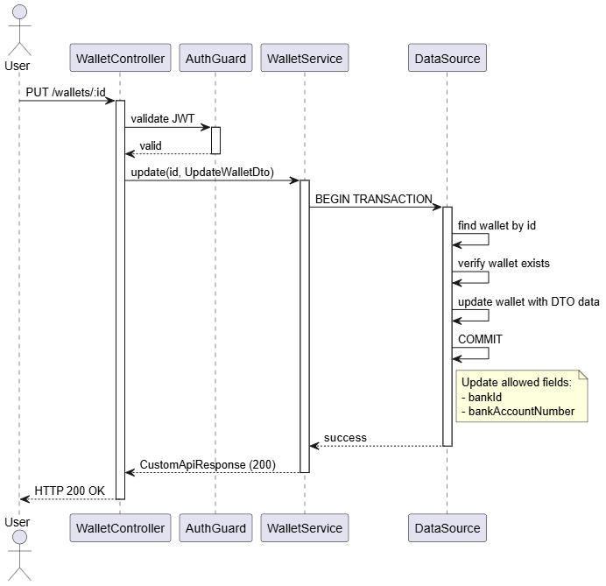

### 3.16 Manage base credential

#### 3.16.1 Class Diagram

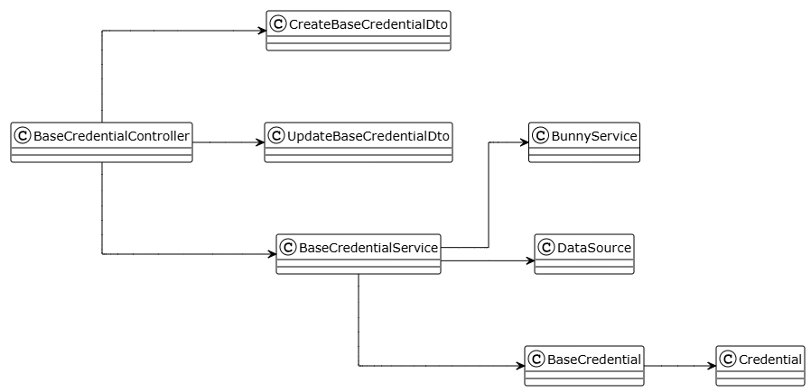

##### **Class: BaseCredentialController**

| **No** | **Method** | **Description** |
| --- | --- | --- |
| 01 | findAll(pagination, sort, filter) | Get all base credentials with pagination, sorting, filtering |
| 02 | findOne(id) | Get specific base credential by ID |
| 03 | create(CreateBaseCredentialDto, file) | Create new base credential with optional image upload |
| 04 | update(id, UpdateBaseCredentialDto, file) | Update existing base credential with optional image replacement |
| 05 | delete(id) | Soft delete base credential by ID |

##### **Class: BaseCredentialService**

| **No** | **Method** | **Description** |
| --- | --- | --- |
| 01 | findAll(pagination, sort, filter) | Query all base credentials with pagination, sorting, filtering |
| 02 | findById(id) | Find base credential by ID |
| 03 | create(CreateBaseCredentialDto, file) | Upload image to Bunny CDN, create credential |
| 04 | update(id, UpdateBaseCredentialDto, file) | Upload new image if provided, update credential |
| 05 | delete(id) | Soft delete base credential by ID |

##### **Class: CreateBaseCredentialDto**

| **No** | **Method** | **Description** |
| --- | --- | --- |
| - | None | Properties: name (string, 2-255 chars), description (string, optional), type (CourseCredentialType enum), publicUrl (string, optional, auto-assigned from upload) |

##### **Class: UpdateBaseCredentialDto**

| **No** | **Method** | **Description** |
| --- | --- | --- |
| - | None | Properties: name (string, optional), description (string, optional), type (CourseCredentialType enum, optional), publicUrl (string, optional, auto-assigned from upload) |

##### **Class: BaseCredential**

| **No** | **Method** | **Description** |
| --- | --- | --- |
| - | None | Base credential template for courses. Properties: id, name, description, type (CourseCredentialType enum: CERTIFICATE/BADGE/LICENSE), publicUrl (image URL), credentials (OneToMany Credential), createdAt, updatedAt, deletedAt. |

##### **Class: Credential**

| **No** | **Method** | **Description** |
| --- | --- | --- |
| - | None | Course-specific credential instances. Properties: id, baseCredential (ManyToOne BaseCredential), course, learner. |

#### 3.16.2 View All

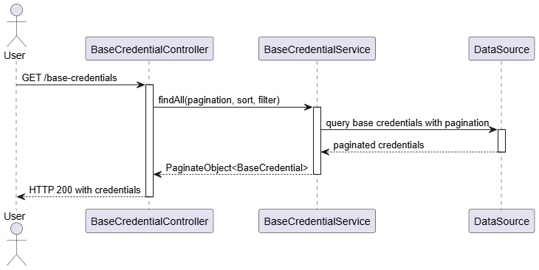

#### 3.16.2 View One

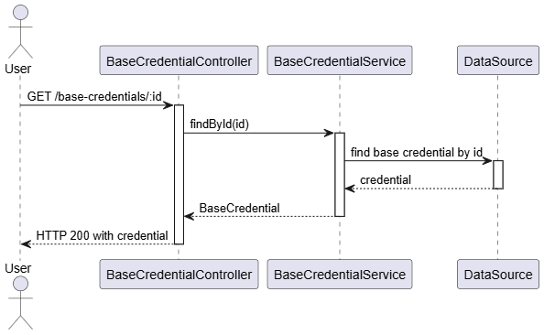

#### 3.16.3 Create base credential

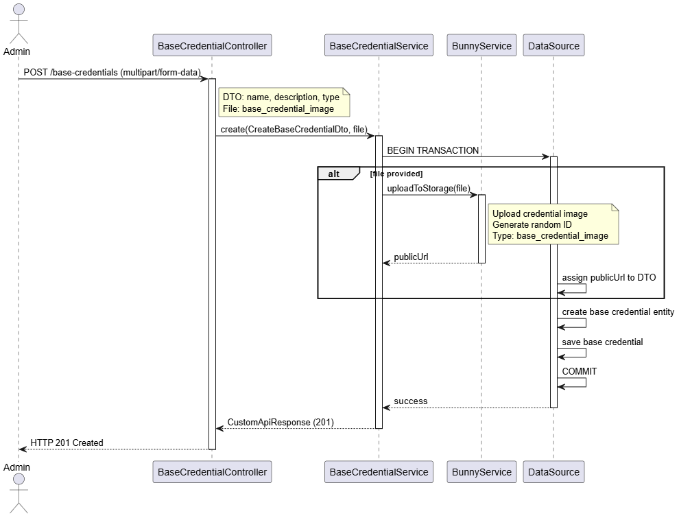

#### 3.16.4 Update base credential

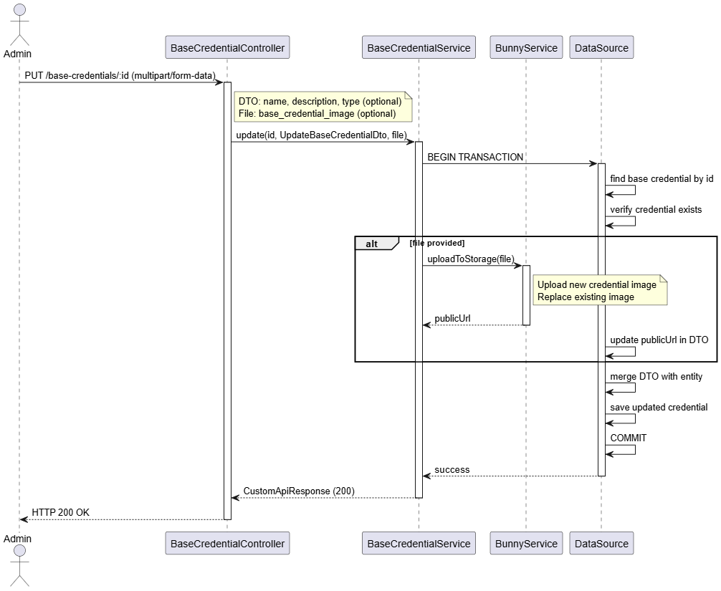

#### 3.16.5 Delete base credential

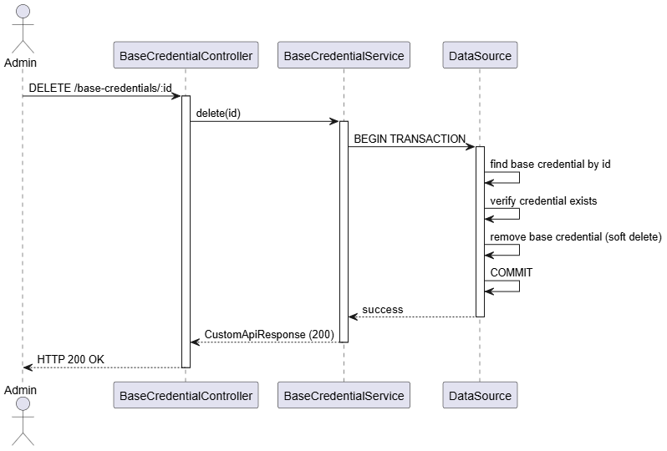

### 3.17 Manage Court

#### 3.17.1 Class Diagram

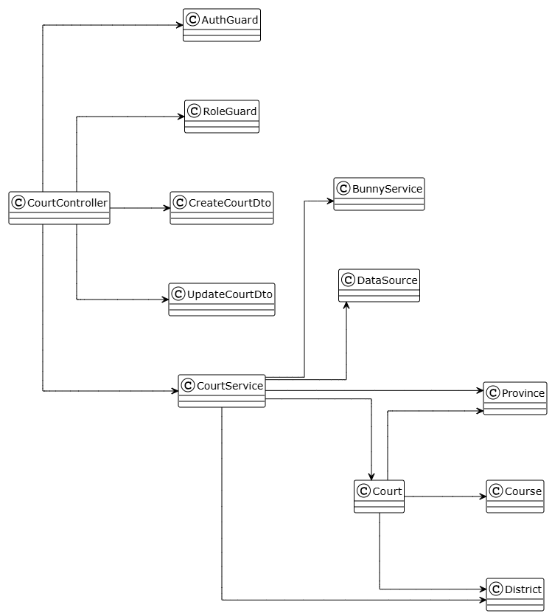

##### **Class: CourtController**

| **No** | **Method** | **Description** |
| --- | --- | --- |
| 01 | findAll(pagination, sort, filter) | Get all courts with pagination, sorting, filtering |
| 02 | findOne(id) | Get specific court by ID (public access) |
| 03 | create(CreateCourtDto, file) | Create new court with optional image upload (Admin only) |
| 04 | update(id, UpdateCourtDto, file) | Update existing court with optional image replacement (Admin only) |
| 05 | delete(id) | Soft delete court by ID (Admin only) |

##### **Class: CourtService**

| **No** | **Method** | **Description** |
| --- | --- | --- |
| 01 | findAll(findOptions) | Query all courts with pagination, sorting, filtering |
| 02 | findOne(id) | Find court by ID |
| 03 | create(CreateCourtDto, file) | validate province/district, upload image to Bunny CDN, create court |
| 04 | update(id, UpdateCourtDto, file) | validate court exists, update province/district if provided, upload new image if provided, update court |
| 05 | delete(id) | verify court exists, soft delete court |

##### **Class: CreateCourtDto**

| **No** | **Method** | **Description** |
| --- | --- | --- |
| - | None | Properties: name (string, required, max 100), phoneNumber (string, optional, VN format), pricePerHour (number, required, min 0), publicUrl (string, optional, auto-assigned), address (string, required), latitude (number, optional), longitude (number, optional), provinceId (number, required), districtId (number, required) |

##### **Class: UpdateCourtDto**

| **No** | **Method** | **Description** |
| --- | --- | --- |
| - | None | Properties: name (string, optional), phoneNumber (string, optional), pricePerHour (number, optional), publicUrl (string, optional, auto-assigned), address (string, optional), latitude (number, optional), longitude (number, optional), provinceId (number, optional), districtId (number, optional) |

##### **Class: Court**

| **No** | **Method** | **Description** |
| --- | --- | --- |
| - | None | Sports court/venue for courses. Properties: id, name, phoneNumber (unique), pricePerHour, publicUrl (image URL), address, latitude, longitude, province (ManyToOne Province, eager), district (ManyToOne District, eager), courses (OneToMany Course), createdAt, updatedAt, deletedAt. |

##### **Class: Province**

| **No** | **Method** | **Description** |
| --- | --- | --- |
| - | None | Province/city for location. Properties: id, name, courts (OneToMany Court). |

##### **Class: District**

| **No** | **Method** | **Description** |
| --- | --- | --- |
| - | None | District/ward for location. Properties: id, name, courts (OneToMany Court). |

#### 3.17.2 View all

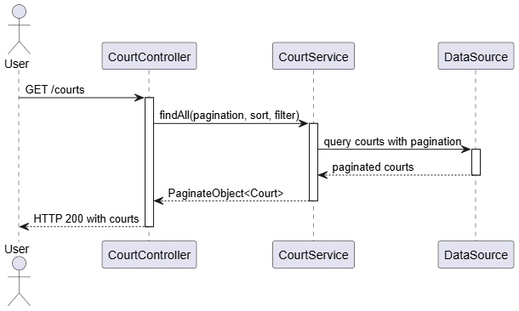

#### 3.17.3 View details

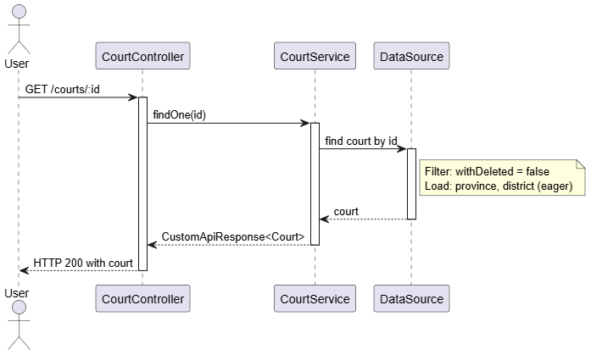

#### 3.17.4 Create court

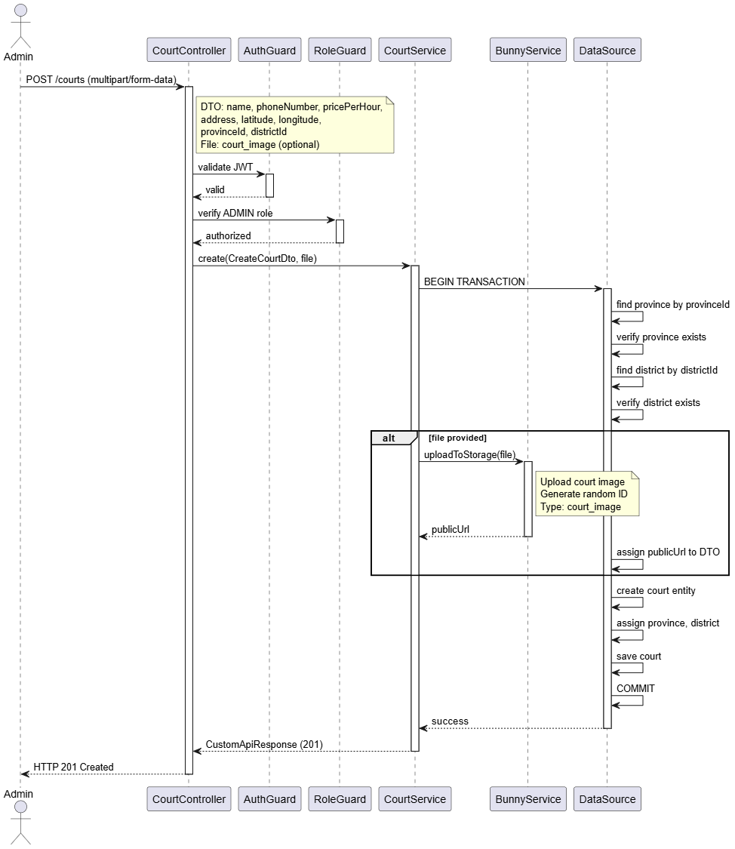

#### 3.17.5 Update court

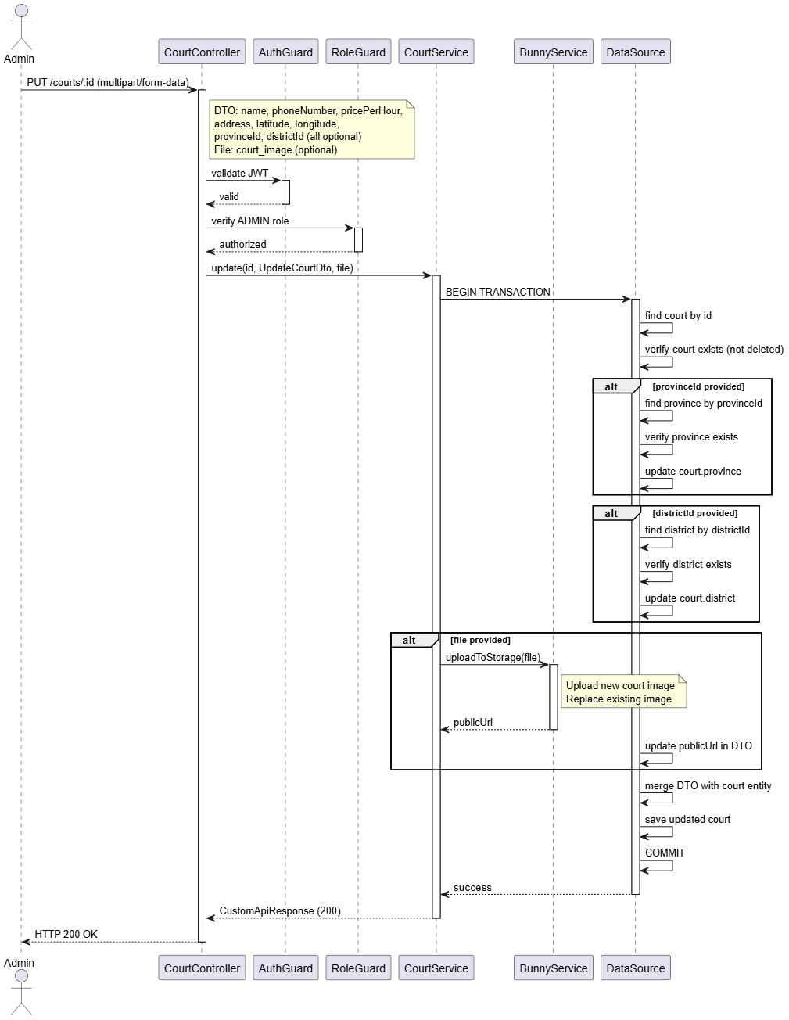

#### 3.17.6 Delete court

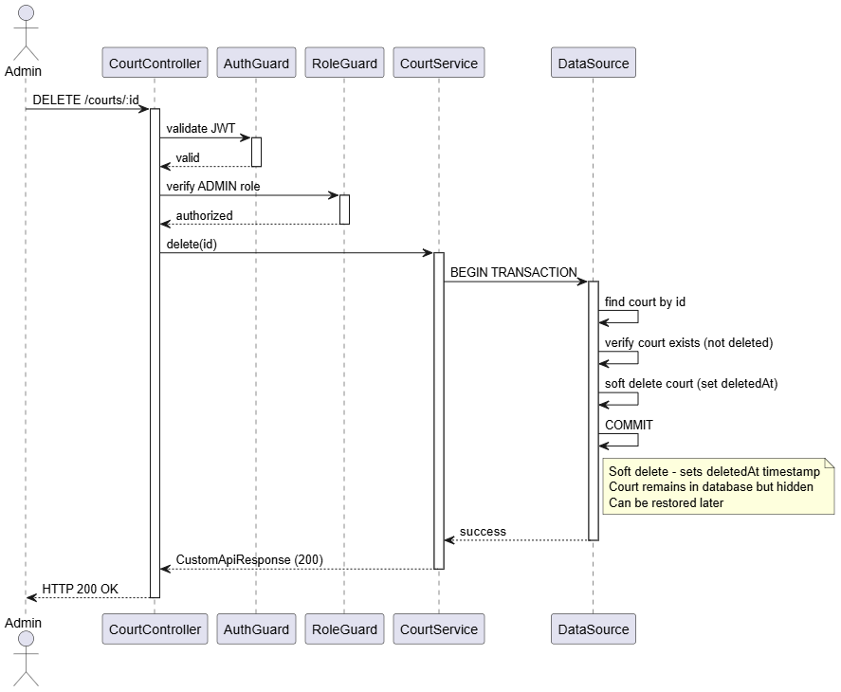

# V. Software Testing Documentation

## 1. Scope of Testing

1.1 Scopes of Test

1. **Features & Functions to Be Tested**
2. User Authentication & Authorization

* Login, Register, Logout
* Role-based access (Learner, Coach, Admin)

1. Learner Course Module

* View course list
* View course details
* View lessons
* Upload practice video
* Receive AI feedback

1. Coach panel

* View student’s submitted practice video
* Provide manual coaching feedback
* Review course history

1. Admin panel

* Manage course
* Manage account
* Monitor system activities

1. AI Analysis Pipeline

* Video upload → processing
* Receive results from AI model
* Display analysis score & suggestions

1. Non-functional Requirements

* Performance (video upload time, response time)
* Reliability (no crash)
* Security (token validation, password hashing)
* Usability (UI/UX clarity)

1. **Features Not Tested**

* Advanced machine learning accuracy benchmarking
* Cross-platform browser compatibility
* Stress testing for 1,000+ concurrent users
* Payment gateway (not in scope)

1.2 Testing level

* Unit testing
* **In-charge:** Backend + Mobile Developers
* **Focus:** API validation, UI handlers, utility functions
* **Acceptance Criteria:**
* Functions return expected values
* API status codes correct
* No logic-breaking errors

### Integration Testing

* **In-charge:** Developers + QA (Quality Assurance)
* **Focus:**
* Mobile App ↔ Backend
* Video Upload ↔ Storage
* **Acceptance Criteria:**
* Modules communicate correctly
* No broken data flow
* Upload-process-download works
* System Testing
* **In-charge:** QA team
* **Focus:** End-to-end flow
* **Acceptance Criteria:**
* All main user journeys run without error
* System meets SRS requirements

1.3 Constraints and Assumptions

* Constraints
* Video upload speed dependent on network
* Backend hosted locally during development
* Assumptions
* Users have stable internet
* All team members can maintain test environment
* Test accounts are available and functional

## 2. Test Strategy

### 2.1 Testing Types

1. Functional Testing

* **Objective:** Verify all functions match requirements
* **Technique:** Black-box, scenario-based
* **Completion Criteria:** All test cases passed, no major defects left

1. Integration Testing

* **Objective:** Ensure connected modules function correctly
* **Technique:** API integration tests, data flow validation
* **Completion Criteria:** All interfaces return correct data

1. Usability Testing

* **Objective:** Ensure UI is intuitive for learners & coaches
* **Technique:** User observation, heuristic evaluation
* **Completion Criteria:** No critical UX blockers

1. Performance Testing

* **Objective:** Ensure upload/AI processing within acceptable time
* **Technique:** Load tests, manual measurement
* **Completion Criteria:**
* Video upload < 15 seconds
* AI results < 25 seconds

1. Security Testing

* **Objective:** Validate safety of user data & authentication
* **Technique:** Token validation check, role-access testing
* **Completion Criteria:** Unauthorized access attempts blocked

### 2.2 Test Levels

| **Type of Tests** | **Test Level** | | | |
| --- | --- | --- | --- | --- |
| **Unit** | **Integration** | **System** | **Acceptance** |
| Functional Testing | X | X | X | X |
| Integration Testing |  | X | X |  |
| Performance Testing | X | X | X |  |
| Usability Testing |  |  | X | X |
| Security Testing | X | X | X |  |

### 2.3 Supporting Tools

| **Purpose** | **Tool** | **Vendor/In-house** | **Version** |
| --- | --- | --- | --- |
| API Testing | Postman | Postman Inc | Latest |
| Mobile testing | Expo go | Expo | Latest |
| Issue Tracking | Github issus | Github | - |
| UI testing | Android/iOS simulator | Apple/Google | Android 8.0+  IOS 13+ |

## 3. Test Plan

### 3.1 Human Resources

| **Worker/Doer** | **Role** | **Specific Responsibilities/Comments** |
| --- | --- | --- |
| HungLT | Backend Dev | Unit testing API, Integration with AI |
| TuanNA | Mobile Dev | Unit test components, integration testing |
| HoaiNTT | Tester | System test, report defects |
| QuangDM | Tester | System test, report defects |

### 3.2 Test Environment

| **Purpose** | **Tool** | **Provider** | **Version** |
| --- | --- | --- | --- |
| Mobile testing | Android Emulator | Google | 8+ |
| Mobile testing | iOS Emulator | Apple | 13+ |
| Backend | NestJs Sever | In-house | 18+ |
| Database | PostgreSQL | Open-source | 15.x |
| Cloud Storage Test | AWS S3 | AWS | Latest |

### 3.3 Test Milestones

| **Milestone Task** | **Start Date** | **End Date** |
| --- | --- | --- |
| Prepare Test Plan | 09/09/2025 | 20/09/2025 |
| Unit Testing | 21/09/2025 | 10/10/2025 |
| Integration Testing | 11/10/2025 | 30/10/2025 |
| System Testing | 01/11/2025 | 20/11/2025 |
| Acceptance Testing | 21/11/2025 | 05/12/2025 |
| Final Report | 06/12/2025 | 15/12/2025 |

## 4. Test Cases

* *Unit Test Cases:* [*Report5_UnitTest.xlsx*](https://docs.google.com/spreadsheets/d/1oKhGVT6YSSlD1CEPLldOro8HpUju0Gsc/edit?gid=1139003067#gid=1139003067)
* *System Test Cases:* [*Report5_Test Report.xlsx*](https://docs.google.com/spreadsheets/d/1oKhGVT6YSSlD1CEPLldOro8HpUju0Gsc/edit?gid=1139003067#gid=1139003067)

## 5. Test Reports

* *Unit Test Cases:* [*Report5_UnitTest.xlsx*](https://docs.google.com/spreadsheets/d/1oKhGVT6YSSlD1CEPLldOro8HpUju0Gsc/edit?gid=1139003067#gid=1139003067)
* *System Test Cases:* [*Report5_Test Report.xlsx*](https://docs.google.com/spreadsheets/d/1oKhGVT6YSSlD1CEPLldOro8HpUju0Gsc/edit?gid=1139003067#gid=1139003067)

# VI. Release Package & User Guides

## 1. Deliverable Package

| **No.** | **Deliverable Item** | **Description** |
| --- | --- | --- |
| 1 | Schedule/Task Tracking | Project schedule and weekly checklist managed in Notion. Each week the team plans and completes 3–4 features from backend to frontend. |
| 2 | Project Backlog | Product backlog managed in Notion, including epics, user stories and technical tasks |
| 3 | Source Codes | 1. Learner & Coach Mobile App (Expo React Native)  <https://github.com/NguyenTuan03/capstone-project-mobile> 2. Admin Web Portal (Next.js) – repo: <https://github.com/NguyenTuan03/capstone-fe> 3. Backend Core API (NestJS with TypeORM) – repo: <https://github.com/gs4lthung/capstone-project-be> |
| 4 | Database Script(s) | Database schema is defined via TypeORM entities and  migrations. All database objects are created using the  migration command: `npm run migration:run` (configured in package.json and libs/database/src/data-source.ts). |
| 5 | Final Report Document | [Report7_Final Project Report.docx](https://docs.google.com/document/d/1Zv1RHQ4h2Hagg1UsYVEkXPYXTqqtHRxW) |
| 6 | Test Cases Document | Manual test cases and Postman API collections used for  functional testing of mobile apps, web portal and APIs |
| 7 | Defects List | Defect and UI issue list tracked in Notion: “Checklist Admin UI, Learner UI, Coach UI”. |
| 8 | Issues List | Technical issues and change requests tracked via GitHub Issues across the project repositories. |
| 9 | Slide | PickleLearn project defense presentation slide  (PowerPoint file name to be finalized). |

## 2. Installation Guides

### 2.1 System Requirements

### 2.1.1 Hardware & Platform Requirements

#### a. Admin Web Portal (Next.js)

**Client Machine Requirements:**

* **CPU:** Dual-core processor (Intel Core i3 or equivalent) or higher
* **RAM:** Minimum 4 GB
* **Storage:** At least 500 MB available
* **Internet:** Stable internet connection required for API communication

**Supported Web Browsers:**

* All modern web browsers are supported
* Recommended: **Google Chrome (latest version)** for best compatibility with Next.js features

#### b. Learner & Coach Mobile Application (Expo React Native)

* **Android:** Devices supporting the latest **Expo Go**, recommended **Android 8.0+**
* **iOS:** Devices supporting the latest **Expo Go**, recommended **iOS 13+**
* **RAM:** Minimum 2 GB
* **Network:** Stable Wi-Fi or 4G connection for video upload, AI analysis, and video calling features

#### c. Backend & AI Services (NestJS + Google Gemini)

**Server Requirements:**

* **CPU:** 4 vCPUs
  + Required for NestJS, TypeORM, video processing (FFmpeg), and AI requests
* **RAM:** 8 GB
  + Ensures stability for concurrent jobs, PostgreSQL connections, and AI processes
* **Storage:** Minimum **40 GB SSD**
  + Used for temporary video files, logs, and database growth
* **Operating System:** **Ubuntu 22.04 LTS** (recommended)
* **Database:** **PostgreSQL 15.x**
* **AI Processing:**
  + Google Gemini API (cloud-based)
  + **GPU is not required** — all pose extraction and analysis run on CPU

### 2.1.2 Software Requirements

#### Server-side Software

* Node.js 18+
* npm or yarn
* PostgreSQL 15.x
* Git (for cloning source repositories)
* Optional: Nginx or reverse proxy for production deployment

#### Client-side Software

* Expo CLI & Expo Go (for development/testing the mobile app)
* Modern web browser (Chrome/Edge/Safari/Firefox) for Admin Portal

### 2.2 Installation Instruction

### 2.2.1 Admin Web Portal (Next.js)

##### 2.2.1.1 Local Development Setup

**Clone the repository**

git clone <https://github.com/NguyenTuan03/capstone-fe>

cd capstone-fe

1. **Install dependencies** npm install
2. **Create environment file** (.env.local)  
    Example environment variables:  
    NEXT_PUBLIC_API_BASE_URL=http://localhost:8386

NEXT_PUBLIC_WEB_SOCKET_URL=ws://localhost:8386

1. **Run the development server** npm run dev
2. Open the Admin Web Portal at:  
    **http://localhost:3000**

##### 2.2.1.2 Production Deployment

Build and start:  
 npm run build

npm start

* The system is primarily deployed using **Vercel**, where builds and environment variables are configured automatically through the connected GitHub repository.

### 2.2.2 Learner & Coach Mobile Application (Expo)

##### 2.2.2.1 Local Development Setup

**Clone the repository** git clone <https://github.com/NguyenTuan03/capstone-project-mobile>

cd capstone-project-mobile

1. **Install dependencies** npm install
2. **Create environment configuration** (.env)  
    Example variables:  
    API_BASE_URL=http://localhost:8386

GEMINI_API_ENDPOINT=https://generativelanguage.googleapis.com

1. **Start the Expo development server** npx expo start
2. Scan the QR code using **Expo Go** on an Android or iOS device.

### 2.2.3 Backend Core API & AI Integration (NestJS)

##### 2.2.3.1 Backend Installation Steps

**Clone the backend repository**

git clone <https://github.com/gs4lthung/capstone-project-be>

cd capstone-project-be

1. **Install dependencies** npm install
2. **Create environment file** (.env)

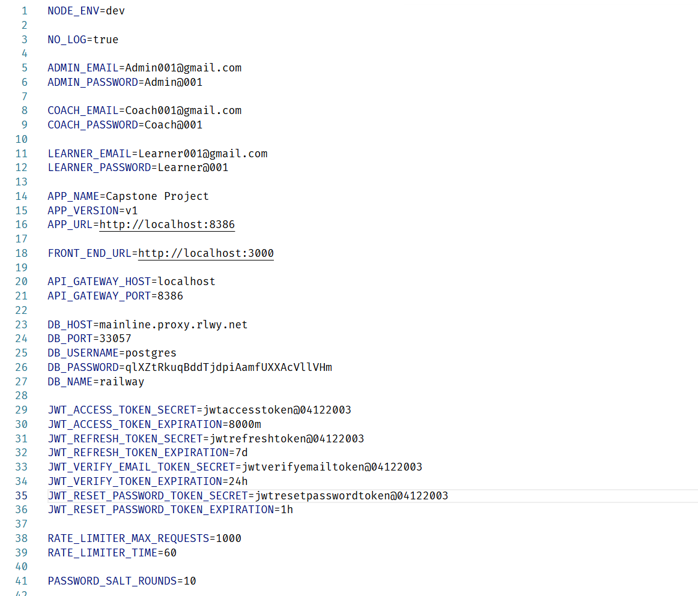

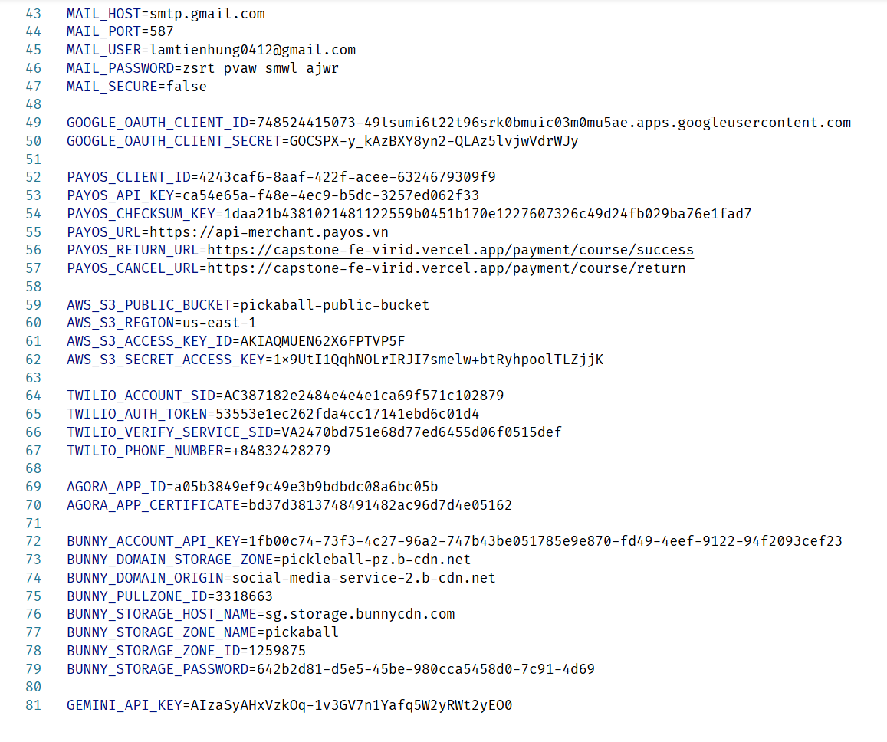

**Prepare database**

* + Create an empty PostgreSQL database matching

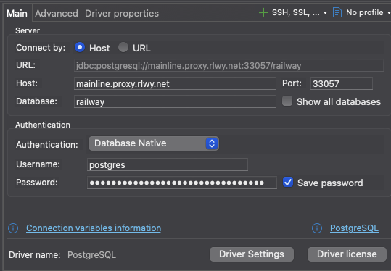

**Run database migrations** npm run migration:run

1. Start all backend services

npm run start

or in development mode:  
 npm run start:dev

1. Backend API is now available at:  
    **http://localhost:8386**

## 3. User Manual

## 3.1 Overview

The **AI-Enhanced Pickleball Learning and Coaching Connection Platform (PickleLearn)** allows learners and coaches to connect through an integrated training ecosystem enhanced with AI-powered video analysis. The system consists of three main components:

1. **Learner Mobile Application** – enables learners to register, browse courses, purchase training sessions, upload practice videos, receive AI-based analysis, and track progress.
2. **Coach Mobile Application** – allows coaches to create professional profiles, verify credentials, design courses, manage schedules, deliver online training sessions, and track student performance.
3. **Admin Web Portal** – used to manage users, verify coaches, approve courses, monitor platform operations, and manage achievements.

The platform integrates AI to compare learner techniques with professional coaches, helping learners improve faster with objective insights.

## 3.2 Workflow 1 – Coach Registration Workflow

## Purpose

This workflow manages the complete coach onboarding process: from initial registration, profile creation with credentials, to admin verification and account activation.

## Workflow Steps

### 1. Account Registration

* Coach accesses the platform (mobile app)
* Selects "Register as Coach"
* Provides basic information:
  + Email address
  + Password (with strength requirements)
  + Full name
  + Phone number
  + Address



### 2. Create Professional Profile

Coach completes comprehensive profile with the following sections:

**Teaching Specialties**:

* Examples: "forehand backhand serve volley dinking"
* Multiple specialties can be selected

**Teaching Methodology**:

* Examples: "drills video-analysis game-based progressive technical"
* Describes coaching approach

**Experience Details**:

* Years of coaching experience
* Detailed experience description

**Professional Bio**:

* Personal introduction
* Coaching philosophy
* Teaching style description
* Notable achievements

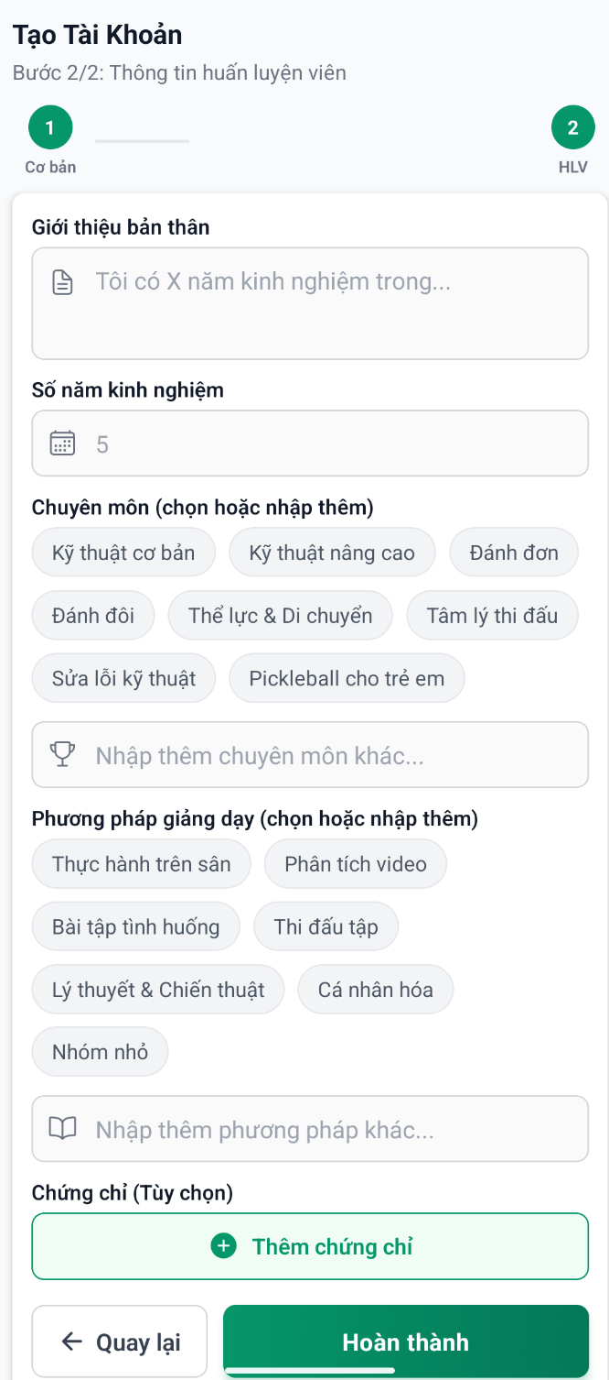

### 3. Admin Verification Process

Admin reviews the profile and has two options:

#### Option A: Approve

* Admin clicks "Approve"
* Profile status changes to **"Verified"**

#### Option C: Reject

* Admin provides clear rejection reasons
* Profile status changes to **"Rejected"**

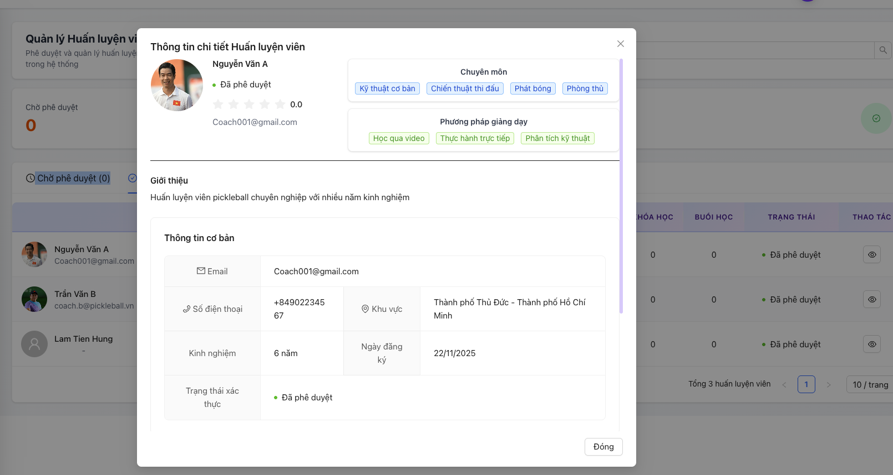

## 3.3 Workflow 2 - Create subject

## Purpose

This workflow manages how coaches create and organize subjects (content templates) that contain lessons, videos, and quizzes. Subjects serve as reusable content libraries that can be applied to multiple courses.

## Workflow Steps

1. Access subject library

* Coach navigate to my materials
* View existing subjects with status
* Two creation options:
  + AI Quick Create
  + Manual Create

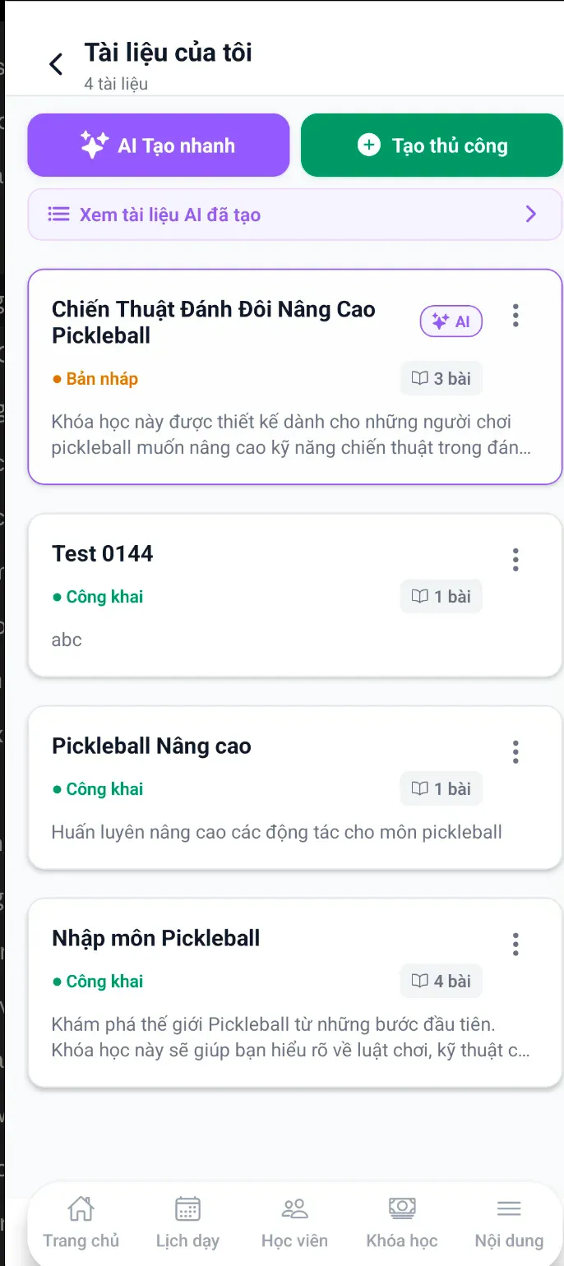

1. Create new subject - Manual comprise:

* Subject Name
* Description
* Skill Level

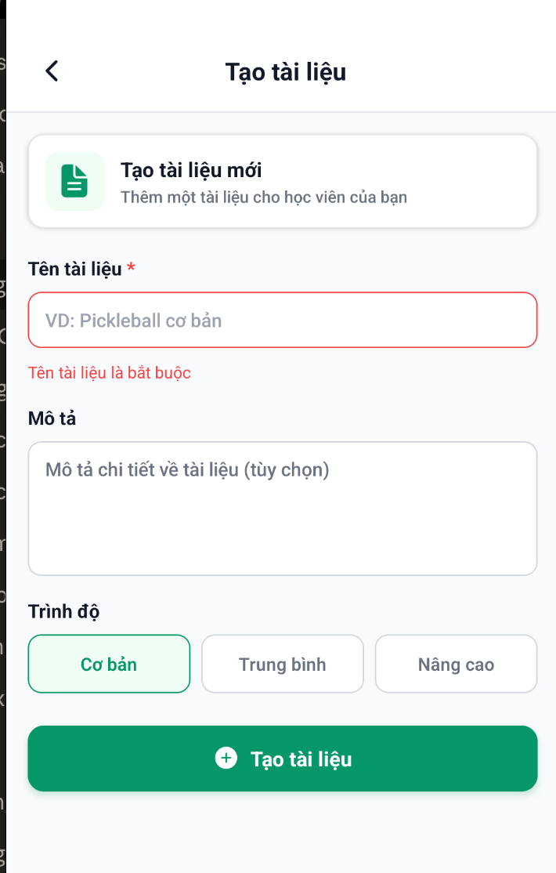

2.1 Create new subject - AI quick creation

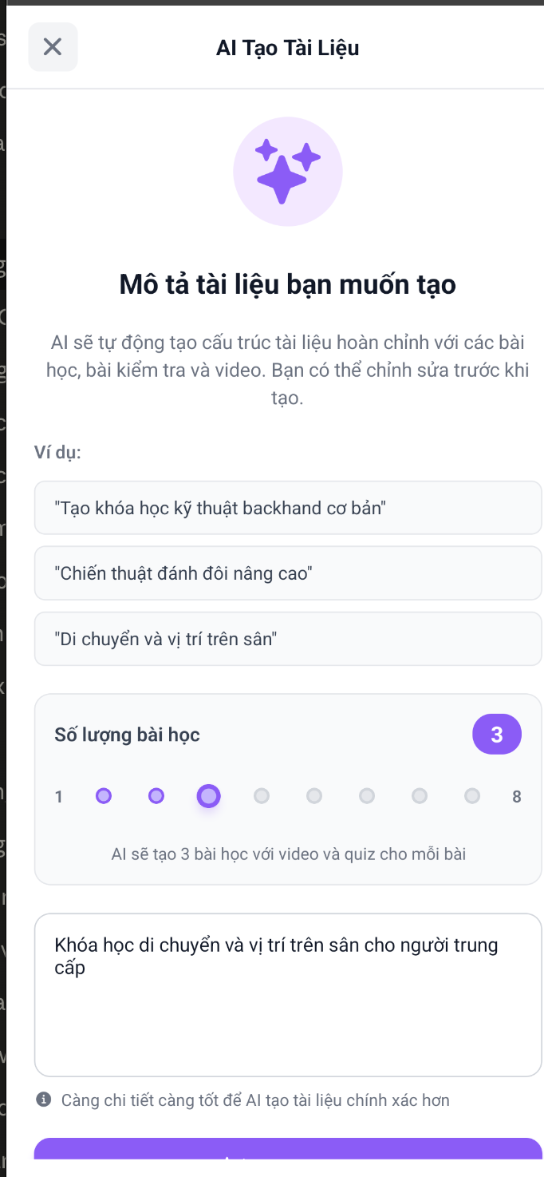

1. Choose subject to create the lesson structure

* Add new lesson (name, description)  
  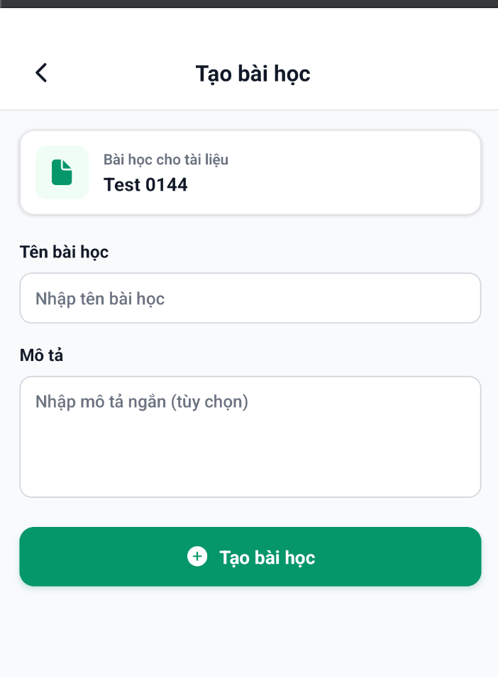
* Add new video followed by the lesson

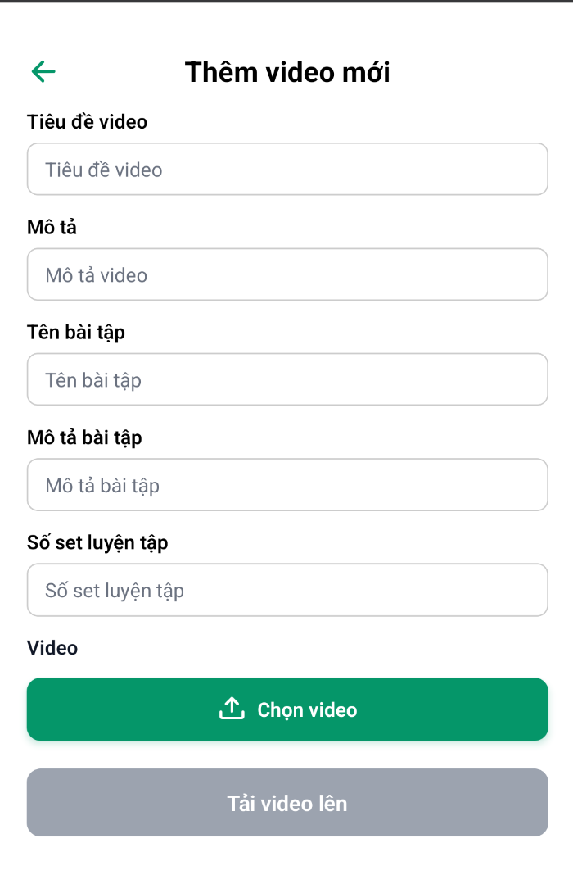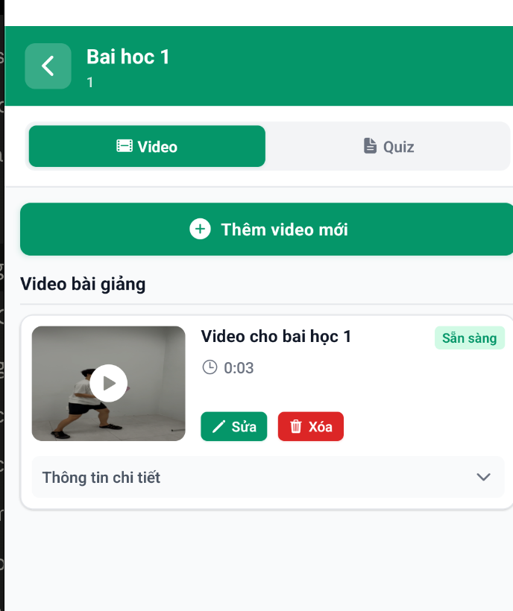

* Add new Quiz followed by the lesson

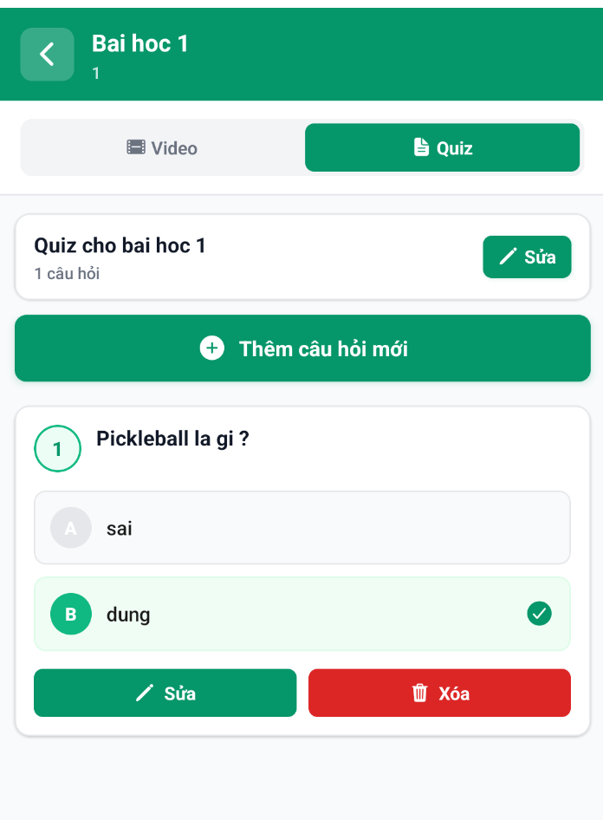

1. Public subject after finished creating

* Change mode from DRAFT to PUBLIC
* Save change

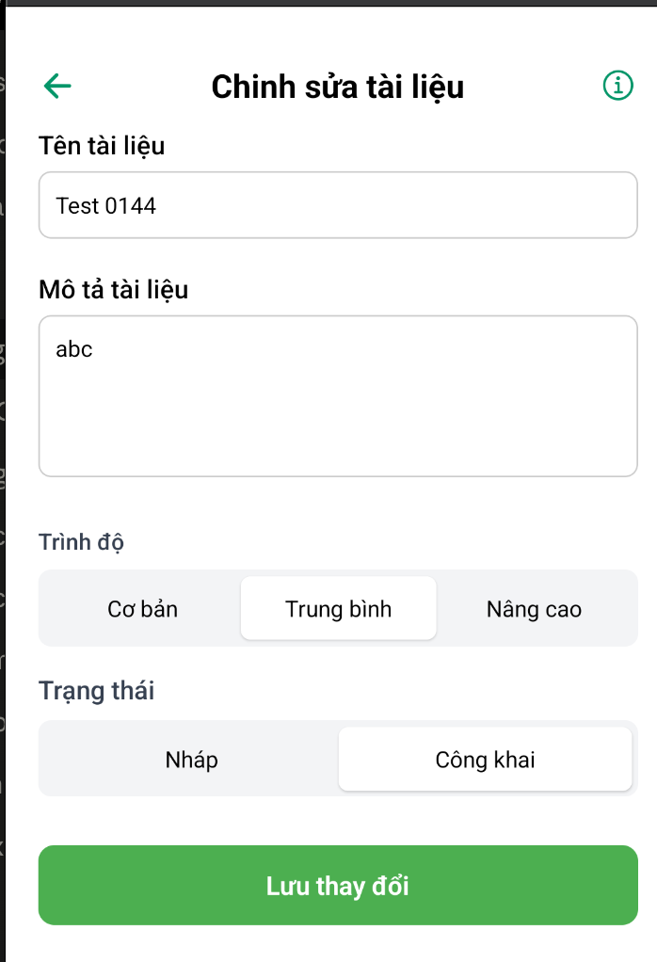

## 3.4 Workflow 3 – Approve Course Creation

## Purpose

This workflow manages the complete course creation process by coaches, from building course structure with lessons and schedules, to admin approval before becoming visible to learners.

## Workflow Steps

### 1. Coach create Course - Basic Information

* **Select Subject** (TÀI LIỆU): Choose from available public subjects
  + Only approved public subjects are available
* **Upload Course Thumbnail** (ẢNH KHÓA HỌC):
  + Recommended ratio 16:9
  + Max size < 5MB
* **Course Type** (HÌNH THỨC HỌC):
  + Individual (Nhóm) - 1-on-1 coaching
  + Group (Cá nhân) - Multiple students
* **Number of Students** (SỐ LƯỢNG HỌC VIÊN):
  + Use range slider (1-12 students)
  + Set minimum (e.g., 2)
  + Set maximum (e.g., 6)
  + Display range: "2 - 6"
  + If minimum not met by start date → Auto-refund all enrolled students
* **Display Course Summary**:
  + Price per session (250.000đ VND/giờ)
  + Physical address if offline
  + Coach contact number
* **Select Location on Map**:
  + Tap map to choose location
  + Or select from saved locations
  + Location appears as pin on Google Maps
* **Google Meet Link** (LINK GOOGLE MEET):
  + Auto-generated or custom link
  + Format:<https://meet.google.com/abc-defg-xyz>
  + For students who cannot attend in-person
* **Price Per Student** (GIÁ MỖI HỌC VIÊN):
  + Use +/- buttons to adjust
  + Minimum price validation
  + Display in VND
* **Revenue Breakdown** (shown to coach):
  + Total course price: 100%
  + Platform fee: 10%
  + Coach earnings: 90%
  + Payment released per session after completion

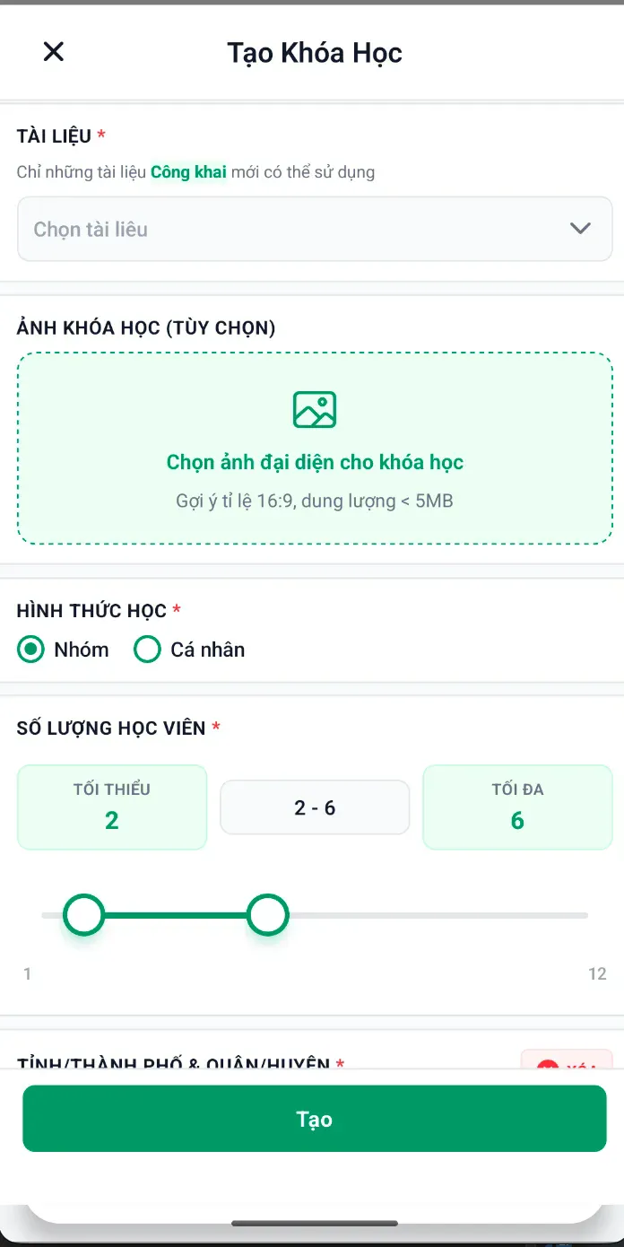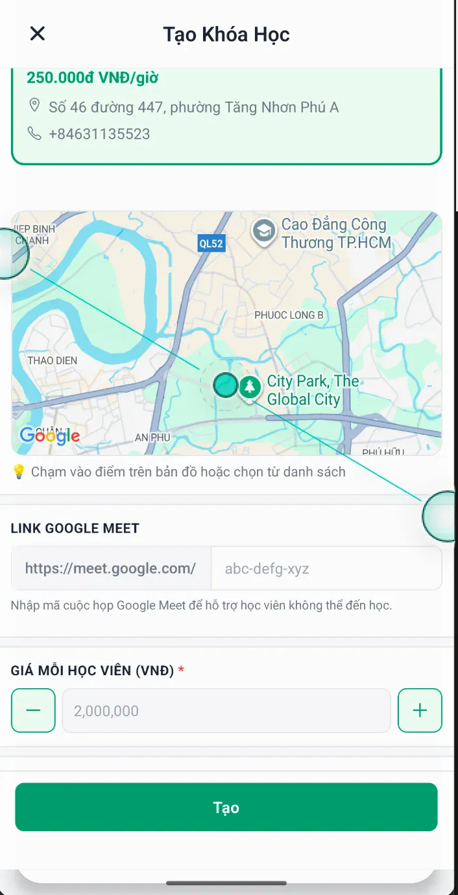

### 2. Admin verify course

* **Open Course (pending) details**
  + Course name
  + Description
  + Skill level
  + Number of lessons
  + Content type: Videos, Quizzes, or both
* **Lesson List**:
  + Each lesson includes:
    - Lesson number and title
    - Lesson description
    - Attached video (with Video badge)
    - Attached quiz with question count (Quiz 5 câu, Quiz 3 câu)
  + Example structure:
* **Action Buttons**:
  + "Đóng" (Close) - Cancel creation
  + "Từ chối" (Decline) - Delete draft
  + "Phê duyệt" (Approve) - Submit for approval

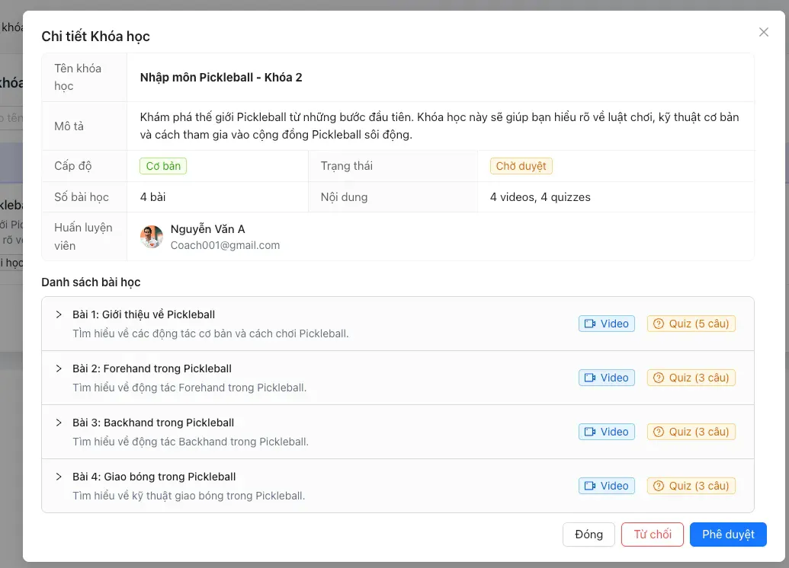

## 3.5 Workflow 4 – Register a Course and access to the materials

## Purpose

This workflow manages the complete learner journey from browsing courses, enrolling with payment, accessing course materials (videos, quizzes, assignments), and tracking progress through the course..

## Workflow Steps

1. Learner choose a course to start in course tab

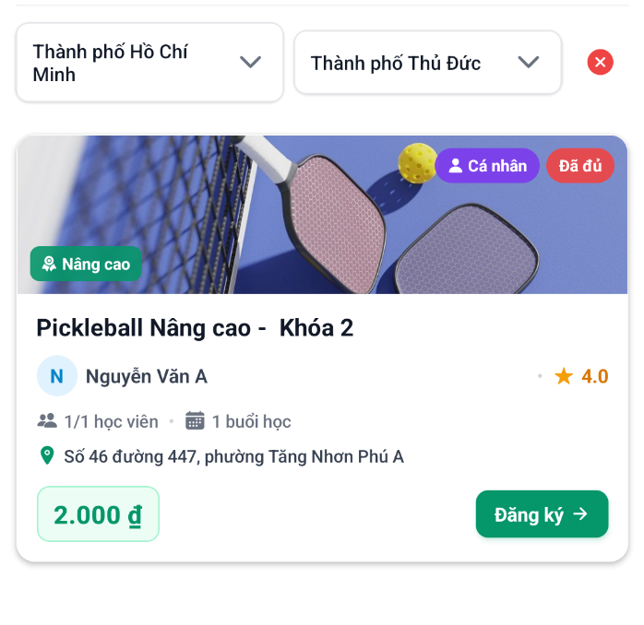

1. After payment successfully, learner can start to learn go to offline course or via google meet (if cannot attend)

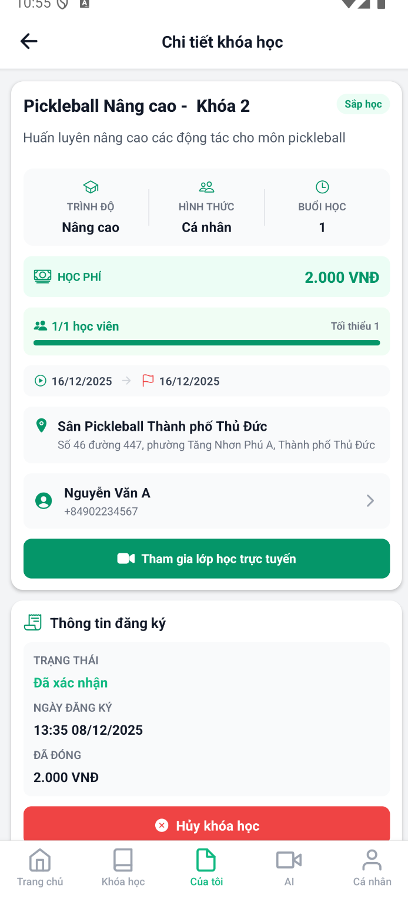

1. Coach check attendant after a lesson finish

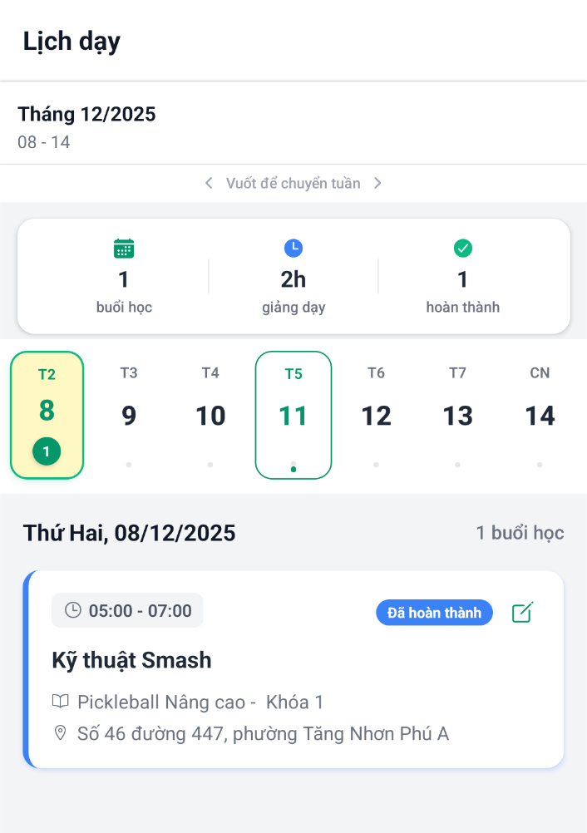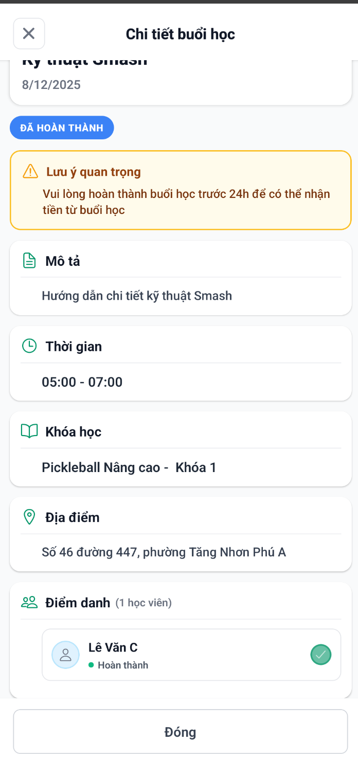

1. Learners upload video and do quiz after finishing a lesson

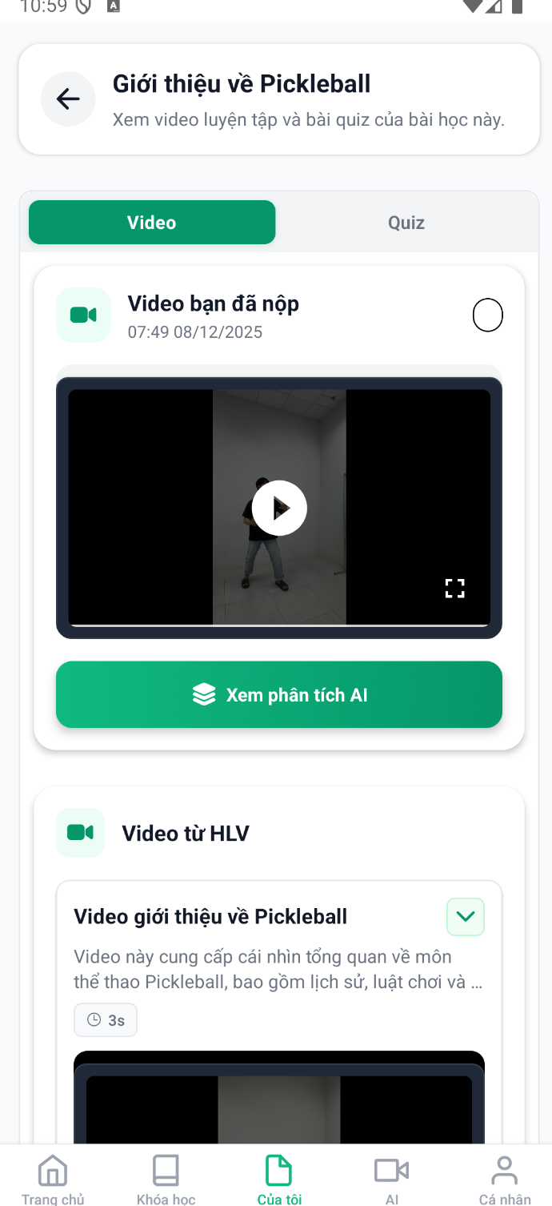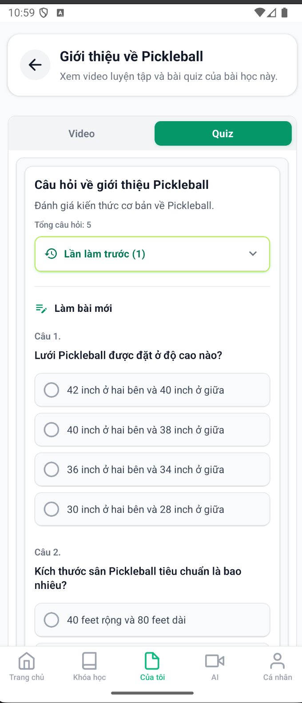

1. After finishing the course, learners can write feedback (course has FINISHED status)

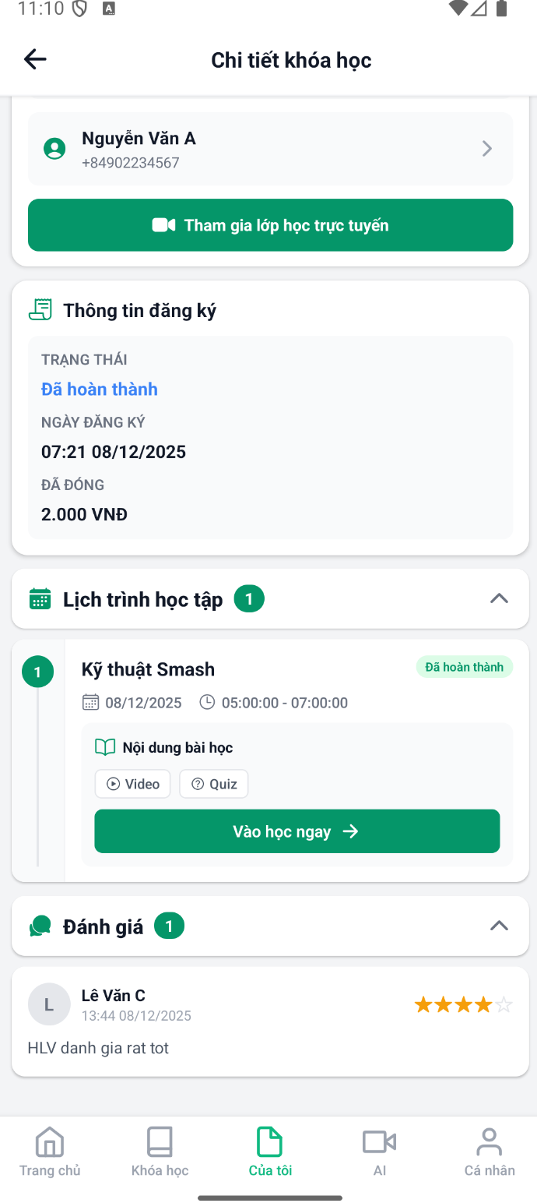

## 3.6 Workflow 5 – AI-compare assignment videos

## Purpose

This workflow manages the AI-powered video analysis system that compares learner practice videos against coach demonstration videos, providing detailed technique feedback, movement classification, and improvement suggestions.

## Workflow steps

1. Coaches open assignments of learner and start to review (open my learner tab)

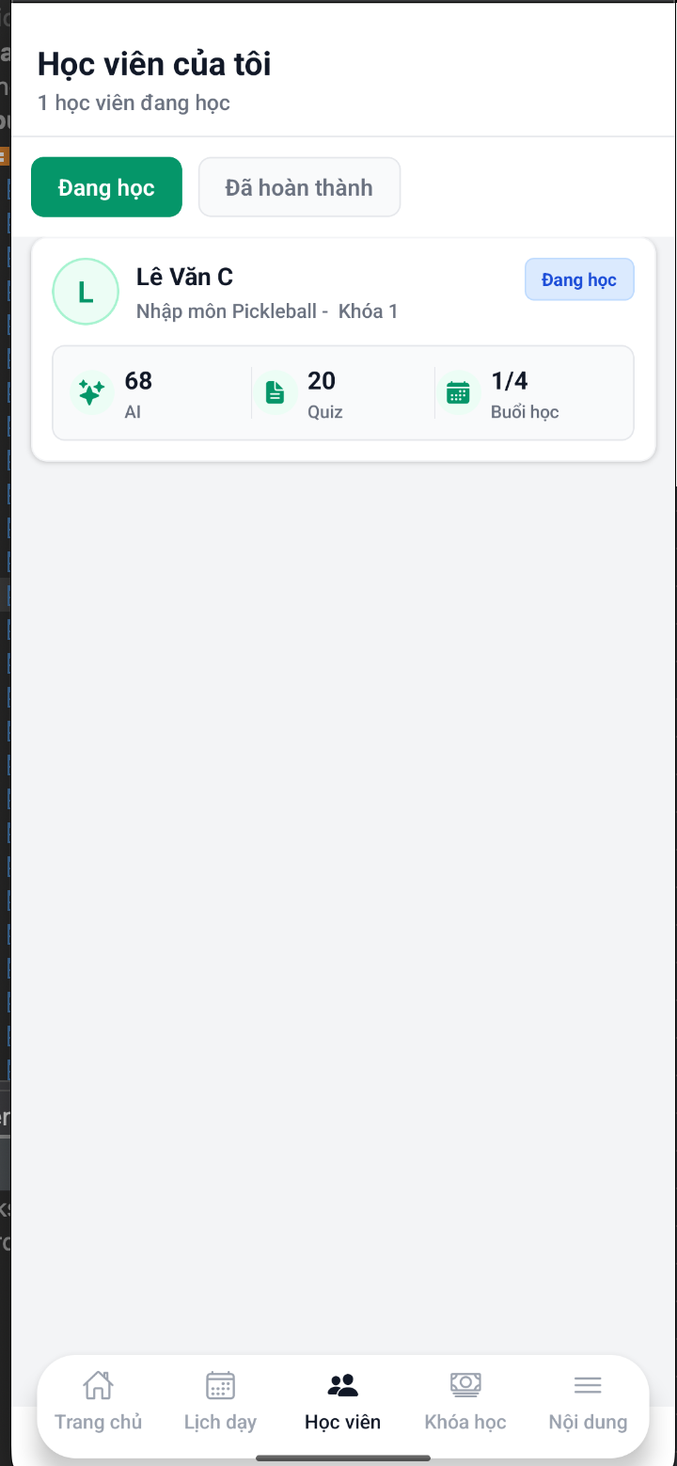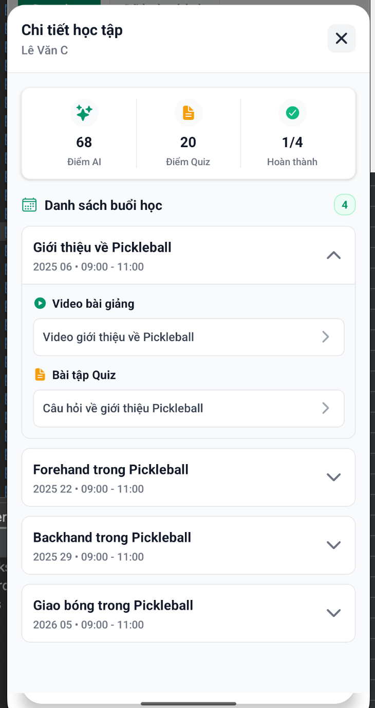

1. Coach click to video to watch learner’s videos and click to AI review button

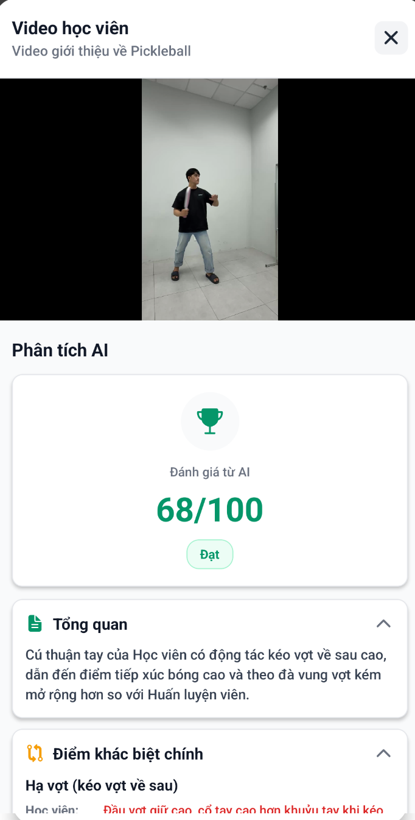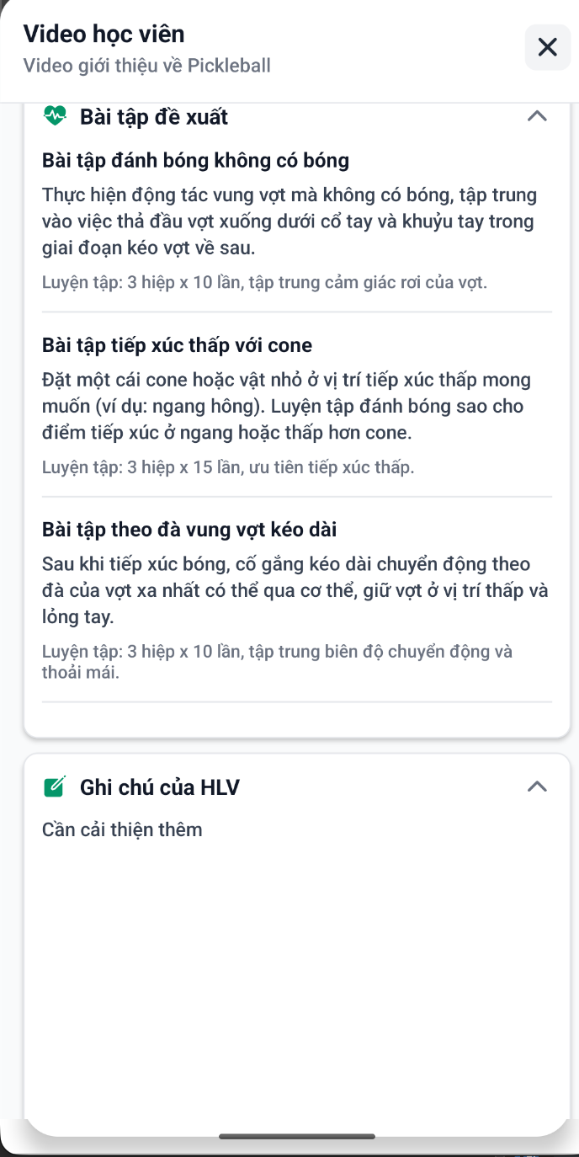

3 After sending feedback success, learners can view in assignments

* Choose layer or split option to view clearly
* View feedback of AI and coach

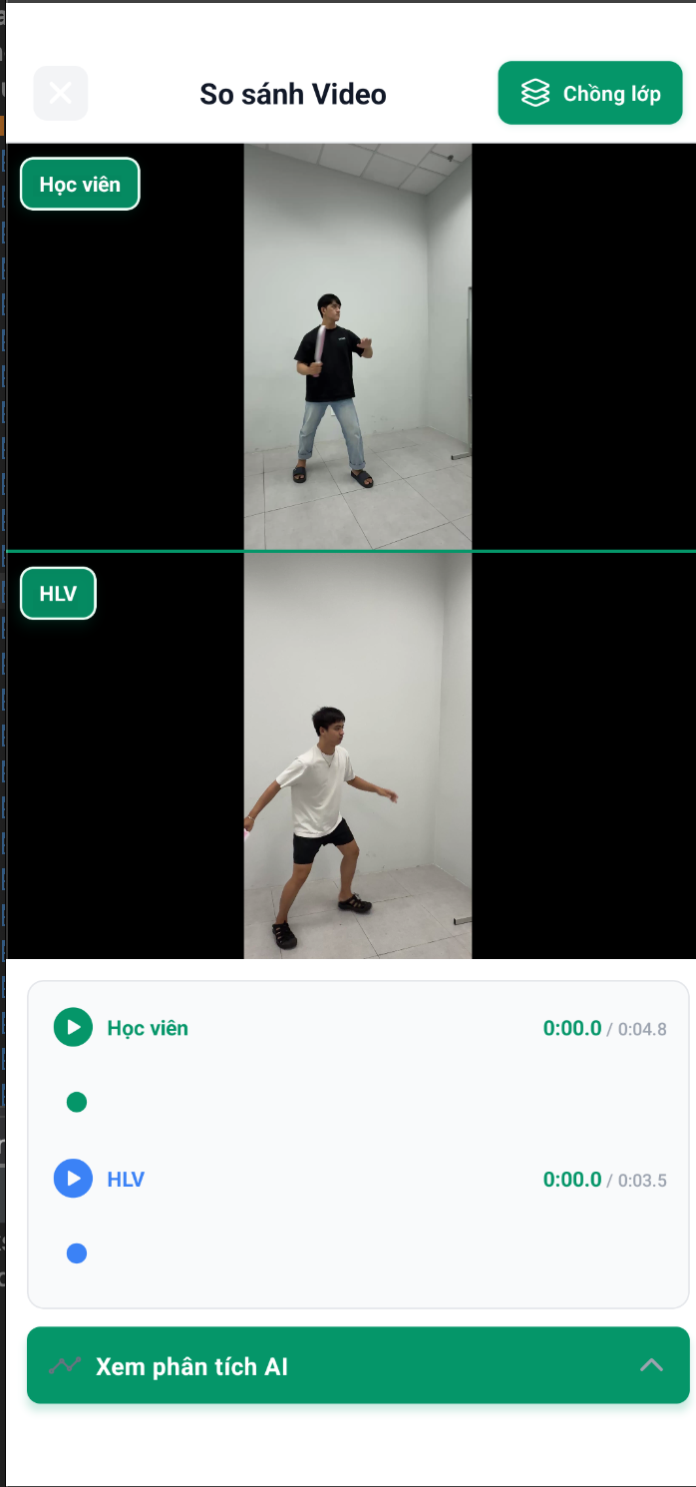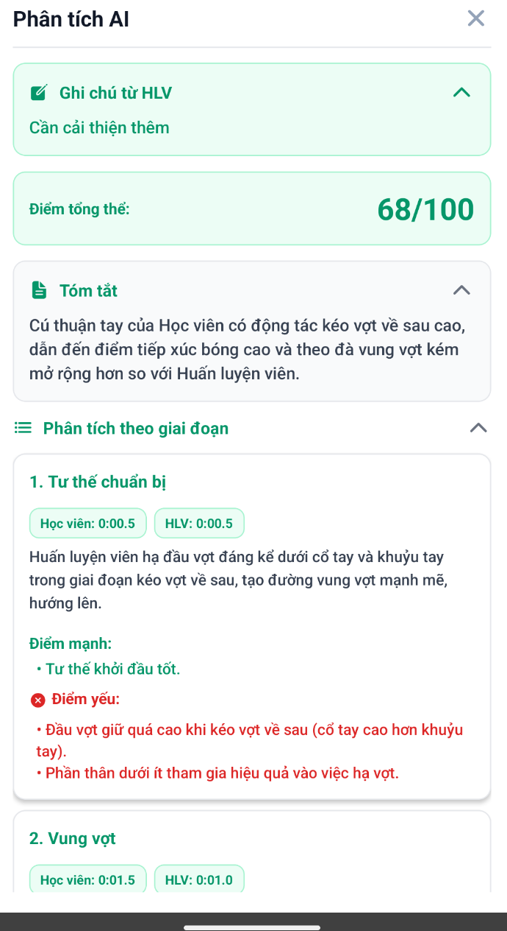

## 3.7 Workflow 6 – Revenue Management Workflow

## Purpose

This workflow manages the complete financial system including course payments, revenue distribution, refund processing, coach payouts, and platform commission tracking.

## Workflow steps

1. Coaches go to my wallet and fill in credit information

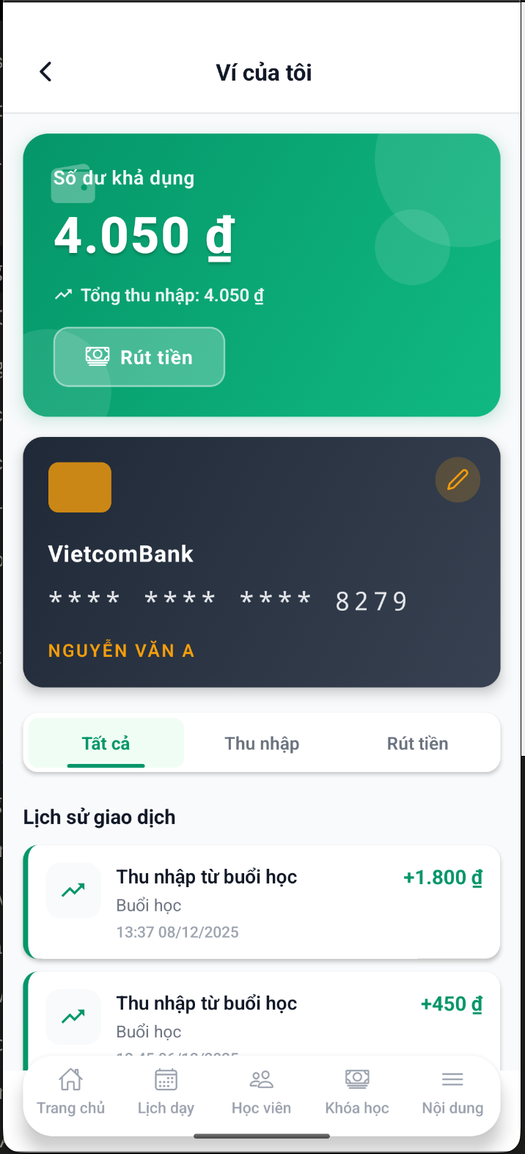

1. Go to Fund holding

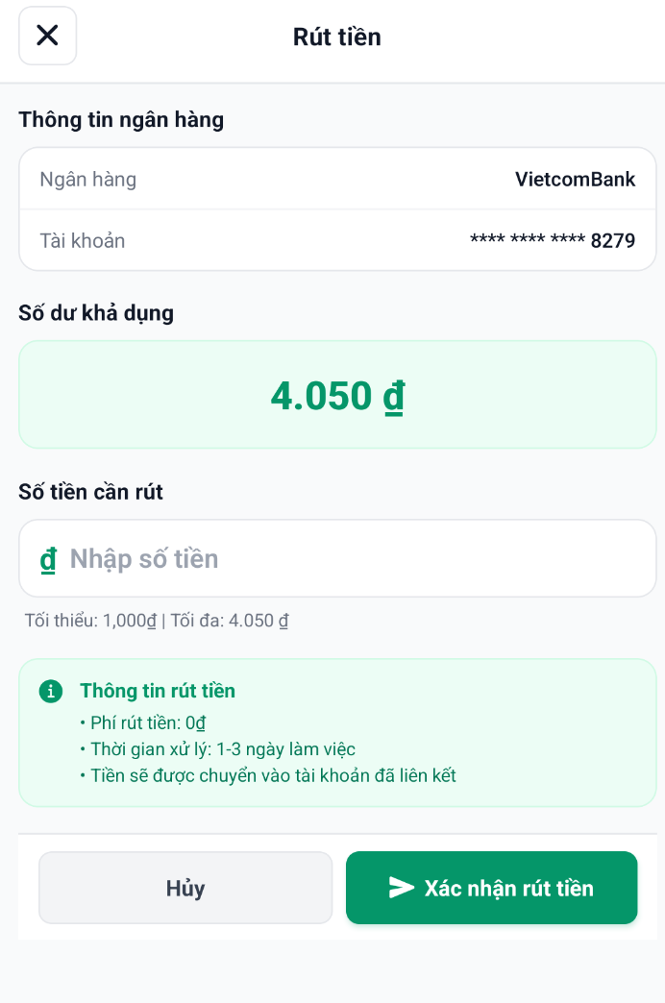

## 3.8 Workflow 7 – Achievement Management

## Purpose

This workflow manages the achievement and badge system that gamifies learner engagement, tracks progress milestones, and rewards consistent participation. Administrators create and configure achievements, while learners earn them automatically based on their activities**.**

## Workflow Steps

1. Admin Creates and Edits Achievement

* Type
* Event Counter
* Attribute Check
* Time-based
* Goal-based
* Description
* Upload image (optional, JPG/PNG/GIF/SVG, max 5MB)
* Event name
* Target Count

**Conditions**:

* Target: Learner | Coach | Admin
* Attribute:
  + Sessions attended
  + Course progress %
  + Quiz score
  + Average rating
* Operator: >=, >, <=, <, ==, !=
* Value: 5, 80, 100, etc.

**Settings:**

* Status: Toggle ON/OFF (Active/Inactive)
* Creator: Auto-filled admin info

**Actions**: Cancel | Create

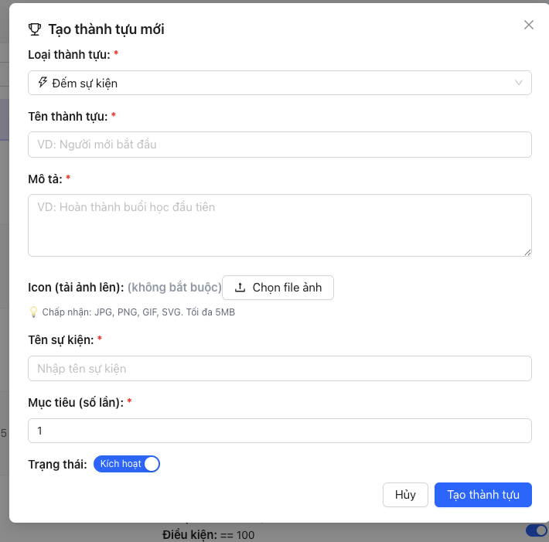

**2.** Admin views and deletesAchievement

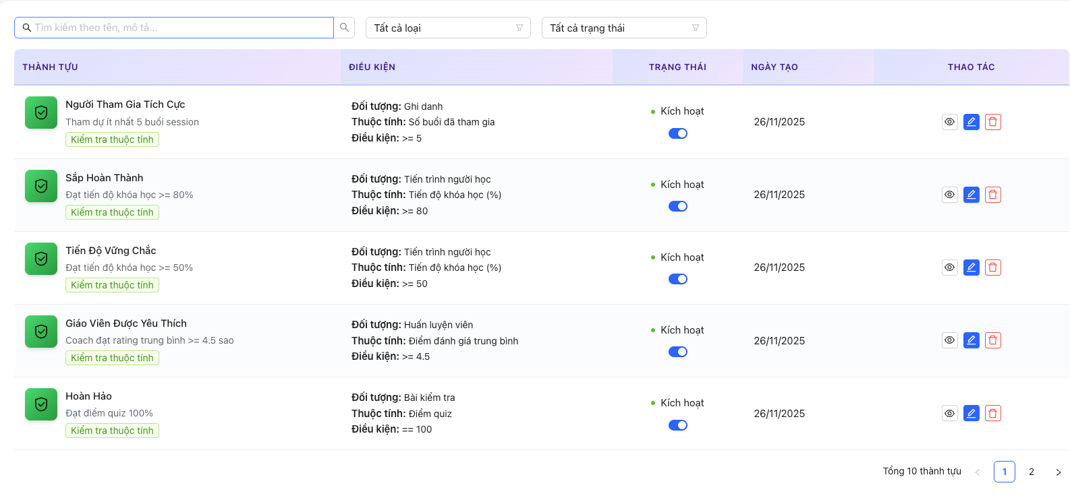

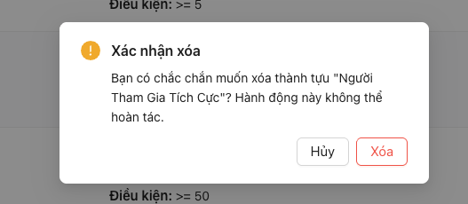

## 3.9 Workflow 8 – Court Management

## Purpose

Manage pickleball courts/facilities where offline courses are conducted, including court registration, availability scheduling, and booking management**.**

## Workflow Steps

1. Admin Adds Court

* Navigate to "Quản lý sân" (Court Management)



2. Create and edit a court

* Enter city, district, name, price per hour, phone number, url

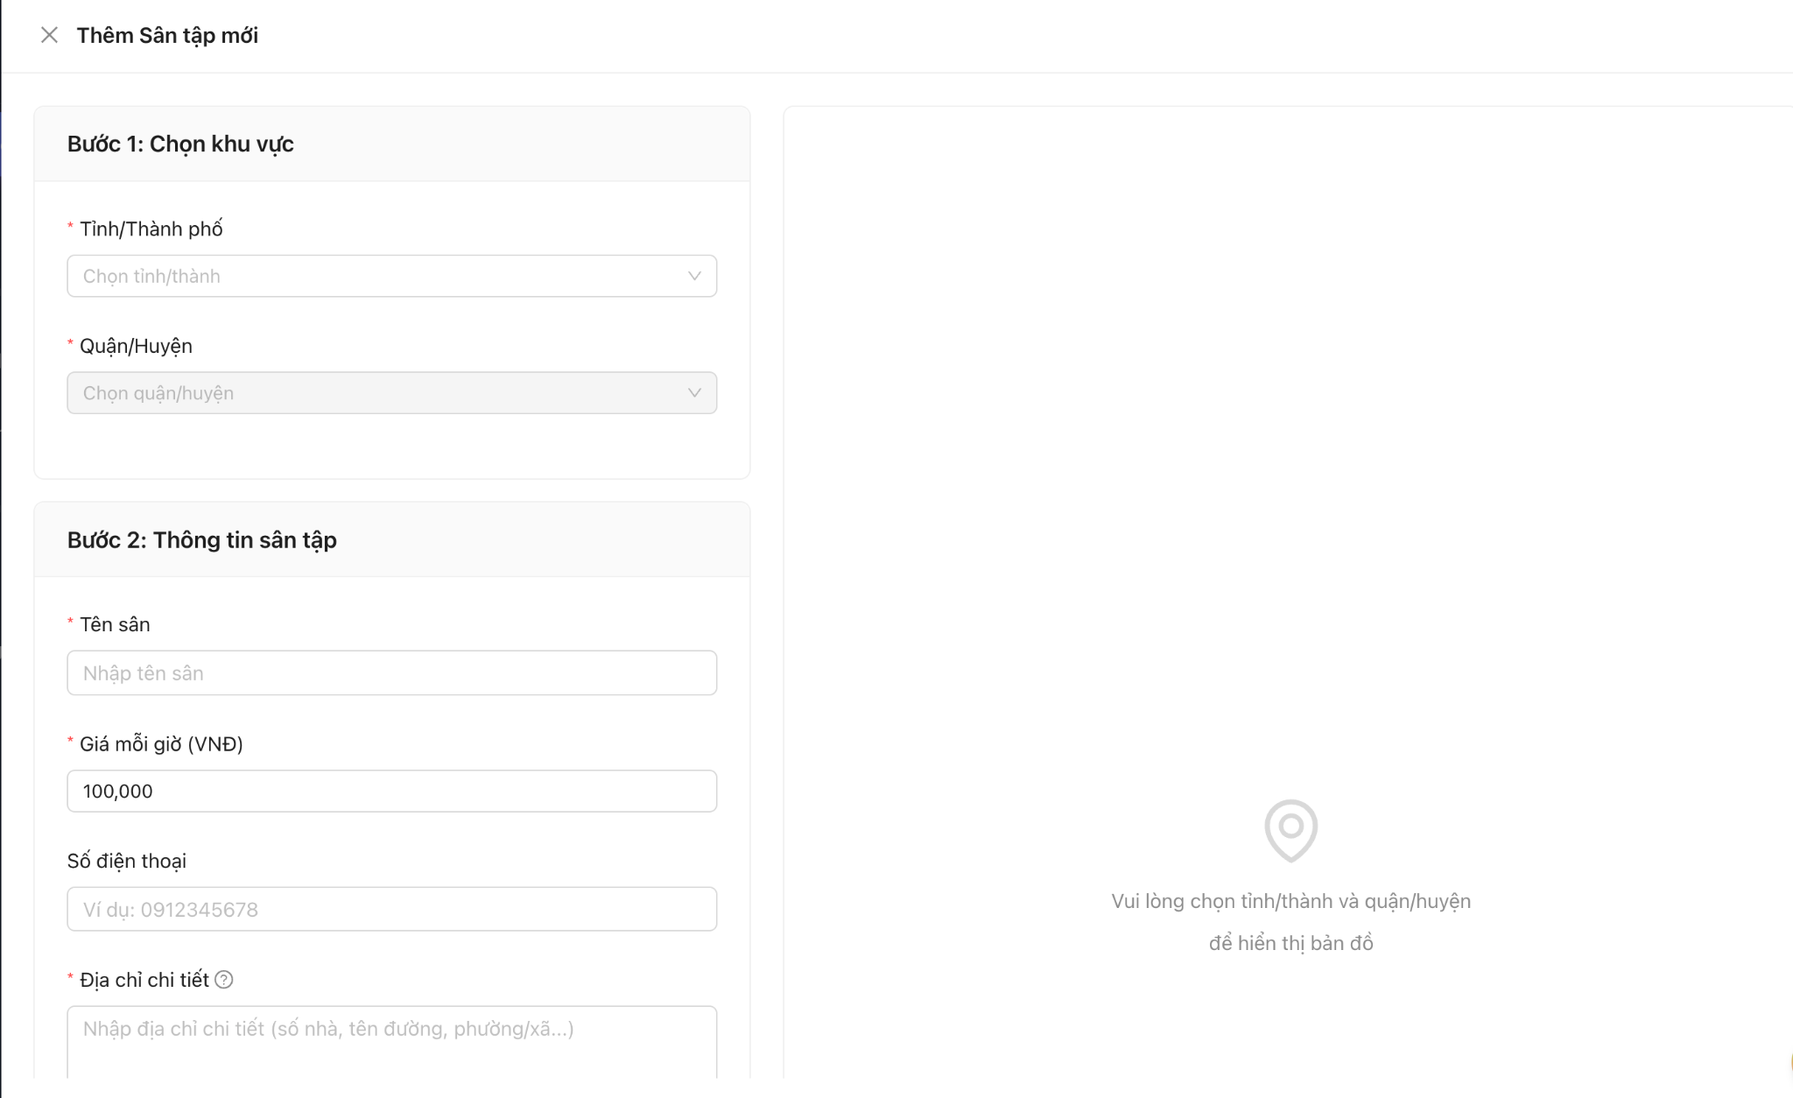

1. Delete a court

* Click to delete button and confirm

